South Dublin Libraries Report Aug/Sept 2021

Our libraries are open for borrowing, returning, and printing services. All Covid 19 guidelines are being observed and libraries are operating as normally as possible within this framework.
This summer has seen the limited return of in person events at South Dublin Libraries, taking place in outdoor spaces attached to some of our libraries and in parks throughout South Dublin. These events include Scavenger Hunts in Collinstown Park, Sean Walsh Park, Rathfarnham Castle Park and Massy’s Wood. Other outdoor highlights in August were history workshops with the School of Irish Archaeology, music classes, arts and crafts, School Fitness Ireland, Gymboree, teddy bear’s picnics, storytimes and many more.
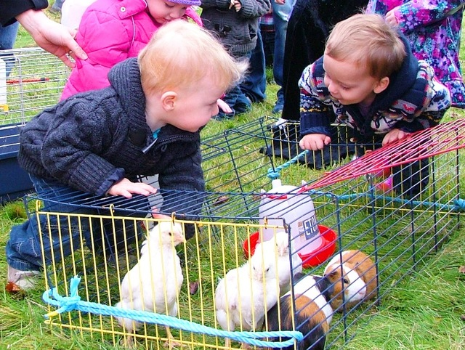 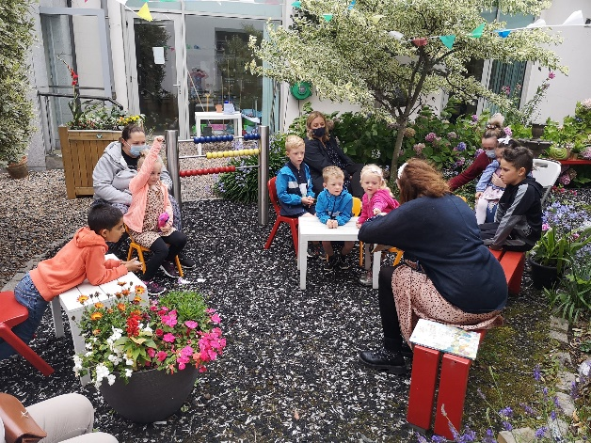 Woolly Wards Farm at NCL Garden Stories at Tallaght Library
Some adult events also moved out of doors such as outdoor music at Ballyroan Library, Tai Chi in Rathfarnham Castle Park, and Crafty Fridays in the garden of North Clondalkin Library.
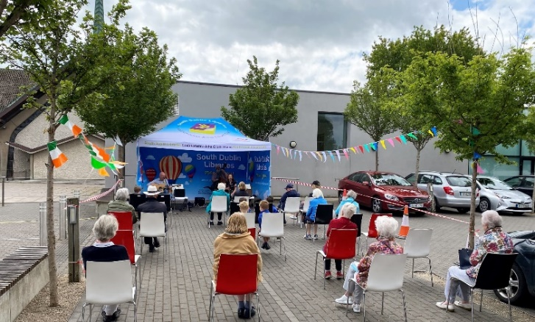
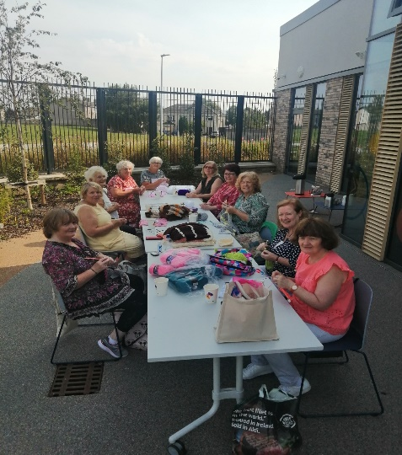

Online events continued to be an important element of our programme and included writing workshops with authors Dave Rudden and Wayne O’Connor, space exploration with the Exploration Dome, parenting talks by Mary O’Kane on the transition from primary to secondary school, screenwriting workshops with Burning House Media Company and many others.
As well as this, libraries have been able to again welcome local literacy and numeracy camps either by facilitating events for them in outdoor spaces attached to the libraries or by visiting the camp at their location. North Clondalkin library had 13 literacy and numeracy camps down to the library in August.
Heritage Week
Heritage Week 2021 took place from 14-22 August this year and included several events held by South Dublin Libraries. Events included Irish History Live Vikings show at NCL, guided heritage walks throughout the county, County Library Tallaght produced a History and Heritage Children’s Printable Activity Pack and held Viking Dagger & Design Workshops for children. Clondalkin library’s highlight was a talk on the history of the Irish Language which was opened and attended by Mayor Peter Kavanagh.
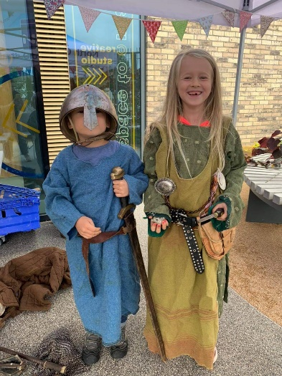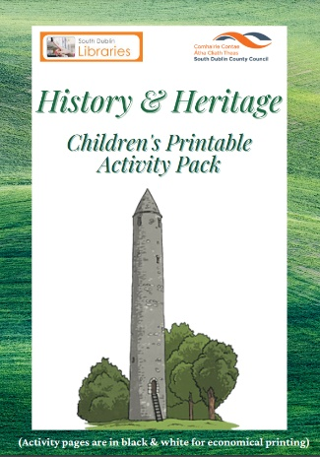
Irish History Live History and Heritage Activity Pack
Exhibition Highlights Aug:
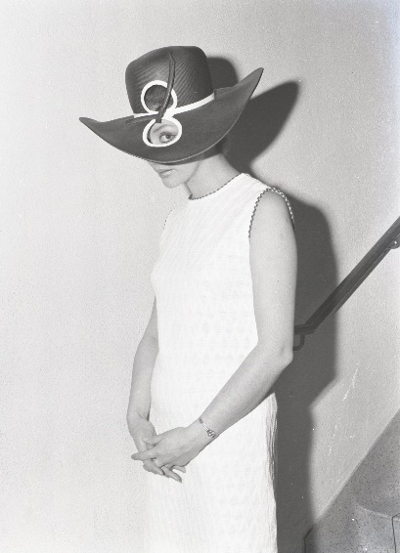
July/August 2021 Exhibition: Fashioning a Suburban Neighbourhood in the Late 1960s
This exhibition celebrates the work of local photographer Gerry O’Shea who along with his wife Kitty ran Rosemount Art Studio, at their family home on Anne Devlin Avenue, between 1968 to 1972. Prior to taking up residence in Ballyroan, Gerry worked as a press photographer for the Sligo Champion and the Munster Tribune. Most of the work of the Studio in Ballyroan entailed photographing families from the then new suburb of Ballyroan – Rathfarnham. Christenings, communions, confirmations, weddings, and, less frequently, individual requests for portraits, were grist to the mill of the camera’s lens. Occasionally Gerry was requested to shoot fashion shows by the late Charley Nichol who ran a lady’s fashion boutique called Tanya Boutique in Rathfarnham Shopping Centre during the 1960s and 70s. The latest trends from London were displayed in sometimes in a 'not too serious' manner. The exhibition documents a selection of images from the period and should be of interest to locals and non-locals alike. The photographs will be archived in South Dublin Libraries digital archive Source following the exhibition.

The Friends of the Camac Photo exhibition in Clondalkin Library opened during Heritage Week and was available until Sat next 21st August. The exhibition included the history and beautify of your local Camac river, including the photo archives of the Clondalkin Anglers Association (1958-1987). L/R Lisa Colwell (Library staff), Adair Cowan (FOTC), Una Ruddock SDCC PPN Secretariat, Maria O'Connor (FOTC), Trevor Kilgannon (Library Staff), Brian Ronan (FOTC)
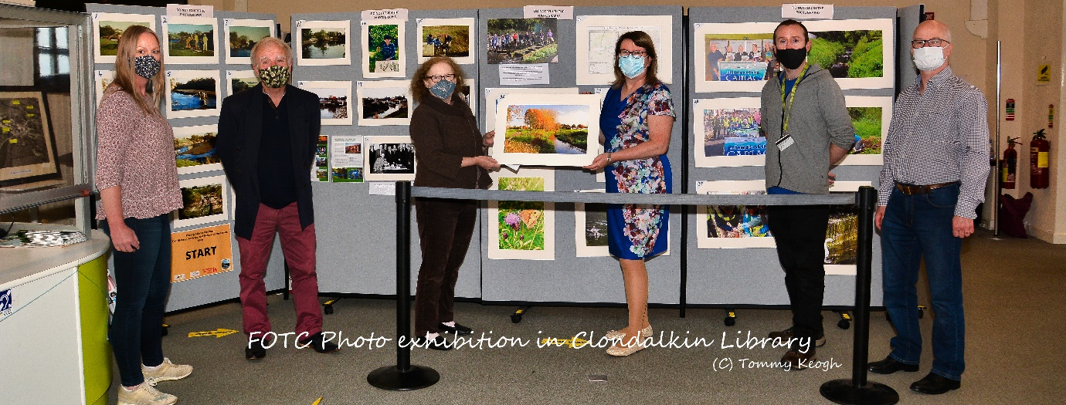

Decade of Centenaries:

Autumn/Winter Lecture Series
A series of online (Zoom) talks with some of the leading historians of the period. All talks are open for booking now at http://southdublinhistory.eventbrite.ie

Saturday 4th September at 11am
Dr. David McCullagh From Truce to Treaty: de Valera's 1921
This lecture will explore Éamon de Valera’s leadership during the truce period and treaty negotiations, including an examination of his controversial refusal to go to London for negotiations with the British government in late 1921.

Thursday 9th September at 7pm
John Dorney Nationalist revolution in Ireland and Europe 1919-23
Between 1919 and 1923, Ireland experienced upheaval, revolution, partition, and civil war. This experience was common to swathe of countries across Europe, as the German, Austro-Hungarian and Russian empires collapsed in the wake of the First World War. This lecture aims to put Ireland's experience in its European context.

Historian in Residence
Liz Gillis has been appointed as the Decade of Centenaries Historian in Residence for South Dublin County. Liz specialises in the Irish Revolutionary period, is a lecturer at Champlain College Dublin and has worked as a researcher on The History Show on RTE Radio, as well as a curator on the RTE 1916 Centenary Project. She is the author of several books including Revolution in Dublin: A Photographic History 1916-1923, Women of the Irish Revolution, and May 25: Burning of the Custom House 1921. Liz has great experience in public engagement and delivering community history projects.
Plans for the residency include:
- Working with the County Promotion Unit in the delivery of a revolutionary trail app.
- Talks (online and in-person where possible) about the role of South Dublin County in the Irish Revolutionary period.
- ‘Then and Now’ workshops with primary and secondary schools and community groups.
- Leaving Cert history workshops with 5th and 6th year students.
- Engagement with local history societies.
- Interviewing relatives of those who participated in the Irish Revolution with a view to recording their stories.

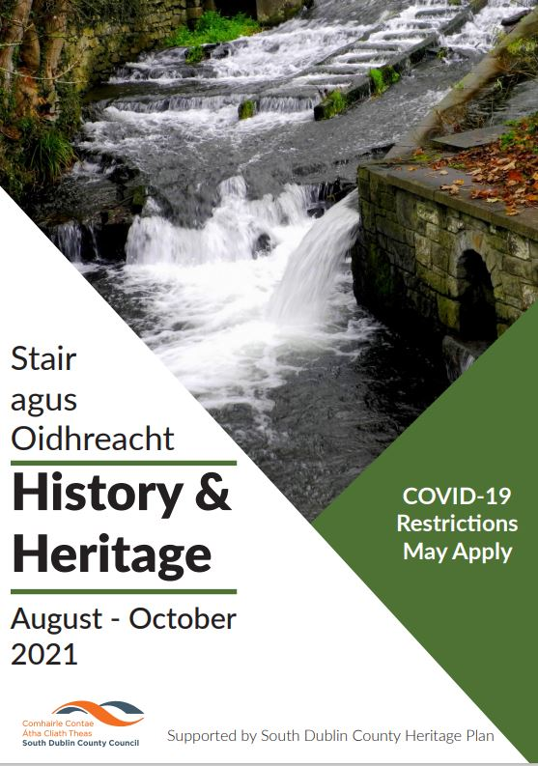
History and Heritage August-October 2021
This is a programme of online and in-person outdoor events organised with the support of the South Dublin County Heritage Plan.
Highlights include the ever-popular series of heritage walks, talks on a wide range of topics from Frederick Douglass to the history of Dublin Port, and in-person events for children including Irish History Live living history shows, and archaeology workshops with the School of Irish Archaeology. Full details are available at https://www.sdcc.ie/en/events/library-events/popular-library-events/history-and-heritage-at.html

Local Live Performance Programming Scheme
South Dublin Libraries received funding under this scheme to provide live outdoor events connected to South Dublin Libraries. To this end Circus 250 will be performing their show Daring Dames which consists of an all-female cast of astounding acts and feats of strength. Shows will take place at County Library Tallaght (schools), Ballyroan library, Castletymon library and North Clondalkin Library on Friday 3rd and Saturday 4th September. For booking, please see
https://www.eventbrite.ie/e/circus-250-daring-dames-outdoors-tickets-168282031085?aff=ebdsoporgprofile
https://www.eventbrite.ie/e/daring-dames-with-circus-250-tickets-168087617589?aff=ebdsoporgprofile
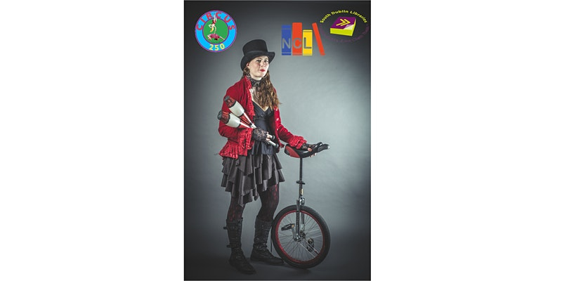
Also included will be a live performance by Pennies from Heaven band and live children’s entertainment outdoor at the launch of the new Castletymon Library and mobile vans on 16th September.
Red Line Book Festival
Programming for the festival, which will take place from 11th – 17th October, is now complete and will be launched at Casement Aerodrome on Tuesday 14th September by Mayor Peter Kavanagh at a photocall. The festival (the theme this year is The Roaring 20s) will include over 80 events both online and in person taking place at libraries throughout South Dublin County as well as in the Civic Theatre and Rua Red.
The 2021 Red Line Book Festival Writer in Residence, poet and biologist Jane Robinson has been appointed and will be running a course of masterclasses titled Unroar - Online Outdoor Poetry in a Time of Ecological Crisis. This will consist of writing outdoors at a variety of different kinds of locations followed by an online session with Jane. Jane will also deliver a series of one-to-one poetry clinics in a library as part of her residency.
Opening of Castletymon Library & Launch of 2 new Mobile Library Vans
Thursday 16th September 11.00am.
We are delighted to be opening the new Castletymon library and launching our 2 new mobile library vans. This will be done by Mayor Peter Kavanagh. A local primary school class will be invited to take part in creating a collage with artist Kim Jenkinson which will be displayed in the new library.
Family friendly entertainment will be provided by the fantastically funny Jack Flash with mellow music from the wonderful Pennies from Heaven!
Culture Night September 17th September
Culture Night 2021 will be celebrated in person this year with events planned at all our libraries.
Ballyroan:
Muhibbah, an exhibition by Ariyana Ahmad
Muhibbah is a Malay word meaning a feeling of friendship, camaraderie, tolerance, and understanding. Commonly used in a multi-racial, multi-cultural setting (like in Malaysia and currently now in Dublin). Ariyana’s work focuses on Malaysian folklore but with a mix of folklores from other countries. Supported by the Creative Ireland programme South Dublin. (this runs from 30th August – 18th September)
Tales from the Shadows Puppetry Show Shadow puppetry is a traditional art form of Malaysia and Indonesia and Ballyroan Library is delighted to present this show by Tales from the Shadows, based on a Malaysian fairy tale. 10-minute shows will take place throughout the evening. Supported by the Creative Ireland programme South Dublin.
NCL:
Celebration of Summer Stars. A night of celebration of summer reading where participants can come along to collect their certificates, prizes and take part in onsite entertainment provided.
Magic Show with Waffles the Wonderful: Enjoy Ireland's favourite female magician. This magic show is a whirlwind of fun and laughs as young and old join in the tricks. Meet Waffles mind reading bear Boo-boo, see children make objects appear and disappear, and guess what animal will magically arrive. Waffles was chosen by President Higgins to entertain at the Aras and has been making children and parents happy for over 15 years.
Launch of the Humans of Balgaddy Project with Cllr. Joanna Tuffy & Peter Varga (The Humans of Dublin)
Tea Dance Dust down your dancing shoes, get that rhythm going and come along on Friday 17th September 2021 at 5.45pm for a trip down memory lane. The band and the floor await your ‘twinkle toes’. Take that ‘necessary trip’. Young or old, can partake. Light Refreshments provided.
Tallaght:
James Devlin is a Dublin based visual artist whose powerful pieces of work were previously on display at the In-spire Galerie on Gardiner Street and GalleryX.
County Library Tallaght will be hosting a selection of work by artist James Devlin from 1st to 30th September 2021. Subject to government guidelines there will be a launch of the exhibition and an opportunity to meet the artist on Culture Night.
Screening of visual art piece by Artist Una Gildea (funded by Creative Ireland funding)
Visual artist Una Gildea hosted stop motion workshops for ages 11- 13-year-olds in August from which a video was created. The finished video will be shown in the library on Culture Night subject to government guidelines.
Lucan:
Enjoy a classical concert while you browse in Lucan library on Culture day. We will a select a concert from our free online music resource, Medici.tv for your enjoyment. Medici Tv has the largest collection of online classical music videos-orchestral, ballet opera and performance. All you need is your South Dublin libraries card and an internet connection. Ask at the desk and we will guide you in accessing this fabulous resource.
Clondalkin:
Talk by Social Historian Cecelia Hartsell on JFK in the summer of 1963- an Irish homecoming. Cecelia will also show footage of the visit during the talk.
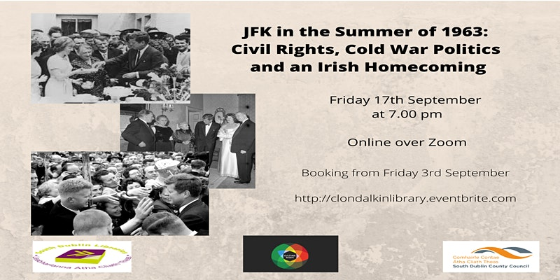

Dublin Climate Action Week
South Dublin Libraries are taking part in the 1st Dublin Climate Action Week, which will take place from 13th – 17th September. These events will all be delivered online.
Dublin Climate Action Week: Let’s Talk Climate Action is an introductory Climate Action workshop for secondary schools. This workshop will help students to better understand the need for climate action in their day to day lives while giving voice to their concerns about climate change as young citizens. (School’s event). This event will also be held at a separate time aimed at community groups.
Sustainable Energy Communities Information Seminar. Find out about sustainable energy solutions for homes, schools, businesses, and communities at this free online workshop!
Schools Workshops online by Dale Treadwell and the Irish Peatlands Conservation Council.
Other September Highlights
Sat 4 Sep 2021 11am Tallaght Library
Dr David McCullagh: From Truce to Treaty: de Valera's 1921
This lecture will explore Éamon de Valera’s leadership during the truce period and treaty negotiations, including an examination of his controversial refusal to go to London for negotiations with the British government in late 1921.
The event is part of South Dublin Libraries Local Studies History and Heritage 2021 and Decade of Centenaries programmes.
Wed 8th Sept Irish History Live Castletymon Library
Mike Moylan takes 3 classes on a live action tour through the wonders of Ancient Egypt! Part of History and Heritage week. Takes place in Tymon Park.
Thursday 9th September at 7pm NCL
Nationalist revolution in Ireland and Europe 1919-23. Between 1919 and 1923, Ireland experienced upheaval, revolution, partition, and civil war. This experience was common to swathe of countries across Europe, as the German, Austro-Hungarian and Russian empires collapsed in the wake of the First World War. This lecture by John Dorney aims to put Ireland's experience in its European context.
Monday 13th September at 7:00pm Ballyroan Library
Revolution in Dublin with Liz Gillis.
Liz Gillis has been appointed Decade of Centenaries Historian in Residence for South Dublin County Council. In this introductory talk, she will give an overview of the history of the War of Independence in Dublin and will outline her plans for the Historian in Residence programme
September 18th: Live launch of 16 Bars NCL NOISE Music is a brand-new music programme for young people aged 14 -18 in South Dublin County who are interested in DJing, singing, rapping & making beats in genres such as hip-hop, techno & house music. The programme connects creative young people with artists and musicians who make the kind of music that they listen to.
To launch the NOISE Music programme the team of music mentors working on the NOISE Music programme have been commissioned to create 6 new tracks as part of a special project in partnership with North Clondalkin library called 16-Bars.
A Live performance will take place on Saturday 18th September @ 1pm.
This event is a collaboration between Contact Studio, Music Generation and NCL.
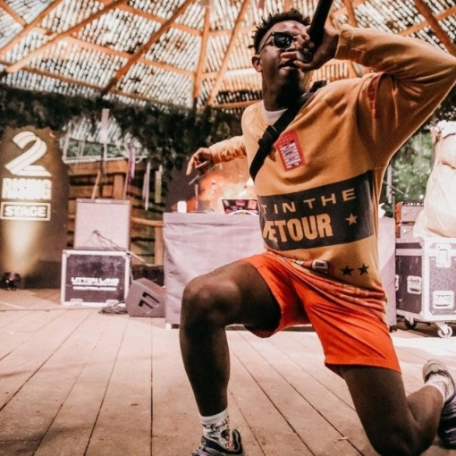

Monday 20th September at 1:00pm Ballyroan Library
Using Technology to Access Accurate Information about Health and Wellbeing
A talk with Bennery Rickard, HSE Librarian at Dr. Steeven’s hospital. This is the first in a series of talks on health literacy.
Tuesday 21st September at 7:00pm
Irish Women and Global Leaders
A talk with Turtle Bunbury.
Irish women have played key roles in international history. Turtle Bunbury recounts some of the most fantastic stories, including the tales of Violet Gibson (the Dubliner who tried to kill Mussolini); Eliza Lynch (the Cork lady who became First Lady of Paraguay); and Lola Montez (the Cork woman who caused the King of Bavaria to abdicate). Turtle Bunbury is a best-selling author, historian, and TV presenter. His latest book The Irish Diaspora - Tales of Emigrants, Exile & Empire (Thames & Hudson) launched in March 2021.
Monday 27th September at 12.30pm Lucan Library
NEW Lucan Lunchtime Reading Group – introducing a NEW Lunchtime Reading Group, aimed at adults who enjoy reading popular fiction.
Clondalkin Library will be starting a new reading schemes advisory service for parents. Parents will be asked to book an appointment. This service will also be advertised through the schools also. This is a new initiative.
Mobile Libraries are continuing with their delivery service for older people which is going extremely well and are hoping to resume their services to primary schools from late September.

Dormant Accounts Funding
South Dublin Libraries has secured funding for three projects to provide Library Supports for Marginalised, Socially Excluded and Disadvantaged Communities.
Project | Total Cost | DRCD Funding
Sorry I’m Late – I have Kids!  Series of parenting talks and workshops | €9,900.00 | €8,910.00
Let’s Make a Movie  Film-Making Project, working with clients of Cheeverstown House | €4038.00 | €3634.20
Snapshots of South Dublin  This project works with schools in the Tallaght area and encompasses 7 weeks of workshops and field trips culminating in a digital book of collated work by the students. | €7,780.00 | €7,002.00
English Language Support for Parents of School-Going Children  Intensive English language classes for parents who have limited English language ability. | €2,055.00 | €1849.50
Lexia Pilot at Ballyroan Library.  Lexia is literacy software designed to target skills gaps as they emerge and accelerate lasting progress. | €3250.00 | €2925.00
Coding at Castletymon  Engagement of children and young people aged 7 - 14 years from the Castletymon area of Tallaght with STEAM and coding workshops in the new library in Castletymon. | €3,000.00 | €2700.00
Health Literacy Seminar Series  A series of talks aimed at older people on health matters including advocating for their own health and wellbeing, communicating with medical professionals, accessing local services, advice for carers, and trusted sources of information on health and wellbeing. | €4614.00 | €4152.60
TTT (Toys, Training, Technology)  This programme is designed to offer support to children and adults with learning difficulties, disabilities or more significant needs. | €15,500.00 | €13,950.00
Outdoor Accessible Sensory Space in North Clondalkin Library  The sensory garden will be carefully designed to engage the senses and will involve interactive elements which will be accessible to all. | €7,450.00 | €6705.44
Total | €57,587.00 | €51,828.74

North Clondalkin Library
The Creative Studio project as part of NCL (North Clondalkin Library)has been shortlisted for the Best Library at the Chambers Ireland Excellence in Local Government Awards 2021.

