COMHAIRLE CONTAE ÁTHA CLIATH THEAS
SOUTH DUBLIN COUNTY COUNCIL



MEETING OF SOUTH DUBLIN COUNTY COUNCIL

Monday 13th September 2021

HEADED ITEM NO. 9 (c)

Chief Executive’s Report on Public Consultation for Proposed Social Housing Development of 12 homes for Older Persons at St. Aongus’ Green, Dublin 24.

Introduction
In accordance with the requirements of Part XI of the Planning and Development Act, 2000 (as amended) (the Act) and Part 8 of the Planning and Development Regulations, 2001 (as amended) (the Regulations), South Dublin County Council is seeking planning consent to develop social housing for independent living by older persons, consisting of twelve homes at St. Aongus’ Green, Dublin 24.

The purpose of this Chief Executive’s Report is to present the outcome of the consultation, to respond to submissions made during the consultation period and to make recommendations in relation to the proposed development where appropriate. In tandem, this report:

- Describes the nature and extent of the proposed development and is accompanied by an appropriate plan of the development and appropriate map of the relevant area;
- Evaluates whether or not the proposed development would be consistent with the proper planning and sustainable development of the area to which the development relates, having regard to the provisions of the development plan;
- Is accompanied by the screening determination on why an environmental impact assessment is not required and specify the features of the proposed development and the measures to avoid or prevent adverse effects on the environment of the development;
- Is accompanied by the County Architects report on the public consultation in relation to the proposed development;
- List the persons or bodies who made submissions or observations;
- Summarise the issues, with respect to the proper planning and sustainable development of the area in which the proposed development would be situated, raised in submissions and observations, and give the responses of the Chief Executive; and
- Recommends whether or not the proposed development should be proceeded with as proposed, or as varied or modified as recommended in this report.

Site Description
The proposed site is located in the townland of North Tymon, South Dublin County with the proposed development situated at the undeveloped lands between St. Aongus’ Green and St. Aongus’ Park. The proposed development comprises an area of 0.382 hectares on land relatively free of onsite services and is adjacent to residential development St. Aongus’ Green and St. Aongus’ Park to the north and east with open space to the south while the roadway of St. Aongus’ Green forms the north and west site boundaries

Description of the Proposed Development
On 27th May 2021, the Council gave notice of a Part 8 development proposal on undeveloped land at St. Aongus’ Green comprising of:
      - 6 no. 1-bedroom one storey houses (2 person)
      - 2 no. 2-bedroom one storey houses (3 person)
      - 2 no. 1-bedroom ground floor apartments (2 person)
      - 2 no. 1-bedroom first floor apartments (2 person)
      - Community room facility for age friendly supports

The proposed works also include: landscaping works to boundaries and all necessary associated ancillary works on the site and to adjacent areas. All proposed new homes will have a minimum A2 BER rating and the housing provision comprises of one storey terraced units and two storey terraced end-units grouped in three blocks, located around a central courtyard.

Detailed plans, drawings and reports in relation to the proposed development are available at the following links:
Sheet 1 - Site Location Existing Site Constraints
Sheet 2 - Proposed Site Plan
Sheet 3 - Proposed 3D Aerial Views
Sheet 4 - Proposed GF and FF Plan
Sheet 5 - Proposed Elevations
Sheet 6 - Proposed 3D Views
Sheet 7 - Proposed House Types
Sheet 8 - Proposed Community Facility
County Architects Report
Screening for Appropriate Assessment
Screening for Appropriate Assessment Determination
Screening for Environmental Impact Assessment Report
Screening for Environmental Impact Assessment Determination

Public Consultation
The statutory public consultation took place from 27th May 2021 to 9th July 2021 inclusive. During this period for public consultation, information on the proposed development was made available to the public and submissions were invited.

The public consultation on the proposed social housing development included the following statutory and non-statutory elements:
  - Newspaper notices in the Echo and the Gazette.
  - Public consultation display in South Dublin County Council offices at County Hall in Tallaght (available by appointment only due to due to Covid-19 restrictions)
  - A briefing and consultation meeting for local Elected Members and representatives of local residents.
  - Information on social media including Facebook and Twitter.

The Council presented the proposed site and initial design for age friendly housing at St. Aongus’s Green to the local Area Members in November 2020 and subsequently proceeded with the publication of the proposed Part 8 development in May 2021.

Legislative Background
Section 179 (3) (a) of the Act, requires that the Chief Executive shall, after the end of the public consultation period, prepare a written report in relation to the proposed development and submit the report to the members.

Section 179 (3) (b) of the Act outlines that a report shall—
- Describe the nature and extent of the proposed development and the principal features thereof and shall include an appropriate plan of the development and appropriate map of the relevant area.
- Evaluate whether or not the proposed development would be consistent with the proper planning and sustainable development of the area to which the development relates, having regard to the provisions of the Development Plan and giving the reasons and the considerations for the evaluation.
- List the persons or bodies who made submissions or observations with respect to the proposed development.
- Summarise the issues, with respect to the proper planning and sustainable development of the area in which the proposed development would be situated, raised in any such submissions or observations, and give the response of the Chief Executive thereto.
- Recommend whether or not the proposed development should be proceeded with as proposed, or as varied or modified as recommended in the report, or should not be proceeded with, as the case may be.

Under Section 179(4) of the Act, the Elected Members shall, as soon as practicable, consider the proposed development and the report of the Chief Executive. Following the consideration of the Chief Executive's report, the proposed development may be carried out as recommended in the Chief Executive's report, unless the local authority, by resolution, decides to vary or modify the development, otherwise than as recommended in the Chief Executive's report, or decides not to proceed with the development. A resolution must be passed not later than six (6) weeks after receipt of the Chief Executive's report.

Environmental Impact Assessment and Appropriate Assessment
The proposal has undergone an Appropriate Assessment Screening under the Habitats Directive (92/43/EEC) and it has been determined by the Council that the implementation of the proposed development would not be likely to have significant adverse eﬀects on the integrity or conservation objectives of any Natura 2000 network of sites. The proposal has also undergone screening for an Environmental Impact Assessment and the Planning Authority has determined that there will be no real likelihood of significant effects on the environment arising from the proposed development and therefore an Environmental Impact Assessment is not required. Both screening determinations accompany this report and are available in the links provided above.

Therefore, in accordance with Part XI of the Act, the Elected Members of the Council can consider the proposed social housing development of twelve homes for older persons and a community room at St. Aongus’ Green, Dublin 24, under Part 8 of the Regulations.

- Outcome of Public Consultation Programme:
A total of 21 submissions/observations were received. All submissions were read, analysed, and summarised. A list of all the persons, organisations and bodies that made submissions is provided in the table below together with a copy of the submission received. The submissions can be viewed individually by clicking on the links embedded in the table. (For reasons of data protection, these documents have the personal addresses of submitters redacted.)

 | Person/Prescribed Body | Submission
1 | Submission of Aundrea Kirwin | Link
2 | Submission of Cllr. Suzanne McEneaney | Link
3 | Submission of David Stokes | Link
4 | Submission of David Stokes Email | Link
5 | Submission of Donna Griffin | Link
6 | Submission of Gemma Lawlor | Link
7 | Submission of Geological Survey Ireland | Link
8 | Submission of Inland Fisheries Ireland - Surface Water Management | Link
9 | Submission of Irish Water | Link
10 | Submission of Jennifer Murray | Link
11 | Submission of Jenny and Derek Kilpatrick | Link
12 | Submission of John McBride | Link
13 | Submission of Joh Murray | Link
14 | Submission of Julieann Hatton | Link
15 | Submission of Leona Kavanagh | Link
16 | Submission of Marie Kearney | Link
17 | Submission of Martin Breen | Link
18 | Submission of Mary Murray | Link
19 | Submission of Melanja O Flynn | Link
20 | Submission of Susan Swaffer | Link
21 | Submission of Waste Policy and Resource Efficiency Division | Link
Many of the issues raised in the 21 submissions raised were interrelated and were categorised under 7 separate headings for the purpose of providing holistic responses and recommendations and also to identify the number of times issues were raised under each category heading. The table below provides a breakdown of the number of times issues were raised under each category heading.
 | Category of Submission | Count
1 | Public Realm/Loss of Green Space/Recreational Amenity/Impact of Existing Services | 88
2 | Road/Traffic Matters/Parking | 16
3 | Design/Density/Site Location | 48
4 | Construction Period Concerns | 6
5 | Site Investigations/Project Scoping | 3
6 | Statutory Bodies Submissions | 3
7 | Non-planning related matters | 7

Summary of Issues Raised and Chief Executive’s Responses and Recommendations

This section summarises the issues, with respect to the proper planning and sustainable development of the area in which the proposed development would be situated, raised in submissions and observations, and give the responses of the Chief Executive followed by recommendations. The summaries, responses and recommendations are collated and categorised under relevant headings.

The responses and recommendations of the Chief Executive have been framed in a manner that takes account of proper planning and sustainable development of the area to which the development relates while having regard to the provisions of the County Development Plan and relevant guidelines.

8.1 Issues raised in relation to Public Realm/Loss of Green Space/Recreational Amenity/Impact on Services/ Loss of Secure Space for Children to Play
    - Loss of Green Space/open space/ mountain view/ community amenity
    - Loss of memorial to deceased child on site.
    - Loss of well-established trees and impact on local wildlife, birds & bats.
    - Reduces ability to exercise in a safe space, impacts health & safety of children and mental health of local residents by removing play area/green space
    - Walking route for school children will be impacted by development.
    - Removal of 10 trees contradictory to 'Urban Forest' initiative.
    - No alternative outside space for disabled tenant with extension in back garden
    - Reduces the ability to further provide a reliable service to the public.

Response:
Concerns in relation to the proposed development on open space are noted. This site is one of several sites within the County proposed to provide age friendly housing. The provision of appropriate housing for the county’s ageing population is stated policy within the current County Development Plan 2016-2022 (CDP). Specifically, it is the policy of the Council to support the provision of accommodation for older people in established residential and mixed-use areas that offer a choice and mix of accommodation types to older people (independent and semi-independent living) within their communities and at locations that are proximate to services and amenities. The Development Plan seeks to address the housing needs of older people within their communities, in accordance with these approved objectives:
- To promote and support high quality infill development in existing built-up areas (CS2 Objective 5)
- To support community led housing developments for older people in established areas on lands designated with Zoning Objective “OS” (To preserve and provide for open space and recreational amenities), where the quality and quantum of remaining public open space is deemed to be adequate, and the amenities of the area are preserved (H3 Objective 3)

This site is designated Zoning Objective “OS” upon which residential development and housing for older people are open for consideration. The proposal meets the criteria age friendly housing given its proximity to community, transport, health, social and other services while also preserving a quantum of open space to be enhanced in association with the proposal. The immediate area and nearby environs are well-served by several well- maintained green spaces supporting a scheme that offers a balanced between much needed age-friendly housing with the potential to release a number of under- used homes to growing families and the enhancement of the remaining part of the open space as a more intensive amenity space.

Building in areas of existing houses always presents issues with real or perceived reduction or effect on privacy. It is proposed to provide the part of the remaining open space at St. Aongus Green with usable activity areas to include for a paved zone for outdoor community events (home zone - south of the proposed development), paved walking paths and enhanced green areas for children’s play and exercise and sub-division of the larger green space into more human scale. In addition, most of the houses adjacent to the proposed development with existing mountain views, will retain these views from their upper storey.

Provision has been made for new trees and other planting to the remining open space to support and enhance wildlife and an existing environment. A more detailed landscape proposal will be developed by a Landscape Architect at the detailed design stage of the project in consultation with the Council’s Public Realm department informed by an Arborist’s report.

Should the proposed development be approved, a liaison group will be established between the housing department, architects, local resident representatives and local area members to communicate matters relating to the construction project including boundary treatments between the green space and the new housing proposed. The current memorial on site to a deceased child will be subject of sensitive and appropriate liaison between the Council and relevant local residents and/or their representatives to manage any movement of the memorial and its incorporation into the development as appropriate. Planting as appropriate will be incorporated into the scheme in accordance with the requirements of the Council’s Public Realm Taking in Charge standard.

The development will increase the passive surveillance of the exposed boundaries of existing dwellings. The new dwellings orientated towards larger open space will provide passive surveillance to the North part of the green area.

An EIA Screening Report completed on behalf of the Council for the proposed development determined that no likely significant impacts are expected as a result of the proposed development. This is due to the small size of the development and the distance and lack of pathways to Natura 2000 sites. Equally, once operational, the proposed development is expected to be low in environmental impact. There are similarly sized residential developments in the surrounding area, and the development includes open green spaces and extensive additional planting. The EIA screening shows that the walkover survey of the site by consultant ecologists found no evidence of the breeding places of species protected under the Wildlife Act.

A Screening for Appropriate Assessment carried out on behalf of the Council advised regarding existing habitat that a desk survey of the baseline ecology at the site was performed and is further supported by an Invasive Non-native Species survey. Most of the site falls under amenity grassland (GA2) with a small tree line (WL2) running along the street facing border. These habitats are not qualifying interests of any Natura 2000 within the Zone of Influence, and unlikely to support protected species of these Natura 2000 sites

Habitat map of proposed site
The site mainly consists of managed grass used for amenity green space, predominantly Ryegrass Lolium spp (currently out of season for species identification), as well as Daisy Bellis perennis and Dandelion Taraxacum spp.
Amenity Grassland (GA2) comprises majority of proposed site.

A treeline of Field Maple Acer Campestre runs along the roadside borer of the site with none of the trees having bat roosting potential. No protected flora or fauna were recorded at the time of the site visit. A desk study of the National Biodiversity Data Centre records (2021) indicates that within the 2km tile (012E) of the site that four qualifying interests of the Dublin Bay SPAs were recorded within the last 10 years. These qualifying interests were Common Redshank Tringa totanus, Black-headed Gull Choicephalus ridibundus, Brent Goose Branta bernicla, and Oystercatcher Haematopus ostralegus. Otter Lutra lutra was also recorded within 2km of the site in the last 10 years, Otter is a qualifying interest of the Wicklow Mountains Special Protection Area.

Brent Geese are known to frequent larger parks in Dublin to graze on grass during the latter half of the winter months. The nearest park with a known population of wintering geese is the 120 hectares Tymon Park, the boundary of which is approx. 300m from the proposed site. The peak count of Brent Goose for Tymon Park was 600, in a study of use of inland feeding sites by Brent Geese (Benson, 2009). Due to the semi-enclosed nature of St. Aongus' Green, with trees, roads and paths, the proposed site is assessed as not offering important supporting habitat for any of the four bird species listed above. There is also no habitat or water course within the site suitable for Otters. Apart from Brent Goose, these qualifying interests were not considered further in the Screening for Appropriate Assessment. It is noted that mature dense planting and trees near St. Aongus Park are proposed to be retained and enhanced with additional native planning to support existing flora and fauna.

Chief Executive’s Recommendation:
It is recommended that no variation or modification be made to the proposed development.

8.2 Issues raised in relation to Road/Traffic Matters/Parking
- Potential additional traffic and associated safety concerns including for children, elderly people, wheelchair users and walking frame users.
- Current lack of parking spaces, insufficient parking provision in proposed development, possible parking congestion and potential road congestion.
- Concerns over more demand for public services

Response:
The concerns and comments regarding traffic related matters are noted.

The County Development Plan sets out an overarching objective around transport and mobility to promote the sustainable development of the County through the creation of an integrated transport network that services the needs of communities and businesses. The Council’s policy and objectives for Transport and Mobility in relation to new developments are outlined below and the proposed scheme is aligned to these:
- To spatially arrange activities around, and improve access to, existing and planned public transport infrastructure and services (TM1 Objective 2)
- To ensure that streets and roads within the County are designed to balance the needs of place and movement, to provide a safe traffic-calmed street environment, particularly in sensitive areas and where vulnerable users are present. (TM Policy 6-Road and Street Design)
- To appropriately apply speed limits considering the characteristics of the surrounding area, the design of the street environment and the presence of vulnerable users (TM6 Objective 1)
- To re-balance movement priorities towards more sustainable modes of transportation by prioritising the development of walking and cycling facilities within a safe and traffic calmed street environment (TM Policy 3 Walking & Cycling)
- To ensure that all streets and street networks are designed to prioritise the movement of pedestrians and cyclists within a safe and comfortable environment for a wide range of ages, abilities and journey types (TM3 Objective 3)
- To take a balanced approach to the provision of car parking with the aim of meeting the needs of businesses and communities whilst promoting a transition towards more sustainable forms of transportation (TM Policy 7 Car Parking)
- To carefully consider the number of parking spaces provided to service the needs of new developments (TM7 Objective 1)
- To ensure that car parking does not detract from the comfort and safety of pedestrians and cyclists or the attractiveness of the landscape (TM7 Objective 3)
The Council’s Roads Department were consulted and have advised that, due to its limited size, the development will not impact in a significant way on the traffic in the area and safe egress and access can be readily achieved. Transport Infrastructure Ireland (TII) is one of the prescribed bodies who received the proposed scheme details but did not make the specific observations and it is noted that the site is well serviced with public transport links which can be accessed by tenants and visitors of the proposed housing development.

Traffic and parking requirements resulting from age-friendly housing are significantly lower than for a standard housing development and it is not considered that there will be any significant additional traffic in St. Aongus Green because of the proposed development. 17 parking spaces are proposed to be provided (6 new parking spaces in addition to six existing spaces that will be upgraded on the north-eastern side of development & 11 spaces along the end of the cul de sac road, adjacent to the open space area) which will comfortably provide for projected resident and visitor parking at the proposed development.

Roads and public footpaths will be developed to taking in charge standards and Design Manual for Urban Roads & Streets (DMURS) criteria and fully compliant with Part M Technical Guidance.
Chief Executive’s Recommendation:
It is recommended that no variation or modification be made to the proposed development.

  - Issues raised in relation to Design/Density/Site Location
      - Alternative site locations proposed
      - Impact on visual and residential amenity of the existing street.
      - Visual barrier between existing homes and remaining green.
      - Proposal to reduce from two storey to one storey / concern over scale of development & proposed 2.5 storey development
      - Green space within development for new residents only/proposed scheme is enclosed and cut off from existing homes.
      - Proximity to existing older persons accommodation in the area.
      - Lack of Design Statement Report in application. Additional information requested on design process and decisions.
      - Lack of detail in information, design and layouts provided in proposal under Part 8 (compared to standard planning application process). Clarification requested on location of PV panels; footpath kerb detail; materials proposed and query on use of timber cladding in the development.
      - Minimal information on boundary treatment to the front gardens of development Recommend more soft landscaping (planting/planters) to proposed front gardens to screen and soften streetscape. Only schematic landscape shown on the site plan /lacking information relating to the landscape design /lack of Landscape Architect report.
      - No CGI views of northern side of development.
      - Public lighting not shown on the site plan; recommendation for outdoor light fittings’ choice be revisited.

Response:

The site for the proposed development is one of many sites considered for the provision of age friendly specific housing and this development is carefully designed as part of the co-ordinated delivery of age friendly housing in the Council’s social housing delivery programme.

Ireland has a rapidly ageing population and, by 2041, it is projected that there will be 1.4 million people in Ireland over the age of 65 (one of every four people) of which 60,000 will be in South Dublin County. (There were 59,472 residents aged 55 years or older at the 2016 Census) highlighting the growing and future challenges with ensuring the provision of appropriate accommodation and other supports and services for older persons.

In September 2020, the Council approved an Age Friendly County Strategy that recognised the need to provide appropriate housing options to meet the needs of our ageing population and that support older people to live in mixed demographic communities. Under the strategy, the Council further committed to delivering a range of older persons housing developments across the County.

A multi-criteria assessment is carried out when considering a site for development including site size, access, location, ownership, constraints (e.g., overground/underground utilities and services), development potential, proximity to local age friendly and other services, facilities and amenities resulting in the site being deemed suitable for age friendly homes.

In addition, an under-occupancy study of existing Council tenancies in the County has shown more than 1,000 current tenancies comprising solely of single or joint occupiers of three- and four-bedroom homes aged 55 or over, who could be candidates for rightsizing to new and more appropriate age friendly homes (if it is the right option for them) that will enable them to live independently for longer in their own communities with their associated network of support and services. Mapping these tenancies has further informed prospective locations for targeted infill development of age friendly homes within existing communities and our Healthy Homes assessment programme in conjunction with Age Friendly Ireland will help these tenants to explore rightsizing options, if they wish to, in conjunction with other supports. It is likely that such underoccupancy is replicated in existing private homes in the County and up to 10% of homes in new age friendly housing developments can be allocated to such private rightsizing applicants under the Community List (Financial Contribution Scheme) in the Council’s Policy for Rightsizing and Allocation of Age Friendly Accommodation. This proposed development is designed as step-down accommodation for local older people currently living in the area, that will enable them to stay within local environment and community whereas the housing planned for Clonburris SDZ will create new communities but will not offer the same opportunities to stay locally within well-known and established community networks for older residents.

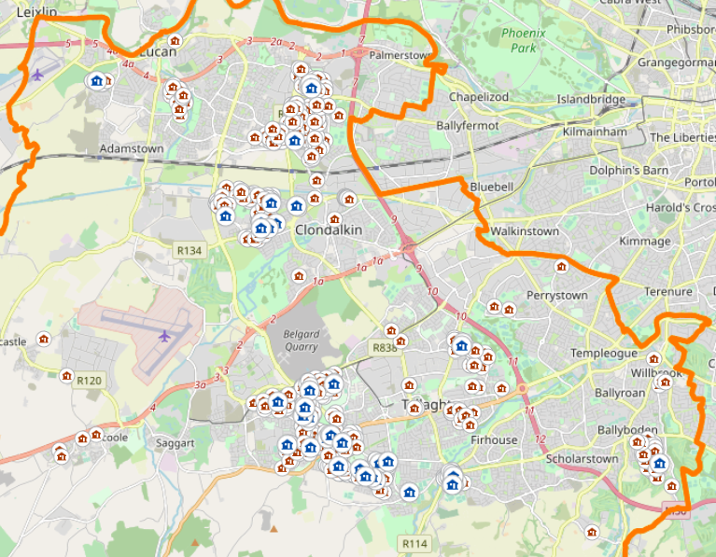

Mapping of cluster of underoccupied tenancies in proximity to proposed Part 8 site

Furthermore, there are currently almost approximately 900 applications on the Council’s housing list, comprising solely of single or joint applicants aged 55 or over requiring accommodation in the County.

CGI Aerial View of Proposed Development

Alternative locations for the development, outside the red line site area shown for the proposed development, whether within this larger green area or beyond, as proposed in some of the submissions, cannot form part of this planning process. Alternative sites proposed may be assessed and considered for separate planning consent applications given the prevailing and projected need for age friendly accommodation in the County and, if appropriate, may be the subject of separate, future Part 8 processes. The potential to relocate the development within the subject site was explored but are not considered viable alternatives due to various design, services and layout constraints and/or challenges.

A site analysis was carried out to address the scale, siting and layout of the proposed new development taking account of the local context. Architectural integration with the surrounding built is provided through density, features such as roof forms, heights, fenestration patterns, materials and finishes. The modest size, massing and quantum of the development is keeping in with the character and scale of existing properties, with the majority of proposed dwellings being one-storey in height, posing no visual barriers to the existing two-storey homes nearby. The proposed development complements the existing urban grain of the area by continuing the existing building line and the rhythm of adjacent housing, forming natural, visual ending of the streetscape. The two proposed two-storey blocks within development are in scale with existing housing and are orientated towards the road, facing blank gables of existing one-storey homes. They are also located sufficient distance from existing properties on the other side of the road and from the adjacent properties to the east to eliminate overlooking and overshadowing issues. No 2.5-storey buildings being proposed in the development and all homes provided will be to standard domestic height and will not have excessive floor to ceiling height.

The proposal provides for a courtyard-type development within its confines that is designed to support independent living for older persons while encouraging communal interaction through secure, shared space. The courtyard merely utilises the space that would have ordinarily been provided for individual rear gardens for each home in a shared fashion for the residents as the design seeks to establish a “village” model with one and two storey terraced homes grouped around a central courtyard. That space creates shared rear gardens for the residents with small adjoining private patios. This approach to the design offers a secure, sheltered environment to residents while also providing passive surveillance to both the proposed scheme and adjacent areas. A more standard, linear layout of houses would use more area than the efficient courtyard arrangement proposed. The layout proposed was carefully considered and developed in consultation with Age Friendly Ireland and is not intended as gated, enclosed and cut off development but rather as a being complementary and managed amenity for older persons to enjoy within step-down accommodation within their familiar environment and community. The proposed community room provides a facility for healthcare and other support visits to residents of the proposed development and the residents of the existing age friendly housing across the road, similar to facilities in other existing and planned age friendly housing developments.

All displayed information and layouts of the proposed Part 8 development follow the required and standard level of detail, scale and information for a Part 8 process under Section 179 of the Planning and Development Act 2000. A Design Statement Report is not required within this process due to the small scale and type of proposed development. The primary purpose of the process is to notify the public of the proposal and incorporate any observations validly submitted into a report to inform the Council on its decision to recommend the proposal.

The recommendation for more soft landscaping in the form of planting and planters to front gardens of the development to screen and to soften streetscape is noted - a more detailed landscape proposal will be developed by a Landscape Architect at the detailed design stage of the project in consultation with the Council’s Public Realm Department and in accordance with the requirements of the Council’s Public Realm Taking in Charge standard and Department of Housing, Local Government and Heritage Requirements for Detail Design of Quality Housing.

The boundary treatment to the front gardens of the proposed dwellings will be in line with urban character of the development and will incorporate low-level brick or stone finish walls with intervals of low-level railings, and with some built-in in low-level planters integrated into design to provide an active interface with the street (see figure below for reference). The detail and elements will be developed at the detail design stage of the project.
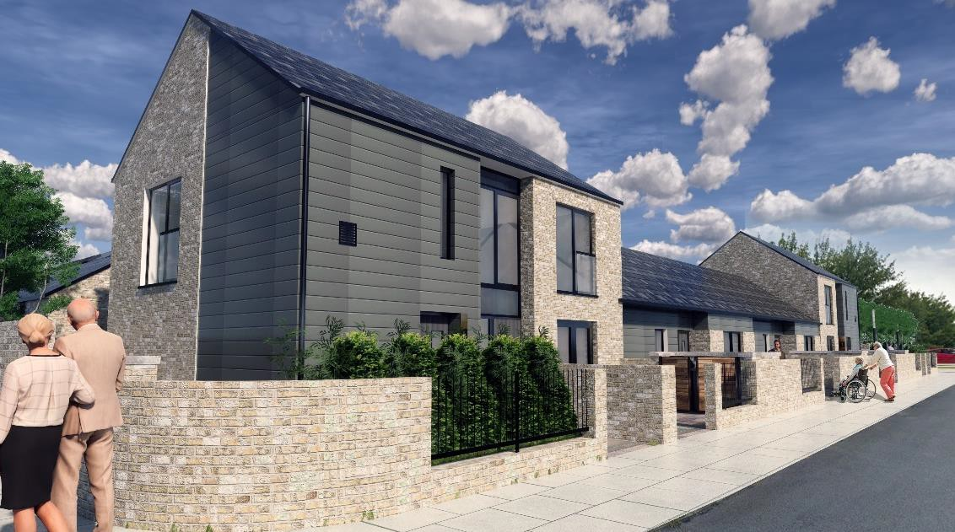

CGI showing proposed front garden boundary treatment

The street will also benefit by the provision of new accessible pathways to allow ambulant and wheelchair users move freely. Public lighting and courtyard outdoor light fittings will be developed at the detailed design stage of project in consultation with the Council’s Public Lighting section and in compliance with public lighting specification.

The proposed development is designed having regard to sustainable design and the County Development Plan standards and to meet the requirements of The Department of Housing, Local Government and Heritage and South Dublin County Council. The buildings will be designed to Near Zero standards and external finishes will be chosen to be robust, durable, sustainable, good quality, easily maintained and vandal resistant. Materials will be sympathetic to existing surrounding housing finishes. It is proposed to use good quality brick, with inserts of high strength, durable and robust cladding material to the streetscape elevations, and high quality self-cleaning monocouche render system to the rear elevations. External glazing will be thermally broken and provide good levels of sound insulation. Timber-cladding is not proposed for the development. The PV supplemented energy-coordinated energy design will be developed and calculated at the detailed design stage and the positioning of the PV panels will utilize the of the best roof orientation and height, primarily facing south where possible.

The Computer-Generated Image (CGI) provided with the displayed documentation are for illustrative purposes only and it is not expected to demonstrate 3D views for all angles/elevations. The displayed documentation included an aerial view and linear drawing of the north elevation (see extracts below).
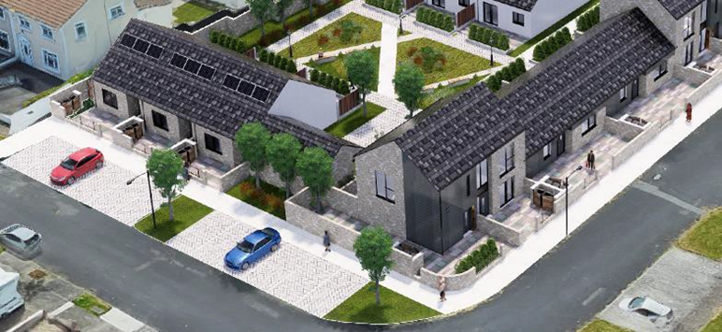

EXTRACT FROM AERIAL 3D VIEW OF NORTH SIDE OF DEVELOPMENT
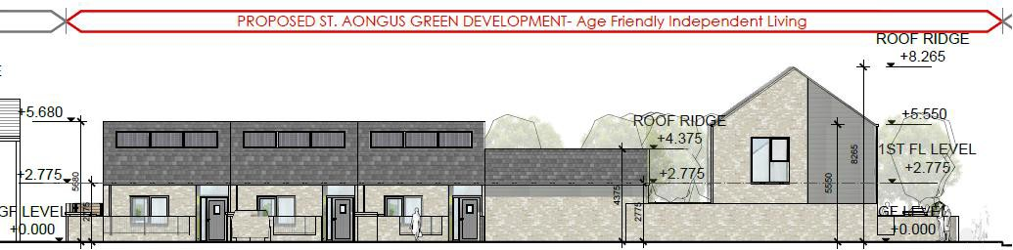

Extract from North East Elevation

All footways and roads detailed in the design will be in compliance with the requirements of the Council’s Public Realm Taking in Charge [TIC], Part M Technical Guidance Document (TGD), and Design Manual for Urban Roads and Streets (DMURS) criteria and developed in consultation with SDCC Road department. The dished kerb will be used only locally, where it is required to comply with the current standards and regulations.

Chief Executive’s Recommendation
It is recommended that no variation or modification be made to the proposed development.

  - Issues raised relating to construction period
- Impact of construction period on local residents and concerns relating to construction traffic, safety, noise, disruption and extended working hours

Response:
During construction, typical impacts such as noise, dust, traffic disruption, and the generation of small amounts of waste are expected but will be mitigated by environmental operating plans devised by the on-site contractor in accordance with relevant guidance and best practice guidance. In addition, the contractor will be required to nominate a community liaison person to engage with local residents during the construction period and a comprehensive Construction Traffic Management Plan will form part of the contract should the development be approved. As with all sites being developed, the site will generate the construction traffic and some temporary congestion that will have to be managed appropriately but which will be mitigated rapid off-site construction and a shortened- on site construction period.

Contractor working hours will be restricted to permissible working time under the County Development Plan (Section 11.6.3 Environmental Hazard Management (ii) Noise) and this condition will form part of any contractual agreement with any deviation from permissible working time requiring the Council’s approval.

Chief Executive’s Recommendation:
It is recommended that no variation or modification be made to the proposed development.

  - Issues raised in relation to site investigations/project scoping
- Request for Landscape and Visual Impact Assessments.
- No analysis of sunlight hours or potential for overshadowing presented.

Response:
Due to the scale and type of proposed development, Landscape and Visual Impact Assessments are not requirement in the Part 8 process.

Internal 3D software shadow analyses conducted by the Council’s Architectural Services team concluded that there will not be overshadowing by proposed development of existing adjacent properties. Careful consideration was given to the site layout and building orientation design (in a mainly east/west orientation) to ensure that all the dwellings will receive morning or afternoon sunlight during the day.

Chief Executive’s Recommendation
It is recommended that no variation or modification be made to the proposed development.

  - Statutory Bodies Submissions
A number of Submissions were received from various statutory bodies as follows:
- Geological Survey Ireland: No specific comment or observations made.
- Department of Communications, Climate Action and Environment: Requiring consultation with the Regional Waste Management Planning Office regarding the proposed development of the final plans.
- Inland Fisheries Ireland: IFI recommend a revised surface water layout for the operation of the development which would incorporate soft engineering options such as swales or bio-retention areas rather than the hard-underground attenuation Stormtech system proposed.
- Irish Water: A public 225mm wastewater sewer runs in a south easterly direction within the site boundary requiring a minimum setback distance of 3m to be maintained between the outer diameter of this sewer and proposed building boundary walls to ensure adequate access for maintenance and to ensure no additional loading imposed onto the sewer from adjacent buildings. A public 101.6mm uPVC watermains traverses the site in certain areas requiring a minimum setback distance of 3m to be maintained.

Response:
The statutory bodies’ submissions are noted and their recommendations and requested will be implemented as appropriate in the detailed design stage of development but, due to the small scale of the development, the possibility of implementation of soft engineering options such as swales or bio-retention areas are limited.

The project delivery and construction will be in line with Construction Environmental Management Plan (CEMP) and the Council will consult with the Regional Waste Management Planning Office regarding the proposed development on ongoing basis, during detailed design and construction stages of the project. The Irish Water observation and recommendation regarding the wastewater sewer and public watermains services are noted and the recommended exclusion zone distances will be incorporated into the detailed design of the development. The Council will also engage with Irish Water through the Pre-Connection Enquiry (PCE) process and further as necessary.

Chief Executive’s Recommendation
It is recommended that no variation or modification be made to the proposed development and that recommendations proposed by statutory bodies as appropriate be implemented at the detailed design stage.

  - Issues raised in relation to non-planning matters:
- Security and anti-social behaviour relating to new development and remaining green area.
- Reducing passive surveillance of the green area will result in it being less secure.
- Impact on property values in St. Aongus Green.

Response:
The raised, while outside of the scope of the planning application, are noted.

The new homes, if approved, will be allocated only in accordance with the Council’s recently adopted Policy for Rightsizing and Allocation of Age Friendly accommodation. This provides for allocation to persons aged 55+ only, from the housing list, existing social housing tenants transferring on “rightsizing” grounds or from the Community List (whereby a financial contribution is paid by former private homeowners who “rightsize” into age friendly accommodation). Our estate management team will work closely with residents to ensure that they meet their responsibilities as Council tenants as well as working with the local community to address wider anti-social behaviours issues in the area.

Technology provision in the new homes will provide security and comfort appropriate to the residents’ age profile, with recognition of the age profile including monitoring / call assistance, perceivable security assurance, closeness to facilities/transport and low running costs for energy.

The passive surveillance of the remining green area will be improved by this development and planned enhancement landscape strategy (as outlined earlier in this report). The new development dwellings orientated to the south will overlook the space directly, providing a passive surveillance to public open space.

The construction of new high-quality housing for older persons in this area and the potential to release existing under-occupied homes to growing families should be considered beneficial to the area and its residential and community value.

Chief Executive’s Recommendation
It is recommended that no variation or modification be made to the proposed development.

Recommendation
Following detailed consideration of the issues outlined and noting the view of that the issues raised in submissions will be satisfactorily addressed as outlined in the foregoing report with no variation or modification of the proposal recommended, it is considered that the proposed development is in accordance with the proper planning and sustainable development of the area and therefore it is recommended that the Council adopt the following Motion:

“That this Council approves the proposed social housing development of twelve homes for older persons at St. Aongus’ Green, Dublin 24, it being in accordance with the proper planning and sustainable development of the area.”

