# **European Environmental Noise Directive.**

# **Round 4 Strategic Noise Mapping**

**Update report to Environment SPC, September 2021.**

## Summary

* The European Communities (Environmental Noise) Regulations 2018, S.I. No. 549 of 2018, implements EC Directive 2002/49/EC (END) on assessment and management of **Environmental noise in Ireland.**
* The END requires Member States to prepare and publish, every 5 years, strategic noise maps and noise management action plans for transport noise sources (i.e. roads, railways and airports) and industry.
* The aim of the END is to provide a common framework to **avoid, prevent or reduce,** on a prioritised basis, the harmful effects of exposure to environmental noise through the preparation of strategic noise maps and the development and implementation of action plans.
* We are currently starting off on **Round 4** of this noise mapping and action planning cycle (2020–2025).

Under the above Regulations, all Local Authorities are responsible for strategic noise mapping of non-National major roads, i.e. all roads with more than 3 million vehicle passages per year.

Under the Regulations, Noise Mapping Bodies (NMBs) are required to deliver certain reports and data to the EPA acting in its role as national competent authority for Ireland under the Regulations.

In order to reduce the burden on the Urban Local Authorities, in Dublin and Cork and to improve the efficiency and consistency of the noise maps, it is proposed to undertake the R4 noise mapping using a more centralised approach.

* South Dublin is a designated Noise Mapping Body and is a part of the Dublin Agglomeration along with DCC, Fingal and DLR County Councils.
* Other Noise Mapping bodies would include Dublin Airport Authority, Iarnroad Eireann and Luas.
* Road traffic is considered the biggest single contributor to Environmental noise, followed by aircraft noise, railway noise and industry.

**Road Traffic data**

Local Authorities are required to collect and collate detailed traffic flow and road infrastructure data to enable the strategic noise maps to be developed accurately.

Strategic noise maps are to represent the annual average daily traffic flow during 2021. However, it is accepted that this will include lower than typical levels of road traffic flow being experienced due to the Coronavirus pandemic.

The R4 major roads noise maps should be based upon the best available traffic flow information, and should include:

* + The R4 major roads forecast extents reported to the EPA in March 2020;
  + Any relevant traffic models;
  + Traffic data in LGCSB MapRoad or GIS;
  + Historic traffic count data; and
  + New traffic count data.
* **Vehicle categories**

For Round 4 a new common EU noise calculation methodology is being used, CNOSSOS-EU 2015. CNOSSUS is an acronym for Common Noise Assessment throughout Europe.

The CNOSSOS-EU vehicle classes are shown in Figure 1 below.

**Figure 1:** CNOSSOS-EU vehicle classes

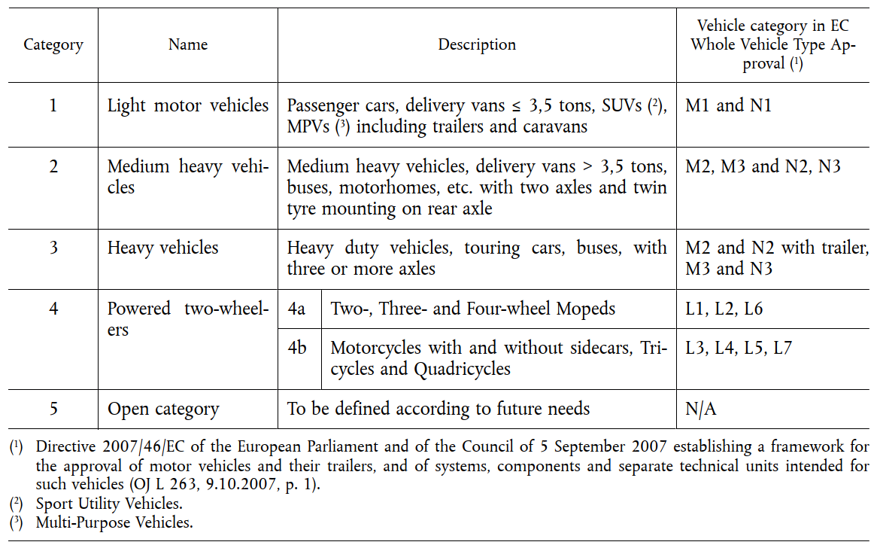

**Note 5:** For the purpose of traffic flow collection, Category 5 will be used to count the number of electric and hybrid (EV & HV) light vehicles within the traffic flow, if the data is available. EV & HV vehicle counts will be most relevant to low speed roads, below approximately 40 km/h, at medium and high speeds EV & HV noise emission will be the same as Category 1 light vehicles.

* **R4 assessment year is 2021**

The nominal assessment year for Round 4 of the strategic noise mapping is 2021, however the data used for the mapping may be up to three years old. In the case of traffic count data which was captured prior to 2021 it should be adapted from the base year to the nominal 2021 assessment year using appropriate traffic growth factors derived from local traffic count data. The types of data needed for the Noise Mapping process includes the following

* Traffic Volumes.
* Traffic speeds.
* Direction of travel
* Road surface type.
* Age of surface
* Junction type including traffic lights, pedestrian crossing, roundabouts.

As part of the Noise mapping process, NMBs are expected to seek to achieve Quiet Areas in their respective counties. South Dublin has identified, measured and mapped 4 such areas and will be submitting to the Department for assessment, and seeking Ministerial approval.

Side by side with the Noise Mapping process, members are advised that SDCC currently has 10 permanent noise monitors throughout the county and live noise updates than we viewed on the SDCC website.

David O’ Brien (PEHO)

Env Health Department