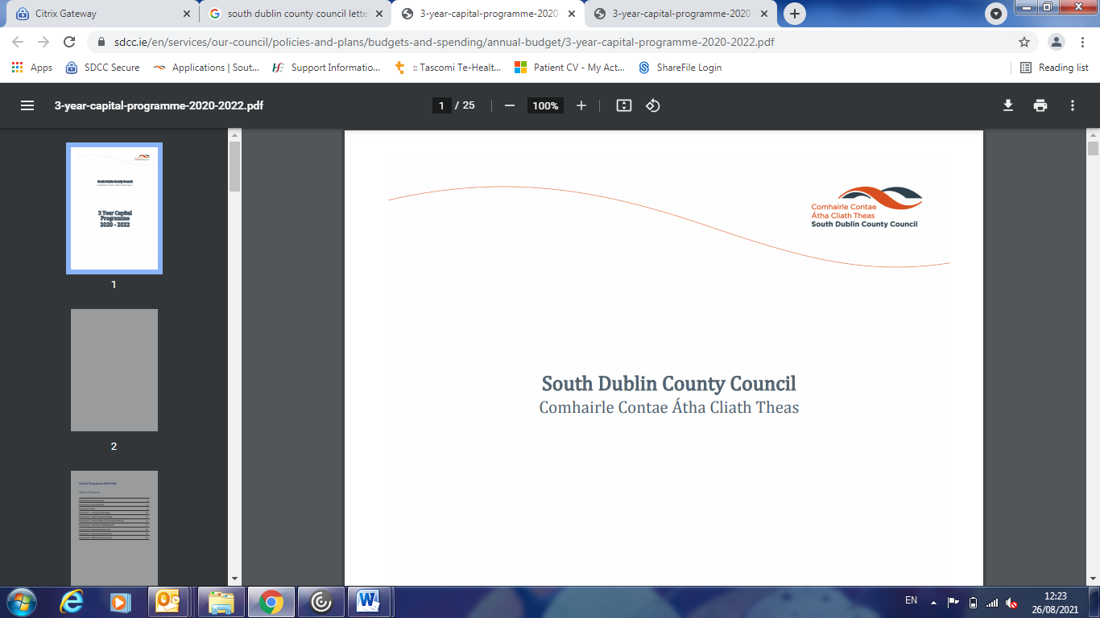

**Dublin Region Air Quality Plan Update for September Environment, Public Realm and Climate Change SPC Meeting.**

An exceedance of the EU Air Quality limit value for nitrogen dioxide was recorded at the St John’s Road West air pollution monitoring station in Dublin in 2019. An average NO2 concentration of 43ug/m3 was measured at the site for the year and this was above the EU annual limit for NO2 of 40 ug/m3. This exceedance of an air pollution standard was the result of heavy traffic passing this monitoring station.

The exceedance was reported to the European Commission and the required Air Quality Plan by Dublin Local Authorities in conjunction with the EPA is being prepared in accordance with the Air Quality Standards Regulations 2011. The plan must be submitted to the EU Commission by the end of 2021.

This air quality plan must identify the cause(s) and source(s) behind this reported exceedance and the actions required over time to bring ambient air quality back in line with EU limit values. One major element of the plan will involve modelling of current and predicted trends in air quality based on the actions and scenarios for compliance identified in the plan. The prescribed information to be included in the air quality plan is detailed in Schedule 15 of the 2011 Regulations

Development of the Air Quality Plan

In order to develop this plan the following governance structure was agreed by the four Dublin local authorities:

* Oversight by Dublin Regional Chief Executives who are provided with regular progress reports.
* Project Steering Group consisting of regional Directors of Services / Executive Manager.
* Project Management Team consisting of a small team to oversee and co-ordinate the project and work of the Technical Leads.
* Organisational Drafting Group consisting of Technical Leads from each local authority with responsibility for drafting the Air Quality Plan.
* Modelling Group consisting of Technical Leads from each local authority working closely with the Environmental Protection Agency to complete air quality modelling work.
* Data Acquisition Group consisting of staff from the local authorities responsible for liaising with other state agencies in respect of date collection and other measuring information.

Under the guidance and direction of the Project Management Team work began in May 2021 with the production of a project plan consisting of tasks and timelines against which progress can be tracked.

The Operational Drafting Group has been meeting weekly since May to draft the plan and advance the following key features of the plan.

1. Modelling

Using traffic data produced by the NTA, various scenarios have been selected in conjunction with the EPA to estimate emissions arising from various fleet compositions eg 80% bus fleet converted to electric vehicles, 80% taxi fleet converted to electric vehicles, a business as usual “do nothing” scenario whereby fleet change happens due to the market/car replacement by owners etc. The various scenarios will make projections out to 2028 and 2030 and this modelling work is underway and is expected to conclude by mid- September 2021.

1. Stakeholder / Prescribed Bodies Consultation

An Taisce as well as the 8 prescribed bodies outlined in the Air Quality Standards Regulations 2011, namely, the Minister for Health, the Health Service Executive, Local Authorities, An Bord Pleanala, Cystic Fibrosis Association of Ireland, the Asthma Society of Ireland, Met Eireann and Teasgac have each been contacted in writing to notify them of the plan and facilitate early comments should they wish to make any. As a follow on to this a workshop has been arranged for the 1st September 2021 to elicit their views and concerns. A formal four week period of consultation will then follow once a draft of the Dublin Region Air Quality Plan has been completed.

1. Public Consultation

The public were notified through an advertisement in the national press on 23rd July of the Dublin Local Authorities intention to complete an Air Quality Plan with information placed on each local authority website and social media platform with links for comments back to the DCC site. The intention is to engage in a more formal and detailed public consultation exercise over a four week period in September / October when copies of the draft plan will be available in selected libraries, local authority head offices and on local authority websites. However, prior to the formal period of public consultation the draft plan will be presented to Elected Members of each local authority through a variety of means including sub-committees, SPC’s, Council meetings etc. However, it should be noted that the development of this plan is not a reserved function.

1. Strategic Environmental Assessment / Appropriate Assessment Requirements

Consultants were appointed to advise on whether an appropriate assessment/ strategic environmental assessment is required in respect of the Air Quality Plan. They have issued screening reports that show that the plan is not a framework for future development, will not impact adversely on Special Areas of Conservation or other European sites and that consequently, no further work is required on these issues. Next will follow a period of consultation with environmental authorities and depending on their views a final determination will have to be issued by the CE’s for the four Dublin Local Authorities.

The expectation is that the draft plan will be completed in the September/October period and that the final plan will be completed by mid- December 2021.

Tom Prendergast

Principal Environmental Health Officer

South Dublin Co Co.

25th August 2021