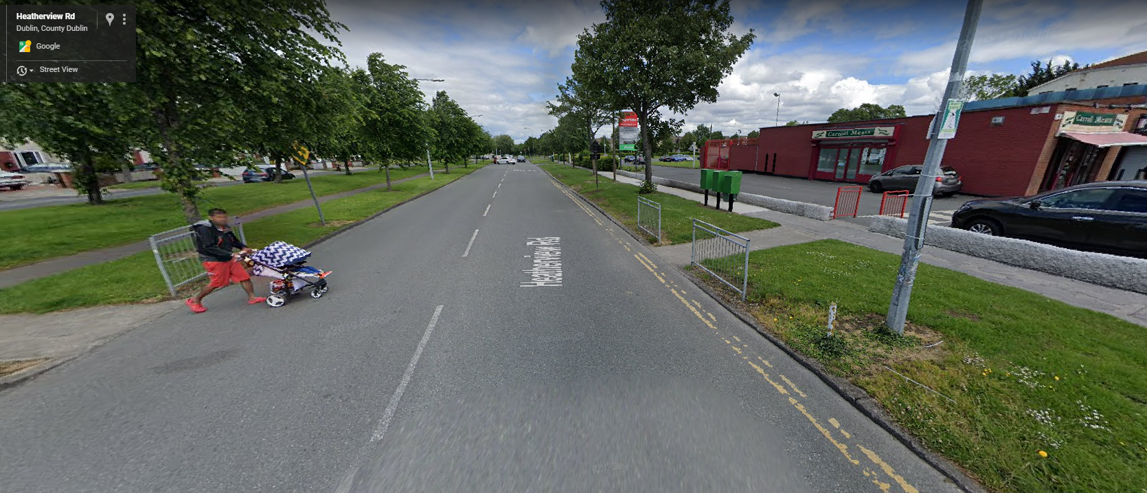

Crossing Point at Aylebury Shopping Centre:

