CE Amendments Arising from Proofing and Other Considerations
Written Statement
Chapter 1 – Introduction
N/A
Chapter 2 – Core Strategy and Settlement Strategy
CE Amendment 1:
Recommendation: to remove CS2 Objective 3: “Planning applications for residential use in the Naas Road / Ballymount lands shall be subject to a Strategic Framework Plan for the area being in place.”
Reason: It is considered that CS2 Objective 1: sufficiently covers the requirement for development to conform to the Masterplan.
For reference, CS2 Objective 1 states:
To prepare a Local Area Plan or other appropriate mechanism for the zoned Regeneration (REGEN) lands at Naas Road/Ballymount to include the Local Centre zoning (LC) at Walkinstown. The LAP or equivalent will provide a framework for the sequential and phased development of the lands, integrating sustainable transport, land use and blue and green infrastructure. The spatial planning of the area will be informed by the Naas Road Framework until such time as a Statutory Plan is in place.
Chapter 3 – Heritage
CE Amendment 2:
Recommendation: Replace existing section (in red strikethrough) with the text in green bold below:
Proposed Natural Heritage Areas
Natural Heritage Areas (NHAs) and proposed Natural Heritage Areas (pNHAs) are designated to conserve and protect species and habitats of national importance in Ireland. NHAs and pNHAs are established under the Wildlife Acts. Both NHAs and pNHAs normally relate to habitats that are considered to be ecologically important or host flora and fauna species whose habitats are considered to need protection. These can include species listed under the European Habitats and Bird Directives.
All designated sites in the County are shown on the Development Plan maps which accompany this written statement.
Proposed Natural Heritage Areas
Natural Heritage Areas (NHAs) are designated to conserve and protect species and habitats of national importance in Ireland and are established under the Wildlife Acts. NHAs normally relate to habitats that are considered to be ecologically important or host flora and fauna species whose habitats are considered to need protection. These can include species listed under the European Habitats and Bird Directives. In South Dublin County there are seven proposed NHAs, which were originally identified on a non-statutory basis but have not been formally designated. A process is underway by the National Parks and Wildlife Service to resurvey and formally designate some pNHA sites as NHAs on a country-wide basis. In the meantime, a degree of protection is afforded to pNHAs under County Development Plans and other environmental protection schemes. All pNHAs in the County are shown on the Development Plan maps which accompany this written statement.
Reason: For the purposes of clarity in relation to Natural Heritage Areas and Proposed Natural Heritage Areas.

CE Amendment 3:
Recommendation: Re-numbering of sections and policies within the Built Heritage section of the Natural, Cultural and Built Heritage Chapter as set out below.
No new sections or no new text have been added and no sections or text have been deleted.
It should be noted that only section headings with paragraph numbering are indicated – there are other sub-sections with no numbering which have also been moved along with the overall numbered section. Where apparently new section headings appear in green that are not appearing in red strikethrough, these are sections that had no paragraph numbering previously and that have now been given numbering.
It should also be noted that there are several objectives under each policy that have also been renumbered accordingly. These have not been indicated here in the interest of brevity.
Reason: In order to correctly reflect the intended order for the topics within Built Heritage.

3.5.4 Architectural Conservation, Adaptability and Placemaking
NATURAL, CULTURAL AND BUILT HERITAGE (NCBH) Policy 21: Architectural Conservation and Design
NATURAL, CULTURAL AND BUILT HERITAGE (NCBH) Policy 22: Adapting and Reusing Historic Buildings
NATURAL, CULTURAL AND BUILT HERITAGE (NCBH) Policy 23: Placemaking and the Historic Built Environment
NATURAL, CULTURAL AND BUILT HERITAGE (NCBH) Policy 24: Climate Change, Adaptation and Energy Efficiency in Traditional and Historic Buildings
3.5.5 Vernacular and Older Buildings, Estates and Streetscapes
NATURAL, CULTURAL AND BUILT HERITAGE (NCBH) Policy 25: Vernacular/Traditional and Older Buildings, Estates and Streetscapes
3.5.6 Features of Interest
NATURAL, CULTURAL AND BUILT HERITAGE (NCBH) Policy 26: Features of Interest
3.6 CLIMATE ACTION AUDIT

3.5.4 Vernacular/Traditional and Older Buildings, Estates and Streetscapes
POLICY NCBH 21: VERNACULAR/TRADITIONAL AND OLDER BUILDINGS, ESTATES AND STREETSCAPES
3.5.5 Features of Interest
NCBH POLICY 22: FEATURES OF INTEREST
3.6 Architectural Conservation, Adaptability and Placemaking
POLICY NCBH 23: ARCHITECTURAL CONSERVATION AND DESIGN
3.6.1 Adapting and Reusing Historic Buildings
POLICY NCBH 24: ADAPTING AND REUSING HISTORIC BUILDINGS
3.6.2 Placemaking and the Historic Built Environment
POLICY NCBH 25: PLACEMAKING AND THE HISTORIC BUILT ENVIRONMENT
3.6.3 Climate Change Adaptation and Energy Efficiency in Historic Buildings
POLICY NCBH 26: CLIMATE CHANGE, ADAPTATION AND ENERGY EFFICIENCY IN TRADITIONAL AND HISTORIC BUILDINGS
3.7 CLIMATE ACTION AUDIT

Chapter 4 – Green Infrastructure
N/A
Chapter 5 – Quality Design and Healthy Placemaking
N/A
Chapter 6 – Housing
CE Amendment 4:
Recommendation: To correct Housing Policy 1, Objective 2
To require that 10% of lands zoned for residential use, or for a mixture of residential and other uses for development of 9 or fewer more houses units or development of houses units on land less greater than 0.1 hectares (or relevant figures as may be revised by legislation) be reserved for social and affordable housing in accordance with the Urban Regeneration and Housing Act 2015 and the Planning and Development Act 2000 (as amended).’
Reason: This was an error in the translation of the relevant section of the Planning and Development Acts.
Chapter 7 – Sustainable Movement
CE Amendment 5:
Recommendation: To amend the text on page 186 first paragraph, as follows:
‘To achieve the above, the studies identify a list of potential projects within the County, some of which are reflected in Chapter 12 Our Neighbourhoods and which are also set out in a report to accompany this Development Plan entitled Sustainable Movement Studies’.
‘The studies have identified a number of potential projects within the County which will be set out in a Sustainable Movement Report for the County which will accompany the Plan’.
Reason:
To more correctly reflect the timeframe for the Sustainable Movement Studies document.

Chapter 8 – Community Infrastructure and Open Space
CE Amendment 6:
Recommendation: Amend COS 5 SLO 1
From:
COS 5 SLO1:
‘To identify and set aside land in order to ensure the delivery of the Burgage South Neighbourhood Park as identified in the Newcastle Local Area Plan (2012), and to pursue all means of achieving this including proactive engagement with stakeholders and through the consideration of planning applications affecting the area’.
To:
‘To identify and set aside land, ensuring the delivery of the quantum of OS within the general area of the Burgage South Neighbourhood Park as identified in the Newcastle Local Area Plan (2012), and to pursue all means of achieving this including proactive engagement with stakeholders and through the consideration of planning applications affecting the area’.
Reason: To reflect the requirements of the LAP
CE Amendment 7:
Recommendation: Amend Objective CO5 Objective 1 adding in the words ‘in line with Table 8.1’ after the word ‘County’, so that the objective reads as follows:
‘To support a hierarchy of multi-functional, accessible parks and public open spaces across the County in line with Table 8.1, based on existing populations and planned growth in accordance with the overall standard of 2.4ha per 1,000 population’.
Reason: To be clear that Table 8.1 identifies the hierarchy of open space

Chapter 9 – Economic Development and Employment
N/A
Chapter 10 – Energy
N/A
Chapter 11 – Infrastructure and Environmental Services
N/A
Chapter 12 – Our Neighbourhoods
N/A
Chapter 13 – Implementation and Monitoring
CE Amendment 8:
Recommendation: Amend Table 13.24 as shown below:
Table 13.24: Minimum Bicycle Parking/Storage Rates
CATEGORY | LAND-USE | LONG TERM | SHORT STAY
Accommodation | Hotel¹ | 1 per 5 staff | 1 per 10 bedrooms
 | Nursing Home | 1 per 5 staff | 1 per 10 residents
 | Residential Apartment | 1 per 5 apartments  1 per bedroom | 1 per 10 apartments  1 per two apartments
 | Student Accommodation | 1 per bedroom | 1 per 5 bedrooms

Reason:
In order to reflect bicycle parking/storage standards as set out in the document Sustainable Urban Housing: Design Standards for New Apartments (Guidelines for Planning Authorities), 2020
CE Amendment 9:
Recommendation: Insert a new map in Section 13.9.5 of Chapter 13 titled ‘Simplified Map for Areas of Significance for Airports’ [see below]
Reason: This map has been developed as a composite map to help with the identification of areas that are subject to airport restrictions and to help identify applications that may need to be referred to the relevant airport authorities.
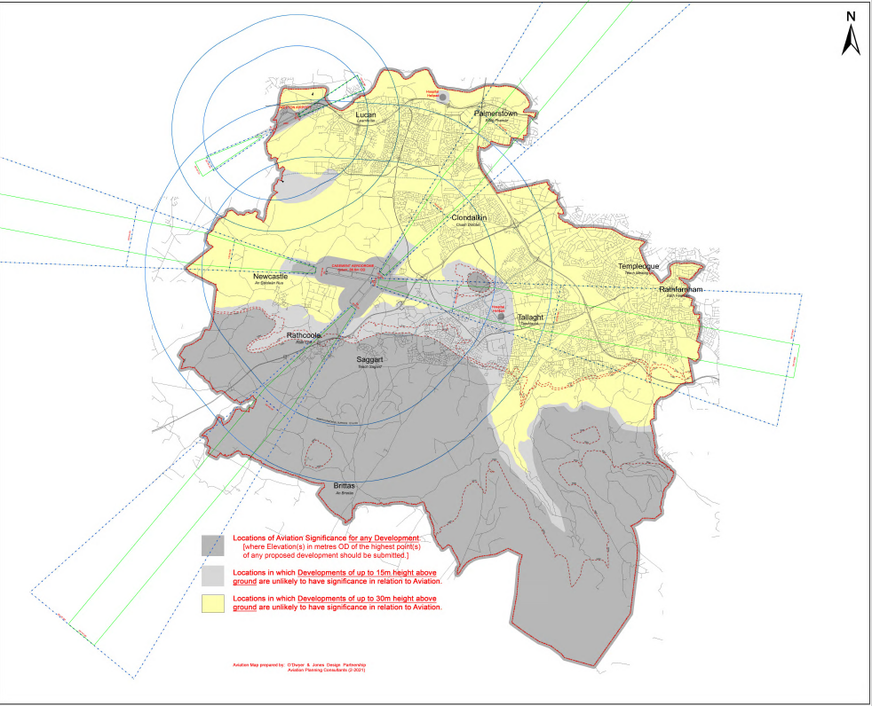

General Proofing
CE Amendment 10:
Recommendation: To correct typographical errors, update references to documents and minor edits where no change to the meaning of text, policy or objectives within the written statement or maps occurs.
Reason: To ensure that the Plan amends typographical errors and minor edits and reflects current policy documents where these may have changed since the writing of the CE Draft prior to publication as the Draft Plan.
CE Amendment 11:
To replace all instances of the words ‘elderly persons’ with the words ‘older persons’.

