Library Report, June 2021
South Dublin Libraries are continuing to deliver online events at present. However, engagements with local schools and communities for online activities is creating connections with the community in the various library localities. This
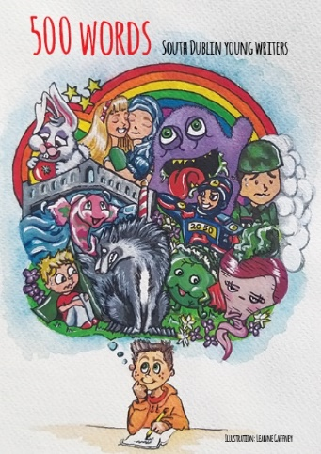
500 Words: South Dublin Young Writers
The online book launch of 500 words took place on 25th May with contributions from children's writers and congratulations messages from everyone from Ryan Tubridy to President Michael D. Higgins. A writing workshop was held for the participants in the hope that they will continue to write their wonderfully imaginative stories. The project will be replicated in North Clondalkin Library in 2021.
Copies have been distributed to all contributing authors, will be sent to schools across the County, and of course will be available to borrow from all branches and available as an e-book on Borrowbox from the South Dublin Libraries website.
Portraits in Pastel Exhibition
An exhibition by local artist Rosie Fleming was opened by Mayor Ed O’Brien and Minister Catherine Martin TD last Saturday 22nd May at Ballyroan Library. Francis Duffy TD and Councillor Emma Murphy also attended the launch.
The exhibition, Portraits in Pastel, is a collection of portraits of people and animals, including a series on Irish native dog breeds. It continues at Ballyroan Library until 4th June.
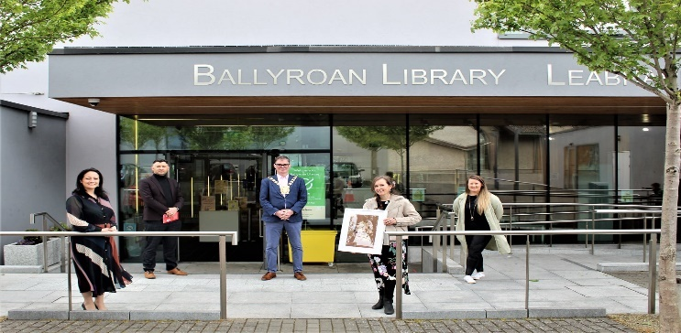

South Dublin Libraries Poetry Competition 2021
This year’s poetry competition was a huge success again with almost 100 entries. Our shortlisted poets were showcased with readings on the South Dublin Libraries Facebook page ahead of the winners’ announcement. It is clear from the standard of the entries that there is a wealth of talented poets in South Dublin and that the poetry community is alive and thriving. A video with readings of all the shortlisted poems is available on the South Dublin Libraries Facebook and YouTube channels. The winners were:
1st Place – Sonnet for a Blue Tuesday by Caroline Bracken
2nd Place – Estuary by Eithne Lannon
3rd Place – Brú na Bóinne by Diarmuid Fitzgerald
Music concerts at Nursing Homes
Pennies from Heaven – live music at Nursing Homes around the County organised by South Dublin Libraries. Residents of South Dublin Nursing Homes were treated to live music from a three-piece band – guitar, double bass and singer. Pennies from Heaven set themselves up at the front of the homes while residents watched from the sitting rooms with all the windows open. The band chose all the great songs of yesteryear, and the residents sang along to their favourites. A highlight of the Bealtaine festivities for sure.
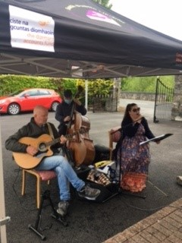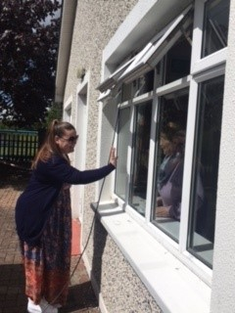

Little Library Bags
Another highlight during May and into June will be the distribution to registered Early Learning Centres and Childminders of the Little Library Bags. These centres will be encouraged to join the library and sign up for a Teachers Block Card, which can be used to borrow multiple items for their group. We look forward to working with them to promote the library to families using these childcare facilities. Each bag contains: 5 Books in English/As Gaeilge, South Dublin Libraries’ Reading Tips Booklet, Library Social Stories Card – a colourful guide for children showing what happens during a trip to the library and promotional library material.
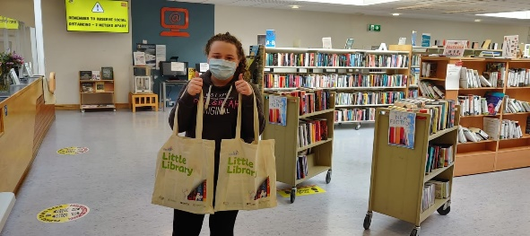

General talks & events June

Bank Holiday Monday 7th June: Family Quiz Night: A General Knowledge quiz night for all the family. There will be rounds on film and TV, history, music, geography and sport.
8th June: LED light up Father's Day card kit for 8-12-year olds, kit to be posted out or collected from library. Use your creativity to make a unique card for your dad on 20th June.
9th June: Lift Your Own Suitcase! Learn about the benefits of strength exercises to do at home and get in shape for your holidays. With Dr. Ailis Brosnan, health and fitness coach.

10th June: Dawdling along the Dodder, a talk by Michael Fewer.

14th & Tue 15th June: Join award-winning Irish crime writer, Louise Philips for an introduction to crime writing.

21st June: Writer and filmmaker Caroline Farrell recommends some adult fiction titles for people to read.
24th June: Astronomy Talk - a talk by David Moore of Astronomy Ireland. David is a fascinating speaker on everything Astronomy, frequently in the media, and we expect this talk to be extremely popular with adults and families.


21st/23rd & 28th/30th: Let’s get South Dublin Moving! Well-Dance classes for seniors is an extremely popular modern dance programme; It’s a movement class that will guide you through a series of simple, modern and creative dance movements & exercises to improve breathing, balance, fluidity, flexibility and strength. This programme has been nominated for the National Lottery Good Cause Awards

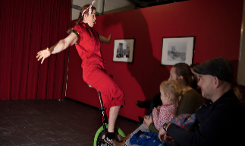
22nd June: Indoor or outdoor performance and workshops for children and families - Strong Women Science is a circus science show for children and families starring two women scientists turned circus performers. Aoife Raleigh is an engineer, Maria Corcoran an environmental scientist.

Headline festivals, events & programmes
Cruinniú ná Nóg: 12th June
A day of free creativity for children and young people. Ireland is the first, and only, country in the world to have a national day of free creativity for children and young people under 18. Cruinniú na nÓg is a flagship initiative of the Creative Ireland Programme’s Creative Youth Plan to enable the creative potential of children and young people. This national day is delivered in partnership with the 31 Local Authorities and supported by RTÉ.
Events taking place online via South Dublin Libraries include:
Flying to Mars a day in the stars with Dr Niamh Shaw
10am: under 10 years: Join Dr Niamh Shaw as she shows you videos of her time in a zero-gravity chamber and simulated mission to Mars, stories from the stars and Niamh’s quest to land on Mars. 5pm: A talk for families. In this talk, Niamh inspires others to seek the freedom that comes from changing your mindset from finite and short-term to infinite and for the greater good of mankind. 7pm: A talk for adults. Niamh gives context to space exploration past, present and future and considers its huge impact on us as a species and on our planet. Copies of Niamh’s’ new book ‘Dream Big’ will be given out to lucky participants on the night.

‘Still Here’: A live theatre performance for children aged 3-5 years old and their adults. Performance times are 10am, 12pm and 2pm. This is a story of boredom, being stuck, being separate – but ultimately making connections and forging new friendships. A story for our times. ‘Still Here’ is directed by acclaimed Children’s Theatre specialist – and director of BigKidLittleKid , Anna Newell.
Live event: Mother Tongues: Interactive Museum of languages. A selection of artifacts based on language will be on show throughout the day. 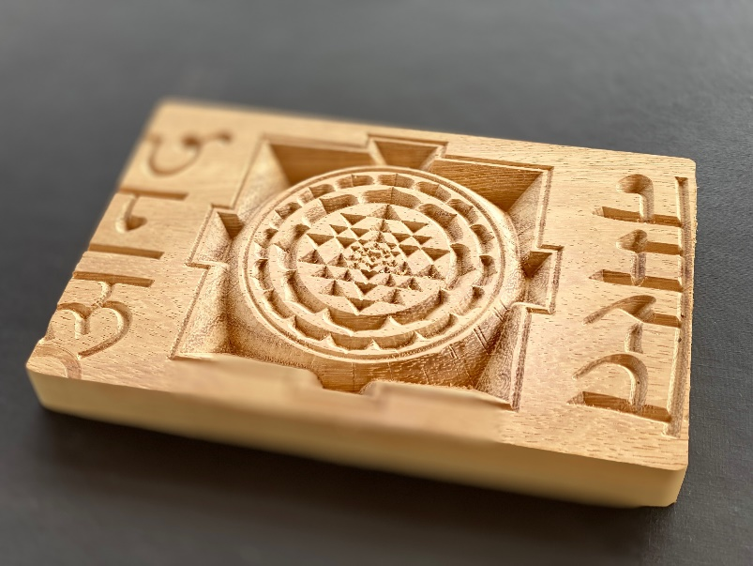

Music Generation – Magic Cushion Ride via Zoom 0-18 Months & 18 Months – 4 years. In the three weeks leading up to Cruinniú na nÓg you and your baby or toddler will learn some new songs and musical activities along with revisiting some old ones and fly on a magic cushion journey. These music sessions, led by MGSD music educator, Grace Corrigan, will culminate in one final music session at Cruinniú na nÓg, 12 June, where we will revisit your baby’s favourite activities.

Summer Stars at SDL
June is all about promoting the Summer Stars Reading Programme 2021. South Dublin Libraries have events planned for schools and the public. These include: Clayotic Workshops for children, 17th June, MAD4Tales – a creative writing workshop for a school group with Maeve Devoy, 15th June Alan Nolan – illustrator and author, for this school event, Alan will tell stories and teach the children how to draw characters from his books. 14th June Tallaght author Nicola Pierce will visit schools and talk about her book Chasing Ghosts: An Arctic Adventure, 15th June Anyone4 Science will visit schools for STEAM workshops.
History & Heritage
South Dublin Libraries and Live History Present Behind Glass: An Interactive Historical Mystery Date: Saturday 19th June Show Times: 11.30am, 1.30pm, 3.30pm, 5.30pm This is a free, interactive show for the family taking place outside at the Clondalkin Round Tower Centre
Book Clubs
The New Chapters book club will meet via Zoom on 9th June. This month they will be discussing Her Kind by Niamh Boyce. The book for June is Why the Moon Travels by Oein DeBhairduin.

