**Library Report April, May 2021**

South Dublin Libraries are continuing to deliver online events at present. However, engagements with local schools for online activities is creating connections with the community in the various library localities. This is important and ensures local visibility**.**

**A sample of online statistics**

January to end of March 2021 South Dublin Libraries had 386 online events.  
Total Views/Reach: 40176  
Total Engagement: 3629  
Total Number of Attendees: 7401

The following online activities received significant Reach and Engagements:   
**TTT talks** had a **Reach of 18639** and **Engagements of 731** [3 posts] **Grow It Forward** promotional [6 posts] had **a Reach of 8164** and **Engagement of 316 Poetry Day Ireland** promotional [14 posts] had a **Reach of 7494** and **Engagement of 128**  
  
**Regarding Twitter:**   
32.5K impressions over the past 27 days [1st – 27th April inclusive]   
Top Tweets:   
1. Poetry Day Ireland Programme: 3699 Impressions, 69 engagements  
2. Dublin Literary Award Giveaway: 2148 Impressions, 71 engagements  
3. Neurodiversity in the Workplace: 2087 Impressions, 17 engagements

**New online resources**

A new eMagazine service from Overdrive was implemented nationwide on April 26 and South Dublin Library patrons will had access to over 3000 magazines. To use this service, you must be a member of the library with a library card and pin.

April 30, saw the launch of a new online resource for children called iVox. This is an interactive story time resource; it will include animated book characters and highlight words being read to aid reading development. New titles will be added throughout the year.

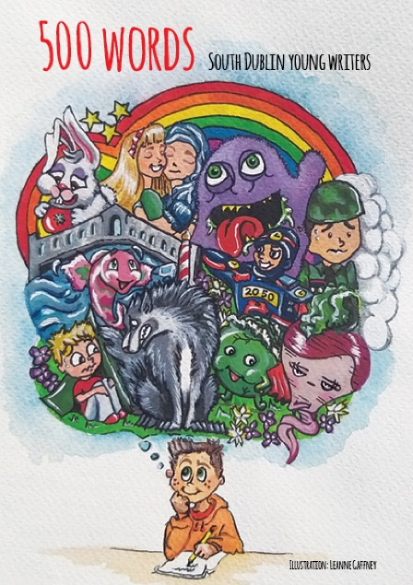**500 Words: South Dublin Young Writers**

Imagine trying to write a story in just 500 words and in the middle of a pandemic! Well, that's just what the children of South Dublin County did! All the stories were so good we decided to publish them in this wonderful book.

This publication is the work of children whose ideas jump off the page. All truly original and imaginative and never dull!

Copies have been distributed to all contributing authors, will be sent to schools across the county, and of course will be available to borrow from all branches of South Dublin Libraries.

**History All Around Us: South Dublin County Colouring Book**

South Dublin Libraries have produced a colouring book as part of our History All Around Us project, supported by the Dormant Accounts Fund. The aim of the project is to promote the heritage of South Dublin County, to foster pride of place and hopefully inspire a new generation of local historians!

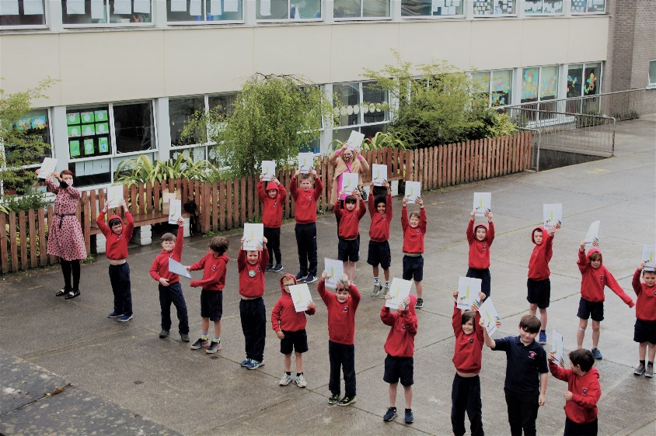The book is being provided to all children in second class in primary schools throughout South Dublin.

**Poetry day Ireland 29 April**

A jam-packed day of poetry at South Dublin Libraries to celebrate Poetry Day Ireland, with a series of six events – including topics such as climate change, the Irish language, New Irish poets, local voices, and a headline event with Eilean Ní Chulleanain - throughout the day.

**Bealtaine**

South Dublin Libraries have a programme of 17 events organised as part of the Council programme for Bealtine. Including paint club, yoga classes, vegan cookery classes, hanging basket herb gardening, a fun and lively drama production by Carnation Theatre “Getting Hitched”, all events can be booked **via the various libraries Eventbrite pages and details are detailed on the South Dublin Libraries central Facebook page.**

**Grow it Forward.**

The grow it forward national initiative continues to ‘grow’. 800 packs of seeds have been provided to individuals, schools and community groups across the county.

**Decade of Centenaries Lecture Series 12 May 7pm**

What did you do in the War of Independence, Grandad? with Myles Dungan. Based on his new book Four Killings, Myles Dungan extracts three of the killings - which took place during the War of Independence - and talks about the bloody narrative of his extended family during the revolutionary era and offers suggestions on how to research the activities of your own ancestors in that seminal conflict.

Booking essential at <http://southdublinhistory.eventbrite.com>

**Researching and Writing Your Own Family History with Sinéad McCoole**. **25 May, 7pm**

Following on from Myles Dungan’s talk on his family involvement in the revolutionary period, this complementary talk will help you get started in researching and writing your own family history. Sinéad McCoole is an Irish historian, author, broadcaster, and scriptwriter, specialising on women in Irish history. Full details and booking at <http://southdublinhistory.eventbrite.com>

**Talks**

**Introduction to Impressionism – art history with Jessica Fahy 14 May 7pm**

We are delighted to host a talk by art historian Jessica Fahy. Impressionism is the ideal artistic style to explore in the month of May. Impressionists painted outdoors and were particularly drawn to flowers and sunny landscapes. They wished to record modern life in a new and exciting way. This talk will cover the development of this style from its rebellious origins to its present-day fame. Artists to be discussed include Monet, Renoir, Degas and Cézanne. Booking at <https://www.eventbrite.ie/o/lucan-library-4590537389>

**Toys, Technology and Training Talks**

Wednesday 5th May 7pm

Managing Anxiety in 3rd Level Education for people with hidden disabilities

Presented by Michael Ryan (Child and Adolescent Psychotherapist)

Thursday 6th May 11:30am

Six steps to the Grace App Presented by Lisa Domican (Co-creator Grace App)

Thursday 6th May 7pm

The Role of the Speech and Language Therapist in a Multi-Disciplinary Team for a Child of Autism

Monday 10th May 7.30pm

Negotiating mainstream life as a teen/adult with a hidden disorder. Presented by Michael Ryan (Child and Adolescent Psychotherapist)

Tuesday 11th May 7pm

Managing Anxiety for Young People who have a Neuro- Diverse Diagnoses

Presented by Michael Ryan (Child and Adolescent Psychotherapist)

Wednesday 12th May 7pm

What is ADHD? Presented by Ken Kilbride ADHD Ireland

Wednesday 13th May 7pm

Helping Siblings – When Your Child has a Neurodiverse Diagnosis (ASD, ADD, ADHD, Dyspraxia, Dyslexia etc) Presented by Fiona Hall MIACP

Thursday 20th May 7pm

Teenagers with Speech, Language and Communication Needs. Presented by Oonagh McMahon SLT

**Music Programming**

North Clondalkin library are working with a local secondary school to provide a one week in person project, Rock Jam will provide hour long sessions over 5 days for local students, topics include editing, technical work, video production and performances.

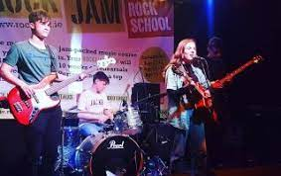

**Art project**

**Community call! for urban art project**

KinMx is a world-renowned street artist who is based in Dublin. North Clondalkin Library in association with CONTACT Studio has invited her to create her latest piece in our new library. She is looking for your stories, images, videos & photographs to help her create a piece of street art that will showcase our unique history and community in North Clondalkin. Submissions can be sent to ncl@sdublincoco.ie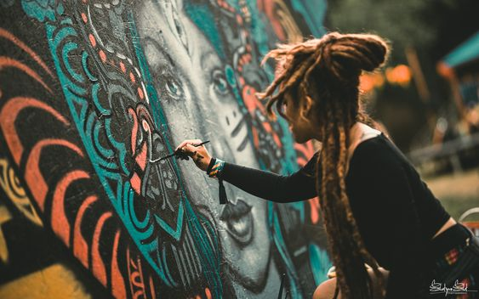

**Book Clubs**

**25th May, 7pm**

Via Zoom. This will be the third meeting of the Adult Book Club. This month they will be discussing Bright Burning Things by Lisa Harding. Details can be found on North Clondalkin Facebook page.