**Library Reopening including new Branch Libraries**

Following the government’s announcement on the gradual lifting of Covid-19 restrictions, all Branch Libraries will reopen on **Monday 10th May** on full library hours, from 9.45- 20.00 Monday - Thursday, and from 9.45-16.30 on Friday and Saturday. Initially there will be a quick browse service and Library users can enter the Library to browse, return and self-issue books and other library materials. Library users may also choose to drop off library items in a return bin if they do not wish to enter the library.

Printing services will also be available and patrons can send printing via **the** [Print Copy And GO](https://www.printcopyandgo.com/) **app**.

**The Home Delivery Service** will continue for those who may still require it, along with book drops to schools, creches, nursing homes and day care centres. **Online services** will continue, and a new online service for children has been introduced called iVOX. A varied programme of online events continues, including events for Bealtaine and a series of history lectures as part of the Decade of Centenars programme.

**iVOX is a children's book app** for ages 3-8, which engages and delights curious young minds with the latest in storytelling technology. - it is part eBook, part audiobook and part virtual pop-up. Children follow along with the exciting stories while interacting with 3D characters and scenes - immersed in the narrative and learning as they go.

All you need is the iVOX app (available for iOS and Android), your South Dublin D4 library card number and PIN.

**A sample of online statistics**

January to end of March 2021 South Dublin Libraries had 386 online events.  
Total Views/Reach: 40,176  
Total Engagement: 3,629  
Total Number of Attendees: 7,401

The following online activities received significant Reach and Engagements:   
**Toys Technology Training talks** had a **Reach of 18,639** and **Engagements of 731** [3 posts]; **Grow It Forward** promotional [6 posts] had **a Reach of 8,164** and **Engagement of 316; Poetry Day Ireland** promotional [14 posts] had a **Reach of 7,494** and **Engagement of 128**

**NCL (North Clondalkin Library)**NCL will reopen its doors on Monday 10th May at 9.45am. Initially there will be a quick browse service and Library users can enter the Library to browse, return and self-issue books and other library materials. Staff will be concentrating on registering new members, including welcoming those who may not have used a library before. Outreach programmes with local schools, creches and community organisations will continue, subject to HSE advice and guidelines. We are exploring holding small events with children in pods in the outdoor gardens.

**Creative Studio**

A Creative Studio in NCL is almost completed. The studio will offer a free digital maker space, facilitating the creation of music recordings, podcasts, videos, digital stories, and oral histories. At the centre of this space is a recording booth providing library patrons with access to a variety of audio and video recording equipment and software.

The idea of introducing The Creative Studio is to engage with younger people in particular - encourage them to upskill in digital media, with a view to expanding their musicality, and possibly start their future careers.

We have established links with several Music Organisations in South Dublin and have developed music outreach programmes with them which will specifically target young people in the locality.

These include:

* Music Generation South Dublin
* Contact Studio/Arts Office
* Rockjam Rock School

**Music Programming**

North Clondalkin library are working with a local secondary school to provide a one week in person project. Rock Jam will provide an hour-long session over 5 days for local students, topics include editing, technical work, video production and performances.

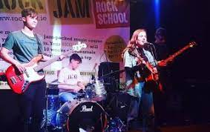

**Urban Art Project**

Community call! for an urban art project. KinMx is a world-renowned street artist who is based in Dublin. North Clondalkin Library in association with CONTACT Studio has invited her to create her latest piece in our new library. She is looking for your stories, images, videos and photographs to help her create a piece of street art that will showcase our unique history and community in North Clondalkin. Submissions can be sent to ncl@sdublincoco.ie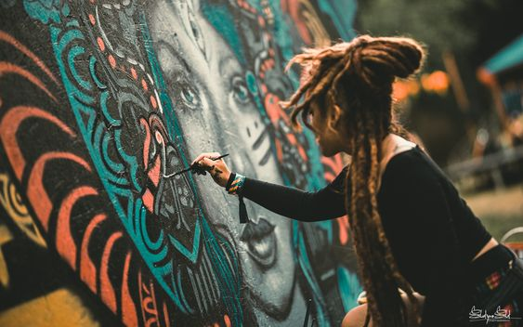

**NCL Adult Book Club**

25th May, 7pm Via Zoom. This will be the third meeting of the Adult Book Club. This month they will be discussing “Bright Burning Things” by Lisa Harding. Details can be found on North Clondalkin Facebook page.

**Community Benefits**

The introduction of a state-of- the- art community library in the heart of North Clondalkin has already many quantifiable benefits:

These include:

* Membership figures: 4,000 people registered in 3 weeks opened.
* Improvement in Reading literacy (Free access to Touch, type Read and Spell (TTRS) programme provided to 85 students in 5 local primary schools in the local area)
* Number of online events offered: Since January NCL 80 online events organised for adults and children with excellent uptake from locals in the area (STEAM/ art /Book clubs/Genealogy/Music/Language classes/ Craft sessions)
* Links established with local schools (both primary & Secondary).
  + To date NCL has organised 13 virtual events with local primary schools and 8 virtual events with secondary schools with 3 more to follow before June 2021)
* Involvement with national initiatives: NCL has participated in LGMA initiatives Healthy Ireland/Work Matters/Right to Read.
* Participation in Music Sessions:
* Rockjam sessions will cater for 30 students.
* A new online innovative Music Programme for teenagers combining STEAM and music is organised for the end of May in partnership with a Technology Creative company and will cater for 20 teenagers.

**Castletymon Library**

Following the lifting of restrictions for construction, we expect final snagging and electrical works to be completed by the end of May 2021. A handover of the building will be followed by the delivery of loose furniture, ICT equipment, and library stock. We anticipate opening the library is Q3.

A full range of library services will be available in the new library, including adult, young adult and childrens' services. Books, DVDs, CDs, Newspapers and Magazines will be available for borrowing along with free access to the Internet and Wi-Fi. Computer classes will be offered as well as online information, E-Books, E-Audio and other online resources. Regular story times are planned, along with STEAM activities, class visits and Babies Love Books session

**Promotion of Castletymon Library Services**

In terms of promotion, contacts have been made to date with the following:

* Every school in the area via email and phone. We are currently offering STEAM sessions virtually to the schools and a poetry event to secondary schools
* We are working with Rose Cottage and Tymon North Community Unit to provide ACORN tablets for older people and music sessions also
* Creative writing sessions for Tymon Park Friends are planned for May
* Contact with St. Aengus' Community Centre and Kilnamanagh Family Recreation Centre
* Series of Toys, Technology and Training events for Parents and children with additional needs, promoted initially through the local schools
* First Five Little Library bag to be distributed to Early Learning Centres in May
* Early Years music generation sessions planned for June, along with recycling workshops for children

Closer to the opening there will be planned media articles for the local press and social media platforms.