COMHAIRLE CHONTAE ATHA CLIATH THEAS

SOUTH DUBLIN COUNTY COUNCIL

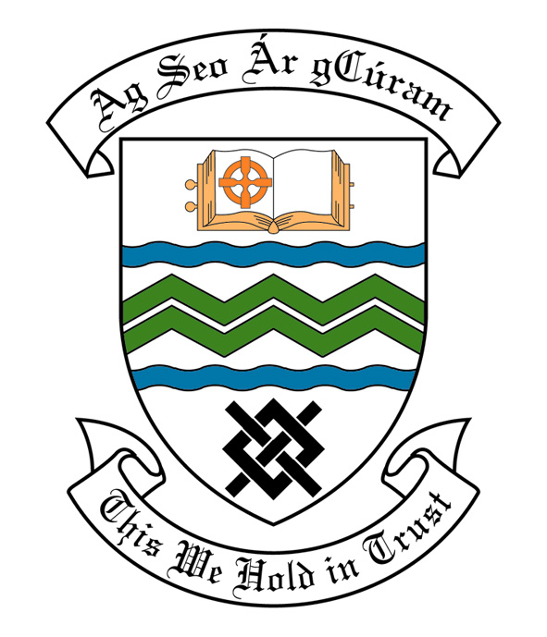

MEETING OF SOUTH DUBLIN COUNTY COUNCIL

Monday 10th April, 2006

Headed Item No. H-I (3 g)

MEETING OF THE LUCAN/ CLONDALKIN AREA COMMITTEE(2)

Tuesday 28th March, 2006

COMMUNITY BUSINESS

Application for Grants

Applications for grants under the Council’s Community Grants Scheme have been received from the organisations listed below. Payment of these grants to these organisations, in accordance with the conditions of the scheme, in the amounts set out hereunder, is recommended for approval:-

Ref: | Group | Type of Application | Date of Application | Amount
SCRA 1542/ GF 1384 | Bawnogue Community Centre,  Clondalkin,  Dublin 22. | Upgrading of existing community centre towards the repair of roof. | 08/02/06 | €3,910
SCRA 1679/ GF 1388 | Clondalkin Village Community Games,  51 Monastery Drive,  Clondalkin,  Dublin 22. | Community Activity Including Sporting Activity | 13/02/06 | €500
SCRA 1390/ GF 1699 | Dunawley Residents Association,  16 Dunawley Grove,  Clondalkin,  Dublin 22. | Environmental Improvements | 17/02/06 | €700

Contributions are being made to the following groups:-

Ref: | Group | Type of Application | Date of Application | Amount
 | Choir Festival,  Lucan Community College,  Lucan,  Co. Dublin. | Contribution towards the cost of attending a choir festival in Germany. | 15/03/06 | €2,200
SCRA 1678 AGF 518 | Interface  Gino Kenny  62 Cherrywood Avenue  Clondalkin  Dublin 22 | Arts Contribution | 25/01/06 | €300

It was proposed by Councillor Fintan McCarthy, seconded by Councillor Eamonn Tuffy and RESOLVED:

“That this Committee recommends that South Dublin County Council approve payment of the above grants and contributions, as recommended in the foregoing Report.”

