**Introduction**

South Dublin libraries continues to deliver a range of online events and activities for all ages with 155 events taking place in March 2021.

**Highlights**

**South Dublin Libraries applied for and were successful in receiving funding from the Healthy Ireland/Sláinte Care Resilience fund for the purchase 45 of Acorn tablets.**

These tablets are designed for ease of use by older people and anyone who finds using a normal tablet difficult. The tablets will come preloaded with the libraries online resources apps including Borrowbox, allowing instant access to thousands of titles. Zoom will also be installed, and this will allow those using them to get connected to library events. North Clondalkin Library and the new library at Castletymon will pilot a project aimed at connecting nursing homes in the local areas for virtual coffee mornings, storytelling sessions and other engagement activities. Other projects using the tablets including basic classes are being explored and will be developed when our libraries re-open.

**Don’t Worry, Be Happy, Keep well, 10 April from 2pm**

Put your cares on hold and join us on Saturday the 10th of April for an afternoon of relaxation and learning featuring live music, mindfulness, drawing, gardening, and cooking. We want you to "Don't Worry, Be Happy and Keep Well" for a wonderful afternoon of entertainment.

Booking opens this Thursday 1 April at 10am at <https://www.eventbrite.ie/e/dont-worry-be-happy-tickets-147797471215>

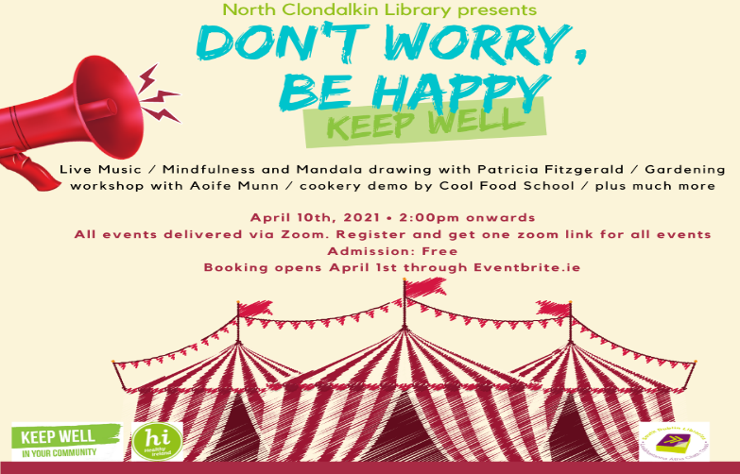

**Tech Week 17 -23 April 2021**

To celebrate tech week, South Dublin Libraries have organised six digital fabrication workshops to be provided to a school in the local area of each branch. The workshop will include, product prototyping using 3D printing technology, demonstration of 3D design software, discussion around how this is used in industry and potential jobs of the future, digitizing real world objects, demonstration of 3D scanning, the 3D printing process, demonstration of a 3D printer, and other tools for digital fabrication including a video of laser cutting engraving, machine Discussion, and demonstration of design in the world around us.

**Poetry Day Ireland @ South Dublin Libraries 29 April**

Join us for a jam-packed day of poetry at South Dublin Libraries as we celebrate Poetry Day Ireland with a series of six events – including topics such as climate change, the Irish language, New Irish poets, local voices and a headline event with Eilean Ní Chulleanain - throughout the day.

Details of how to book will be available on [www.southdublinlibraries.ie](http://www.southdublinlibraries.ie) from 12, April.

**Saturday Super Stories**

Saturday 3, 10, 17 and 24 April 11am – 12

If your child is struggling with reading this year after missing a lot of school then join us every Saturday in April with literacy expert, Barbara Coughlan, to spend time together reading, writing, talking, singing, and playing.

**Digital media** a 4-week programme of events starting 6 April 7pm

Educator Ricardo Castellini da Silva presents this exciting series of webinars designed to help us counter the dangers of fake news and disinformation. Topics include:  Disinformation and Covid 19, Fighting disinformation and fake news, Data Privacy and Surveillance, News media, journalism, and the information crisis

Each week Ricardo will tackle a different topic of concern and offer context, tips, and practical advice.

Booking at [www.lucanlibrarydublin.eventbrite.com](http://www.lucanlibrarydublin.eventbrite.com)

**North Clondalkin Library - pilot Project with Tallaght Hospital:**

As part of Healthy Ireland and Keep Well campaigns, NCL (in association with Tallaght Hospital) is delighted to pilot a lending initiative to patients and staff in the hospital.

The initial loan will consist of 30 playaways and 30 adult fiction books and will commence in April 2021.

Online resources will also be promoted, with particular emphasis on BorrowBox.

The box of items was delivered by NCL library staff on Monday 15th March @ 2.30pm to Tallaght Hospital. The resources were warmly welcomed by Danielle Anderson-Head of Patient Advice and Liaison Services Tallaght University Hospital and her team. It is envisaged that the playaways will be used by patients in the Stroke Unit and by older patients, who are likely to find them very easy to handle because of their small size.

The hospital itself is going to highlight and promote the service through its internal Newsletter.

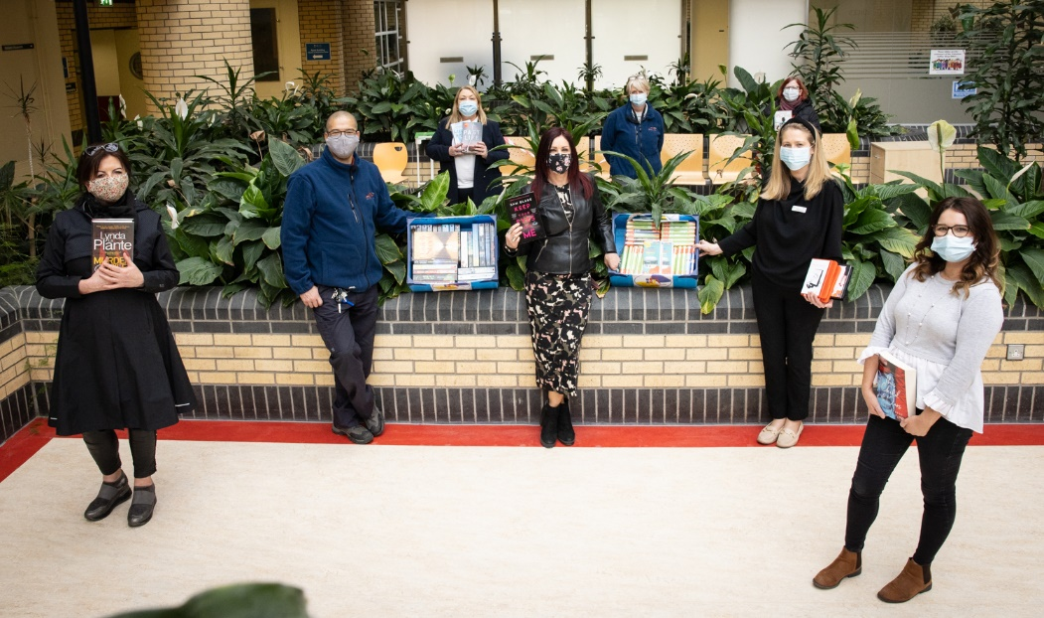

**South Dublin Libraries TTT (Toys, Training, Technology) project presents its free online workshops throughout April/May.**

These events offer further guidance, support and networking opportunities for parents, teachers, and healthcare professionals. To view the full list of free TTT workshops taking place online throughout April/May please visit the library website at [www.southdublinlibraries.ie](https://eur04.safelinks.protection.outlook.com/?url=http%3A%2F%2Fwww.southdublinlibraries.ie%2F&data=04%7C01%7CLCorry%40sdublincoco.ie%7C1bcde79de8784f6e262808d8f4369dae%7C6a3c00c019d0492da8de95fad8fda1d4%7C0%7C0%7C637527862708220327%7CUnknown%7CTWFpbGZsb3d8eyJWIjoiMC4wLjAwMDAiLCJQIjoiV2luMzIiLCJBTiI6Ik1haWwiLCJXVCI6Mn0%3D%7C1000&sdata=aDc5I5qdO75OEXjWhCPa9DLrlzHTOoMWJz%2FUMn98JRg%3D&reserved=0) or email [gomeara@sdublincoco.ie](mailto:gomeara@sdublincoco.ie) or [bmulcahy@sdublincoco.ie](mailto:bmulcahy@sdublincoco.ie).

**Supporting Someone with ASD in the classroom** Fri 16th April 11am Book your place here: [Castletymon Library Events | Eventbrite](https://eur04.safelinks.protection.outlook.com/?url=https%3A%2F%2Fwww.eventbrite.ie%2Fo%2Fcastletymon-library-32465225843&data=04%7C01%7CLCorry%40sdublincoco.ie%7C1bcde79de8784f6e262808d8f4369dae%7C6a3c00c019d0492da8de95fad8fda1d4%7C0%7C0%7C637527862708220327%7CUnknown%7CTWFpbGZsb3d8eyJWIjoiMC4wLjAwMDAiLCJQIjoiV2luMzIiLCJBTiI6Ik1haWwiLCJXVCI6Mn0%3D%7C1000&sdata=8sNiZkvPo19vRdDusjXXytweB%2BBqz3Y%2FjhsmbzJWpKo%3D&reserved=0)

**Developing Social Communication Skills with Pre-Verbal Children with Autism** Wed 21st April 7pm Book your place here:  [Clondalkin Library Events | Eventbrite](https://eur04.safelinks.protection.outlook.com/?url=https%3A%2F%2Fwww.eventbrite.ie%2Fo%2Fclondalkin-library-6012673139&data=04%7C01%7CLCorry%40sdublincoco.ie%7C1bcde79de8784f6e262808d8f4369dae%7C6a3c00c019d0492da8de95fad8fda1d4%7C0%7C0%7C637527862708230324%7CUnknown%7CTWFpbGZsb3d8eyJWIjoiMC4wLjAwMDAiLCJQIjoiV2luMzIiLCJBTiI6Ik1haWwiLCJXVCI6Mn0%3D%7C1000&sdata=8e4yOc4ttAXuXxVKM5K479tcewtRV54zvx6%2BW0%2B7k3k%3D&reserved=0)

**Neurodiversity in the work place** Wed 28th April 8pm Book your place here:  [Ballyroan Library Events | Eventbrite](https://eur04.safelinks.protection.outlook.com/?url=https%3A%2F%2Fwww.eventbrite.ie%2Fo%2Fballyroan-library-2184216231&data=04%7C01%7CLCorry%40sdublincoco.ie%7C1bcde79de8784f6e262808d8f4369dae%7C6a3c00c019d0492da8de95fad8fda1d4%7C0%7C0%7C637527862708230324%7CUnknown%7CTWFpbGZsb3d8eyJWIjoiMC4wLjAwMDAiLCJQIjoiV2luMzIiLCJBTiI6Ik1haWwiLCJXVCI6Mn0%3D%7C1000&sdata=j90brR81CzLvq0JbkGKthgudNnoqUjanU%2FGzH7KZYtI%3D&reserved=0)

**Autism 101** Thurs 29th April 11am Book your place here:  [Lucan Library Events | Eventbrite](https://eur04.safelinks.protection.outlook.com/?url=https%3A%2F%2Fwww.eventbrite.ie%2Fo%2Flucan-library-4590537389&data=04%7C01%7CLCorry%40sdublincoco.ie%7C1bcde79de8784f6e262808d8f4369dae%7C6a3c00c019d0492da8de95fad8fda1d4%7C0%7C0%7C637527862708240314%7CUnknown%7CTWFpbGZsb3d8eyJWIjoiMC4wLjAwMDAiLCJQIjoiV2luMzIiLCJBTiI6Ik1haWwiLCJXVCI6Mn0%3D%7C1000&sdata=rzRceJbhm1T2ULMx6UUYox4R7VtPvwj2EpfEjTdC%2FCo%3D&reserved=0)

**Negotiating mainstream life as a teen/adult with a hidden disorder** Mon 10th May7.30pm Book your place here:  [Palmerstown Library Digital Hub Events | Eventbrite](https://eur04.safelinks.protection.outlook.com/?url=https%3A%2F%2Fwww.eventbrite.ie%2Fo%2Fpalmerstown-library-digital-hub-29712818925&data=04%7C01%7CLCorry%40sdublincoco.ie%7C1bcde79de8784f6e262808d8f4369dae%7C6a3c00c019d0492da8de95fad8fda1d4%7C0%7C0%7C637527862708240314%7CUnknown%7CTWFpbGZsb3d8eyJWIjoiMC4wLjAwMDAiLCJQIjoiV2luMzIiLCJBTiI6Ik1haWwiLCJXVCI6Mn0%3D%7C1000&sdata=ibwUNIZWmfApMyCQEBJisD%2FAi8gBMsW9JG9LKm7AYYk%3D&reserved=0)

**Managing Anxiety for Young People who have a Neuro-Diverse Diagnoses** Tues 11th May 7pm Book your place here:  [North Clondalkin Library Events | Eventbrite](https://eur04.safelinks.protection.outlook.com/?url=https%3A%2F%2Fwww.eventbrite.ie%2Fo%2Fnorth-clondalkin-library-31079450849&data=04%7C01%7CLCorry%40sdublincoco.ie%7C1bcde79de8784f6e262808d8f4369dae%7C6a3c00c019d0492da8de95fad8fda1d4%7C0%7C0%7C637527862708250308%7CUnknown%7CTWFpbGZsb3d8eyJWIjoiMC4wLjAwMDAiLCJQIjoiV2luMzIiLCJBTiI6Ik1haWwiLCJXVCI6Mn0%3D%7C1000&sdata=Nn3dOKAS8eSfkGlDaRTgmB0lIVETWMUgpNib85rvjjo%3D&reserved=0)

**Grow it Forward**

This is a national programme in association with Libraries Ireland, Healthy Ireland and Grow it Yourself as part of the governments Keep Well initiative.

We have free Grow it Forward kits available to send out to you! Each kit contains seeds for 5 different vegetables, instructions and gift cards to share your plants with others. Just contact your local library with your name and address and we will post it out to your home.

The programme will be supported by a series of online events held by South Dublin Libraries including.

**Grow it Forward for small spaces and balconies. 12 April 4.00pm** Join Aoife Munn for this informative session concentrating on the seeds from your Grow it Forward Kit available by post from your local library. Booking from <https://www.eventbrite.ie/o/palmerstown-library-digital-hub-29712818925>

**Grow it Forward with Dee Sewell of Greenside Up, 22nd of April at 11.00am**A how to look at planting, harvesting, and sharing your GIF vegetables. Booking at [www.talib.eventbrite.com](http://www.talib.eventbrite.com) from 1st April at 10.00am.

**Grow it Forward for Kids, 22nd of April at 11.00am** Join us online for our grow it forward session. This is suitable for kids of all ages. You will need to have your seeds from the grow it forward initiative, some compost, pots and containers with holes in the bottom (old flower pots, empty fruit containers like grapes that have holes in the bottom), lolly pop sticks if you have them and some markers for decorating pots. Booking at [www.eventbrite.ie/o/palmerstown-library-digital-hub-](http://www.eventbrite.ie/o/palmerstown-library-digital-hub-)

**Plant Powered Cookery. Tasty, nutritious, plant-based eating with Dr. Ailis Brosnan**. **28 April 7.30pm** Learn how you can prepare well-balanced, healthy salads, snacks and more for all the family with fruit, vegetables, nuts, seeds and grains. Incorporating your Grow It Forward vegetables.

Booking from https://www.eventbrite.ie/o/palmerstown-library-digital-hub-29712818925