Motion 20 Councillor Derren Ó Brádaigh

Item 69201

That this committee supports a fully marked school children's pedestrian crossing to be located on the Balgaddy Road, directly outside the entrance to Lucan Community National School to provide children with safe crossing.

Reply:

There is an existing Toucan Crossing on the Ballygaddy Road outlined in yellow. The road up to the School is a private road and not taken in charge by SDCC.

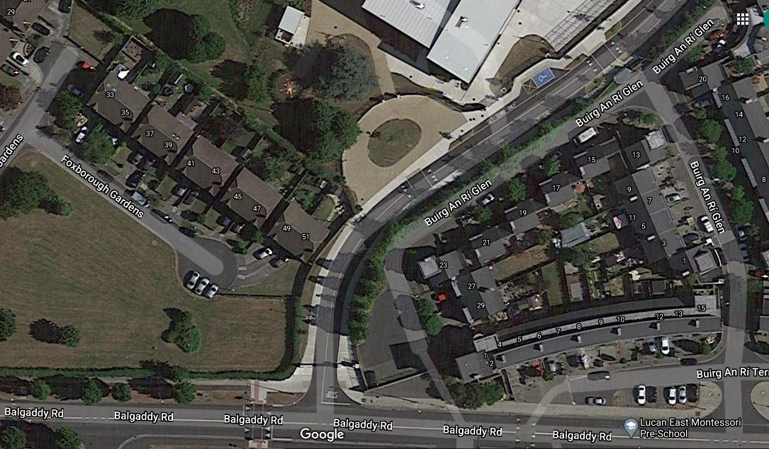

Existing Toucan

Crossing

Private Road – Not taken in Charge