This committee asks the Chief Executive to report to the members what works were carried out following the floods in November 2020 as part of the flood alleviation along the river Griffeen. This area has been continuously subjected to flooding over sometime and more recently the flooded areas have increased and many park users have taken to sharing these flooded areas online or directly with me. The footbridge in the park on Hayden's lane was full of water under neath resembling what looked like a river running under it. Given that there's plans to construct ICW's along the Griffeen park, could the management confirm of the recent floods will be resolved when the ICW's are completed. To also ask if management could indicate if Griffeen park will have attenuation tanks installed, and to indicate once again how many are planned for the Griffeen extension, given that a new major link road is to be built through the park.

**Reply to the Motion**

**Background to the current situation**

In January and early February, many rivers in country including Dublin are at an elevated level, these are shown in yellow in the map below. This means that rivers are approach or at bank full conditions.

Soils are also saturated following a very wet January.

Recent Met Eireann flood forecasting update:

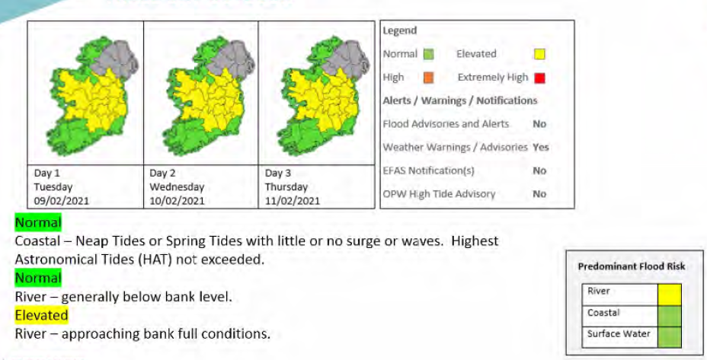

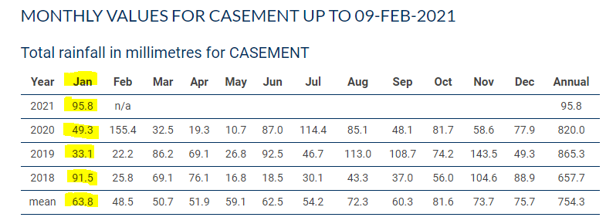

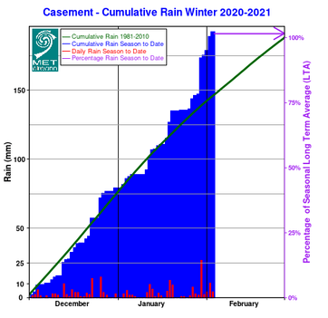

January rainfall was 95.8 mm measured at Casement and is the wettest January in the past four years and well above the monthly mean for winter months. The cumulative rainfall this year is already at 100% of the long run average. This has led to saturated soils and hence there has been ponding and high river levels.

**Integrated Constructed Wetlands ICW’s**

One integrated Constructed Wetland has been granted Part 8 Planning Approval in Griffeen Valley Park. This ICW is part of the Dublin Urban Rivers Life Project. The main goal of this ICW is the improvement of water quaklity in the Griffeen River. While there are other benefits that ICW’s provide in relatioi to biodiversity, habitat creation and some attenuation. The ICW will not have an impact on the flood processes in the wider catchment.