South Dublin Libraries Update March 2021

**Online Services**

**Borrowbox**

There continues to be an increase in demand for ebook and audiobooks, as we have seen over the past year.

* eBook loans saw a 2.2% increase since January 2021, and 155% increase from February 2020.
* 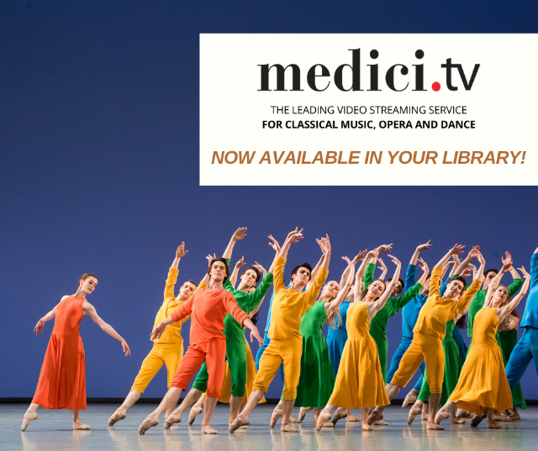We saw a 6% increase in eAudiobooks loans since January 2021, and 131% increase from February 2020.
* Active users have seen a 7.6% increase since January 2021, and 109% increase from February 2020.
* Overall 89% increase in users 2019 vs 2020.

**Medici TV**

This is a new streaming service for South Dublin Libraries patrons, featuring classical music, opera, and dance performances. We hope it will be the perfect antidote to the Covid chaos!

**Find My Past**

This is another service new to South Dublin Libraries patrons which gives access to millions of records to assist them in researching their family histories, including birth, marriage and death records, census, church records, travel and migration records, newspaper archives and more. Patrons can contact their local branch library for access details.

**HOME DELIVERY SERVICE**

The Mobile Library Service continues to provide a home delivery service to the housebound and older people who have been long-term cocooning. In addition to this, the new ‘Little Learners Library’ delivery service is now available for parents of children with additional needs where they can avail of books and sensory toys from our TTT collection. The contact for this is [mobiles@sdublincoco.ie](mailto:mobiles@sdublincoco.ie) or 01 4597834.

**Online Events March and April 2021**

**BETWEEN THE RED LINES FESTIVAL** 22nd – 28th February 2021

**Between the Redlines Festival** was a special offering for 2021 to engage with our citizens during this difficult time and to increase awareness of the upcoming RLBF in October 2021. The festival included events for adults and children, including creative writing events and author sessions, a book quiz and theatre event, and was very well received. Also part of the festival was a talk on Dublin’s connections to the Camino, which had over 200 people attending.

**OTHER EVENTS HIGHLIGHTS**

Engineers Week Events for Children

* **Everyday Engineering** with the Rediscovery Centre (Tuesday 2nd March)
* **Energy Workshop** with the Rediscovery Centre (Tuesday 2nd March)
* **Designing Habitats with Dublin Zoo** (Thursday 4th March)
* **Family Virtual Engineering Workshop** (Thursday 4th March)
* **Digital Fabrication** Workshop with Tech Create (Friday 5th March)
* **Bioengineering Workshop** with Anyone4Science (Saturday 6th March)

Seachtain na Gaeilge agus Lá Fhéile Phádraig

* **Mobile Music School** (Saturday 6th March, Tuesday 9th March) These music workshops through Irish will enable children to learn about the world by music as they take part in interactive activities and fun musical games
* **Irish Classes** for Adults – Beginners and Intermediate (Various dates)
* **Shamrocks and Shillelaghs at the National Botanic Gardens** (Tuesday 16th March) To celebrate Seachtain na Gaeilge and Lá Fhéile Phádraig, join the National Botanic Gardens for an exploration of some of the best-known Irish plants, their habitats, uses and folklore.
* **The Big Irish Quiz** (Tuesday 16th March)Test your knowledge of all things Irish with this online quiz!
* **Sadhbh Devlin virtual class visit**: Geansaí Ottó: Join Sadhbh for a reading of her brand-new book and a chance to design some jumpers of your own! (Thursday 11th March)
* **ÓgaYoga;** Rang yoga spraíúil do pháistí 7-11 mbliana d'aois. Bí linn ar thuras samhlaíochta a nascann deasuithe ióga bríomhara le gluaiseachtaí ainmhithe. (Friday 12th March)

Early Years and Children’s Events

* **Toddler Stories and Crafts** and **Baby Book Clubs** (continuous regular events)
* **Music Generation** Early Years Music Courses (various dates – March 2021)
* Clever Little Handies **Baby Sign Language Course** (various dates – March 2021)
* **Toddler Yoga** (various dates – March 2021)
* **Easter Bake Along** with Cool Food School (1st and 8th April)
* **Virtual Discovery Walk** with The Reptile Zoo (7th April)
* Various **STEAM workshops** including Scratch Animation, Online Java in Processing, Light-Up LED Card Making, Music Tech Masterclass, Scribblebots, and more. (various dates)
* Live storytelling sessions for schools on **World Book Day** (Thursday 4th March)

#KeepWell and Life Long Learning Events for Adults

* **Sustainable Living Workshop**: in this workshop with Aoife Munn, you’ll learn how to make beeswax wraps, biodegradable pots, and get lots of tips on sustainability. (Wednesday 10th March)
* **Planting for Biodiversity** - how to plant up your garden to create better wildlife areas, corridors and protect against pollution. (Saturday 18th March)
* **Knitting Course for Beginners** and **Crochet Course for Improvers** (various dates – March and April 2021)
* **Crime Writing Course** with author Louise Phillips(6 week course - various dates April and May 2021)
* **Media Literacy Series**: Ricardo Castellini Da Silva of DCU Silva presents a series of media literacy talks every Tuesday for the month of April, covering topics including fake news, controlling personal data online and data privacy. (various dates – April 2021)
* **Genealogy for Beginners course** – 6 week course with expert genealogists from Eneclann (various dates March and April 2021)
* **Decade of Centenaries: The War of Independence** **– the South Dublin Perspective**, a talk with historian Catherine Scuffil (Tuesday 23rd March). This will be the first in our Decade of Centenaries Lecture Series for 2021.
* **Healthy Ireland - Mood Foods: Shaping Your Brain with Essential Nutrition** – a talk with nutritionist Paula Mee (Monday 15th March)
* **Mindful Chair Yoga** (various dates March and April)
* **International Women’s Day Events**

International Women’s Day

* **Modern Women in Modern Times: A talk by Cecelia Hartsell** (Monday 8th March at 7:00pm

The industrial revolution changed the character of America, drawing workers from farms to cities. This talk will examine the experience of urban female workers in the early 1900’s through the lenses of class and race, delving into the types of employment they could secure, how society viewed their efforts to build new urban lives and how social norms were accordingly stretched, broken and re-defined. Cecelia Hartsell is a U.S. historian specialising in African American history and American social history. She is a contributor to the RTE History Show and frequently gives U.S. history talks for the Dublin Festival of History.

* **Women and Creativity: Staying focused in Times of Covid** (Tuesday 9th March at 7:00pm)

Join writer and filmmaker, Caroline Farrell as she chats to authors Lisa Harding, Lindsay J. Sedgwick and Fíona Scarlett on their creative experience and staying focused (or not!) during these challenging times.

* **Helena Molony: A Radical Life** (Thursday 11th March at 7:00pm)

Nell Regan talks about one of the many remarkable women who were public figures during the Irish revolutionary period. Her biography Helena Molony: A Radical Life 1883 – 1967 (Arlen House) was a 2017 Irish Independent Book of the Year and tells the fascinating story of Helena Molony. This Abbey actor, feminist and trade unionist fought in the 1916 Rising, was a courier in the War of Independence and was implacably opposed to the Treaty. She went on to be one of the Free State's leading trade unionists. Regan will also explore why the histories of these remarkable women and their organisations have only been recognised and written about in recent years.

Local Enterprise Week and Work Matters

* **Entrepreneurship Event** for secondary schools: Noel McNamara of North Clondalkin Library interviews entrepreneurs from South Dublin County in three different areas including: Woodworking Company(www.customwooddesigns.ie ); Sensory Rooms (www.sensoryhouse,ie), Beauty products (Bia Belle promoters). (Tuesday 2nd March)
* **Starting your own Business**: Advice from a successful Entrepreneur with Lisa Cunningham (Monday 1st March)
* **Taking the Stress out of Working from Home**: avoid pitfalls, Tips, and good practices with Joe Morris from CATTS (Thursday 4th March)
* **Social Media for your Business**: a workshop with Felicity McCarthy (Friday 5th March)