r

Mick Mulhern

sOUTH DUBLIN COUNTY COUNCIL

rEPORT TO ROADS SPC: Review of Transport STRATEGY FOR THE gREATER dUBLIN AREA 2016-2035

**Contents Page:**

**Item 1:**

**Introduction: Review of Transport Strategy for the Greater Dublin Area 2016-2035 Page 2**

**Item 2:**

**The Process of Development of a New Transport Strategy for the GDA up to 2042 Page 2**

**Item 3:**

**South Dublin County Council (SDCC) Submission to the National Transport Authority**

**(NTA) Greater Dublin Area (GDA) Transport Strategy Review Page 3**

**Item 1:**

**Introduction:** **Review of Transport Strategy for the Greater Dublin Area (2016-2035)**

The National Transport Authority, (the “Authority”) has commenced the review of the Transport Strategy for the Greater Dublin Area 2016-2035, and the preparation of a new strategy, which will consider the future development of the transport system in the GDA for the period up to 2042.

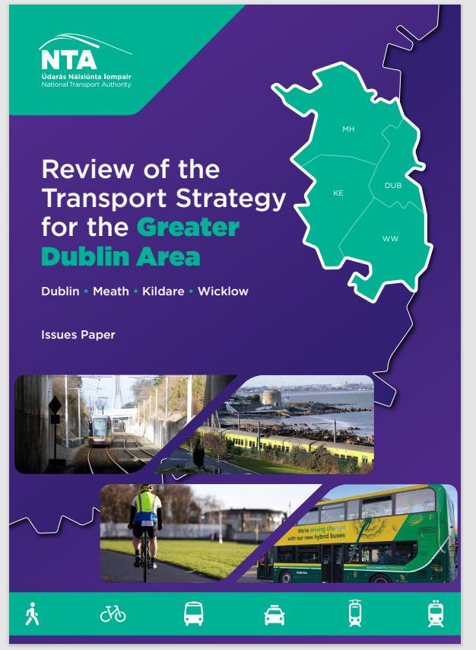

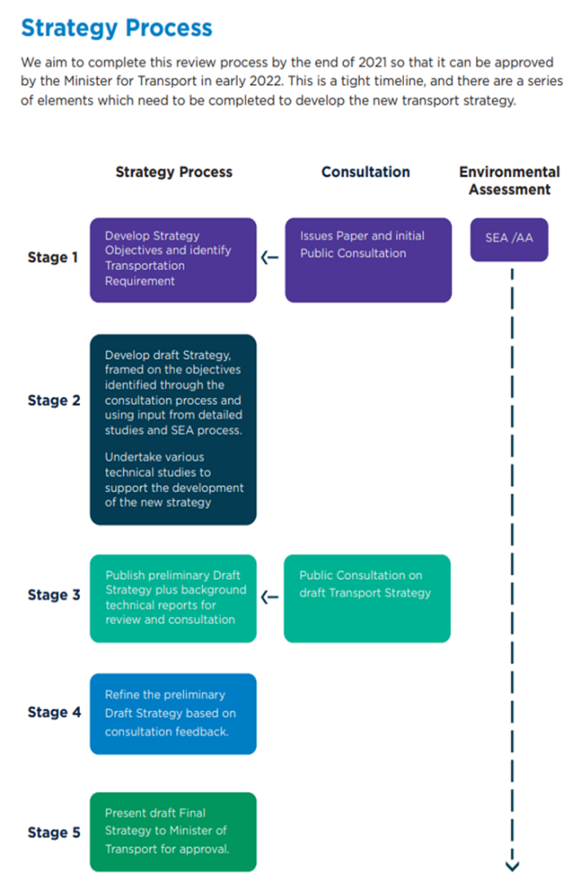

**I****tem 2: The Process of Development of a New Transport Strategy for the GDA up to 2042:**

* Determine, in agreement with the NTA, the appropriate scale and pattern of travel demand to be accommodated in 2042;
* Consult with the relevant local authorities in relation to any objectives which may impact transport in the study area;
* Review and identify any relevant considerations from the Dublin City Development Plan and South Dublin Development Plan;
* Agree an assumed transport network for 2042 – a project reference case – for the purposes of options assessment;
  + Identify a realistic set of appropriate transport options to meet the demand within the area and for travel to and from the study area, with an emphasis on travel demand to and from Dublin City Centre;
  + Assess the options with a focus on the relative merits of light rail and bus as options, taking into account emerging proposals on this corridor and adjacent corridors.

As part of the **Stage 1** **Consultation process**, South Dublin County Council made a submission to the Issues Paper on the 19 January 2021. The Response report is set out below:

**Item 3:**

**South Dublin County Council (SDCC) Submission to the National Transport Authority (NTA) Greater Dublin Area (GDA) Transport Strategy Review**

**Strategic Context**

**1** In September 2020, SDCC initiated a review of its County Development Plan (CDP) 2016 – 2022. In February 2021, the Council will agree a set of Strategic Directions to guide the preparation of the CDP (2022 – 2028). Public consultation on the draft plan will take place from June 2021 and there is a programme to have a final adopted CDP in place by summer 2022. As part of this process, we have examined population growth projections beyond 2031 and are developing a draft Core Strategy that sets the spatial framework for the development of the County for the plan period.

2 As part of reviewing the CDP, SDCC is working closely with the NTA to prepare a County Mobility Strategy. This strategy should be completed in time for public consultation on the CDP in June 2021. The strategy looks across the entire County and it will be important that the content and key recommendations from the County Mobility Strategy are reflected in the final GDA Transport Strategy. The Council will continue to work closely with the NTA to ensure this happens.

3 To address both existing levels of activity in the County and to accommodate future growth, the principal aim of strategic land use and transport planning strategy for the SDCC area is to seek to promote ease of movement within, and access to South Dublin County, by integrating sustainable land-use planning with a diverse and high-quality transport system for people and goods.

4 SDCC is committed to changing travel patterns and behaviour to reduce car dependence in favour of more sustainable modes of transportation, such as walking, cycling and public transport. It is recognised that a well-managed transport network will attract businesses, ensure competitiveness and provide employment opportunities for the people of South Dublin County.

5 SDCC supports the principle of directing ‘compact growth’ around existing and planned public transport services. The GDA transport strategy should clearly promote the integration of public transport with homes and employment space. These uses should be integrated to the greatest extent possible so that the demand for travel in general and for car-based travel is reduced.

6 To achieve this, significant investment will be needed at the national and regional level, in major public transport infrastructure projects to support change that enables growth whilst influencing travel patterns and behaviour.

7 Since 2000, a variety of major public transport projects have been identified, including new Luas lines and extensions, Metro, Interconnector, Rail upgrades and Bus Rapid Transit (BRT). Whilst a number of these have been delivered or are in the process of design or construction, the status of some remains uncertain. Future strategy in relation to these will have a significant influence on land use and transport planning and development.

8 The review of the GDA Transport Strategy is an opportunity to provide clarity on the future of these projects and to outline further projects, in some cases as successors to Projects previously planned, in order to shape the long-term development of the GDA. This submission outlines SDCC priorities for the development of strategic transport infrastructure at a Countywide and Regional level.

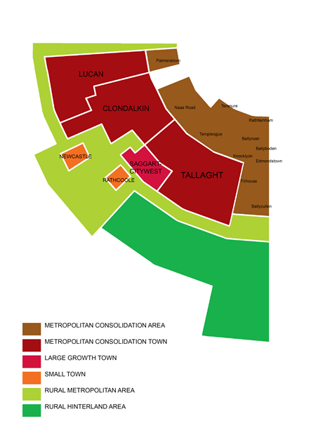

***Extract from the South Dublin County Development Plan Draft Core Strategy.***

**SDCC Regeneration Lands:**

**9** There are several key regeneration lands across South Dublin where increased transport investment is required to support the delivery of new homes as per DHPLG housing targets and in line with the principles of compact growth as set out in the NPF.

10 Significant and sustained transport investment will be critical to unlocking these lands. Over time this investment will likely need to include new services, increased capacity, new and improved stations (bus and rail), as well as new roads, streets, and cycle lanes;

• Adamstown SDZ

• Clonburris SDZ

• Naas Road (a separate submission to the NTA will be made on the Naas Road lands as

outlined 7 below)

• Tallaght

11 There is also a need for further investment in public transport services at

• Fortunestown

• Ballycullen

• Newcastle

12 Appendix 1 provides more detail on the key regeneration lands in South Dublin.

**13** Within South Dublin there are also several rural villages and existing rural communities. It is important that the provision of public transport is provided to support the sustainable movement of our existing rural communities. In many instances it will be challenging to provide improved cycle infrastructure across these locations and so improved bus services will be needed.

**Area Based Study: Naas Road / Ballymount**

**14** South Dublin County Council are supportive of the NTA’s commitment to identify the Naas Road/Ballymount lands as an Area Based Study in the GDA Transport Strategy and as part of which, SDCC are in the process of undertaking a significant level of growth development and trip generation analysis for the study area in collaboration with the NTA. This work will be completed in mid-February and a formal response outlining the results of this analysis will be issued to in response to the Transport Strategy review at that time.

15 This area comprises of c.700 hectares of brownfield lands in South Dublin County and Dublin City Council areas and is identified in the Regional Spatial and Economic Strategy (RSES) and Metropolitan Area Strategic Plan (MASP) as a strategic development area within the M50. The location and scale of regeneration potential of these brownfield lands position this area as of national significance in terms of achieving the objectives of the National Planning Framework - Project Ireland 2040 (the NPF) for compact growth, intensification of uses and regeneration. There is major potential for residential development and more intensive employment/mixed-uses through the intensification of underutilised older industrial estate lands. The significant development potential of these lands is planned for the medium to long-term and subject to gradual site assembly, background studies and investment in public infrastructure and services.

16 South Dublin County Council and Dublin City Council are working collectively in the preparation of a masterplan for this area in order to realise the development potential of these lands through a plan-led approach, which will identify the development capacity of the area, where future development will take place, the spatial distribution of development, including residential, commercial, industrial and community facilities, complete with the identification of a credible delivery programme for the initial phases of development. In seeking to meet the objectives of the masterplan, which will be in place at the end of 2021, major investment in public services will be required, particularly in public transport and sustainable modes of transportthrough permeability projects andquality walking and cycling networks. While the detailed requirements for this major regeneration landbank are to be determined, the provision of a new train station on the Kildare Line adjacent to Kylemore Road and a new Luas stop on the Red Line between the Kylemore and Red Cow stops (as per the RSES and MASP) are measures which would enhance the development potential of these lands and could be delivered in the short-medium-term.

**17** The Transport Strategy should recognise the importance of this landbank area for growth in the medium to long-term and the transport and movement requirements which will be determined in further detailed analysis. The potential for increased demand on Luas Red Line services should also be acknowledged and planned for in terms of capacity and frequency upgrades. Allied to this, the role of bus services in the area will need to be continuously reviewed, with the expectation for increased investment in meeting future demand, coupled with required investment in the provision of orbital services.

**Mode Share Hierarchy**

**18** The GDA Transport Strategy should include a mode share hierarchy. The hierarchy should promote with pedestrian and cycle movement at the top, followed by rail, bus, and then private vehicle. This hierarchy should be used by all authorities to guide both policy development and public investment in sustainable transport.

**Pedestrians and Cyclists**

**19** SDCC is committed to improving pedestrian and cyclist mobility, with the view to reducing the number of short journeys taken by car and improving access to public transport services. The formation of walkable new communities will be guided by spatial plans, such as Local Area Plans and SDZ Planning Schemes.

20 SDCC strongly supports investment in walking and cycling infrastructure and training to build confidence. Investment should support the delivery of comprehensive and joined up walking and cycling networks that offer people of all ages and abilities choice and safety.

21 SDCC is progressing the preparation of a 10-year programme called Cycle South Dublin. In support of this, the NTA should:

**•** commit to funding the delivery of the projects identified in the NOW phase of Cycle South Dublin, which are set of projects the Council wants to deliver over the next five years. The NTA must move beyond single year funding commitments. Longer term funding certainty will help local authorities to build local and political support for cycling infrastructure. Longer term commitments will help to show people that there is a comprehensive plan in place with a commitment to provide a joined-up network.

• commit to providing the staff resources needed to fund the design and delivery of these projects.

• Provide additional funding for the maintenance and upkeep of existing cycle lanes.

**22** Where walking and cycling projects cross County boundaries, the NTA should play an important role in facilitating and encouraging cross-boundary projects.

**Public Transport**

**23** South Dublin may be characterised as an ‘Outer Suburban’ part of the GDA. As well as generating significant trips both within the County and to and from the County, there is also a significant element of national and regional trips moving through the County.

24 Given the developed nature of the County’s Road network, with the N4, N7 and N81 forming three key radial routes and the M50, Newlands-Fonthill and Outer Ring Road forming three key orbital routes, there is a need to prioritise the delivery of major public transport capacity.

25 The current patterns of outer suburban movement and development have arisen because of improvements to orbital and radial road networks in recent years. Public transport routes do not reflect this pattern and have remained focussed in a radial pattern on Dublin City Centre. To date, they have also been subject to City Centre-related constraints and as a result, suffer from relatively poor levels of service to the Central Business District.

26 This means that direct, high-capacity public transport connections from South Dublin County to the City Centre are constrained. Moreover, there is no effective high-capacity orbital link between radial public transport routes, either within SDCC or to elsewhere within the GDA.

27 Significant demand for orbital movement on the M50 has been apparent for some time and is projected to reach saturation levels within the next decade in a ‘do-nothing scenario’.

28 Further to this, analysis undertaken as part of the review of the County Development Plan identifies growing demand for orbital movements between employment and population centres in the vicinity of the Outer Ring Road, such as Citywest, Grangecastle and Lucan. This demand will increase further due to forecast employment and population growth in these areas (including the Adamstown and Clonburris Strategic Development Zones).

29 In this regard SDCC would wish to see the GDA Transport Strategy identify as priorities:

**Heavy Rail and DART+:**

30 The delivery of the Kildare rail line DART+ programme to Heuston and the City Centre via the Phoenix Park tunnel must be a priority. An Interconnector-facilitated DART level of service on the Kildare Rail line would have a potentially transformational impact on West Dublin. It would change geographic perception of much of the SDCC area because of greater accessibility to the City Centre and many other parts of the GDA, as well as of significantly improved journey times.

31 Example journey times from existing rail stations on the Kildare rail line located within the Adamstown and Clonburris SDZs to St Stephen’s Green would be comparable to current Luas Green Line journey times to Dundrum and Sandyford (15-20 minutes). This is approximately 3-4 times faster than the current journey time from Adamstown or Clonburris to St Stephen’s Green and has the potential to serve new development areas that have the capacity to accommodate tens of thousands of people and jobs.

32 As part of this the NTA and Irish Rail should work towards the opening of the Kishogue rail station at Clonburris in early 2022 to align with the delivery of the first homes in the Clonburris SDZ lands, where there is potential to deliver up to 11,000 new homes.

33 The NTA and Irish Rail should assess the option of having an Inter County rail service that stops at Clonburris (Kishogue station) that would provide people with direct access to new employment space at Clonburris but that would also give people direct access to the Grange Castle business park.

34 The delivery of a rail station at Kylemore on the Heuston Rail line will be required in time to support the regeneration of the Naas Road lands. More detailed work on the design options for this station should be progressed at this stage of the DART+ programme, beyond just non-preclusion.

35 To further support DART+ strong orbital connections will be required to ensure outer suburban connectivity to and from the Kildare line. When combined with a small number of high-capacity radial routes, this has the potential to form an effective public transport network ‘grid’ as an alternative to the existing more developed road ‘grid’.

**LUAS:**

36 The intensification of land at Tallaght, Fortunestown and in time in the Naas Road area will likely result in capacity issues on the LUAS. The NTA should carry out the necessary assessment work now to determine what additional capacity should be provided and when this investment is needed to support the delivery of homes and employment space.

37 The Council supports the delivery of the LUAS to Lucan and would welcome further discussions with the NTA as to the likely timescales for progressing feasibility work on this important transport project.

**Bus Connects and Bus Services:**

**38** The Council supports the principle of the Bus Connects programme and will continue to work with the NTA on the details of the proposal. The Council has made a detailed submission to the NTA on the latest round of public consultation (December 2020) and would welcome a detailed discussion on the issues raised in that submission before the proposals are finalised.

39 As set out elsewhere in this submission, there is a significant need for increased orbital public transport routes across South Dublin. In recognition of this, the NTA should continue to progress delivery of additional orbital corridors for high frequency public transport in the form of Bus Connects and/or Light Rail that would link major areas of current demand and future growth.

40 A Bus Connects route is already proposed from Clongriffen/City Centre to Tallaght via Rathfarnham. It is considered that previously planned Metro (Metrowest) and Lucan Luas (Line F) lines could also be developed as BRT lines. In the context of the Interconnector providing DART level of service, and future development in accordance with the draft County Development Plan Core Strategy, there is also considerable potential for new orbital BRT lines along the Outer Ring Road and Adamstown-Citywest corridors.

41 Whilst the Council accepts the current Bus Connects service plan is based on current need, the NTA must recognise that as new development across SDCC regeneration lands starts to come forward, the NTA must continue to work with SDCC to plan for the delivery of improved bus services in these areas.

42 The NTA should enhance its Local Link Rural Transport Programme so that it can provide people across our existing rural communities with access to improved bus services.

**Schematic Illustrations of Possible Public Transport routes:**

**43** Illustration 1 identifies the existing fixed high-capacity public transport network in SDCC, the Luas Red Line and Kildare Rail Line to Heuston, where both routes interchange.

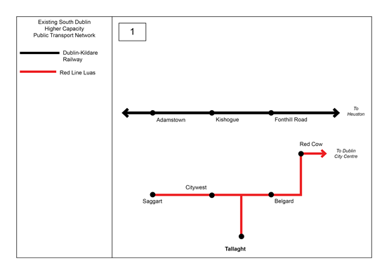

**44** Illustration 2 adds the current planned fixed high-capacity public transport network in SDCC. This comprises a direct Kildare Rail Line link to Connolly/Docklands via the Phoenix Park tunnel in the short term, with replacement by DART upgrade via the City Centre Interconnector in the longer term. It also includes a new BRT line from Tallaght to the City Centre and Clongriffen via Rathfarnham.

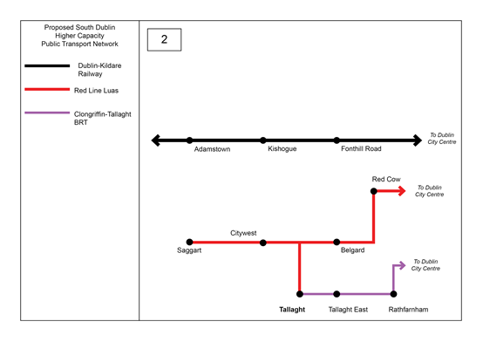

**45** Illustration 3 adds the previously proposed Metrowest line as a BRT or LRT line from Tallaght to Blanchardstown and Dublin Airport, via Clondalkin, Liffey Valley SC and Clonburris/Fonthill. It is considered that with sufficient priority and segregation including a public transport/pedestrian/cyclist bridge over the River Liffey Valley, this critical orbital link would be the first step in the formation of a public transport grid that would join all existing and planned radial routes and upgrades. This route could be developed in phases as the completion of Interconnector could make a Liffey Valley SC-Tallaght route alone viable.

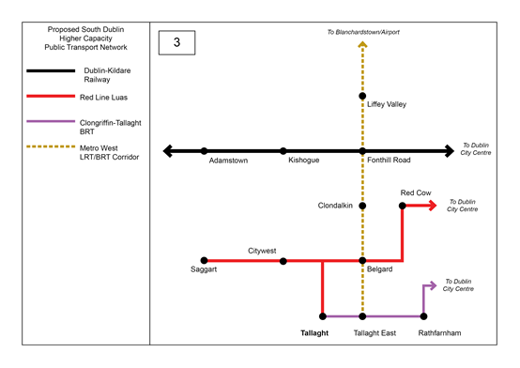

**46** Illustration 4 adds the previously proposed Lucan Luas line F as a BRT or LRT line from Lucan Shopping Centre at the northern end of the Adamstown SDZ, to Dublin City Centre via Liffey Valley Shopping Centre. If developed as a BRT line, this additional radial link could possibly use the existing Lucan QBC from the M50 to the City Centre, with improved segregation and priority where required. If the proposed orbital line in 3 above were to be developed on a phased basis initially from Tallaght to Liffey Valley SC, a suitable variation may be to continue this along the line of a Lucan-City Centre route westwards from Liffey Valley to Lucan north of Adamstown.

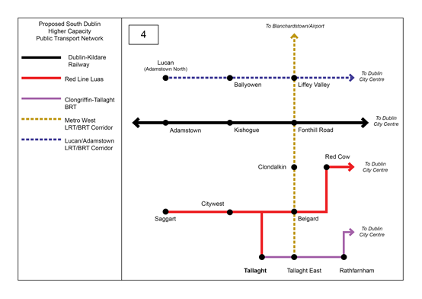

**47** Illustration 5 adds a new orbital link from Lucan as a BRT or LRT line to Tallaght via Kishogue, Grange Castle and Citywest. If developed as a BRT line, it may be possible to continue this route along the line of the planned Tallaght-Rathfarnham BRT to Dundrum and/or Sandyford, or alternatively to terminate the route in Tallaght and have a separate BRT line to Dundrum or Sandyford via the planned line to Rathfarnham.

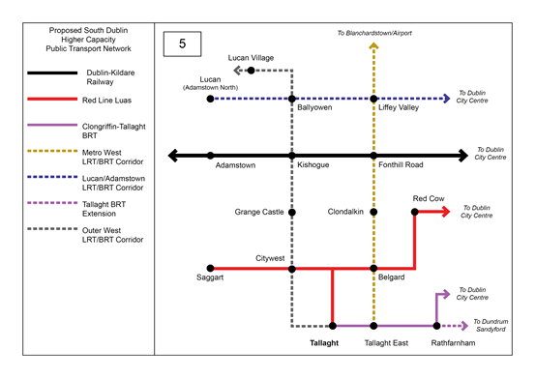

**48** Illustration 6 indicates a possible future scenario that allows for further orbital and radial links. It adds a new orbital link from Lucan north of Adamstown as a BRT or LRT line, south via Adamstown. This could be developed as an extension of 4 above or could form part of a new route or routes to Clondalkin, Saggart or Citywest/Tallaght or further afield via Peamount and Grange Castle. This illustrates that if an efficient, high capacity, public transport grid can be identified and established, opportunities for future extensions and links will become more apparent and can be integrated with future land use plans for delivery in tandem with development.

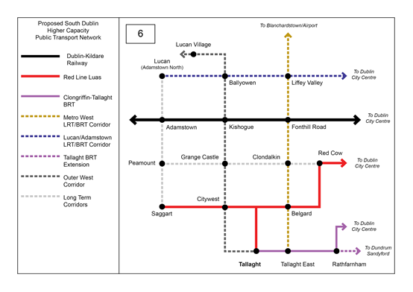

49 It will be important that the GDA transport strategy identifies future routes for new and extended strategic public transport as suggested above, but also addresses the need for new and improved public transport services generally, including improvements to the efficiency and flow of bus services via infrastructure and technology upgrades.

50 Other public transport related matters that should also be addressed to include the development of transport hubs at key locations (such as centres and where routes meet) to promote multi-modal interchange and the provision of Park and Ride facilities at appropriate locations, such as at transport nodes and along strategic transport corridors.

**Motor Vehicles:**

51 Improvements to the road network and some new roads will be required in SDCC in order to more efficiently manage traffic, provide access to new development areas and emerging communities and to support the economic development of the County (and in particular the movement of goods).

52 The principal strategic road network in the County comprises the N4, N7 and N81 forming three key radial routes and the M50, Newlands-Fonthill and Outer Ring Road forming three key orbital routes. The NTA, SDCC and TII should continue to work together to protect the capacity of these important strategic roads, including where necessary junction upgrades at key locations onto the network.

53 Given current and projected demand for orbital movement on the M50 and planned future population and employment growth in the County. The NTA, TII and M50 Concessions should progress innovative demand management measures on the M50.

54 SDCC would welcome the support of the NTA in assessing the potential to make changes to the N81 at a) from Tallaght Town Centre to the boundary of the County and b) on the section of the N81 at the Tallaght Town Centre, where there the Council believes there is the opportunity to:

• provide an improved physical environment that responds to Tallaght Town Centre

and recognises the role of Tallaght as the County Town.

• Improve connections across the N81 for pedestrian and cyclists.

55 Investment in active travel and public transport infrastructure should be at the top of the transport hierarchy. However, there will continue to be a need to invest in new road and street infrastructure. This will be of particular importance where new streets are needed to unlock brownfield land to support the delivery of new homes and employment space in line with the principles of compact growth.

56 The current GDA transport strategy and the SDCC’s County Development include an objective to deliver a new strategic Outer Ring road to provide further linkage to the N3 in the Fingal CC area to the North and to the N81 within SDCC. The Council would welcome further discussion on the need and benefits of this proposal as part of revisions to this Transport Strategy.

**Schematic Illustrations of possible Strategic Road Transport Routes:**

**57** Illustration 1 identifies the existing strategic road network in SDCC, the N4, N7 and N81 and the M50, Newlands-Fonthill and Outer Ring Road. Current main Town Centres, employment areas and development areas within the County are also illustrated.

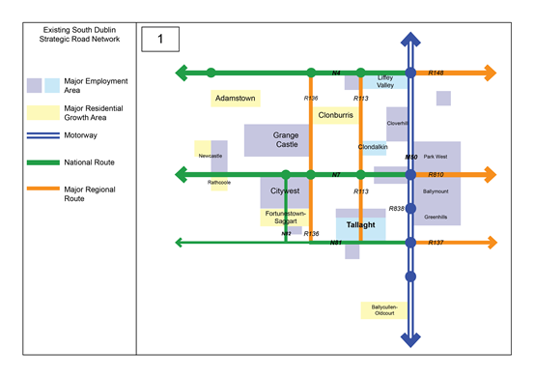

**58** Illustration 2 identifies proposed additions and improvement to the strategic road network in SDCC. This comprises the N4-N7 outer orbital, with links to the N3 in Fingal and N81 in SDCC. It also includes the proposed N81 upgrade from Tallaght to the County boundary (ultimately to Hollywood Cross in Co. Wicklow).

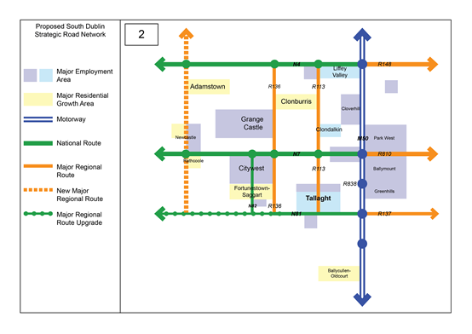

**Parking:**

59 SDCC acknowledges that there is a causal relationship between car parking provision rates and the number of vehicles attracted to the road network. The availability and cost of parking has a major impact on the traffic that is generated by a development and/or is attracted to an area. This requires a balanced approach that takes into account the individual needs of businesses and households, with the need to limit the impacts of traffic congestion and promote more sustainable forms of transportation.

60 To address this issue the GDA Transport Strategy should consider the need to limit the number of spaces to be provided for any given development according to need and ensure the efficient turnover of spaces.

61 The National Transport Authority (NTA) has published a set of standardised maximum parking rates for application in the Greater Dublin Area (GDA), via the Achieving Effective Workplace Travel Plans: Guidance for Local Authorities and Draft GDA Transport Strategy. These rates should be updated and include further guidance, for all land uses, on how these rates may be reduced in circumstances such as:

**•** The proximity of the site to public transport and the quality of the transport service

it provides (i.e. PTAL);

• The proximity of the development site to services that fulfil occasional and day to

day needs (i.e. ASOS);

• The existence of a robust and achievable Workforce Management or Mobility

Management Plan for the development;

• The ability of people to fulfil multiple needs in a single journey;

• The levels of car dependency generated by particular uses within the development;

• The ability of residents to live near the workplace and

• Peak hours of demand and the ability to share spaces between different uses.

**62** Provide guidance and clarity on the role and locations of future Park and Ride facilities.

63 Consideration should also be given to providing guidance on the quantum of bicycle parking required to service a development.

63 The NTA should also provide guidance on standards for EV Charging and Car and Bike Sharing.

Enforcement

64 The NTA should progress legislation with the Department of Transport to address and ensure robust enforcement is taken against illegal parking, and driving, in bus and cycle lanes.

**Monitoring**

**65** The GDA Transport Strategy should include additional guidance on:

• sustainable transport indicators, including a) targets for mode share that reflect the

differences between urban and rural authorities; and b) measures that would allow

Local Authorities to monitor the carbon reduction benefits of different transport interventions. Thiswould allow all authorities to monitor the policies and objectives of the Plan more effectively over its lifetime.

• Active Travel Plans and Traffic Management Plans

• Freight Management across the Dublin area

**Appendix 1: Development Areas:**

**1. Adamstown SDZ, Clonburris SDZ and the Wider Lucan/Clondalkin Area**

A key future growth enabler of the NPF is “Progressing the sustainable development of new greenfield areas for housing, especially those on public transport corridors, such as Adamstown, Cherrywood, Clonburris and Clongriffin”. The importance of these sites in delivering on the objectives of the NPF is further reinforced in the RSES and MASP as strategic development areas in the western suburbs, including Kilcarbery and the Lucan/Clondalkin area.

Adamstown SDZ has a total designated area of 223.5 Hectares with potential to accommodate up to 9,395 residential units (c.25,000 population equivalent). Home to a purpose-built train station since 2007, Adamstown will also provide for 127,000 sq. metres of non-residential floor space, a district centre, 5 schools, a primary health care facility, as well as two regional parks. A total of 4,405 residential units have been granted planning permission with 2,665 completed to date. 3no. schools and a supermarket have been completed to date. Phase 1 of the District Centre adjacent to Adamstown Train Station was recently granted planning permission, comprising of a mixed-use development of 278 residential units and 9,653sqm retail and food/beverage space.

Home to 23,000 residents when complete, Clonburris SDZ will deliver 9,000 new homes, 7,300 sq. metres of community floorspace, 90 hectares of parkland, 8 schools, minimum 5,000 sq.m of retail floorspace and 31,000 sq.m of employment floorspace. The Clonburris SDZ lands are traversed by the Grand Canal and the Dublin-Kildare Railway Line, including two train stations. Plans are advancing to activate construction of enabling infrastructure with a planning application recently lodged for the South Link Street and utility corridor due to be constructed within a two-year time horizon that will unlock the delivery of c.5,000 housing on the SDZ lands to the south of the railway line, which will be delivered over the next 7 years.

This area of West Dublin will continue to experience further major residential and non-residential development in particular at Kilcarbery, Grange Castle Business Park and Liffey Valley.

In meeting its obligations in accordance with Rebuilding Ireland, SDCC is leading the delivery of c.1,150 new homes at Kilcarbery, Clondalkin, a site to the south of Clonburris SDZ. Furthermore, there are 11 infill serviced sites in the Clondalkin area which have capacity to provide for 2,082 residential units.

Grange Castle Business Park is a strategic employment/mixed-use area as per the MASP and a key enabling infrastructure identified in the MASP is public transport and access. Home to some of the world’s largest companies in the pharmaceutical, research and development and information technology sectors, who have chosen this location to strategically locate their multi-billion-euro facilities. There are currently 2,500 people employed on the campus. A variation to the South Dublin County Development Plan in 2018 extended the spatial footprint of the Business Park to the west by 193 hectares, which can support up to 10,000 new jobs in the area.

Liffey Valley Shopping Centre is a Major Retail Centre and Level 2 Major Town Centre in the retail hierarchy of the RSES with a floor area of 71,000 sq. metres. Planning permission is currently being sought for retail floorspace extension of 46,783 sq. metres, which will create up to 450 new jobs when operational. Planning permission is in place for a Transport Interchange within the Liffey Valley Shopping Centre campus which will serve an essential function in the wider bus network and the NTA’s Bus Connects project.

In light of the significant level of development that is going to take place in these areas in the short-to-medium term as outlined above, public transport investment in rail, bus, cycling and walking infrastructure will be a prerequisite in ensuring these areas align with national policy in creating sustainable neighbourhoods where there is an integration of land-use and transportation.

**2. Tallaght**

Tallaght is identified in the MASP as a strategic development area for residential and employment growth through regeneration of older industrial brownfield lands at Tallaght Town Centre/Cookstown for more intensive mixed-use development. The Tallaght Town Centre Local Area Plan 2026 (‘the Tallaght LAP’) was prepared in this regard, recognising the significant development potential of these lands to implement the policies and objectives of the RSES and NPF.

In the 6-year period to 2026, the Tallaght LAP provides for between 3,500-5,000 new housing units, the potential for significant additional non-residential floorspace through more intensive employment, commercial and industrial uses, new schools and public services. The LAP also provides the blueprint for regeneration of these lands over the longer term (c.20+ years) with potential to accommodate up to 11,000 new residential units (c.27,700 population equivalent) and up to 1 million sq.m. of non-residential floorspace. Key to the realisation of the short-term development potential of these lands are the implementation of the Transport Interchange adjacent to the Tallaght Luas Stop, BusConnects, enhanced orbital and local bus services and improved pedestrian and walking networks, including permeability measures within the LAP area and to neighbouring areas. In addition to these measures, increased capacity and frequency in the Luas service will need to be provided to coincide with the incremental build-out of the Local Area Plan lands.

**3. Citywest/Fortunestown**

The area covered by the Fortunestown Local Area Plan 2012 comprises c.144 hectares of lands dissected by the Luas Red Line to the west of Tallaght, east of Saggart Village and south of Citywest Business Park. Fortunestown is identified in the MASP as a strategic development area: “a new district near the merging town of Citywest/Saggart”. As of Q1 2020, a total of 3,488 residential units (c.9,400 population equivalent) had been granted planning permission in the LAP area with 814 units completed and 701 units under construction. There were ongoing pre-planning discussions at that stage in relation to proposals for 1,430 further residential units. Citywest Business Park is also an established major employment centre.

**4. South West City Corridor**

There is major demand for long-term sustainable transport solutions to serve the south-west of the city and suburbs. This corridor broadly includes the existing suburban residential areas of Harold’s Cross, Kimmage, Terenure, Rathfarnham, Knocklyon, Firhouse, Ballycullen/Oldcourt and South Tallaght. Car use in this corridor is high and it is not served by a major transport route, road or public transport service and generally experiences high levels of private motor traffic with piecemeal bus corridors and local bottlenecks. Excluding Tallaght, the current South Dublin County Development Plan core strategy identifies development potential of c.9,620 residential units on infill serviced sites within the M50 and at Ballycullen/Oldcourt, primarily within this corridor.

It is acknowledged that there are existing constraints on this corridor in terms of high-capacity public transport intervention as there are no existing railway lines, or multi-lane roads and much of the area has developed over time as expanding suburban neighbourhoods. Nevertheless, possible high-capacity public transport solutions should be assessed as part of the revised Transport Strategy, considering potential to link in with other major population centres, such as Tallaght.

**5. Other Areas**

In addition to the above, in delivering South Dublin County Development Plan’s core strategy, there are a number of other residential and mixed-use infill sites available in the County which will require enhanced public transport and investment in sustainable modes of transport.

The core strategy identifies potential for major residential development in Rathcoole (1,062 residential units) and Newcastle (701 residential units). Much of this development potential has been borne out by planning permissions granted and commencement of construction. As well as residential development there has been major non-residential development at Greenogue Business Park at the edge of Newcastle, which has experienced a significant expansion of industrial, warehouse and commercial facilities in recent years. More direct bus services to Dublin City Centre and major employment, population and retail centres would ensure the sustainable development of these areas.

**END.**