**Local Authority Climate Action Training Programme**

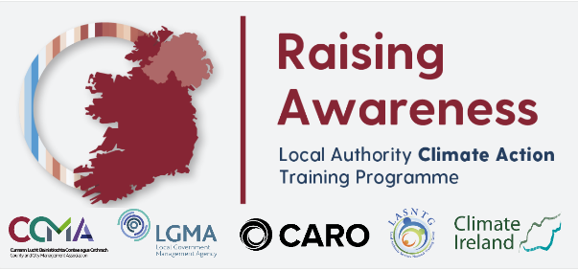Action 150 of The National Climate Action Plan 2019 ‘To Tackle Climate Breakdown’ calls to ‘Support the development of Local Authority climate action leadership and capacities’. To facilitate the delivery of this action, the County and City Management Agency, Climate Action Regional Office, and Climate Ireland developed a Local Authority Climate Action Training Programme to be delivered to all 29,000 Local Authority staff and elected members throughout 2021. Training will be made available through an online platform to staff in groups starting with grade 7s and analogous grades in January/February.

The suite of training pillars identified in the short term under the Local Authority Climate Action Training Programme stems from an immediate requirement to develop climate action capacity to deliver on the actions of the adaptation strategies/action plans and to begin to promote positive influence across and functions and activities performed by local authorities. Training will be provided to all staff and elected members across the following framework:

* Elected members and senior staff – Championing Leadership - training to harness the leadership role of local authority elected members and senior staff in driving climate action
* Climate Action Teams – Building Capacity - training to build capacity of climate action teams to deliver local climate action measures across all local authority functions
* Indoor staff – Raising Awareness – online training to raise awareness of the role of local authorities in leading on climate action at local and community levels
* Community facing roles – Empowering Communities - training to empower local authority staff to promote and encourage climate action across local communities
* Outdoor staff – Actioning Policy - training to mobilise local authority staff to implement practical outdoor climate action measures
* Targeted training – Implementing Action - training specifically targeted to embed climate action into particular local authority functions.

All staff are required to complete the training, which aims to increase knowledge, understanding and awareness of global climate change and what it means for Ireland, for Local Authorities and for our citizens. The course is expected to take between 2 – 2.5 hours to complete. Notification and instructions on how to set up and complete the training will be forwarded to participants in advance. On completion of the course, participants will be awarded a certificate.

**Local Authority Climate Action Training Programme.**

