"This Area Committee acknowledges the recent flooding in Corkagh Park and how the overflow drain on the West and North sides of the GAA pitches in Clondalkin Park has been engaged, and calls on the the Drainage Section of South Dublin County Council to brief members on the functioning of flood controls on the parts of Clondalkin that are in the Camac flood basin."

**Reply to the Motion**

**Background to the current situation**

Currently many rivers in country including Dublin are at an elevated level, these are shown in yellow in the map below. This means that rivers are approach or at bank full conditions.

Soils are also saturated following a very wet January.

Recent Met Eireann flood forecasting update:

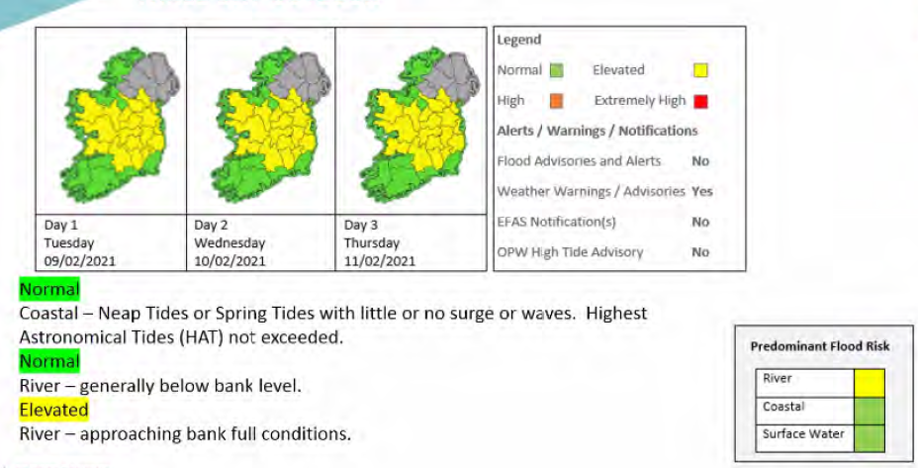

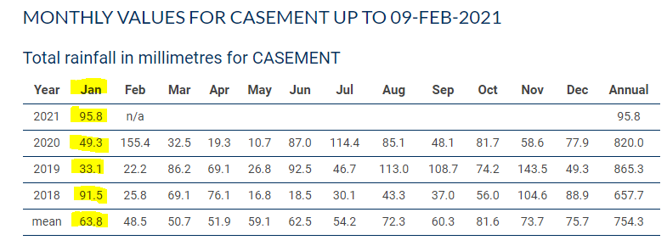

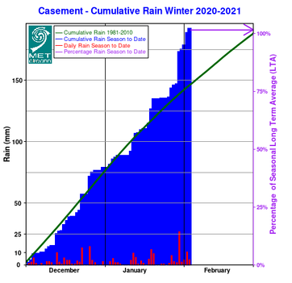

January rainfall was 95.8 mm measured at Casement and is the wettest January in the past four years and well above the monthly mean for winter months. The cumulative rainfall this year is already at 100% of the long run average. This has led to saturated soils and hence there has been ponding and some of the management systems such as described below have come into use.

**Camac Catchment**

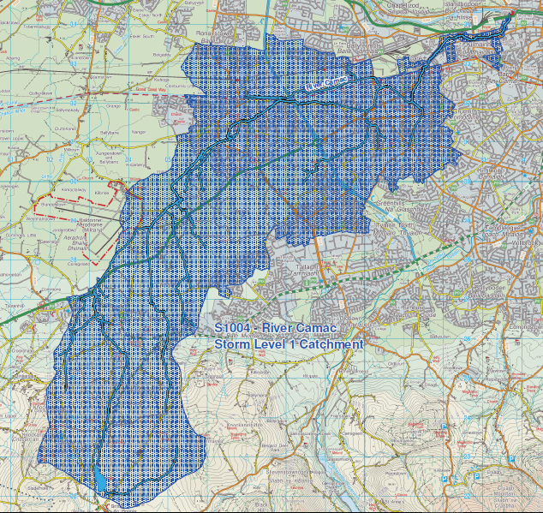

**Camac Improvement Scheme Phase 1 - 1993-4**

The Camac Improvement scheme Phase 1 commenced in 1993/94 and was designed to protect houses in Cherrywood which had a history of flooding.

The scheme consisted of berms built within the park at the boundaries to protect the homes. It also consisted of a new conveyance channel and a culvert under the Fonthill Road, This conveyance channel and culvert allowed for the controlled management of flooding, it attenuation in open space in the park, acting in a natural way like a flood plain and hence protecting homes and residents. A point of controlled overflow from the Camac was also created and this feed the conveyance channel and allowed the Camac to flood in a controlled way at times of high water levels. Previously the Camac would have burst its banks in an uncontrolled fashion and had flooded homes and other premises.

The flow path of the scheme in uses is shown below, point A is the overflow point.

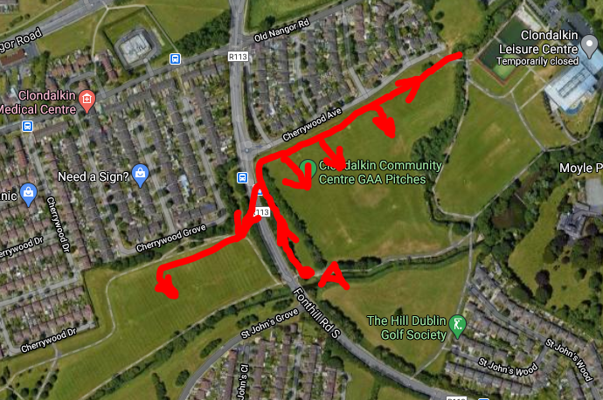

The drawing below shown the extent of the flood in a 1:100 and 1:1000 year flood. All of the neighbouring houses are outside the flood zone due to this scheme.

