**Comhairle na nÓg Report January 2021**

**Overview**

Comhairle na nÓg are local youth councils based in the 31 local authorities in Ireland. They are designed to give young people aged 12-17 who are not yet able to vote a voice in the services, policies and issues that affect them in their local area. Comhairlí are youth led and participation is voluntary.

Each local authority is required to facilitate the running of Comhairle under the auspice of the Department of Children, Equality, Disability, Integration and Youth, and operating under set guidelines and youth participation principles.

**2021 Topic and Work to Date**

The topic for the Comhairle this year is Climate Change, with an emphasis on Mental Health and what young people can do to feel that they have agency to affect change, as many young people feel significant levels of anxiety and helplessness around the issue. We have a secondary topic of Covid 19 and Mental Health, as this is obviously a pressing issue in the current climate.

The Comhairle have been working with Darby Mullen, the Senior Executive Engineer with responsibility for Climate Change. The SDCC Climate Change Action Plan 2019-2024 states the intention to work with the Comhairle;

“The Council aims to develop further links with younger citizens in enhancing climate change awareness and developing educational initiatives in partnership with schools and youth organisations such as Comhairle na nÓg”

Darby has been working with the Comhairle on a project promoting Biodiversity and Sustainable Transport; a planter filled with pollinator friendly plants which doubles as a bicycle rack. It is hoped that these will be installed in at least two locations in the county. Darby is liaising with the Roads Department, as they had a similar project in mind so there may be opportunity for collaboration. Teresa Walsh is aware of and supportive of this work.

The topic of Climate Change lends itself very well to the structure of Comhairle, because as a Council we have the means and resources to positively affect the outcomes. It is also of value to SDCC in that they represent the voices of young people in the county who do not yet have the vote. Prior to the pandemic, members of the Comhairle were involved in the promotion of World Water Day with the Climate Change office. Fionnghuala Ryan, the new Climate Change and Environmental Awareness Officer is also keen to work with the young people in Comhairle.

Every Dublin Comhairle has chosen the topic of Climate Change and it is also the topic for the Comhairle na nÓg National Executive. Due to the prevalence of Climate Change as an issue for young people, the Dublin Climate Action Regional Office (CARO) is working with each Comhairle, with the hope that the four Dublin Comhairlí can work on a combined initiative.

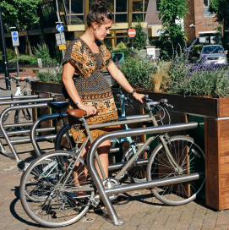

***Example of planter/bike rack***

Obviously, the pandemic and lockdown has curtailed the work plan of the Comhairle, and the switch to online communication only has affected the quality of engagement with the young people. However, towards they put together two videos, one of things the members are doing to maintain their wellness with the hashtag #staysafe and the other on how to construct a bug hotel;

[https://www.instagram.com/tv/B-hou0DnIQW/?igshid=1s7w44czprwr3](https://eur04.safelinks.protection.outlook.com/?url=https%3A%2F%2Fwww.instagram.com%2Ftv%2FB-hou0DnIQW%2F%3Figshid%3D1s7w44czprwr3&data=02%7C01%7Csclarke%40sdublincoco.ie%7C0cc6e0359e384f12d41708d8296edc90%7C6a3c00c019d0492da8de95fad8fda1d4%7C0%7C0%7C637304903987207023&sdata=z9tPIo99I9pbTOhm0OJGnBif28joD5xJpNLRv0vmj44%3D&reserved=0)

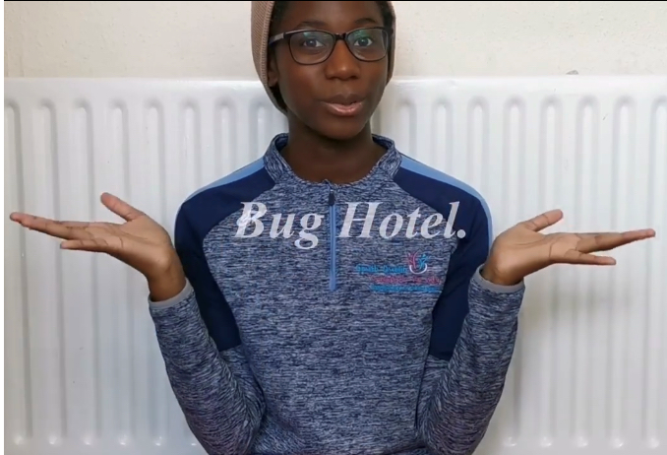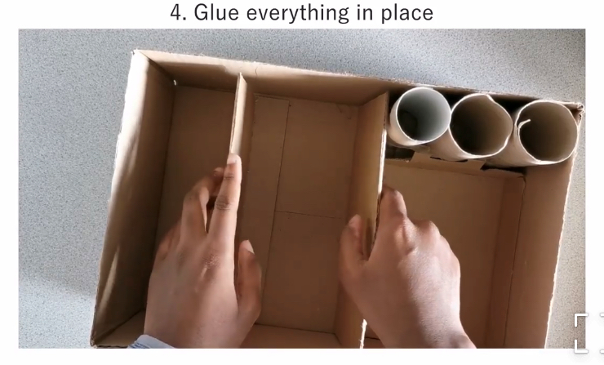

***Bug hotel video***

**Membership**

All 38 secondary schools in the county are contacted in advance of the AGM requesting them to send a max of four delegates to the AGM, two from the junior and two from the senior cycles. Youth Services are also contacted. Participation by the schools in the AGM is voluntary. At the AGM, delegates are asked to express their interest in joining Comhairle and are contacted afterwards and invited to an initial meeting in November when Comhairle in general and the topic is discussed.

While every effort is made to ensure a geographical spread across the county, integration into schools is often dependant on teachers and principals who are interested in youth participation committing to sending a delegation to the AGM, and also the interest of the young people themselves as participation is voluntary.

The new 2021 Comhairle has 26 members who come from the following schools/youth services:

* Adamstown Community College
* Firhouse Community College
* Greenhills Community College
* Loreto High School Beaufort Rathfarnham
* Lucan Youth Service
* Mount Seskin Community College Tallaght
* St Joseph’s College Lucan
* St Mark’s Community School Tallaght
* St MacDara’s Community College Templeogue
* St Paul’s Secondary School Greenhills
* Tallaght Community School

**Local Breakdown**

In relation to this electoral area here are the figures for the young people on the group

2019-2020 Comhairle member –

* 2 from Lucan
* 6 from Clondalkin

2020-2021 Comhairle –

* 5 from Lucan

We had our first meeting in early November and the took part in the National Showcase. The new Comhairle is due to meet again in January for team building and will then elect officers and start to work on the topic.

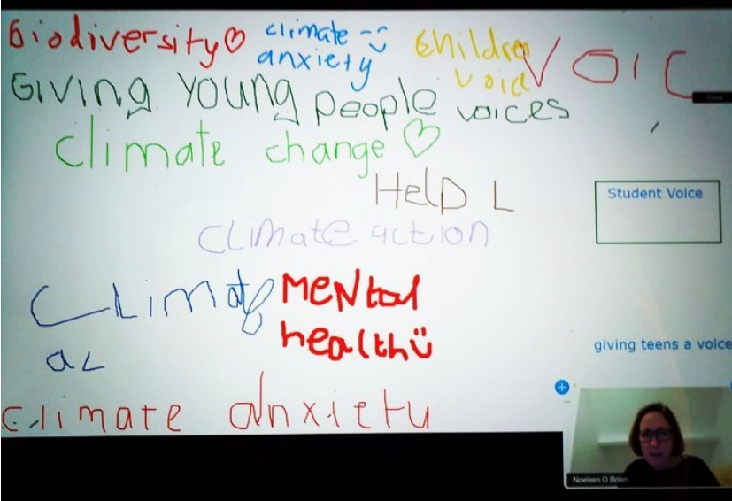 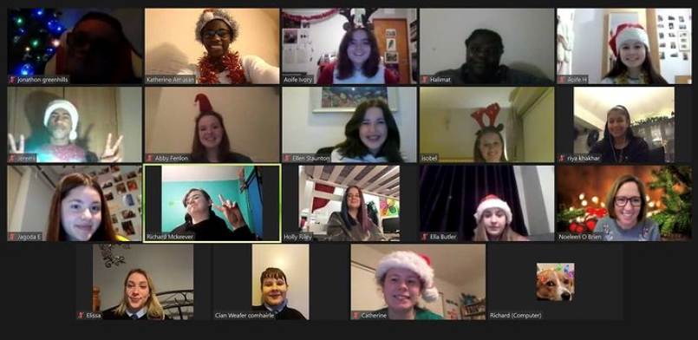

***First meeting of South Dublin Comhairle 2021***

**Facilitation**

Facilitation services are provided by Foróige Youth Services Tallaght. One youth worker co-facilitates Comhairle meetings with the SDCC Community Worker in order to ensure correct ratios for Child Protection. Foróige provides additional youth workers for the Annual General Meeting.

**AGM**

The AGM usually takes place in a hotel or public building with good transport links. All 38 secondary schools are invited to send four representatives to the AGM, two from the junior cycle and two from the senior cycle.

The 2020 AGM took place via Zoom this year and was very well attended, with over 60 young people taking part. Fionnghuala Ryan the Climate change and Environmental Awareness Officer spoke about the Climate Action Plan for South Dublin, and Anja Murray from RTE’s Ecoeye spoke about Climate Change and Mental Health and what young people can do in their own lives to feel that they are making a difference. The delegates were able to ask questions and these topics will form the basis of their work for 2021; both Fionnghuala and Anja are happy to link in with the Comhairle throughout the year.

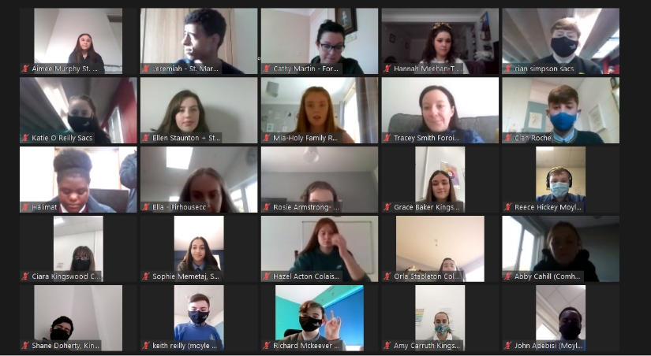

*South Dublin Comhairle 2020 AGM*

**Comhairle na nOg Intergenerational Work**

2020 say South Dublin comhairle members, as part of Social Inclusion Week, take part in an Intergenerational work shop with South Dublin Age Friendly Alliance. Topics discussed at this workshop were Managing during Covid 19 Lockdown, Mental Health Issues and what issues are being faced by older/younger people in our community. Both groups have indicated they want to have more of these during 2021 and they will be facilitated by us.

**Comhairle na nÓg Nationally**

Each Comhairle sends a representative to the National Executive which works on a topic nationally, this year they have chosen Climate Change. The Comhairlí attend the Dáil na nÓg every second year, and the National Showcase on alternate years. Having attended the Dáil na nÓg in the Dáil last November to commemorate the centenary of the first sitting, the Comhairle took part in the National Showcase last November via Zoom.

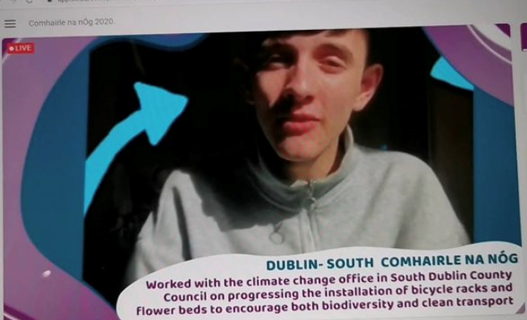

***South Dublin Comhairle represented at the National Showcase.***

**Steering Committee**

The Comhairle na nÓg Steering Committee is a committee made up of key stakeholders and decision-makers, oversees Comhairle na nÓg and is a vital component of a successful Comhairle. The committee is coordinated by SDCC Community Worker. The Committee is designed to advise and assist the Comhairle na nÓg Coordinator in organising the Comhairle’s workplan throughout the year. The role of the Steering Committee includes ensuring that:

* the Comhairle na nÓg is formally connected to local decision-makers and key stakeholders in the area, particularly in relation to the topic(s) being worked on by the Comhairle na nÓg in any given year;
* the Comhairle na nÓg has an opportunity to influence decision-making and service development that will affect young people in the City/County;
* organisations representing seldom-heard young people are engaged in the process and can contribute to all aspects of the Comhairle na nÓg;
* the Comhairle na nÓg is promoted and championed in every key local agency in the area.

The current members of the Steering Committee are;

* Members of Comhairle na nÓg
* CYPSC
* PPN
* CARO
* LCDC
* Foróige
* Crosscare
* SDCC Climate Change and Environmental Awareness Officer

Department of Children, Equality, Disability, Integration and Youth have written to every council emphasising the importance of the Steering Committee and the need for relevant bodies such as the LCDC and PPN to be members in order to fulfil its stated aims.

**Programme for Government**

The new Programme for Government has an emphasis on the importance of the participation of young people in decision making processes at all levels of government;

* Seek to increase funding for the national network of Comhairle na nÓg.
* Publish and implement a successor to *Better Outcomes, Brighter Futures: The National Policy Framework for Children and Young Peopl*e and will develop mechanisms, through a new youth strategy, for the voice and views of young people to be part of decision-making at community, county and national levels.
* Ensure a comprehensive national consultation with young people, as to how better their voice can be heard and the issues that they want their Government to focus on for their future. We will develop a new National Strategy on Children and Young people’s Participation in Decision-making 2021-2025.

-----------------------------