# Climate Innovation Fund – Projects Progressed to date and Planned for 2021

# Introduction

The Climate Innovation fund was established by South Dublin County Council in 2019 as a seed fund source for innovative pilot projects that would prove beneficial towards action against climate change. Projects seeking funding are required to align with actions identified in SDCC’s Climate Action Plan 2019-2024.

Staff throughout the organisation were invited through the Climate Action Teams to submit proposals for funding for innovative projects.

# Projects Completed

Funding was approved for the following projects;

* ECO Driver Training €2,400. ECO driver training is an advanced programme developed to train participants on driving techniques that will reduce engine emissions, reduce wear and improve road safety. The programme was run as a pilot course in 2019.
* EV Charging infrastructure at Kiltipper Park €10,000. As part of the development of car parking at Kiltipper Park, SDCC installed underground service ducts and equipment that will facilitate future Electric Vehicle Charging.
* 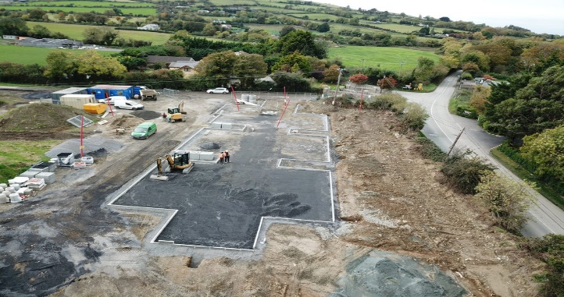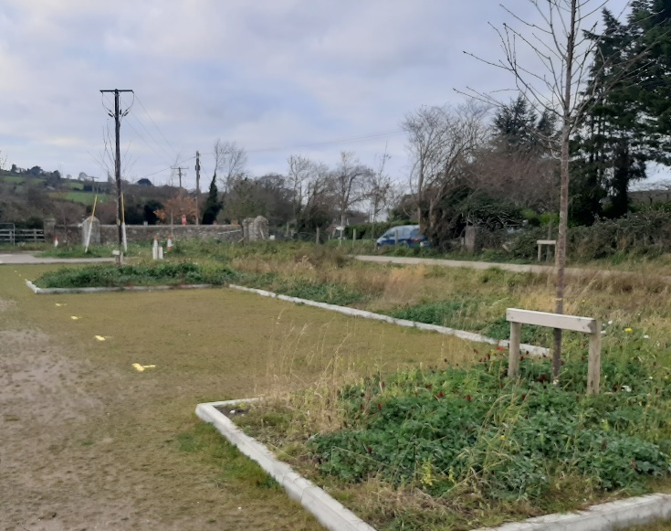SuDS Project at Kiltipper Park €57,635.87. As a pilot SuDS project approximately 700m2 of porous paving surfacing was installed in Kiltipper Park public car park. The porous paving is complimented by a secondary swale system with a mix of suitable planting to manage water runoff.
* Drinking water stations, in 2019/2020 €59,152.29 & €54,752.50 respectively was provided for the installation of drinking water fountains at strategic locations. The drinking water fountains were placed in prominent locations in village centres and parks to encourage active travel and to reduce the amount of single use plastic bottles. The water fountains have provided in excess of **42,000 litres** of water to citizens since they were installed, this is equivalent to **84,000 plastic bottles**(500ml).

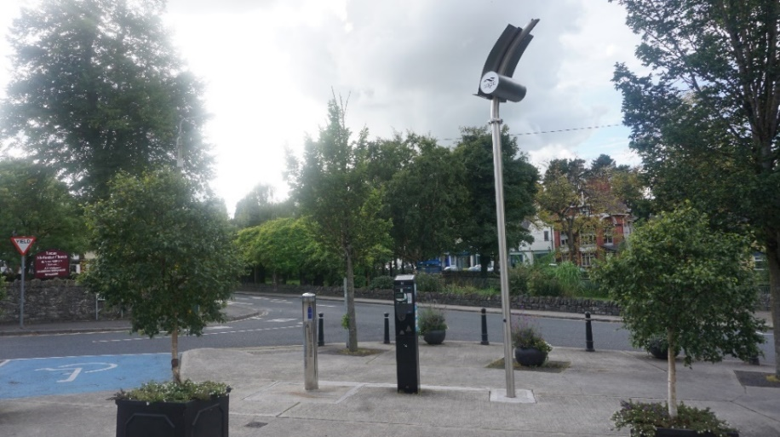

* Climate Change Action Plan Promotional Video €6,826.50. To promote the launch and augment awareness of the SDCC CCAP, a series of climate action videos were produced and circulated on social media. The short clips highlighted the 6 key action areas of the CCAP and showcased the ongoing adaptation and mitigation works. The video can be found at this link: <https://youtu.be/RAqwDULMTU0>

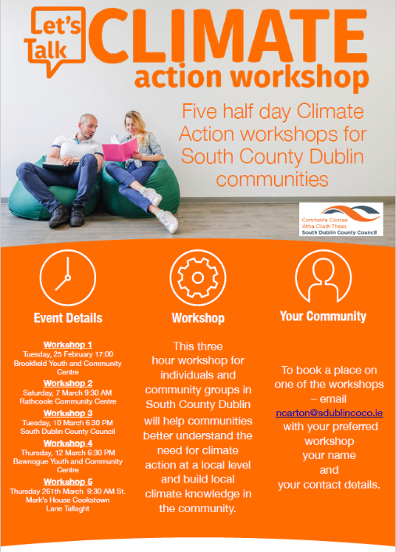

* Climate Change Community Workshops €3,690. A series of 5 Climate Change workshops designed for community groups was delivered in 2020. The workshops presented participants with information and tools on how to make personal lifestyle changes to reduce and negate the impacts of Climate Change on their communities. The workshops were delivered in person at community venues prior to Covid-19 and subsequently were delivered online. One of the workshops was delivered as part of the social inclusion festival. The workshops presented community groups with opportunities to network and share ideas and experience.
* Rehabilitation of Rural Hedgerows €40,000. This project was developed to re-establish the native hedgerows in Kiltipper Park. It is vitally important that we maintain and protect our native hedgerows. These hedgerows are corridors for the movement of wildlife and the protection of biodiversity. The Green Infrastructure Strategy is mapping this type of infrastructure to help ensure its protection and the Climate Innovation fund has also made a contribution to this Strategy
* Roadside Pollinator bulb planting €35,000



These projects are huge biodiversity gains for the county helping pollinators and align with the policies in the Climate Change action plan, the Biodiversity Action plan and the National Pollinator Plan.

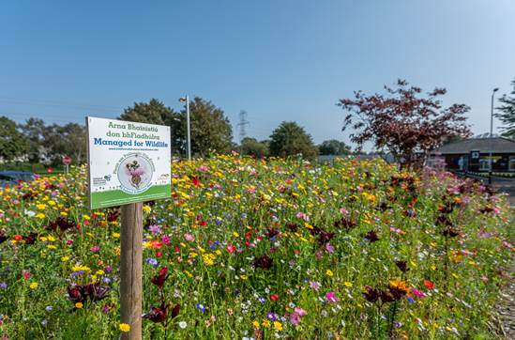

# Projects in progress

* Grand Canal Lighting upgrade €50,000, this project will progress in 2021.

* Regional EV Charging Strategy €12,300 – Report issued to the 4 DLA’s
* 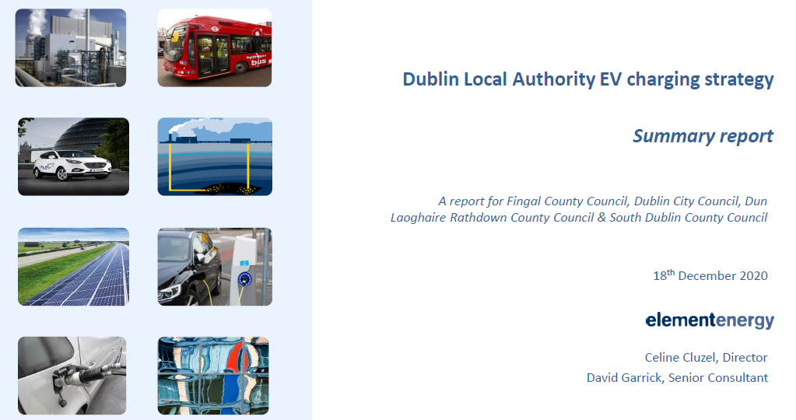
* Green infrastructure Strategy Contribution €25,000 – Work is progressing

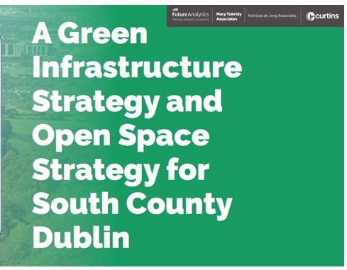

* SuDS Guidance documents and training €25,000- Consultant engaged in January’21
* Citizen Engagement Workshops €20,000 – Progressing in 2021
* Sustainable Business Training Programme €24,231 – Tenders complete

# Climate Innovation Fund 2021

A further €300,000 was provided for in the 2021 budget adopted by Council through the budget process. Proposals for the following works are under consideration

* Grant support to community groups e.g. Tidy Towns. Proposal to support climate action projects at community level. A prize fund of €15,000 would be awarded to the winning projects.
* Sustainable Business Grants. €50,000 prize fund to support innovative business ideas.
* Sustainable Energy Communities €30,000, seed funding support for 3 suitable projects identified under SEC energy masterplans.



* Climate Action Awareness video. €7,500. An update on the CCAP actions and progress being made, highlighting different themes including energy projects and biodiversity.
* 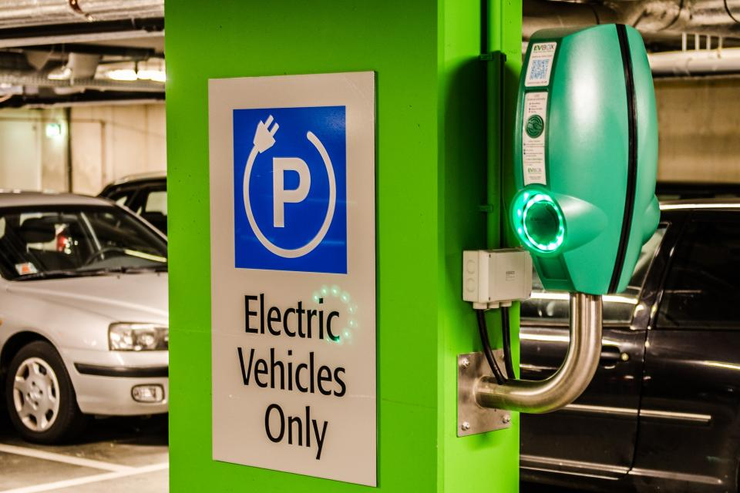EV Charging Infrastructure. €145,000, as a pilot project to install EV charging facilities at suitable locations, (On Street or SDCC facilities)
* Climate Action Website €10,000, it is proposed to update the Climate page of the SDCC website in order create a “one-stop” portal for citizens to engage on all aspects of Climate action, in areas of mitigation, adaptation biodiversity and sustainability.
* Circular Economy training €7,500. Current economic model is based on a linear ‘take-make-waste’ approach, which is costly for businesses and bad for the environment. By contrast, a circular economy is efficient and environmentally sustainable. In a circular economy, products, components and materials are kept in use for as long as possible. Supply and production chains operate in ‘closed-loops’ making them less wasteful and more resilient. New business models based around leasing, re-manufacturing, recycling and upcycling become possible, saving businesses money and reducing environmental impacts
* 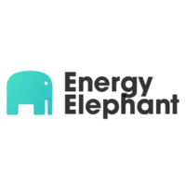Energy Elephant. €15,000. Energy elephant have been awarded a two year contract (€30,000 total) with SDCC to install a full energy monitoring and management system. The project is currently in set-up phase. Once up and running this will be an invaluable tool to monitor in real time the energy performance of the council and to target areas for investment and energy saving.
* ISO 50001 Certification - €20,000. ISO 50001 is a voluntary energy management accreditation programme by the International Organisation for Standards. The standard aims to help organisations continually reduce their energy use, energy costs and greenhouse gas emissions.