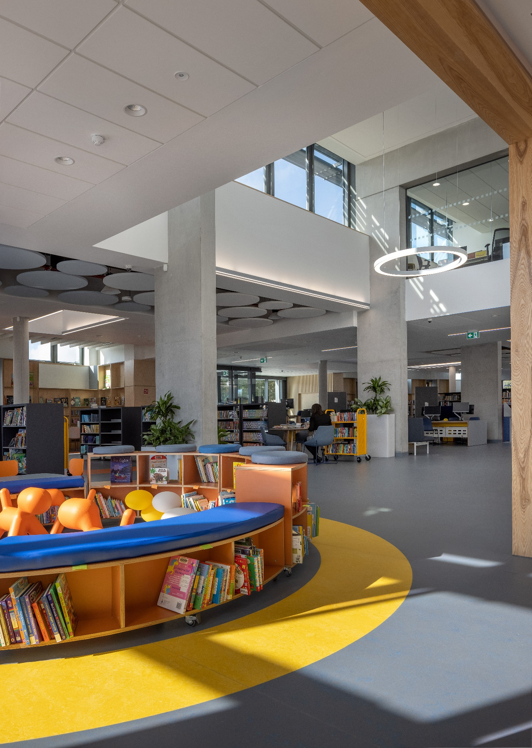

**North Clondalkin Library (NCL)**

In 2019-2020 prior to the opening of NCL, a large programme of engagement took place in the area to raise awareness of and a demand for a library service. Contacts were made with creches, primary and secondary schools in the locality. Links were established with local community groups, other agencies and local education and training boards.

Having received funding from Creative Ireland and from central Government (Dormant Account Funding), a programme of events was successfully organised. Examples of successful events included:

* Rowlagh Community Centre: Cruinniú na nÓg (June 2019), which saw a day long programme of STEAM events for 8-12-year olds.
* Primary and Secondary schools: STEAM events
* Balgaddy Child and Family Centre: The Humans of Balgaddy Project -A Creative Writing project with residents with Peter Varga (The Humans of Dublin) -which resulted in the production of a book.
* Culture Night: Rowlagh Parish Centre

North Clondalkin Library opened its doors to the public on 1st December 2020, and 3,581 people visited the library in the lead up to Christmas. The completed library, placed in the heart of the community will be a source of community development, and a significant resource for learning and exploration. There is an adult, young adult, and a children's library as well as community meeting rooms. Books, DVDs, CDs, newspapers, and magazines will be available for borrowing, with free access to the Internet and Wi-Fi. Computer classes will be offered as well as online information and resources. Hublets (tablets) that can be used in the library are availab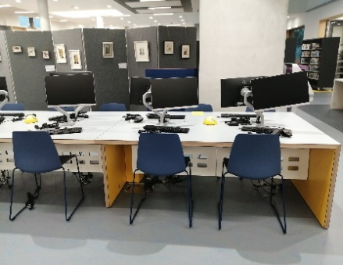le for adults and child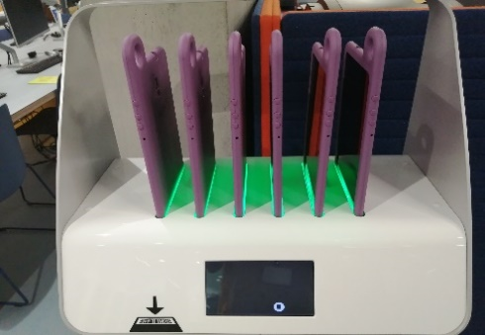ren.

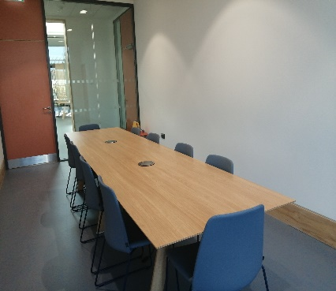 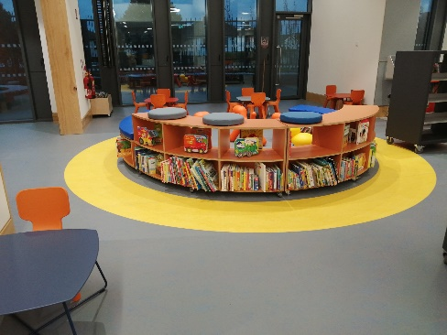

The Ground Floor accommodation plan includes:

* Large Library Hall accommodating all age groups and library activities
* IT Training Room
* Conference Room
* Small Meeting Room for book-clubs and community groups
* Protected Gardens for Library use

An extensive programme of events for children and families will include school class visits, Parent and Toddler Groups, Book Festival events, summer reading events and much more.

The new library will be a place to meet, learn, explore, and discover. It will provide lifelong learning opportunities in areas such as reading, numeracy, creative writing, health matters, local history and arts and crafts.

The library continues to engage with groups in the locality during covid-19 level 5 restrictions with online services and online outreach events. A promotional campaign is anticipated to promote the new library once restrictions are lifted and services can be expanded.

**Cas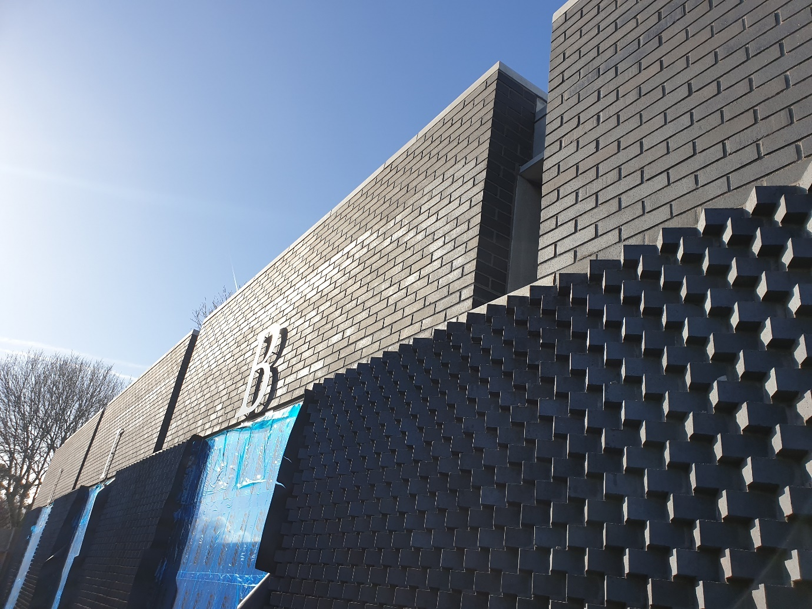tletymon Library**

Castletymon Library is in the final stages of construction completion. A significant number of snags remain outstanding. We expect these will take approx. 1 month to complete once the COVID-19 restrictions are lifted. During the COVID-19 lockdown, the contractor will be working on completing the BCMS certification and other paperwork required to support completion.

Based on the above, if the restrictions are lifted in early March, as per the tentative government plan, we would expect Substantial Completion to be issued in April 2021. If the restrictions are extended for a further period beyond this date, the date of Substantial Completion will correspondingly be delayed by this additional time.

The furniture for the new library was ordered before Christmas and we are awaiting a programme for delivery. We expect the delivery programme to be in the order of 8-10 weeks with a projected delivery date by the middle of March. The anticipated opening of the library will towards the end of Q2.