Lucan ACM Motion:
The Newcastle Road has been identified with an unprecedent number of exits and entrances in previous meetings and discussions. Given there is development currently in progress along the Newcastle, and knowing there's future development planned along the Newcastle road this committee requests the Chief Executive to report on the current number of exits and entrances. To confirm the additional ones planned along the Newcastle road and to provide a map indicating all these exits/entrances both existing and planned. This report will provide a discussion on the traffic lights, pedestrian crossings etc along this road and inform the members of any future traffic junctions and/or road amendments.
1no. V Entrance
4no. V Entrances
3no. V. Entrances
8 no. V. Entrances
5no. Vehicle Entrances
N4 National Road
Section 1: Existing Vehicular Entrances
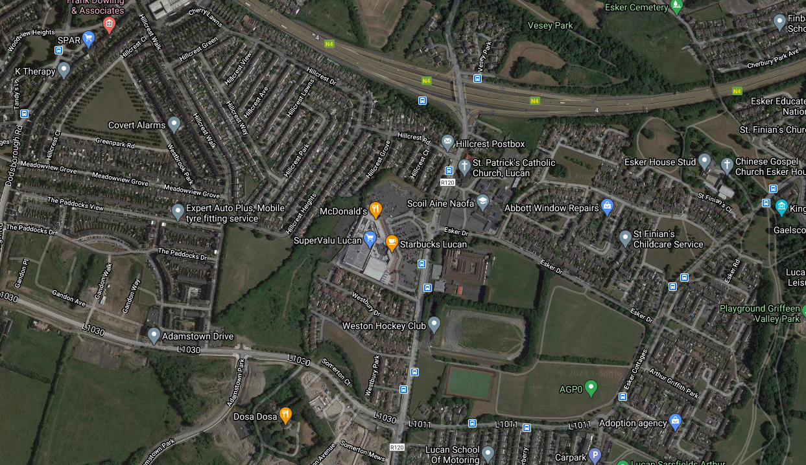
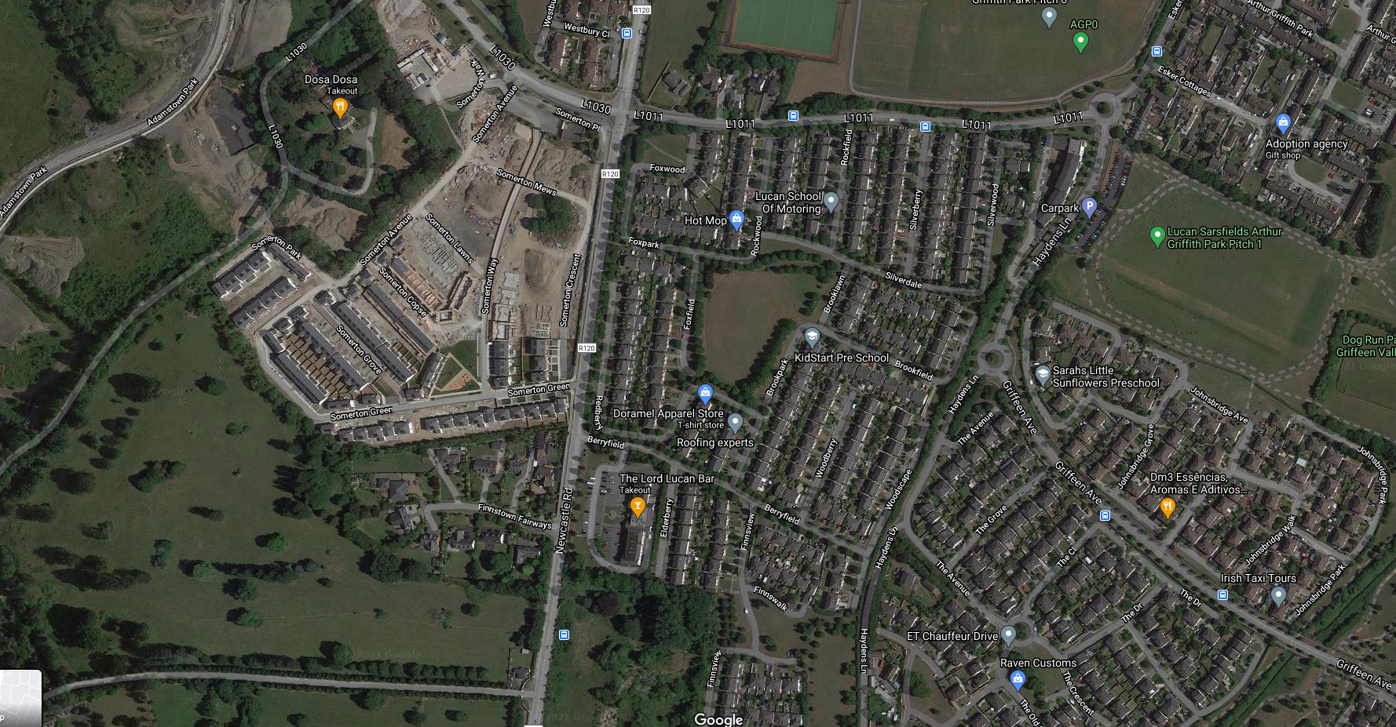
2no. V. Entrances
4no. Vehicle Entrances

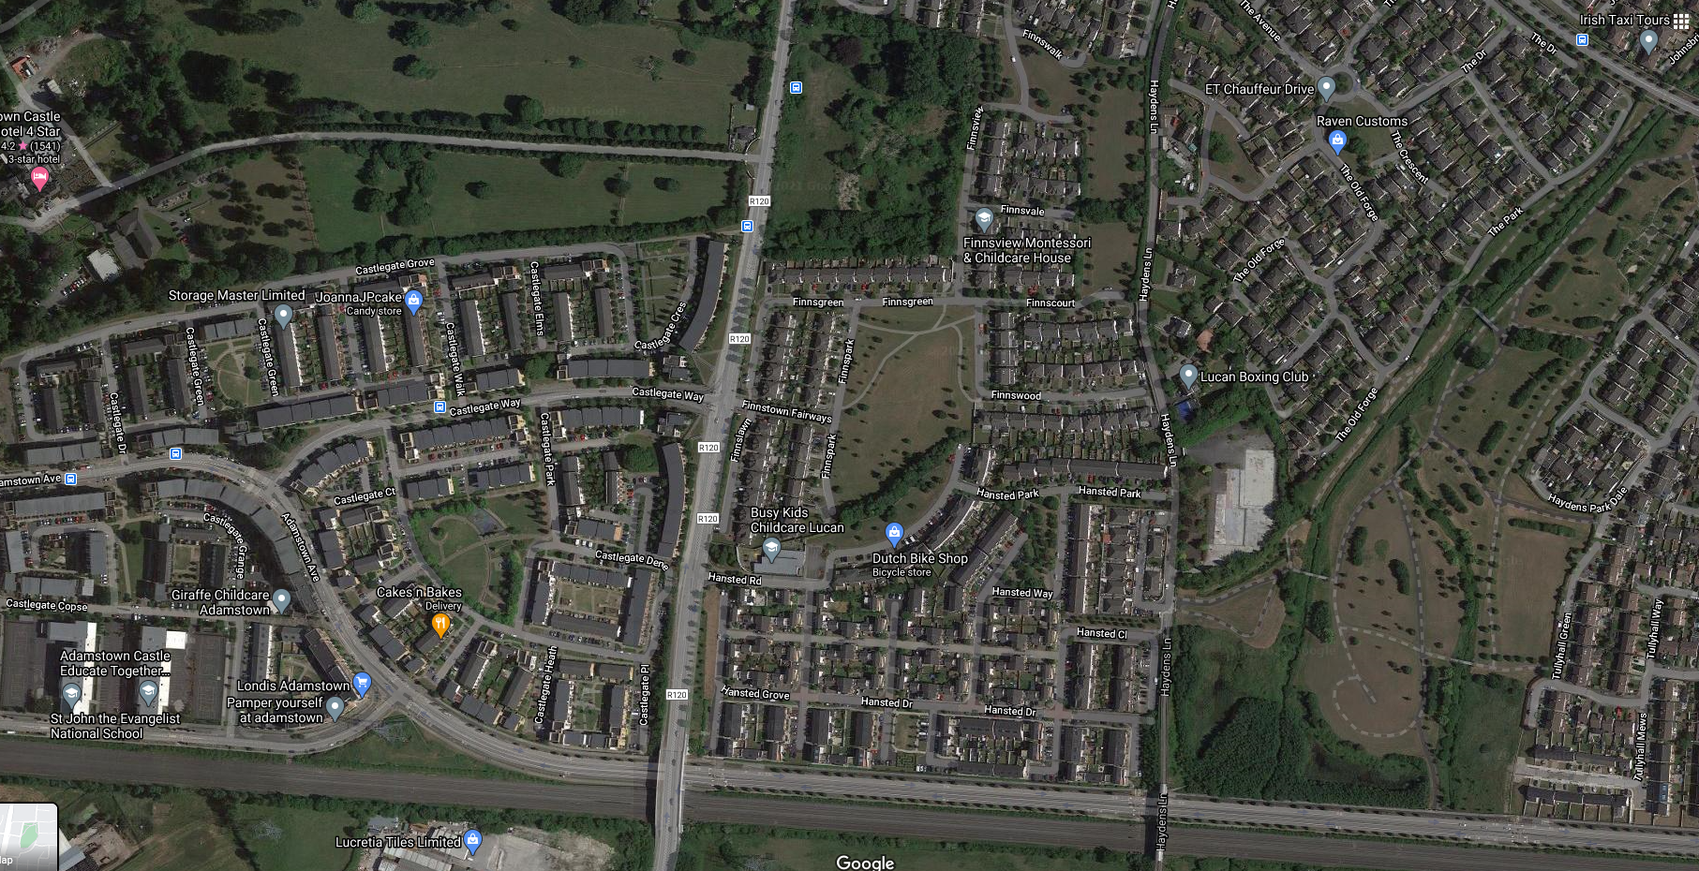
2no. V. Entrances
2no. Vehicle Entrances
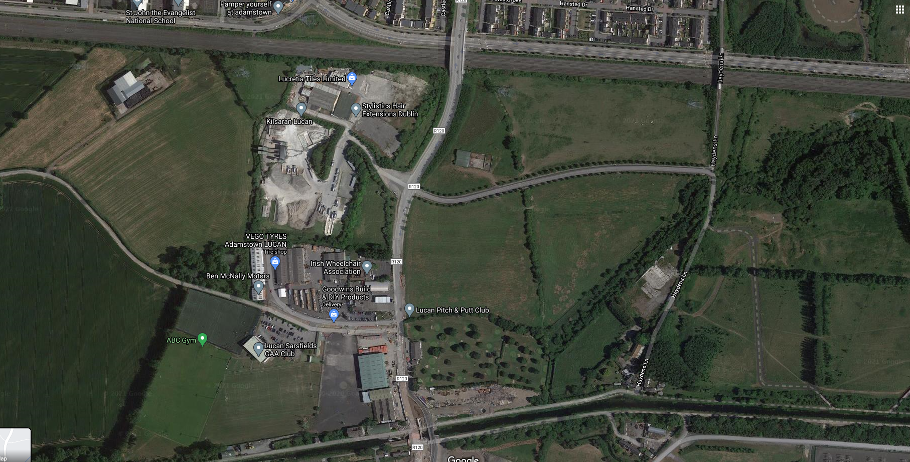
3no. V. Entrances
6no. Vehicle Entrances
Canal
Railway Lines

Summary Count of Existing Vehicular Accesses = 40no. Vehicular Accesses onto R120.
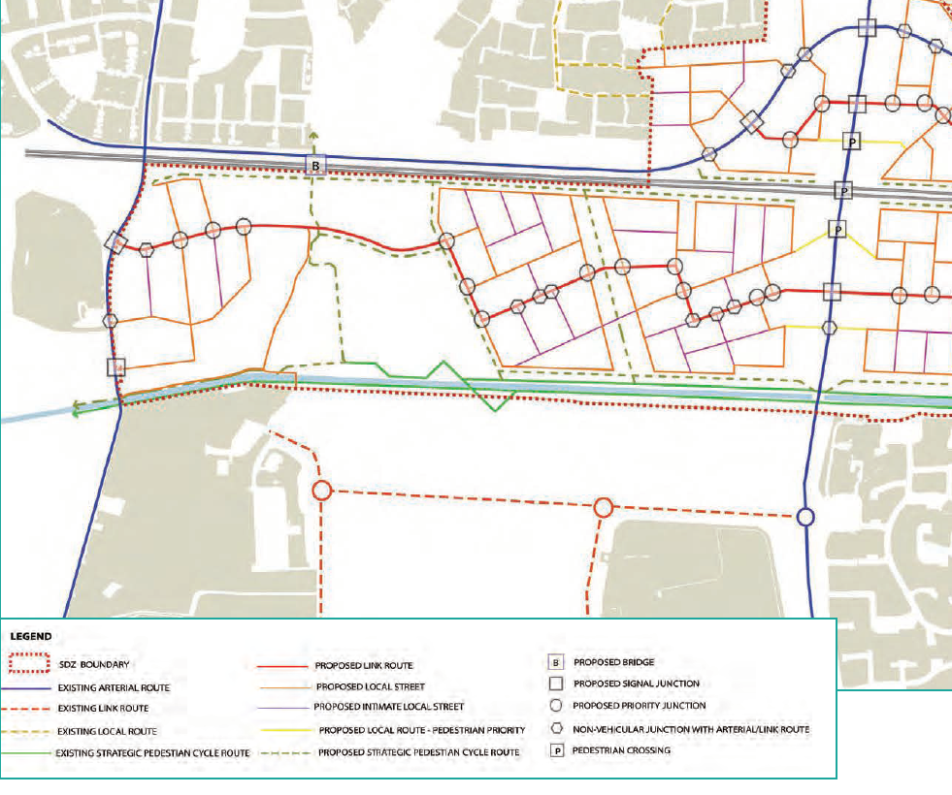
Section 2: Proposed Road Links (Clonburris)

A total of 3no. Existing Vehicular Links will be replaced with 2no. Vehicular links and 1no. Pedestrian / Cycling Link.

Possible Road Links (Zoned Lands)
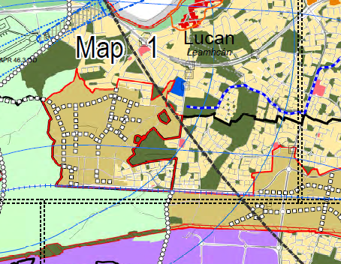
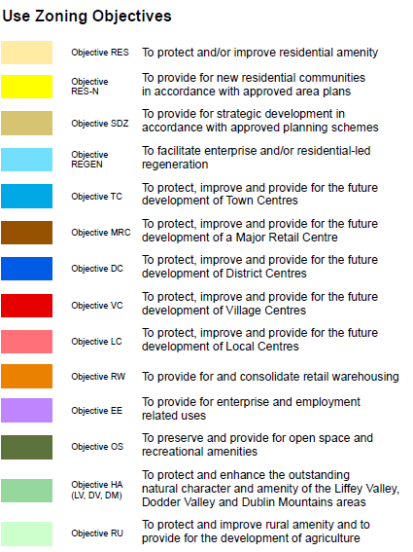
R120
Summary facts:
- The existing number of Vehicular accesses between N4 and the Canal is 40no. Vehicular Accesses.
- The majority of the vehicle Accesses are in the northern third where single dwellings are the dominant type. (21 no. accesses)
- Where newer estates have been constructed, there result is less vehicular access serving larger numbers of dwellings. For example, 4 vehicle accesses serving circa. 400no. dwellings.
- Therefore , any possible infill residential to the north of Railway lines will result in less vehicular accesses where good modern Planning and Design of estates reduce the need for excessive links off the R120.
- Another example is Clonburris to the east of the R120 has 2no. Vehicular Accesses planned which is a reduction of 1no. on the existing number.
- The Area between the Canal and the Railway and West of the R120 is currently Zoned “Improve Rural Amenity” in the current Plan. Therefore, currently no additional Vehicular Accesses planned at this location.

Conclusion: There will be fewer Vehicular Entrances along the R120 going forward with proper planned designs and better development layouts. Each planned access will have to serve larger numbers of dwellings more efficiently.

End of Report.

