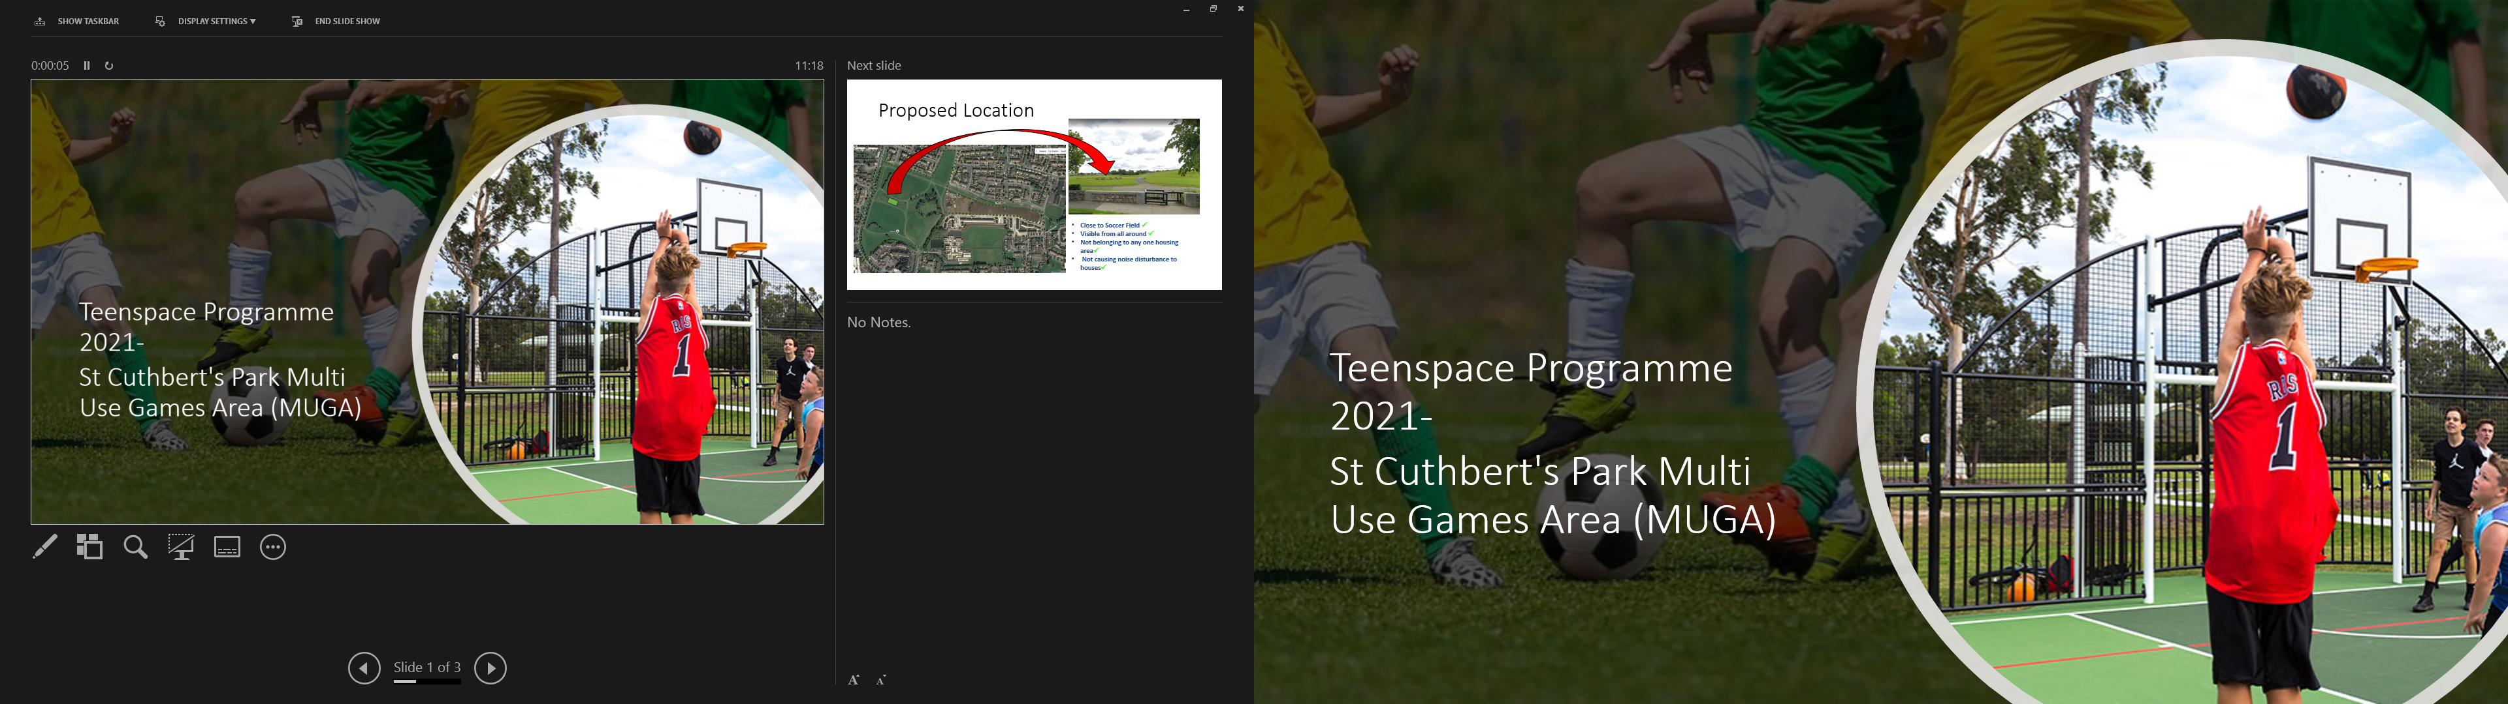

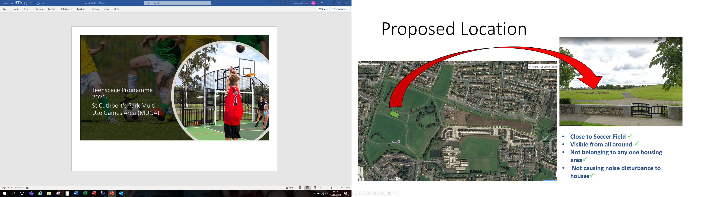

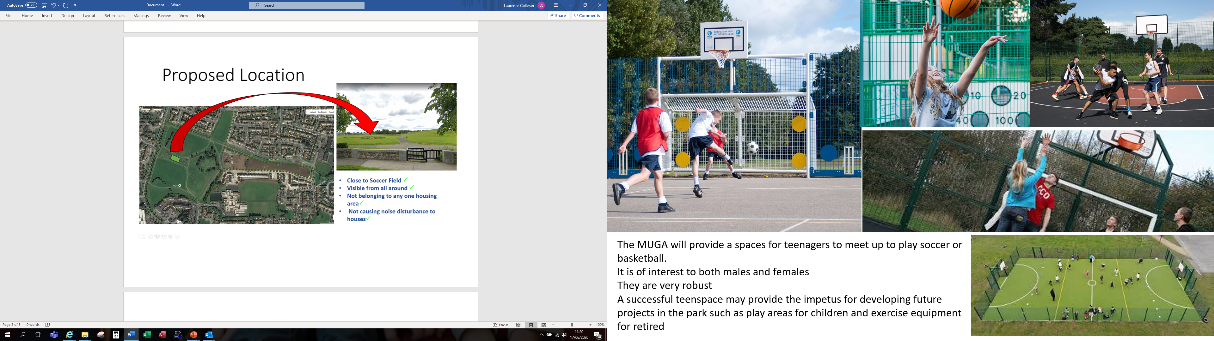

Discussion For ACM 20/01/2021

In June 2020 Public Realm brought plans for a MUGA to this ACM for approval.
Following this there were discussions at the High Level Steering Group for St Cuthberts Park that suggested the MUGA should be postponed and should form part of a separate part 8 for the entire park.
Public Realm would like to progress this project now rather than waiting for the overall plan to be completed. We believe that a successful project here would be a positive start for the rest of the works to follow on from. Are the Councillors in favour of progressing the MUGA at this time?

