# COMHAIRLE CONTAE ÁTHA CLIATH THEAS SOUTH DUBLIN COUNTY COUNCIL



**MEETING OF SOUTH DUBLIN COUNTY COUNCIL**

**Monday, 11th January 2021**

**HEADED ITEM No.13**

**Chief Executive’s Report on Public Consultation in relation to the proposed public realm works for the construction of an integrated constructed wetland and associated landscaping totalling approximately 1.3 hectares in the townland of Kilnamanagh, Tallaght, Dublin 24.**

1. **Introduction**

In accordance with the requirements of Part XI of the Planning and Development Act, 2000 (as amended) (the Act) and Part 8 of the Planning and Development Regulations, 2001 (as amended) (the Regulations), South Dublin County Council is seeking planning consent to and integrated constructed wetland and associated landscaping work totalling 1.3 hectares in the townland of Kilnamanagh, Tallaght, Dublin 24.

The purpose of this Chief Executive’s Report is to present the outcome of the consultation, to respond to submissions made during the consultation period and to make recommendations in relation to the proposed development where appropriate.

# Site Description

The 1.3-hectare site is the green public space situated between Treepark road and the western boundary wall of the M50 motorway in the townland of Kilnamanagh as shown below.

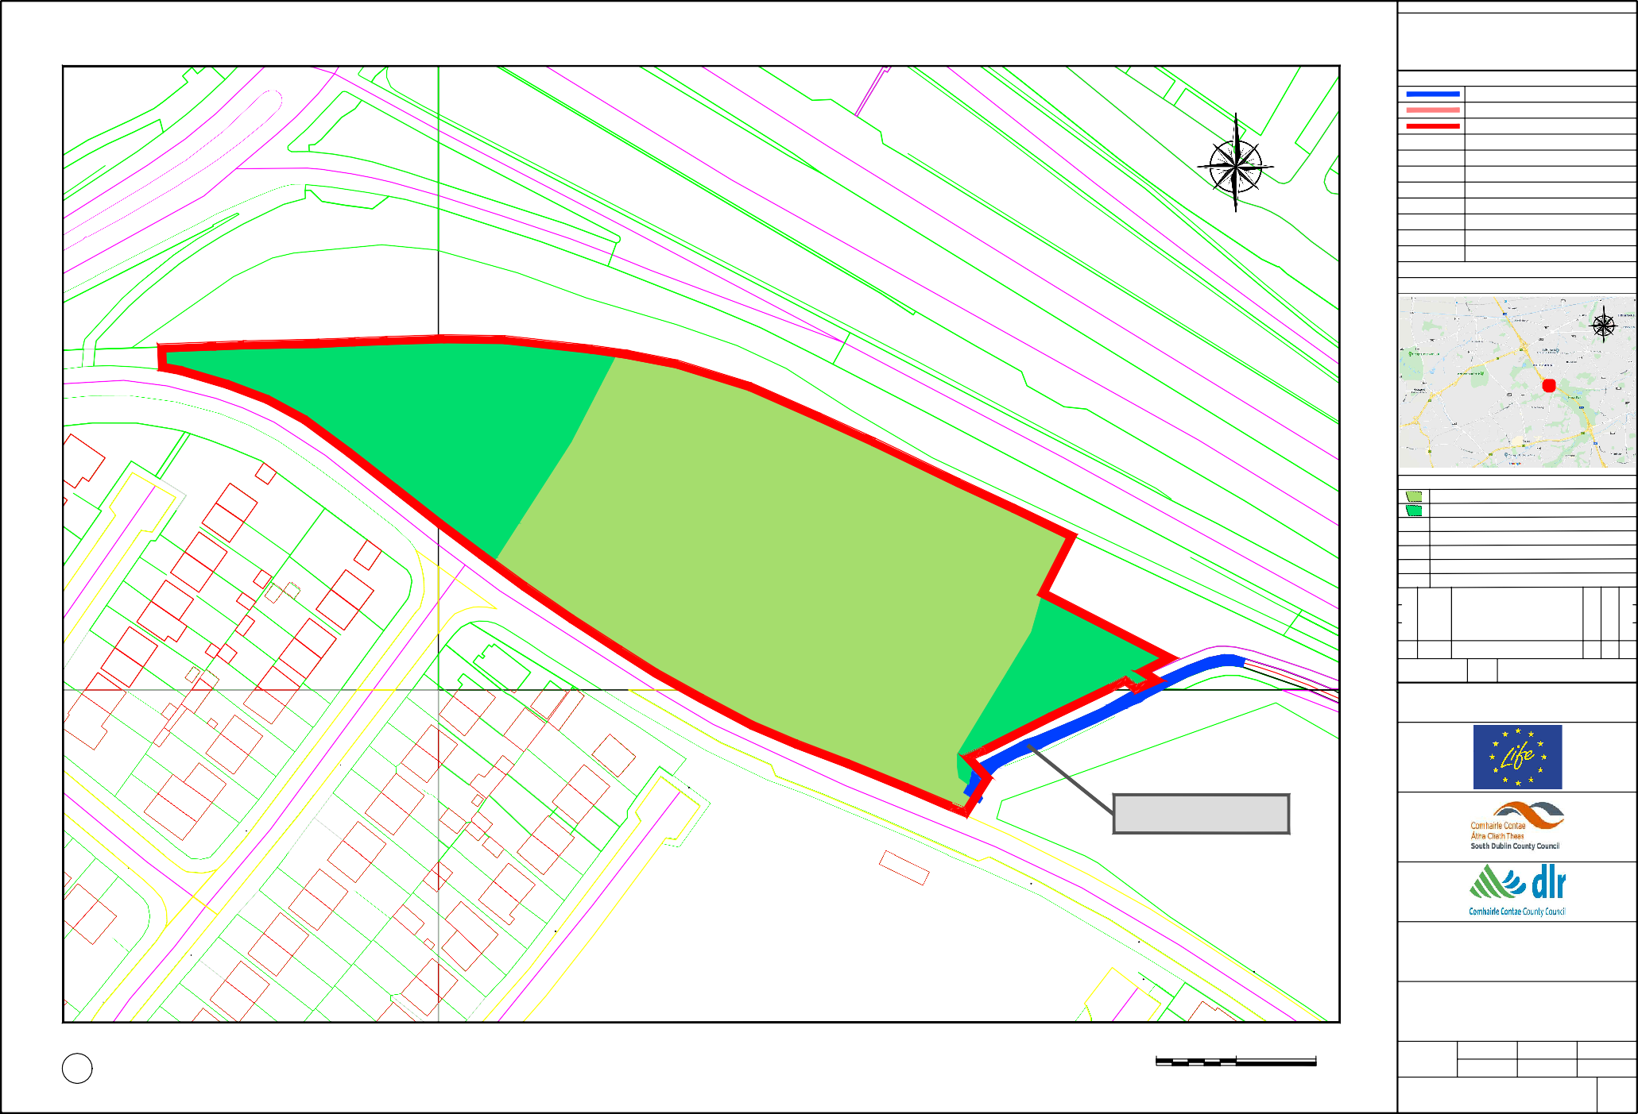

# Scheme Description

The proposal is to take a portion of the total stormwater flow from the Kilnamanagh Stream in Kilnamanagh, route the flow through a wetland in the park adjacent to the stream to purify that water, and then let that purified water flow back into the Kilnamanagh Stream via a new outfall. The proposed development will require:

* Building a new fenced Integrated Constructed Wetland, to treat and improve surface water quality, before discharging to the Kilnamanagh Stream.
* Reuse of excavated subsoil in the adjacent green area,
* Importation of topsoil to supplement existing topsoil at the location,
* Wetland planting scheme to treat surface water while offering greater biodiversity to the surrounding area.
* New surface water piped links between the existing surface water system and the Integrated Constructed Wetlands and a new surface water outfall to the Kilnamanagh Stream.
* Reprofiling of levels and small landscaping berms within the green area.
* All ancillary site development and landscaping works, including biodiverse planting, furniture, and pathways.

The Department of the Environment, Heritage and Local Government’s Integrated Constructed Wetlands (ICWs) documents sets out the principles of operation and build for ICWs in the context of Ireland. It notes. ‘’An ‘Integrated Constructed Wetland’ (ICW) is a series of shallow, interconnected, emergent-vegetated, surface-flow wetland compartments that receive/intercept water-flows from a variety of sources.’’

The intention of the proposed ICW is to optimise stormwater treatment and integrate the benefits from its associated wetland infrastructure to deliver a wide range of environmental returns, such as the protection and enhancement of biodiversity, the delivery of good ecological status of rivers and protection of fisheries. The general construction of the ICWs is they have a standing water depth of approximately 30 cm, are planted with a variety of native Irish wetland plants. They are sparsely planted in the beginning and within a few years they form lush wetlands. They are low maintenance water purification systems with the added benefit of high-density biodiversity and are visually appealing.

The proposed wetland will have a typical standing water depth of 30 cm or approximately 1 ft. which is similar to the adjacent stream in low flow. However, the main difference is the wetland will have a limit to the amount of water it can accept and therefore, the depth of water in the wetland will not fluctuate very much over the year. The wetland is also expected to be approximately 2.5 meters below the existing ground level. Essentially, the wetland is like having a large bowl inserted into the grass at the proposed location. The sides of the wetland will also have a slope gradient of minimum 1:1. This means, for every meter below ground level the side would be 1-metre-wide sloping back up to ground level. The purpose of such a steep slope is to reduce the amount of green space used by the wetland and accommodate other uses in the adjacent green space. Therefore, the wetland will require a perimeter fence be installed to primarily protect the public from the steep drop and to a lesser extent the depth of water in the wetland. Without the installation of the fence the wetland would have to extend a further 15 metres north west into the adjacent green space to meet a 1:5 gradient negating the need for a fence.

Plans and reports for proposed development are shown on the following links:

[Summary Report Kilnamanagh ICW PART 8](https://consult.sdublincoco.ie/en/system/files/materials/5575/Kilnamanagh%20ICW%20Summary%20Report.pdf)

[Drawings Kilnamanagh ICW Part 8](https://consult.sdublincoco.ie/en/system/files/materials/5575/Kilnamanagh%20Part%208%20Drawings.pdf)

[AA Screening Report Kilnamanagh ICW Part 8](https://consult.sdublincoco.ie/en/system/files/materials/5575/Kilnamanagh%20ICW%20AA%20Screening.pdf)

[EIA Screening Report Kilnamanagh ICW Part 8](https://consult.sdublincoco.ie/en/system/files/materials/5575/Kilnamanagh%20ICW%20Preliminary%20Examination.pdf%20)

[Ecological Survey Report Kilnamanagh ICW Part 8](https://consult.sdublincoco.ie/en/system/files/materials/5575/Kilnamanagh%20Ecological%20Survey%20Report.pdf)

[Archaeological Assessment Report Kilnamanagh ICW Part 8](https://consult.sdublincoco.ie/en/system/files/materials/5575/Kilnamanagh%20Archaeological%20Assessment.pdf)

[Site Notice Kilnamanagh ICW Part 8](https://consult.sdublincoco.ie/en/system/files/materials/5575/Kilnamanagh%20Site%20Notice%20Signed.pdf)

[Newspaper Notice Kilnamanagh ICW Part 8](https://consult.sdublincoco.ie/en/system/files/materials/5575/Kilnamanagh%20Newspaper%20Notice.pdf)

# Public Consultation

Plans and particulars of the proposed development were on public display for over six weeks from 5th November 2020 to 18th December 2020 (inclusive). During the public consultation, information on the proposed integrated constructed wetland development was disseminated to the public and submissions were invited.

The public consultation on the proposed integrated constructed wetland development included the following statutory and non-statutory elements:

* Notice in the Echo newspaper,
* Site Notices,
* Details of the proposed Part 8 were sent to prescribed bodies together with an invitation for submissions,
* Public consultation displays in South Dublin County Council offices at County Hall in Tallaght and on the council public consultation portal website, and
* Information on social media (Facebook and Twitter).

Submissions and observations on the proposed integrated constructed wetland development could be made online and in writing for a period of over six weeks from 5th November 2020 to 18th December 2020 (inclusive).

# Legislative Background

Section 179 (3) (a) of the Act, requires that the Chief Executive shall, after the end of the public consultation period, prepare a written report in relation to the proposed development and submit the report to the members.

Section 179 (3) (b) of the Act outlines that a report shall—

1. Describe the nature and extent of the proposed development and the principal features thereof and shall include an appropriate plan of the development and appropriate map of the relevant area.
2. Evaluate whether the proposed development would be consistent with the proper planning and sustainable development of the area to which the development relates, having regard to the provisions of the Development Plan and giving the reasons and the considerations for the evaluation.
3. List the persons or bodies who made submissions or observations with respect to the proposed development.
4. Summarise the issues, with respect to the proper planning and sustainable development of the area in which the proposed development would be situated, raised in any such submissions or observations, and give the response of the Chief Executive thereto. and,
5. Recommend whether the proposed development should be proceeded with as proposed, or as varied or modified as recommended in the report, or should not be proceeded with, as the case may be.

Under Section 179(4) of the Act, the elected members shall, as soon as practicable, consider the proposed development and the report of the Chief Executive. Following the consideration of the Chief Executive's report, the proposed development may be carried out as recommended in the Chief Executive's report, unless the local authority, by resolution, decides to vary or modify the development, otherwise than as recommended in the Chief Executive's report, or decides not to proceed with the development. A resolution must be passed not later than six (6) weeks after receipt of the Chief Executive's report.

# Environmental Impact Assessment and Appropriate Assessment

The proposal has undergone an Appropriate Assessment Screening under the Habitats Directive (92/43/EEC). This Council has determined that the implementation of the proposed development is not likely to have significant adverse eﬀects on the integrity or conservation objectives of any Natura 2000 network of sites.

It has also undergone a preliminary examination for an Environmental Impact Assessment and the Planning Authority has concluded that there will be no real likelihood of significant effects on the environment arising from the proposed development and therefore an Environmental Impact Assessment is not required.

As a result of the above, in accordance with Part XI of the Act, the elected members of the Council can consider the proposed construction of an integrated constructed wetland and associated landscaping work totalling 1.3 hectares in the townland of Kilnamanagh, Tallaght, Dublin 24, under Part 8 of the Regulations.

# Other Assessments

The proposal has also undergone a preliminary examination for an Ecological Assessment and the Planning Authority has concluded that there will be no real likelihood of significant effects on the environment arising from the proposed development.

The proposal has also undergone a preliminary examination for an Archaeological Assessment and the Planning Authority has concluded that there will be no real likelihood of significant effects arising from the proposed development.

# Outcome of Public Consultation Programme

A total of one hundred and three (103) submissions/observations were received.

A list of all persons, organisations and bodies that made submissions is provided in the Table 1 together with links to copies of the submissions received.

**Table 1 List of submitters and links to their submissions.**

|  |  |
| --- | --- |
| **Person/Prescribed Body** | **Link to Submission** |
| Peter Kavanagh | [Link](https://consult.sdublincoco.ie/en/submission/sd-c168-1#obs-2774) |
| Mark Dowling | [Link](https://consult.sdublincoco.ie/en/submission/sd-c168-2#obs-2775) |
| South Dublin Conservation Society | [Link](https://consult.sdublincoco.ie/en/submission/sd-c168-3#obs-2779) |
| Mark Carroll | [Link](https://consult.sdublincoco.ie/en/submission/sd-c168-4#obs-2783) |
| Deirdre Mackin | [Link](https://consult.sdublincoco.ie/en/submission/sd-c168-5#obs-2784) |
| Luke Sheridan | [Link](https://consult.sdublincoco.ie/en/submission/sd-c168-6#obs-2785) |
| David O’Reilly | [Link](https://consult.sdublincoco.ie/en/submission/sd-c168-7#obs-2786) |
| Traffic Infrastructure Ireland | [Link](https://consult.sdublincoco.ie/en/submission/sd-c168-8#obs-2788) |
| Anthony Cummins | Link |
| John Feeney | Link |
| Jennifer Dempsey | [Link](https://consult.sdublincoco.ie/en/submission/sd-c168-11#obs-2794) |
| Lee Hurley | [Link](https://consult.sdublincoco.ie/en/submission/sd-c168-12#obs-2795) |
| Jonathan Geoghegan | [Link](https://consult.sdublincoco.ie/en/submission/sd-c168-13#obs-2796) |
| Anthony Halpin | [Link](https://consult.sdublincoco.ie/en/submission/sd-c168-14#obs-2797) |
| Olivia Walsh | [Link](https://consult.sdublincoco.ie/en/submission/sd-c168-15#obs-2798) |
| Ciara Ennis | [Link](https://consult.sdublincoco.ie/en/submission/sd-c168-16#obs-2799) |
| Tracy Donovan | [Link](https://consult.sdublincoco.ie/en/submission/sd-c168-17#obs-2800) |
| Catherine Kelly | [Link](https://consult.sdublincoco.ie/en/submission/sd-c168-18#obs-2802) |
| Gillian Gobbett | [Link](https://consult.sdublincoco.ie/en/submission/sd-c168-19#obs-2803) |
| Denise Rafferty | [Link](https://consult.sdublincoco.ie/en/submission/sd-c168-20#obs-2804) |
| Carl Curtis | [Link](https://consult.sdublincoco.ie/en/submission/sd-c168-21#obs-2805) |
| Stephen Darcy | [Link](https://consult.sdublincoco.ie/en/submission/sd-c168-22#obs-2806) |
| Eddie Donegan | [Link](https://consult.sdublincoco.ie/en/submission/sd-c168-23#obs-2807) |
| Andrew Reynolds | [Link](https://consult.sdublincoco.ie/en/submission/sd-c168-24#obs-2808) |
| Adam Matthews | [Link](https://consult.sdublincoco.ie/en/submission/sd-c168-25#obs-2809) |
| Paul Reddy | [Link](https://consult.sdublincoco.ie/en/submission/sd-c168-26#obs-2810) |
| James O'Connor | [Link](https://consult.sdublincoco.ie/en/submission/sd-c168-27#obs-2811) |
| Kim Hersee | [Link](https://consult.sdublincoco.ie/en/submission/sd-c168-28#obs-2812) |
| Aimee Barrett | [Link](https://consult.sdublincoco.ie/en/submission/sd-c168-29#obs-2813) |
| Geraldine Kelly | [Link](https://consult.sdublincoco.ie/en/submission/sd-c168-30#obs-2814) |
| Sarka Hnilickova | [Link](https://consult.sdublincoco.ie/en/submission/sd-c168-31#obs-2816) |
| Floyd Donnelly | [Link](https://consult.sdublincoco.ie/en/submission/sd-c168-32#obs-2817) |
| Keith Foy | [Link](https://consult.sdublincoco.ie/en/submission/sd-c168-33#obs-2818) |
| John Murphy | [Link](https://consult.sdublincoco.ie/en/submission/sd-c168-34#obs-2819) |
| Mark Tilly | [Link](https://consult.sdublincoco.ie/en/submission/sd-c168-35#obs-2821) |
| Elaine Ochmanska | [Link](https://consult.sdublincoco.ie/en/submission/sd-c168-36#obs-2822) |
| Tanya Weston | [Link](https://consult.sdublincoco.ie/en/submission/sd-c168-37#obs-2823) |
| Craig Jago | [Link](https://consult.sdublincoco.ie/en/submission/sd-c168-38#obs-2824) |
| Amanda Deering | [Link](https://consult.sdublincoco.ie/en/submission/sd-c168-39#obs-2825) |
| Bernadette McEvoy | [Link](https://consult.sdublincoco.ie/en/submission/sd-c168-40#obs-2826) |
| Paul Furlong | [Link](https://consult.sdublincoco.ie/en/submission/sd-c168-41#obs-2827) |
| Michelle Waine | [Link](https://consult.sdublincoco.ie/en/submission/sd-c168-42#obs-2828) |
| Stephen Maher | [Link](https://consult.sdublincoco.ie/en/submission/sd-c168-43#obs-2829) |
| **Person/Prescribed Body** | **Link to Submission** |
| Gillian Coleman | [Link](https://consult.sdublincoco.ie/en/submission/sd-c168-44#obs-2830) |
| Edel Judge | [Link](https://consult.sdublincoco.ie/en/submission/sd-c168-45#obs-2831) |
| Karen Ellis | [Link](https://consult.sdublincoco.ie/en/submission/sd-c168-46#obs-2833) |
| Linda Tomney | [Link](https://consult.sdublincoco.ie/en/submission/sd-c168-47#obs-2834) |
| Emma Nolan | [Link](https://consult.sdublincoco.ie/en/submission/sd-c168-48#obs-2835) |
| Brigid Warburton | [Link](https://consult.sdublincoco.ie/en/submission/sd-c168-49#obs-2836) |
| Dean Walsh | [Link](https://consult.sdublincoco.ie/en/submission/sd-c168-50#obs-2837) |
| Edel Darley | [Link](https://consult.sdublincoco.ie/en/submission/sd-c168-51#obs-2838) |
| Melissa O’Neill | [Link](https://consult.sdublincoco.ie/en/submission/sd-c168-52#obs-2839) |
| Sonya Stuart | [Link](https://consult.sdublincoco.ie/en/submission/sd-c168-53#obs-2840) |
| Niall Fitzpatrick | [Link](https://consult.sdublincoco.ie/en/submission/sd-c168-54#obs-2841) |
| Adrienne Curtis | [Link](https://consult.sdublincoco.ie/en/submission/sd-c168-55#obs-2842) |
| Lorraine Hamilton | [Link](https://consult.sdublincoco.ie/en/submission/sd-c168-56#obs-2843) |
| Graham Mooney | [Link](https://consult.sdublincoco.ie/en/submission/sd-c168-57#obs-2844) |
| Donna Halpin | [Link](https://consult.sdublincoco.ie/en/submission/sd-c168-58#obs-2845) |
| Stephen Murphy | [Link](https://consult.sdublincoco.ie/en/submission/sd-c168-59#obs-2846) |
| Chris Richardson | [Link](https://consult.sdublincoco.ie/en/submission/sd-c168-60#obs-2847) |
| Michelle Lyons | [Link](https://consult.sdublincoco.ie/en/submission/sd-c168-61#obs-2848) |
| Sue Woodfull | [Link](https://consult.sdublincoco.ie/en/submission/sd-c168-62#obs-2849) |
| Siobhán McBride | [Link](https://consult.sdublincoco.ie/en/submission/sd-c168-63#obs-2850) |
| Stephen O’Reilly | [Link](https://consult.sdublincoco.ie/en/submission/sd-c168-64#obs-2851) |
| Ashling Berney | [Link](https://consult.sdublincoco.ie/en/submission/sd-c168-65#obs-2852) |
| Sharon Kerr | [Link](https://consult.sdublincoco.ie/en/submission/sd-c168-66#obs-2853) |
| James Gobbett | [Link](https://consult.sdublincoco.ie/en/submission/sd-c168-67#obs-2854) |
| Niall Kinahan | [Link](https://consult.sdublincoco.ie/en/submission/sd-c168-68#obs-2855) |
| Damien McCabe | [Link](https://consult.sdublincoco.ie/en/submission/sd-c168-69#obs-2856) |
| John Conroy | [Link](https://consult.sdublincoco.ie/en/submission/sd-c168-70#obs-2857) |
| Maria King | [Link](https://consult.sdublincoco.ie/en/submission/sd-c168-71#obs-2858) |
| Oonagh & Philip Long | [Link](https://consult.sdublincoco.ie/en/submission/sd-c168-72#obs-2859) |
| Elaine Davis | [Link](https://consult.sdublincoco.ie/en/submission/sd-c168-73#obs-2860) |
| Colm Keighery | [Link](https://consult.sdublincoco.ie/en/submission/sd-c168-74#obs-2861) |
| Phil Ledwith | [Link](https://consult.sdublincoco.ie/en/submission/sd-c168-75#obs-2862) |
| Brian Kavanagh | [Link](https://consult.sdublincoco.ie/en/submission/sd-c168-76#obs-2863) |
| Aileen Dowling | [Link](https://consult.sdublincoco.ie/en/submission/sd-c168-77#obs-2864) |
| Jennifer Dalton | [Link](https://consult.sdublincoco.ie/en/submission/sd-c168-78#obs-2866) |
| Ronan O'Reilly | [Link](https://consult.sdublincoco.ie/en/submission/sd-c168-79#obs-2867) |
| Elaine O’Halloran | [Link](https://consult.sdublincoco.ie/en/submission/sd-c168-80#obs-2868) |
| Hilary McEneaney | [Link](https://consult.sdublincoco.ie/en/submission/sd-c168-81#obs-2869) |
| Joanne Smullen | [Link](https://consult.sdublincoco.ie/en/submission/sd-c168-82#obs-2870) |
| Barry Ryan | [Link](https://consult.sdublincoco.ie/en/submission/sd-c168-83#obs-2871) |
| Conor Kenna | [Link](https://consult.sdublincoco.ie/en/submission/sd-c168-84#obs-2872) |
| Mark Maguire | [Link](https://consult.sdublincoco.ie/en/submission/sd-c168-85#obs-2873) |
| Brendan Whelan | [Link](https://consult.sdublincoco.ie/en/submission/sd-c168-86#obs-2875) |
| Emma Delaney | [Link](https://consult.sdublincoco.ie/en/submission/sd-c168-87#obs-2877) |
| Craig Foy | [Link](https://consult.sdublincoco.ie/en/submission/sd-c168-88#obs-2879) |
| **Person/Prescribed Body** | **Link to Submission** |
| Maeve Maguire | [Link](https://consult.sdublincoco.ie/en/submission/sd-c168-89#obs-2880) |
| Ian Creagh | [Link](https://consult.sdublincoco.ie/en/submission/sd-c168-90#obs-2882) |
| Gareth O'Keeffe | [Link](https://consult.sdublincoco.ie/en/submission/sd-c168-91#obs-2883) |
| Colin O'Leary | [Link](https://consult.sdublincoco.ie/en/submission/sd-c168-92#obs-2884) |
| Kilnamanagh AFC | [Link](https://consult.sdublincoco.ie/en/submission/sd-c168-93#obs-2885) |
| Emma McDermott | [Link](https://consult.sdublincoco.ie/en/submission/sd-c168-94#obs-2886) |
| Troy Whelan | [Link](https://consult.sdublincoco.ie/en/submission/sd-c168-95#obs-2889) |
| Suzanne Traynor | [Link](https://consult.sdublincoco.ie/en/submission/sd-c168-96#obs-2892) |
| Jake Dalton | [Link](https://consult.sdublincoco.ie/en/submission/sd-c168-97#obs-2891) |
| Jenny Sweetman | [Link](https://consult.sdublincoco.ie/en/submission/sd-c168-98#obs-2894) |
| David Dowling | [Link](https://consult.sdublincoco.ie/en/submission/sd-c168-99#obs-2899) |
| Elizabeth Reynolds | [Link](https://consult.sdublincoco.ie/en/submission/sd-c168-100#obs-2907) |
| Inland Fisheries Ireland | [Link](https://consult.sdublincoco.ie/en/submission/sd-c168-101#obs-2917) |
| Tallaght Community Council | [Link](https://consult.sdublincoco.ie/en/submission/sd-c168-102#obs-2927) |
| Stephen Wiggins | [Link](https://consult.sdublincoco.ie/en/submission/sd-c168-103#obs-2935) |

The categories of issues raised in submissions received is shown in Table 2 and a summary and responses to issues raised is provided in Section 9 of this report.

**Table 2 Submissions categorised (a submission may contain more than one category)**

|  |  |  |
| --- | --- | --- |
| **No.** | **Category of Submission** | **Count** |
| 1 | Loss of (unofficial) pitch for Kilnamanagh AFC/effect on club | 88 |
| 2 | Alternative space for children (query) | 68 |
| 3 | Support of ICWs as a concept | 14 |
| 4 | Loss of playing space for children (not KAFC specific) | 9 |
| 5 | Housing estate not suitable for ICWs (suitable for parks only) | 6 |
| 6 | Health & Safety concerns due to depth of ICW | 6 |
| 7 | Anti-social behaviour concerns | 4 |
| 8 | Statutory consultee submissions | 2 |
| 9 | Footballs lost to enclosed wetland | 1 |

# Summary of Issues Raised and Chief Executive’s Responses and Recommendations

In addressing the submissions raised it is important to provide the context that the proposed development is a demonstration project within the EU Life Fund Programme and Dublin Urban Rivers LIFE project which is a flagship project for the restoration of water bodies in the county using nature-based solutions such as wetlands. The proposal should also be considered in the context of the Council’s recently released Climate Action Plan 2019-2024 and the Draft Biodiversity Action Plan.

It should also be noted that Kilnamanagh AFC have operated on the green space for a report many years and have marked a pitch on that space which is reportedly used for underage games and training. However, this green space did not in the past or currently have an allocation or was ever a licensed pitch.

# Submission Category 1 – Loss of (unofficial) pitch for Kilnamanagh AFC/effect on club

# Submission Category 2 - Alternative space for children (query)

Submissions raise concerns regarding the loss of a playing pitch for children and the effect this could have on the membership of Kilnamanagh AFC. A significant number of submitters were parents or relations of children members of Kilnamanagh AFC. Most submissions in this category were accompanied by a query regarding an alternative pitch/play location.

# Response:

The Council engaged with Kilnamanagh AFC officials, as representatives of club members, during the consultation period, to address concerns regarding the potential permanent loss of a pitch sized area of green space to the north west of the proposed ICW location. A landscape drawing was prepared in addition to the information and drawings supplied in the Part 8 consultation period, as shown in the Figure 1, and this drawing is combined with drawing information supplied in the consultation period in Figure 2.

**Figure 1 Additional landscape drawing for the Kilnamanagh ICW Part 8 proposal**

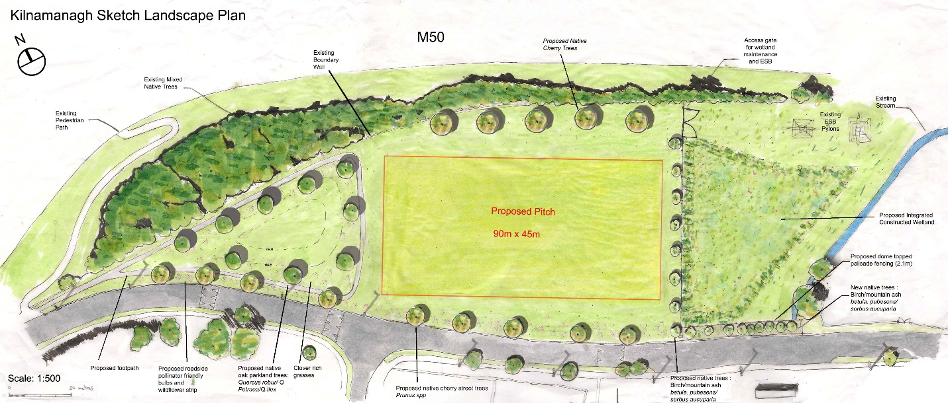

The proposal is clear that the ICW will encroach on the existing green space utilised by Kilnamanagh AFC (KAFC) but there is space to retain a size compliant playing pitch post development. The existing playing area utilised by KAFC will be moved north west.

Figure 2 Landscape drawing combined with some engineering drawing information

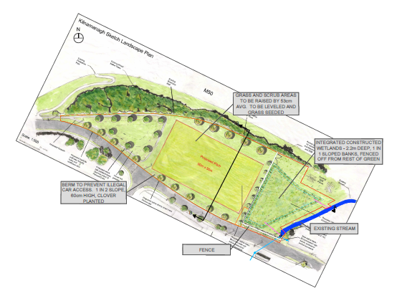

The information provided in the public consultation by SDCC noted the entire green area to the north west of the proposed wetland would be raised by an average of 0.5 metres and more so at the north west end of the space where bonfire activity at Halloween was a problem. The process will require scraping back existing topsoil at the site, placing excavated subsoil from the wetland location into the green space area, and replacing the topsoil and reseeding. This process can take up to two years to complete to a standard where competitive 11 aside games can take place without damaging the regressed area. This will mean any sporting activity on the green space will have to occur in an alternative location. In the Council’s efforts to address those concerns raised in the submission period an alternative pitch allocation (No.128) has been found in Tymon Park (see Figure 2) to act as an interim pitch until the green space at Treepark Road has been fully restored, at which time KAFC can return to this location and apply for a pitch allocation. The Council has given email confirmation Kilnamanagh AFC will receive an allocation as the existing users of that area when the green space is restored.

**Figure 3 Interim pitch No. 128 in Tymon Park location relative to Kilnamanagh**

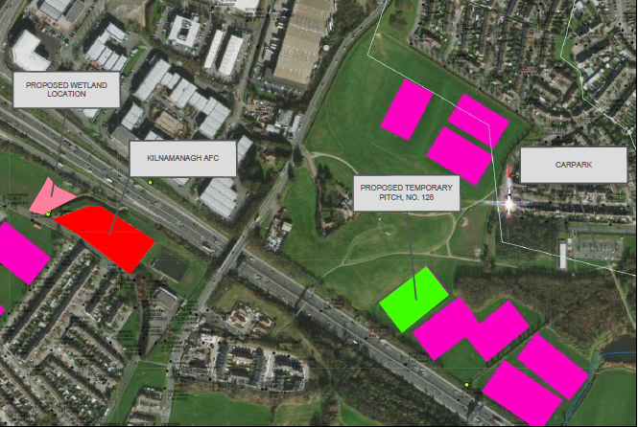

Therefore, if the proposal is approved, the sequence of events which would allow children continue to play sport is a follows:

* Kilnamanagh AFC apply for an allocation for pitch No.128 in Tymon Park which is unused/not allocated at present,
* The Dublin Urban Rivers LIFE project build the wetland and upgrade the adjacent green space,
* Once the grass has fully taken (approximately 1.5-2 years) KAFC apply for a pitch allocation for the green space at Treepark Road. As they were the last users of that space, they will be given first preference, and
* All applications for allocations by KAFC are processed by the Council in line with the allocation’s procedures at the time of applications.

**Chief Executive’s Recommendation**

It is recommended that no variation or modification be made to the proposed development, but the additional landscape drawing is noted in this report.

# Submission Category 4 – Loss of playing space for children (not KAFC specific)

Concerns were raised regarding loss of playing space for children due to the encroachment of the wetland into the existing green space. These submissions were made without any reference to KAFC and were categorised separately.

# Response:

The proposed development will revitalise and improve the north west end of the existing green space which is currently scrub land. At present, this space is not usable as a play space by children, attracts a certain level of dumping, and is considered a prime bonfire location threat during Halloween. It is reasonable to say this space could be significantly improved and of benefit to the children and residents. The proposal shown in Figure 1, raising the area, re-grassing, strategic tree planting and building a footpath around its circumference would transform the location.

**Chief Executive’s Recommendation**

It is recommended that no variation or modification be made to the proposed development, but the additional landscape drawing is noted in this report.

# Submission Category 5 – Housing estate not suitable for ICWs (suitable for parks only)

# Submission Category 6 – Health & Safety concerns due to depth of ICW

Concern raised regarding the suitability of the proposal in a housing estate. This concern was very brief and were usually included with other submission categories. Concern was also raised regarding the health and safety aspects of a deep wetland in the proposed location.

# Response:

The proposed development is situated very close the M50 boundary wall, across Treepark road, opposite Tamarisk and Elmcastle housing estates. It is considered this is one of the remotest locations for a wetland in the area, albeit adjacent to a regularly used green space. As the wetland’s purpose is to treat and improve polluted stormwater in the local stream it is not possible to situate this wetland anywhere else and achieve the same level of effectiveness of treatment and value for money. It is considered the proposed wetland location is removed from the overall Kilnamanagh house development(s). This proposal as part of the Dublin Urban Rivers LIFE project aims to install wetlands in urban areas be, they parks or housing estates, provided the location meets certain criteria, such as drainage, usage, pollution remedy, cost etc. Approximately 40 locations in the county were screened for suitability based on the criteria, and through an iterative process, the proposed Kilnamanagh location was chosen.

Approximately 30% of the proposed wetland would be built in what is currently scrub grassland and adjacent to the steep sided, unprotected, local stream. The bed of the local stream is approximately 2.8 metres below ground level from the top of the stream bank, the sides of which are unprotected and at an estimated gradient of 1:1. The proposal is to dig a wetland with sides of similar gradient (1:1) to the existing stream but to install a suitably strong and high, durable protective fence. While there is a perception of a safety risk with the installation of the wetland the true effect is the wetland would increase safety in the area from direct access as compared to the current open stream access.

**Chief Executive’s Recommendation**

It is recommended that no variation or modification be made to the proposed development.

# Submission Category 7 – Anti-social behaviour concerns

Matters raised included suggestions the position of a fence, with planting in front of it, would create a space for people to essentially hide behind the plantings and become involved in anti-social behaviour.

# Response:

The proposed fence line planting is to reduce and break the visual impact of the fence, not to hide it. The density of that planting will vary depending on the distance from Treepark Road. It is anticipated the further from Treepark road the less dense the planting will be. This will allow for a reasonable degree of visual surveillance towards the M50 end of the fence in line with the Council’s objective for public spaces.

The proposed development will revitalise and improve the north west end of the existing green space which is currently scrub land. At present, this space is not usable as a play space by children, attracts a certain level of dumping, and is considered a prime bonfire location threat during Halloween and the consequential anti-social behaviour. It is reasonable to say this space could be significantly improved and of benefit to the children and residents. The proposal shown in Figure 1, raising the area, re-grassing, strategic tree planting and building a footpath around its circumference would transform the location. This would change the tone of use of this location.

**Chief Executive’s Recommendation**

It is recommended that no variation or modification be made to the proposed development, but the additional landscape drawing is noted in this report.

# Submission Category 8 –Submissions from Statutory Bodies

**Inland Fisheries Ireland (IFI)**

IFI highlighted that ICW’s are only part of the solution and the door-to-door inspections and encouraging proper connection of grey water to the foul sewer is also important. IFI have requested to see the detailed design to ensure that the riparian zone is protected and that it is an environmentally sensitive design. All construction work must be done in line with a detailed site-specific Construction Environmental Management Plan (CEMP), using the best construction practices and minimise the generation of sediment and silt. IFI also suggested a comprehensive water quality programme of physico-chemical and biological parameters to confirm the treatment performance of the ICW and the impacts on the receiving waters.

# Response:

Work in relation to door-to-door inspection and encouraging proper connection to the foul sewer is also part of the Dublin Urban Rivers Life Project (DURL) and will be progressing as part of the DURL project. In relation the design process the DURL project will liaise with IFI during the process. The requirement for a detailed site-specific Construction Environment Management Plan (CEMP) will be included in the tender process and in place for the construction phase should the development be approved. Finally, a comprehensive water quality monitoring programme will be prepared and implemented if the proposal is agreed.

**Transport Infrastructure Ireland (TII)**

TII wanted to know if the proposed wetland would have any impact on the drainage regime of the M50. They also recognised the antisocial behaviour near or at the boundary wall and hoped the wetland development could influence this matter.

# Response:

The proposed wetland will not change the existing drainage arrangements in the location and is not anticipated to change any volumetric discharges to the culvert under the M50. The proposal will draw approximately 10 litres per second (10 l/s) from the existing flow in the stream at the mouth of the culvert, direct that 10 l/s through the wetland and then discharge it back to the stream approximately 50 metres downstream of the mouth of the culvert.

**Chief Executive’s Recommendation**

It is recommended that no variation or modification be made to the proposed development.

# Submission Category 9 – Footballs lost to enclosed wetland

1. Kilnamanagh AFC in their submission noted *‘’Ballstop netting will be required to prevent footballs going into the fenced-in Wetlands area; as there will not be any public access to the Wetlands area, this is a major issue.’’* and *‘’* *The current training lights we use won’t cover the new grass area, making this area unusable in winter months.’’*

# Response:

The pitch is an allocation of public space by to the Council to a club or organisation for use for a defined period, but that space remains public. The Council does not provide facilities such as ballstop netting at these locations, however this can be review over time if it is an issue. The Council’s policy does not provide lighting for allocated pitches and this is the case for any allocation discussed in this report.

**Chief Executive’s Recommendation**

It is recommended that no variation or modification be made to the proposed development.

# Submission Category – Support of ICWs as a concept

It is worth noting submissions contained an acknowledgement of the need for biodiversity and water quality improvement in the community/area/county and were not in opposition to project such as Dublin Urban Rivers LIFE and the funding it brought to the county. However, all such remarks were made embedded in submissions associated with the other Categories listed in Table 2.

# Recommendation

Following detailed contemplation of the submissions as outlined above it is considered that the issues raised in those submissions are appropriately responded to and can be satisfactorily addressed where appropriate as outlined in the foregoing report. In particular, the requirements of Inland Fisheries Ireland, Transport Infrastructure Ireland, and Kilnamanagh AFC as outlined in their submissions, can be incorporated into the proposed development as advertised.

Accordingly, it is considered that the proposed development, as advertised, is in accordance with the proper planning and sustainable development of the area, the County Development Plan 2016-2022 with no amendments required and therefore it is recommended that the Council adopt the following Motion:

*“As the proposed development is in accordance with the proper planning and sustainable development of the area, the Council approves the development of an integrated constructed wetland (ICW) and new stormwater outfall to the Kilnamanagh Stream on Council owned lands in* Kilnamanagh, Tallaght, Dublin 24*”*

*Daniel McLoughlin 11th January 2021*

Chief Executive Date