# COMHAIRLE CONTAE ÁTHA CLIATH THEAS SOUTH DUBLIN COUNTY COUNCIL



**MEETING OF SOUTH DUBLIN COUNTY COUNCIL**

# Monday, 14th of December 2020

**HEADED ITEM NO. 10**

# Chief Executive’s Report on Public Consultation in relation to the construction of a new “Innovation Centre” for Tallaght which extends to c 2,980msq in a bespoke standalone building.

1. **Introduction**

In accordance with the requirements of Part XI of the Planning and Development Act, 2000 (as amended) (the Act) and Part 8 of the Planning and Development Regulations, 2001 (as amended) (the Regulations), South Dublin County Council is seeking planning consent to construct the following development on SDCC land east of the new link road connecting Fourth Avenue and Belgard Square North, Tallaght, Dublin:

The development will consist of the construction of a new “Innovation Centre” for Tallaght which extends to c 2,980msq in a bespoke standalone building. The scheme comprises;

New four storey structure, which will accommodate;

* Town hall, reception and café at street level engaging with new Public Square (which forms separate Part 8 application)
* Three levels of flexible office accommodation - to support start up enterprise.
* New access road to the north of the site, to include the provision of 11 no. new car parking spaces.
* Associated site works to include secure bicycle parking, an integrated ESB sub station, plant, landscaping, lighting and signage and other support facilities.

The purpose of this Chief Executive’s Report is to present the outcome of the consultation, to respond to submissions made during the consultation period and to make recommendations in relation to the proposed development where appropriate.

1. **Site Description**

The site for the new building is located to the North of the South Dublin County Council offices on Belgard Rd North, at the head of currently unoccupied lands allocated to a park project which is subject to a separate Part 8 planning application. The site comprises a 0.2 hectare, lot of ground (a brownfield site). It shares the south and west boundaries with the public park. The east boundary has a service road to access the Innovation centre. The North boundary is formed by the inclusion of a new link Rd linking the Innovation Centre to Cookstown and Fourth Avenue.

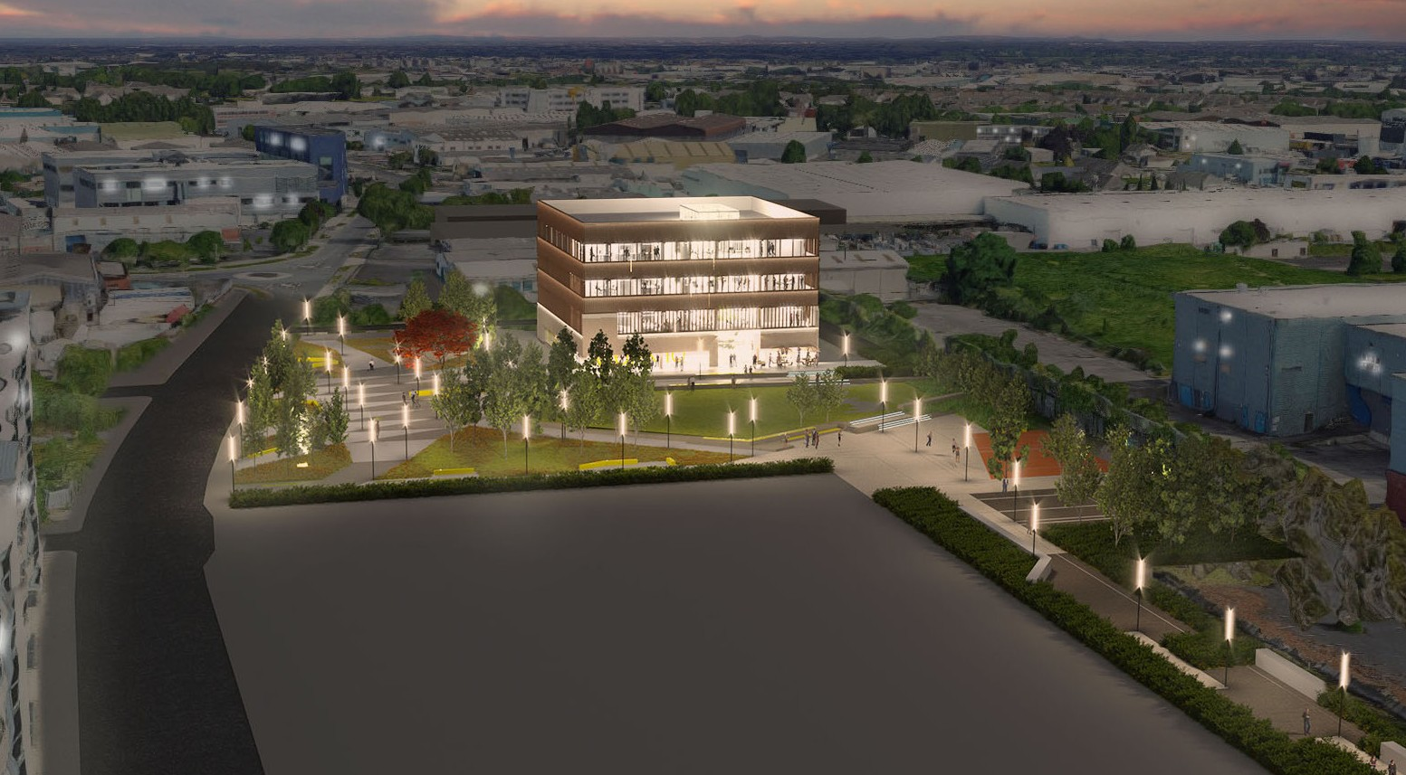

*Site : Aerial View*

The application site is L shaped, and is flat. The site for the building is located to the North of the South Dublin County Council offices, on Belgard Rd North, at the head of lands (currently not occupied) allocated to a park project which is subject to a separate Part 8 planning application and a school project that has not yet been commenced; these will be developed by SDCC in various lots with a view to enhancing Tallaght Town Centre.

The site to the West is proposed to be developed as residential; the sites to the East will be developed as residential; the larger site will be developed for a school and a landscaping proposal in conjunction with the Tallaght Innovation Centre forming a new public park. This is subject to a current Part 8 reg ref no: SD20A/0047

The site is currently subject to some infrastructural works involving road building and services/ drainage placement to facilitate future development. This has comprised a new Link Road running from North to South along the western boundary of the park site. It is proposed that a new East / West link road be included as part of this application as indicated by the red line on the plan.

The site is strategically located close to both the hospital and the university campus. 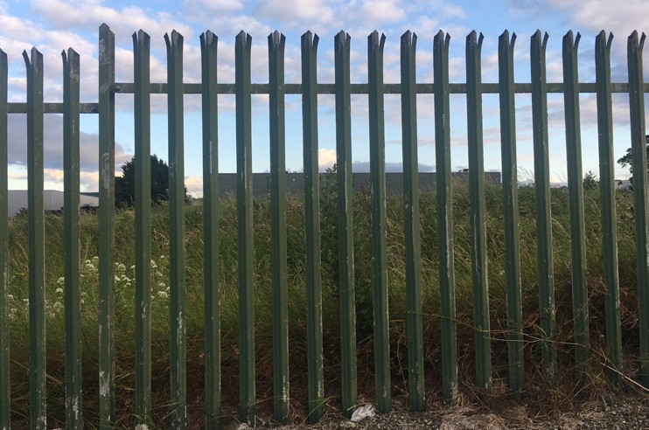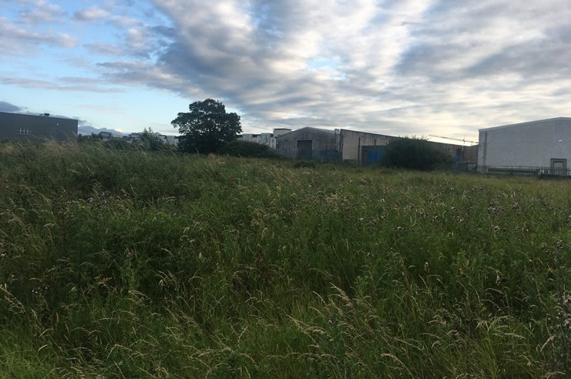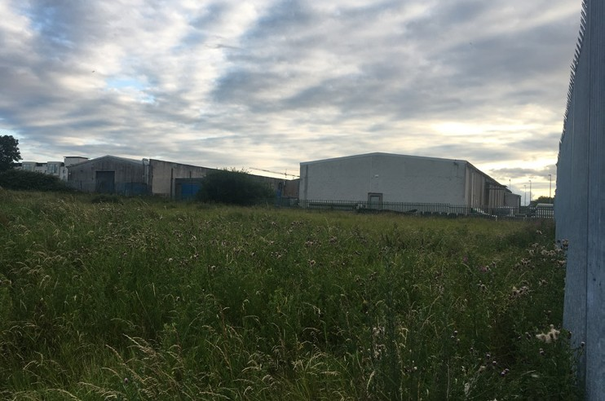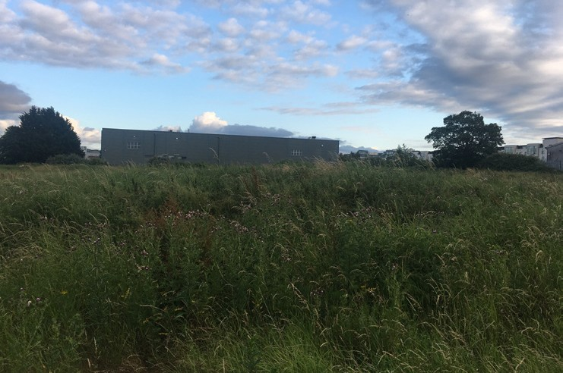

*Existing site boundaries*

# Scheme Description

# The Tallaght Innovation Centre is a landmark building for Tallaght Town Centre, under the procurement of South Dublin County Council. It will sit at the head of a new park / urban plaza on lands north of Belgard Road North and provide a civic focus for this area, that will be developed in other lots to include housing and a school. The Tallaght Innovation Centre is an exciting new initiative aimed at bringing start-up companies to the area by providing office space of differing scales that can be rented for a fixed period of time. The building is a taut metal and glass-clad box that commands the northern end of the site and will be highly visible, with a night and day presence. 4 storeys high, the ground floor is open and inviting, with public interface: you can see through the building from side to side. Above this there are three floors of lettable units that vary in size and look out over Tallaght Town Centre and to the mountains beyond. A void over the Townhall area, flooded with natural light, allows for visual connections between the levels. A south facing outdoor terrace opens out from the café, availing of the amenity of the park. A small amount of parking will be provided to the north and east of the site. The building is 4 storeys high – 3 floors of lettable office space over a publicly-oriented ground floor. The concept is that of a transparent and open building that looks in 4 directions. The ground floor is designed to be viewed through from all sides. The central space is top lit with a lightwell that brings light down into the centre of the plan. Thus, you are drawn into the building from outside. The building will provide a focus for the public park that sits between the building and the front plaza of the Civic Offices.

# Public Consultation

Plans and particulars of the proposed development were on public display for over six weeks from 1st of October 2020 to 12th November 2020 (inclusive). During the public consultation, information on the proposed affordable rental housing development was disseminated to the public and submissions were invited.

The public consultation on the proposed Innovation Centre development included the following statutory and non-statutory elements:

* Notices in the Echo newspaper.
* Public consultation displays in South Dublin County Council offices at County Hall in Tallaght.
* Information on social media (Facebook and Twitter).

Submissions and observations on the Innovation Centre development could be made online and in writing for a period of over six weeks from 1st of October to 12th of November 2020 (inclusive).

# Legislative Background

Section 179 (3) (a) of the Act, requires that the Chief Executive shall, after the end of the public consultation period, prepare a written report in relation to the proposed development and submit the report to the members.

Section 179 (3) (b) of the Act outlines that a report shall—

1. Describe the nature and extent of the proposed development and the principal features thereof and shall include an appropriate plan of the development and appropriate map of the relevant area.
2. Evaluate whether or not the proposed development would be consistent with the proper planning and sustainable development of the area to which the development relates, having regard to the provisions of the Development Plan and giving the reasons and the considerations for the evaluation.
3. List the persons or bodies who made submissions or observations with respect to the proposed development.
4. Summarise the issues, with respect to the proper planning and sustainable development of the area in which the proposed development would be situated, raised in any such submissions or observations, and give the response of the Chief Executive thereto. and,
5. Recommend whether or not the proposed development should be proceeded with as proposed, or as varied or modified as recommended in the report, or should not be proceeded with, as the case may be.

Under Section 179(4) of the Act, the elected members shall, as soon as practicable, consider the proposed development and the report of the Chief Executive. Following the consideration of the Chief Executive's report, the proposed development may be carried out as recommended in the Chief Executive's report, unless the local authority, by resolution, decides to vary or modify the development, otherwise than as recommended in the Chief Executive's report, or decides not to proceed with the development. A resolution must be passed not later than six (6) weeks after receipt of the Chief Executive's report.

# Environmental Impact Assessment and Appropriate Assessment

The proposal has undergone an Appropriate Assessment Screening under the Habitats Directive (92/43/EEC). This Council has determined that the implementation of the proposed development is not likely to have significant adverse eﬀects on the integrity or conservation objectives of any Natura 2000 network of sites.

It has also undergone a preliminary examination for an Environmental Impact Assessment and the Planning Authority has concluded that there will be no real likelihood of significant effects on the environment arising from the proposed development and therefore an Environmental Impact Assessment is not required.

As a result of the above, in accordance with Part XI of the Act, the elected members of the Council can consider the proposed construction of an Innovation Centre development on SDCC lands east of the new link road connecting Fourth Avenue and Belgard Square North, Tallaght, Dublin 24, under Part 8 of the Regulations.

# Outcome of Public Consultation Programme

A total of two (2) technical submissions/observations were received

A list of all persons, organisations and bodies that made submissions is provided in the table below together with links to copies of the submissions received:

|  |  |
| --- | --- |
| **Person/Prescribed Body** | **Link to Submission** |
| Irish Water | [Link](http://www.sdublincoco.ie/viewdocument.aspx?id=ab819846-07e4-4d2e-8bcf-ac3f00aff7c6) |
| TII (Transport Infrastructure Ireland) | [Link](http://www.sdublincoco.ie/viewdocument.aspx?id=5cad29b4-acf3-43b7-b557-ac3f00b07263) |

The categories of issues raised in submissions received is below:

(a summary and responses to issues raised is provided in Section 8 of this report)

|  |  |  |
| --- | --- | --- |
| **No.** | **Category of Submission** | **Count** |
| 1 | Pre-Connection Enquiry for connection to Water infrastructure | 1 |
| 2 | Impact on existing transport network- LUAS | 1 |

# Summary of Issues Raised and Chief Executive’s Responses and Recommendations

In addressing the submissions raised, please note that both submissions were of a technical nature and readily addressed by the existing scheme and its design development. The submissions did not identify or introduce objections to the design and were broadly supportive of the scheme.

In summary

1. The Irish Water submission was reflective of earlier correspondence with Irish Water by the applicant design team and all items are easily addressed by the design team.
2. The submission by TII relates to impact on the Luas. The development is not directly adjoining the Luas line and in advance of development a construction management plan will be agreed with SDCC traffic management section.

# Recommendation

Subject to the statutory consultation and public engagement, the submissions received did not raise any issue of significance.

Accordingly, it is considered that the proposed development, as advertised, is in accordance with the proper planning and sustainable development of the area, the County Development Plan 2016-2022 and the Tallaght Local Area Plan with no amendments required and therefore it is recommended that the Council adopt the following Motion:

*“As the proposed development is in accordance with the proper planning and sustainable development of the area, the Council approves the development of the a new bespoke building for the Tallaght Innovation Centre on Council owned lands east of the new link road connecting Fourth Avenue and Belgard Square North, Tallaght, Dublin 24.”*

*Daniel McLoughlin 2nd of December 2020*

Chief Executive Date