COMHAIRLE CONTAE ÁTHA CLIATH THEAS
SOUTH DUBLIN COUNTY COUNCIL


South Dublin County Council
Procedures for the Execution of Winter Maintenance Operations in the Roads Department of South Dublin County Council
Winter Maintenance System WMS 2020- 2021

1. Table of Contents

1. Table of Contents 2
1.1 Document Management 3
1.2 Glossary of Terms 3
1.3 Purpose and Scope 4
1.4 Precautionary Gritting 5
1.5 Emergency Scenarios 5
1.6 Salt Bins for Public Use 5
1.7 Road Weather Information System Arrangements 6
2. Depots 7
3. Health & Safety 7
3.1 Drivers Daily Defect Report 7
3.2 Lone Working 7
3.3 Covid 19 Procedures ………………………………………………………………………………………………….8
4. Responsible Persons 9
4.1 Duty Engineers 9
4.2 Depot Inspectors and Assistant Foremen of Works (A/FOW) 9
5. PROCEDURES AND ROSTERS 10
5.1 Duties of the duty Engineer 10
5.2 Monday – Friday Procedure 10
5.3 Weekend (Sat. - Sun.) and Bank Holidays Procedure 11
5.5 Rates of Spread for Precautionary Salting 11
5.6 Treatment of snow already on the road after Precautionary Gritting 12
5.7 Treatment of Hard-Packed Snow and Ice 12
6. Appendices 13
6.1 Appendix 1 - Gritting Routes 13
6.2 Appendix 2 – Priority Routes 14
6.3 Appendix 3 - Salt Bin Locations 15
6.3.1 Appendix 3.1 - Salt Bin Locations & Coordinates 16
6.4 Appendix 4 – Risk Assessments 17
RISK ASSESSMENT 17- Winter Maintenance / Gritting 17
RISK ASSESSMENT 26- Mounting and De-mounting Gritter 19
RISK ASSESSMENT 42- Snow Plough 21
RISK ASSESSMENT 45- Teleporter 23
RISK ASSESSMENT -71 Driving -Winter Maintenance Operation
6.5 Appendix 5 – Driver Checklist 25
6.6 Appendix 6 - Safe Working Alone System 29
6.7 Appendix 7 Covid Safe Operating Procedures
SOP 16 : Use of Equipment
SOP 14 : Travel for Work.
6.8 Duty Engineer Roster.

1.1 Document Management

Date | Version | Author
11/09/2014  16/10/2015  07/10/2016 | 2014 Rev01  2015 Rev 01  2016 Rev 01 | S. Tsang  S. Tsang  S. Tsang
18/10 2017 | 2017 Rev 01 | G. Berrigan

08/10/2018 2018 Rev 01 T O’ Grady

18/11/2019 2019 Rev 01 A. Taki

01/10/2020 2020 Rev 01 T O’ Grady

1.2 Glossary of Terms

 | N.P | National Primary
 | N.S | National Secondary
 | S.D.C.C | South Dublin County Council
 | WMS | Winter Maintenance System

1.3 Purpose and Scope

South Dublin County Council (SDCC)’s road network consists of
- 63km National Roads
- 114km Regional Roads
- 789km Local Roads
Winter maintenance is confined to National, Regional and Local routes. National Primary routes are gritted by the NRA; National Secondary, Regional and Local routes are gritted by SDCC. The percentages of roads gritted by SDCC are summarized below in Table 1.

 | Gritted  (km) | Total  (km) | %
National Secondary | 13 | 13 | 100%
Regional | 114 | 114 | 100%
Local | 145 | 789 | 18.5%

Table 1

There are 7 Gritting routes in SDCC. These Gritting Routes can be seen in Appendix 1.

The purpose of this document is to identify the processes, procedures and control measures employed by South Dublin County Council and to ensure that Winter Maintenance works are carried out in accordance with procedural and Health and Safety requirements. All members of staff involved with Winter Maintenance shall be fully acquainted with this Winter Maintenance Strategy and will have access to copies of it.

1.4 Precautionary Gritting

The primary aim is to keep these roads safe and as free as possible from winter hazards.
In order to do this, SDCC Roads Department spreads salt on these roads before ice or snow is expected (called Precautionary Gritting), this operation of pre-salting is timed to be completed before the onset of freezing or snowfall.
Normal gritting times are 7pm and/or 5am.

 | Road
Route 1 | Lucan
Route 2 | Clondalkin
Route 3 | Saggart
Route 4 | Tallaght
Route 5 | Kimmage
Route 6 | Ballyboden
Route 7 | N81
Table 2

1.5 Emergency Scenarios
If snow or ice settles, snow ploughing, and salting is put into action. South Dublin County Council is constantly striving to improve the winter maintenance service.

Priority routes have been prepared to deal with emergency scenarios such as sudden snowstorms or prolonged periods of freezing temperatures. Priority routes also deal with; reduced driver numbers, low salt and heavy snowfall.

Priority Routes can be seen in Appendix 2.

1.6 Salt Bins for Public Use
In the 2011-2012 season, a trial was carried out which involved leaving Salt Bins at 15 specified locations throughout the county (3 per electoral area). These locations are at entrances to estates and areas with severe slopes that are not on our salting routes but have been identified as problem areas during icy conditions. For the 2020-2021 season there are a total of 39 locations where salt bins are located.

These Salt Bins will be kept stocked with salt so that members of the public can treat a road if they deem it required. Instructions on spread rate will be provided. Some of the salt bins are locked and the local resident’s association nominates a member of the public as a keyholder.

Salt Bin locations can be seen in Appendix 3.

1.7 Road Weather Information System Arrangements
The Ice Prediction System is supplied by:
Vaisala TMI Ltd
Vaisala House
349 Bristol Road
Birmingham

Vaisala in conjunction with Met Eireann issue forecasts daily. The server for the network Ice Prediction System is housed at the Vaisala office in Birmingham.

The Ice Prediction System polls the outstations on the network at maximum intervals of one hour. This may be reduced to shorter intervals depending on conditions during the winter season.

The weather station for SDCC is located on the N81 at the Mahons Lane junction.

2. Depots

SDCC currently operates Winter Maintenance operations from Ballymount and Palmerstown Depots. The Ballymount Depot Salt Barn is in close proximity to the M50. The Palmerstown Depot Salt Barn is adjacent to the N4.

3. Health & Safety
SDCC will ensure so far, as is reasonably practicable:
- Safe and healthy working conditions,
- Safe equipment and systems of work,
- Provision of appropriate information, instruction, training and supervision,

This procedural document should be read in conjunction with
- Roads Maintenance – Risk Assessments (Mounting and Loading Gritter, Gritting Roads, Snow Plough and Teleporter)

Risk Assessments in Appendix 4.

3.1 Drivers Daily Defect Report
Before any driver can leave a depot to carry out a salting run, they must carry out a checklist on the vehicle to ensure that there are no obvious defects with it.
This checklist can be seen in Appendix 5.

3.2 Lone Working
Where Lone working occurs, the procedures outlined in Appendix 6 below shall be utilised.

3.3 Covid 19 Procedures

To take account of Covid 19, the following precautions have been taken.

- Each work crew travels and uses the canteen as a unit. This limits the number of contacts in case of a Covid 19 outbreak.

- An increased number of Drivers, Helpers and machinery operators have been trained to allow for substitution.

Palmerstown Depot : 3 Gritting Routes
11 Drivers
11 Helpers
4 Teleporter Drivers

Ballymount Depot : 4 Gritting Routes
13 Drivers
11 Helpers
4 Teleporter Drivers

- On some of the truck cabs, social distancing cannot be achieved between the Driver and the helper. In those cases, a 4 *4 vehicle will travel behind the truck driven by the helper.
Risk Assessment 71 -Driving – Winter Maintenance is in Appendix 4

- Covid Standard Procedures in relation to travel to work, cleaning of cabs before and after use are included in Appendix 7.

4. Responsible Persons

Winter Maintenance coordinator:
Michael Glynn, Senior Executive Engineer, Road Maintenance

4.1 Duty Engineers

Duty Engineer's Name & Initials | Office Phone No | Office E-mail Address
Tony O'Grady (TOG) | 01 4149000 ext. 3225 | togrady@sdublincoco.ie
John McCormack (JMcC) | 01 4149000 ext. 3149 | jmccormack@sdublincoco.ie
Michael Glynn (MG) | 01 4149000 ext. 9235 | mglynn@sdublincoco.ie
Caitriona Lambert (CL) | 01 4149000 ext. 3232 | clambert@sdublincoco.ie
Cian O’ Carroll (COC) | 01 4149000 ext. 3149 | coconnell@sdublincoco.ie

4.2 Depot Inspectors and Assistant Foremen of Works (A/FOW)

Name | Depot | Routes
Paddy Hearns | Palmerstown | 1, 2, 3
Willie O’ Neill | Palmerstown | 1, 2, 3
Paul Rooney | Ballymount | 4,5,6,7
Tony Murphy | Ballymount | 4,5,6,7
Mick Redmond | Ballymount | 4,5,6,7

5. Procedures and Rosters

A roster of Duty Engineers to give 24-hour coverage has been agreed to manage information from Met. Eireann and Vaisala. The Duty Engineer will have authority to instruct treatment as required. Consultation with the Winter Maintenance Coordinator will be carried out as necessary.

The Duty Engineer will also ensure plant and personnel are mobilised. The Duty Engineer will instruct the Inspector/Assistant Foreman of Works (A/FOW) when a decision to treat has been made. The Inspector/A/FOW will ensure the drivers are instructed and ready to treat the road at the time required. The Inspector/A/FOW will take instruction from the Duty Engineer.

5.1 Duties of the duty Engineer
The Gritting Phase will be activated by the Duty Engineer in the event of ice or adverse weather prediction from the Vaisala service. This is normally issued before 2.30pm in the afternoon.
Gritting shall commence at the time determined by the Duty Engineer normally at 7pm and 5am if necessary. As the Vaisala forecast and data is available at 2.30 pm therefore it is expected that the callout is given as early as possible particularly on a Friday in order that arrangements can be made before personnel finish work.

5.2 Monday – Friday Procedure
- The Duty Engineer checks the Vaisala and forecast at or before 2.30pm each day.
- In the event of the forecast of ice conditions the Duty Engineer notifies the Inspector/A/FOW on call before 3.30pm, of routes to be pre-salted and time of commencement.
- The Inspector/A/FOW then notifies the drivers and the Machinery Yard Foreman on call for that week.
- The Duty Drivers proceed to their parking depots at the end of their normal working day and fit the salt spreaders.
- The Inspector/ A/FOW notifies the loader driver, proceeds to the salt depot at the end of normal working time and prepares the depot for loading of salt.
- At the designated time, the drivers will collect their machines, load salt and grit their prearranged routes. On completion the driver will return the spreader to its parking location.
- The Inspector/A/FOW will be on standby in the event of breakdown.
- From the call out time, the Inspector/A/FOW will monitor the operations and in the event of breakdown will call out a fitter or activate the standby salt spreader whichever he feels appropriate.

5.3 Weekend (Sat. - Sun.) and Bank Holidays Procedure
The gritting duty roster is as above
- The Duty Engineer checks the Vaisala and forecast at or before 2.30pm each day.
- In the event of the forecast of ice conditions he notifies the Inspector /A/FOW on call before 3.30pm, of routes to be pre-salted and time of commencement.
- The Inspector/A/FOW notifies the drivers and Machinery Yard Foreman on call for that week, of the time of callout.
- The Inspector/A/FOW notifies the loader driver, proceeds to the salt depot at the time appointed and prepares the depot for loading of salt.
- The Duty Drivers proceed to the depot at the appointed time, load salt, proceeds to complete assigned routes. On completion the driver will return the salt spreader to its parking location.

5.4 Winter Maintenance Duty Engineers’ Roster
The roster for Duty Engineers can be seen in Appendix 7.

5.5 Rates of Spread for Precautionary Salting

It is intended that Precautionary Action forms the major part of winter operations.

For frost and road surface temperatures at or above -2ºC, salt shall be spread at 10-20 g/m² dependent on local conditions and the immediate forecast.

If freezing conditions are expected after rain or frost and the road surface temperature is below -2ºC, spread rates will be increased to 20-30 g/m² according to the amount of moisture present and the temperature expected. Unless freezing conditions coincide with rainfall, salting shall be delayed as long as possible to reduce loss of salt by run-off.

If continuous snow is forecast, salt shall be spread at 30-40 g/m² according to the anticipated severity of the snowfall. Every effort will be made to ensure enough salt is applied before snow starts to stick to the road to melt the initial snowfall and to provide a wet surface.

The spread rates for precautionary salt treatments are summarized below.

Weather Conditions | Definition | Salt Spread RATE (gram/square metre)
Light | Frost and/or light snow | 10
Moderate | Freezing conditions after rain | 20 to 30
Severe | Continuous snow | 30 to 40

For a single precautionary treatment on all Priority 1 and 2 routes at a spread rate of 10 g/m², the tonnage of salt required would be 19t. This would be on a night when a hoar frost is expected, and the road surface temperature will be at or above -2°C.

5.6 Treatment of snow already on the road after Precautionary Gritting

Snow ploughing will commence on major routes as shown in Appendix 2 as directed by the Duty Engineer. Each pass of the plough shall be supplemented by an application of salt at a rate as per the table above. Special salting may be necessary to deal with melted water from snow, which may freeze at night, and a watch will be kept for such conditions.

5.7 Treatment of Hard-Packed Snow and Ice

If the previous procedures are carried out successfully then the formation of hard-packed snow should be prevented. However, in cases where hard-packed snow and ice occur and provided that the ice is no more than 20mm thick and the air temperature is below -5ºC, then removal shall be carried out by successive salt applications of 20-40 g/m².

6. Appendices

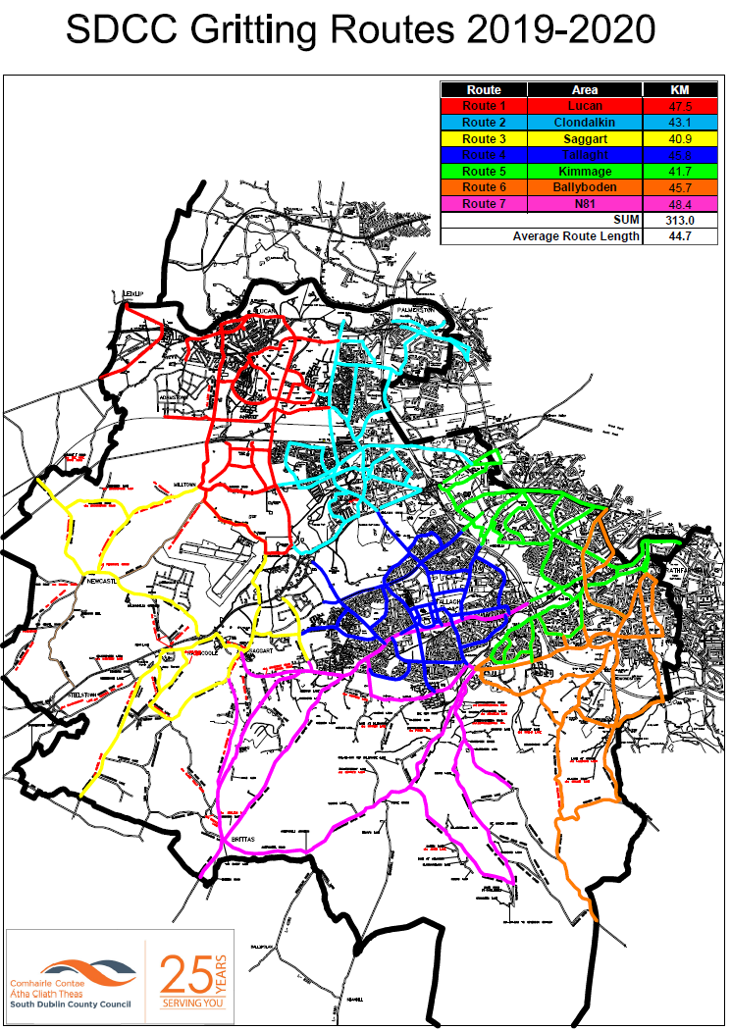
6.1 Appendix 1 - Gritting Routes

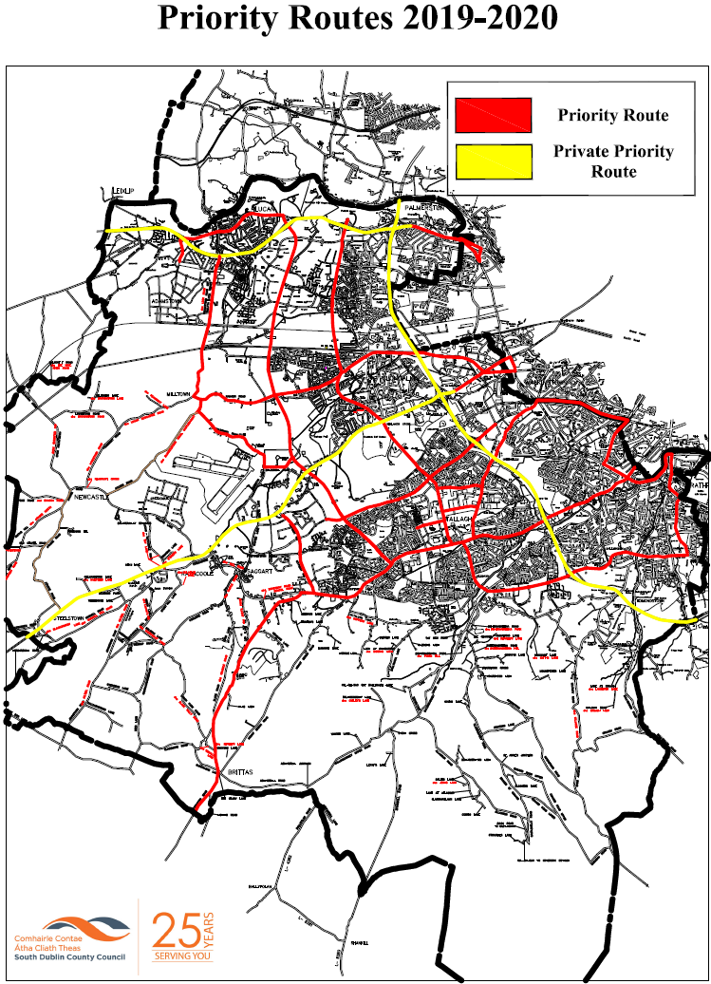
6.2 Appendix 2 – Priority Routes

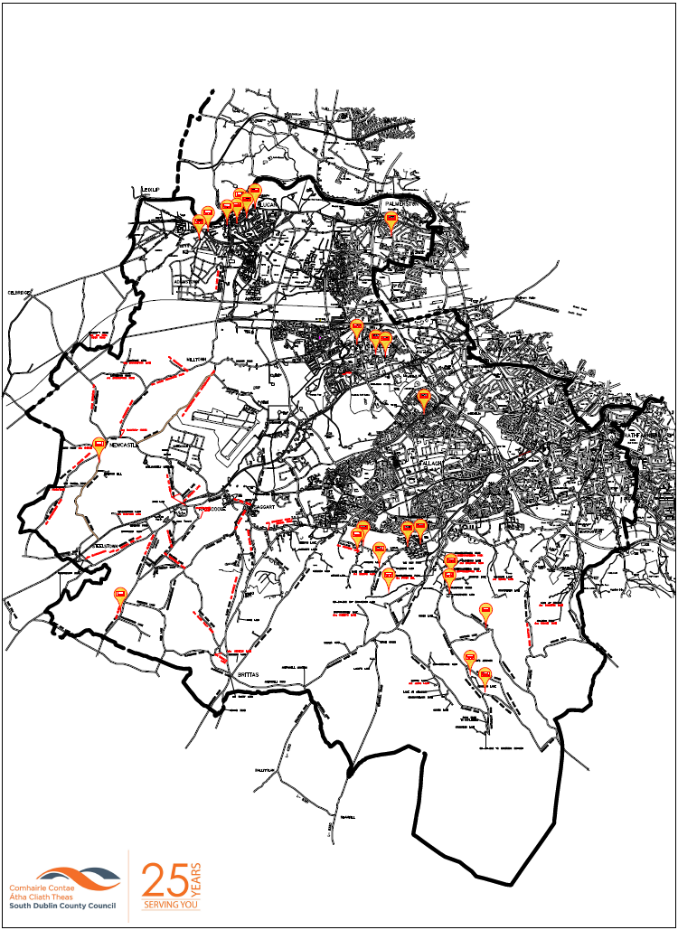
6.3 Appendix 3 - Salt Bin Locations

6.3.1 Appendix 3.1 - Salt Bin Locations & Coordinates

Lucan |  | Rathfarnham- Templeogue
Ardeevin | 53.354878, -6.457864 | Moyville |  | 53.279578, -6.295941
Sarsfield Park | 53.359006,-6.444999 | Palmer Park / Pearse Brothers Park |  | 53.281155, -6.286711
 |  | Prospect Manor |  | 53.274712, -6.301062
Lucan Heights | 53.357686,-6.442150 | Church Lane at Tourville |  | 53.299949, -6.287813
Airlie Heights | 53.352475, -6.462986 | Grangebrook |  | 53.275963, -6.284201
Lucan Garda Station | 53.356030,-6.450813 | Boden Park |  | 53.281360, -6.302745
Brookvale | 53.356455, -6.445812 | Ballyboden Library |  | 53.281463, -6.293376
Chapel Hill | 53.360000,-6.439059 | Idrone Ave |  | 53.284968, -6.317426
Clondalkin |  | Knocklyon Ave |  | 53.288588, -6.324017
Floraville | 53.319842, -6.384441 | Hermitage Drive |  | 53.283140, -6.277703
Monastery Heath | 53.319522, -6.381303 | Hermitage View |  | 53.282748, -6.276617
Highdown Hill | 53.291238, -6.510902 | Firhouse-Bohernabreena
Calliaghstown | 53.251934, -6.503188 | Fairstown |  | 53.256479, -6.355764
Garda Station at Orchard Road | 53.323189, -6.394456 | Cozy Kats Lodge,Piperstown |  | 53.247494, -6.341356
Tallaght Central |  | Conroy’s Lane |  | 53.260101, -6.356336
Sylvan Avenue | 53.303746, -6.365814 | Parklands Court |  | 53.274549, -6.340890
 |  | Ballymaice Lane |  | 53.254184, -6.383372
Tallaght South |  | Parklands Ave |  | 53.269589, -6.369132
Killinarden | 53.267769, -6.396160 | Parklands Ave |  | 53.274549, -6.340890
Deer Park PI | 53.268871, -6.372320
Horans Lane | 53.269134, -6.394143
Ballymana Lane | 53.263819, -6.385915
Palmerstown -Fonthill
Woodfarm | 53.351973, -6.378222

6.4 Appendix 4 – Risk Assessments

 |  |  |  |  | RISK ASSESSMENT 17- Winter Maintenance / Gritting |  |  |  |  |  |  |  |  |  |  |  |  |  |  |  |  |  |  |  |  |  |  |  |  |  |  |  |  |  |  |  |  |  |  |  |  |  | Ref: RDS/MB/RA/0260
Risk Rating: Substantial Risk |  |  |  |  |  |  |  |  |  |  |  |  |  |  |  |  |  |  |  |  |  |  |  |  |  |  |  |  |  |  |  |  |  |  |  |  |  |  |  |  |  |  | Date: 15/10/2020
Work Activity: Winter Gritting |  |  |  |  |  |  |  |  |  |  |  |  |  |  |  |  |  |  |  |  |  |  |  |  |  |  |  |  |  |  |  |  |  |  |  |  |  |  |  |  |  |  | Assessed by: Rd Mntce Safety Committee  Reviewed by: T O’G

HAZARDS
Collisions
Reversing truck

Truck sliding off the road
Gritter dismounting from truck while in motion

Persons Exposed To Risk
Public |  |  |  |  |  |  |  |  |  |  |  |  |  |  |  |  | Other contractors/employees |  |  |  |  |  |  |  |  |  |  |  |  |  |  |  |  |  |  |  | Visitors

Work Description (including location)
Application of grit to public roads using gritting unit attached to truck during hours of darkness

Existing Controls
 |  | Appropriate PPE must be worn
 |  | Gritter must be strapped to truck body by nylon straps before truck moves off. New straps are provided on an annual basis.
 |  | Drivers specially trained in the mounting and operation of gritters
 |  | A helper travels in each truck with the driver
 |  | First aid kits, head lamps and torch in each truck.
 |  | Each truck has a set of winter tyres put on at the start of the season
 |  | Equipment checked on an annual basis

Further Controls
 |  |  |  |  |  |  | IRISK ASSESSMENT 17 |  |  |  |  |  |  |  |  |  |  |  |  |  |  |  |  |  |  |  |  |  |  |  |  |  |  |  |  |  |  |  |  |  |  |  |  |  | Ref: RDS/MB/RA/0260

Monitoring Arrangements
 |  | Monitor compliance with risk assessment
 |  | Monitor wearing of PPE

Supervisor Checks
 |  | Check that PPE is being worn
Check that new starts have undergone induction and appropriate training
Check that drivers have been fully trained in the mounting and operation of gritters
 |  | Check that safe systems of work are being followed

Information, Instruction and Training
 |  |  | Risk Assessment and safe systems of work Communicated through Tool box Talks
 |  |  | Use of PPE
Induction training for new employees
Manual handling training

Personal Protective Equipment (last resort)

Initial Risk Rating (without any control measures)
Severity Rating (A) |  |  |  |  |  |  |  |  |  |  |  |  |  |  |  |  | Exposure Rating (B) |  |  |  |  |  |  |  |  |  |  |  |  |  |  |  |  |  | Exposure Probability Rating (C)
Multiple fatality |  |  |  |  |  |  |  |  |  |  | 15 |  |  |  |  |  | 1 Person |  |  |  |  |  |  |  |  |  |  |  |  |  | 2 |  |  |  | Exposure would rarely occur |  |  |  |  |  |  |  |  |  |  |  | 4
Fatality |  |  |  |  |  |  |  |  |  |  | 12 |  |  |  |  |  | 2 – 5 Persons |  |  |  |  |  |  |  |  |  |  |  |  |  | 4 |  |  |  | Exposure unlikely to occur |  |  |  |  |  |  |  |  |  |  |  | 8
Major injury (hospitalisation) |  |  |  |  |  |  |  |  |  |  | 9 |  |  |  |  |  | 6 – 20 Persons |  |  |  |  |  |  |  |  |  |  |  |  |  | 6 |  |  |  | Exposure likely to occur |  |  |  |  |  |  |  |  |  |  |  | 12
Reportable injury |  |  |  |  |  |  |  |  |  |  | 6 |  |  |  |  |  | 21 – 100 Persons |  |  |  |  |  |  |  |  |  |  |  |  |  | 8 |  |  |  | Exposure occurs regularly |  |  |  |  |  |  |  |  |  |  |  | 16
Minor accident |  |  |  |  |  |  |  |  |  |  | 3 |  |  |  |  |  | 100 + Persons |  |  |  |  |  |  |  |  |  |  |  |  |  | 10 |  |  |  | Exposure certain to occur |  |  |  |  |  |  |  |  |  |  |  | 20
Risk Rating Calculation Risk = A X (B + C) = 192 High Risk

Risk Reduction Rating (after controls introduced)
Severity Rating (A) |  |  |  |  |  |  |  |  | 9 |  |  |  | Exposure Rating (B) |  |  |  |  |  |  |  |  |  |  |  |  |  |  |  | 4 |  |  |  | Exposure Probability Rating (C) |  |  |  |  |  |  |  |  |  |  |  |  |  |  |  | 8
Risk Rating Calculation Risk = A X (B + C) = 108 Substantial Risk
Low Risk = 18 – 59 Medium Risk = 60 – 89 Substantial Risk = 90 - 129 High Risk = 130 - 450

Risk Assessment Review
As and when process changes or yearly
Date of Risk Assessment………01/10/2013…
Reviewed. ………….…………… 15/10/2020…… ……….…………….……………
 |  |  |  |  |  | RISK ASSESSMENT 26- Mounting and De-mounting Gritter |  |  |  |  |  |  |  |  |  |  |  |  |  |  |  |  |  |  |  |  |  |  |  |  |  |  |  |  |  |  |  |  |  |  |  |  |  | Ref: RDS/MB/RA/0330
Risk Rating: Medium Risk |  |  |  |  |  |  |  |  |  |  |  |  |  |  |  |  |  |  |  |  |  |  |  |  |  |  |  |  |  |  |  |  |  |  |  |  |  |  |  |  |  |  |  | Date: 15/10/2020
Work Activity: Mounting and Loading Gritting Trucks |  |  |  |  |  |  |  |  |  |  |  |  |  |  |  |  |  |  |  |  |  |  |  |  |  |  |  |  |  |  |  |  |  |  |  |  |  |  |  |  |  |  |  | Assessed by: Rd Mntce Safety Committee  Reviewed by: T O’G

HAZARDS
Reversing truck
Mounting gritter (insertion of pins) – hand injury
Gritter dismounting from truck while in motion
Manual handling
Trips & Slips

Persons Exposed To Risk
Public |  |  |  |  |  |  |  |  |  |  |  |  |  |  |  |  |  | Other contractors/employees |  |  |  |  |  |  |  |  |  |  |  |  |  |  |  |  |  |  |  | Visitors

Work Description (including location)
Mounting of gritters on to the bed of a truck and demounting the gritter

Existing Controls
 |  |  | Appropriate PPE must be worn
 |  |  | Gritter must be strapped to truck body by nylon straps before truck moves off. New straps are provided at the start of each season
 |  |  | Drivers specially trained in the mounting and operation of gritters. Straps to be used when mounting and dismounting.
 |  |  | Gritter legs must be raised and pinned before truck moves off
 |  |  | Tail board to be lifted off by forklift
 |  |  | Each driver has a helper to assist these works.
 |  |  | First aid kits are provided in each truck
 |  |  | Spinner to be mounted and dismounted by driver and operative, never individually
 |  |  | Truck must be fully switched off while plates are being removed from above worm.
 |  |  | Operatives are not to enter the gritted bed unless machine is fully switched off
 |  |  | All drivers and helpers are to be aware of the emergency stop button

Further Controls
 |  |  |  |  |  |  |  | IRISK ASSESSMENT 26 |  |  |  |  |  |  |  |  |  |  |  |  |  |  |  |  |  |  |  |  |  |  |  |  |  |  |  |  |  |  |  |  |  |  |  |  |  | Ref: RDS/MB/RA/0330

Monitoring Arrangements
 |  |  | Monitor compliance with risk assessment
 |  |  | Monitor wearing of PPE

Supervisor Checks
 |  |  | Check that PPE is being worn
Check that new starts have undergone induction and appropriate training
Check that drivers have been fully trained in the mounting and operation of gritters
 |  |  | Check that safe systems of work are being followed

Information, Instruction and Training
 |  |  |  | Risk Assessment and safe systems of work communicated through Tool Box Talks
 |  |  |  | Use of PPE
Induction training for new employees
Manual handling training

Personal Protective Equipment (last resort)
Additional notes on PPE

Initial Risk Rating (without any control measures)
Severity Rating (A) |  |  |  |  |  |  |  |  |  |  |  |  |  |  |  |  |  | Exposure Rating (B) |  |  |  |  |  |  |  |  |  |  |  |  |  |  |  |  |  | Exposure Probability Rating (C)
Multiple fatality |  |  |  |  |  |  |  |  |  |  |  | 15 |  |  |  |  |  | 1 Person |  |  |  |  |  |  |  |  |  |  |  |  |  | 2 |  |  |  | Exposure would rarely occur |  |  |  |  |  |  |  |  |  |  |  | 4
Fatality |  |  |  |  |  |  |  |  |  |  |  | 12 |  |  |  |  |  | 2 – 5 Persons |  |  |  |  |  |  |  |  |  |  |  |  |  | 4 |  |  |  | Exposure unlikely to occur |  |  |  |  |  |  |  |  |  |  |  | 8
Major injury (hospitalisation) |  |  |  |  |  |  |  |  |  |  |  | 9 |  |  |  |  |  | 6 – 20 Persons |  |  |  |  |  |  |  |  |  |  |  |  |  | 6 |  |  |  | Exposure likely to occur |  |  |  |  |  |  |  |  |  |  |  | 12
Reportable injury |  |  |  |  |  |  |  |  |  |  |  | 6 |  |  |  |  |  | 21 – 100 Persons |  |  |  |  |  |  |  |  |  |  |  |  |  | 8 |  |  |  | Exposure occurs regularly |  |  |  |  |  |  |  |  |  |  |  | 16
Minor accident |  |  |  |  |  |  |  |  |  |  |  | 3 |  |  |  |  |  | 100 + Persons |  |  |  |  |  |  |  |  |  |  |  |  |  | 10 |  |  |  | Exposure certain to occur |  |  |  |  |  |  |  |  |  |  |  | 20
Risk Rating Calculation Risk = A X (B + C) = 192 High Risk

Risk Reduction Rating (after controls introduced)
Severity Rating (A) |  |  |  |  |  |  |  |  |  | 6 |  |  |  | Exposure Rating (B) |  |  |  |  |  |  |  |  |  |  |  |  |  |  |  | 4 |  |  |  | Exposure Probability Rating (C) |  |  |  |  |  |  |  |  |  |  |  |  |  |  |  | 8
 |  |  |  |  |  |  |  |  |  |  |  |  |  |  |  |  |  |  |  |  |  |  |  |  |  |  |  |  |  |  |  |  |  |  |  |  |  |  |  |  |  |  |  |  |  |  |  |  |  |  |  |  |  |  |  |  |  | Exposure Rating (B)
Risk Rating Calculation Risk = A X (B + C) = 72 Medium Risk
Low Risk = 18 – 59 Medium Risk = 60 – 89 Substantial Risk = 90 - 129 High Risk = 130 - 450

Risk Assessment Review
As and when process changes or yearly
Date of Risk Assessment………01/10/2013…
Reviewed. ………….………………15/10/2020… ……….…………….……………

 |  |  | RISK ASSESSMENT 42- Snow Plough |  |  |  |  |  |  |  |  |  |  | Ref: RDS/MB/RA/0480
Risk Rating: Medium Risk |  |  |  |  |  |  |  |  |  |  |  |  |  | Date: 15/10/2020
Work Activity: Snow Plough, mounting and operating |  |  |  |  |  |  |  |  |  |  |  |  |  | Assessed by: Rd Mntce Safety Committee  Reviewed by: T O’G

HAZARDS
Back injury
Hand injury
Eye injury (hydraulic oil under pressure)

Persons Exposed To Risk
Public |  |  |  |  |  | Other contractors/employees |  |  |  |  |  | Visitors

Work Description (including location)
Snow plough, mounting and operating

Existing Controls
 |  | Truck to approach snow plough in end–on position
 |  | Snow plough and truck to be on level ground
 |  | Hydraulic hoses to be in good condition
 |  | Appropriate PPE must be worn
 |  | Exclusion zone around operation.
 |  | Only adequately maintained machinery permitted for use
 |  | Eye protection must be worn when mounting the snow plough. (danger from hydraulic oil under pressure)
 |  | Ploughs must be parked on a stand on concrete at the same level as the truck
 |  | 2 people present when mounting ploughs

Further Controls

 |  |  |  | RISK ASSESSMENT 42 |  |  |  |  |  |  |  |  |  |  | Ref: RDS/MB/RA/0480

Monitoring Arrangements
 |  | Monitor compliance with safe system of work
 |  | Monitor for pedestrians / workers in the area
 |  | Ensure defects are reported

Supervisor Checks
 |  | Monitor wearing of PPE
 |  | The supervisor shall undertake regular inspection of plant
 |  | Ensure pre-use checks are carried out and defects reported
 |  | Ensure safe system of work communicated

Information, Instruction and Training
 |  |  | Operator training in safe use of equipment
 |  |  | Manual handling
 |  |  | Safe system of work explained & communicated through Tool Box Talks
 |  |  | Training register to be kept

Personal Protective Equipment (last resort)
Additional notes on PPE
Eye protection must be worn when mounting the snow plough (danger from hydraulic oil under pressure)

Initial Risk Rating (without any control measures)
Severity Rating (A) |  |  |  |  |  |  |  | Exposure Rating (B) |  |  |  |  | Exposure Probability Rating (C)
Multiple fatality |  |  |  |  |  | 15 |  | 1 Person |  |  |  | 2 | Exposure would rarely occur |  |  | 4
Fatality |  |  |  |  |  | 12 |  | 2 – 5 Persons |  |  |  | 4 | Exposure unlikely to occur |  |  | 8
Major injury (hospitalisation) |  |  |  |  |  | 9 |  | 6 – 20 Persons |  |  |  | 6 | Exposure likely to occur |  |  | 12
Reportable injury |  |  |  |  |  | 6 |  | 21 – 100 Persons |  |  |  | 8 | Exposure occurs regularly |  |  | 16
Minor accident |  |  |  |  |  | 3 |  | 100 + Persons |  |  |  | 10 | Exposure certain to occur |  |  | 20
Risk Rating Calculation Risk = A X (B + C) = 126 Substantial Risk

Risk Reduction Rating (after controls introduced)
Severity Rating (A) |  |  |  |  | 6 |  | Exposure Rating (B) |  |  |  | 2 | Exposure Probability Rating (C) |  |  |  | 8
Risk Rating Calculation Risk = A X (B + C) = 60 Medium Risk
Low Risk = 18 – 59 Medium Risk = 60 – 89 Substantial Risk = 90 - 129 High Risk = 130 - 450

Risk Assessment Review
As and when process changes or yearly
Date of Risk Assessment……… 17/09/13….
Review date… 15/10/2020………….………………… ……….…………….……………

 |  |  | RISK ASSESSMENT 45- Teleporter |  |  |  |  |  |  |  |  |  | Ref:
Risk Rating: Substantial Risk |  |  |  |  |  |  |  |  |  |  |  |  | Date: 11/06/2019
Work Activity: Use of Teleporter |  |  |  |  |  |  |  |  |  |  |  |  | Assessed by: S. Fox  Reviewed by: T O’G

Foreseeable Risks
Hazard |  |  |  | Hazard
Falls from height |  |  |  | Plant malfunction
Collision with other vehicles |  |  |  | Crush injury
Overturning
Collision with pedestrians
Initial Risk Rating (without any control measures) |  |  |  |  |  |  |  | Highlight appropriate figure
Severity Rating (A) |  |  |  |  |  | Exposure Rating (B) |  |  |  |  | Exposure Probability Rating (C)
Multiple fatality |  |  |  |  | 15 | 1 Person |  |  |  | 2 | Exposure would rarely occur |  |  | 4
Fatality |  |  |  |  | 12 |  | 2 – 5 Persons |  |  | 4 | Exposure unlikely to occur |  |  | 8
Major injury (hospitalisation) |  |  |  |  | 9 | 6 – 20 Persons |  |  |  | 6 | Exposure likely to occur |  |  | 12
Reportable injury |  |  |  |  | 6 | 21 – 100 Persons |  |  |  | 8 | Exposure occurs regularly |  |  | 16
Minor accident |  |  |  |  | 3 | 100 + Persons |  |  |  | 10 | Exposure certain to occur |  |  | 20

Persons Exposed To Risk
Public |  |  |  |  |  | Other contractors/employees |  |  |  |  | Visitors
Risk Rating Calculation Risk = A X (B + C) = 192 High Risk
Low Risk = 18 - 59 Medium Risk = 60 - 89 Substantial Risk = 90 – 129 High Risk = 130 – 450

Where risk levels are substantial or high, additional controls must be introduced to reduce the risk to the lowest level practicable

Work Description (including location)
Use of Teleporter

Generic / Existing Controls
 |  | Only trained personnel (SOLAS CSCS or equal approved) are to operate these machines.
 |  | Planned maintenance program applies to this equipment.
 |  | Thorough Examination Certificate must be current and with machine.
 |  | Teleporter should not to be overloaded in excess of manufacturer's recommendations.
 |  | Passengers must not be carried on this vehicle.
 |  | Do not to be leave unattended with engines running or boom raised.
 |  | Palletised loads must be checked for security before carriage.
 |  | Daily driver checks must be made including brake testing and that mirrors are in tact and functional.
 |  | Vehicles must not be driven at excessive speeds; only in accordance with workplace conditions.
 |  | At blind corners, signs and audio visual warnings to be considered.
 |  | Extra care to be taken when working on slopes, especially when crossing gradients.
 |  | A helper is to be used where drivers vision is impaired or operating in congested areas.
 |  | Vehicles must be checked by drivers before use and secured afterwards.
 |  | Site Manager must ensure speed restrictions are enforced, and monitor use on sloping ground.
 |  | Do not lift more than the SWL

Further Controls

 |  |  | 71-RISK ASSESSMENT – Driving- Winter Maintenance Operation |  |  |  |  |  |  |  |  |  |  | Ref: RDS/MA/RA/1000
Risk Rating: Substantial Risk |  |  |  |  |  |  |  |  |  |  |  |  |  | Date: 08/09/20
Work Activity: Helper to drive in separate vehicle to facilitate winter maintenance operations |  |  |  |  |  |  |  |  |  |  |  |  |  | Reviewed by John McCormack

HAZARDS
Collision with other vehicles
Collision with pedestrians
Inclement Weather

Slippery Road Surface
Breakdown

Persons Exposed To Risk
Public |  |  |  |  | ü |  | Other contractors/employees |  |  |  | ü | Visitors

Work Description (including location)
Driving in separate vehicle to facilitate winter maintenance operations. Winter Gritting routes 1-7.

Existing Controls
 |  | All drivers to be fully licensed to drive the appropriate category of vehicle
 |  | Drivers must make regular contact with supervisors as to their whereabouts
 |  | Vehicles must be regularly maintained
 |  | Any defects/ breakdowns/ vehicle concerns must be reported to supervisor/mechanical section immediately.
 |  | DO NOT drive vehicles if there are any suspected faults/ malfunctions
 |  | Carry out daily visual Inspection of vehicle
 |  | Passengers must only be carried in seats and safety belts must be worn at all times
 |  | Adhere to speed limits and rules of the road on all roads/ in all locations
 |  | Ensure all vehicles are provided with a fire extinguisher and first aid kit
 |  | Plan route before leaving depot
 |  | Beware on oncoming traffic and pedestrians at all times
 |  | Drivers must not be impaired by alcohol, drugs or any substance.

Site Specific Controls / Recommendation
 |  | 4x4 Vehicles utilised for hill routes

 |  |  |  | IRISK ASSESSMENT |  |  |  |  |  |  |  |  |  |  | Ref: RDS/MA/RA/0434

Monitoring Arrangements
 |  | Monitor the wearing of PPE
 |  | Monitor compliance with risk assessment
 |  | Check that manual handling techniques are being applied
 |  | Monitor compliance of safe system of work

Supervisor Checks
 |  | That all employees have received manual handling training
 |  | Check that all employees are following the correct principles for safe manual handling
 |  | Ensure workplace is tidy and that items are disposed of promptly
 |  | Ensure that all walkways are kept clear
 |  | The supervisor shall undertake regular inspections of the work area

Information, Instruction and Training
 |  |  | First aid
 |  |  | Safe system of work explanation (Risk Assessments and Safe Systems of work explained
 |  |  | Manual handling training
 |  |  | Housekeeping policy

Personal Protective Equipment (last resort)

ü

ü
Additional notes on PPE

Initial Risk Rating (without any control measures)
Severity Rating (A) |  |  |  |  |  |  |  | Exposure Rating (B) |  |  |  |  | Exposure Probability Rating (C)
Multiple fatality |  |  |  |  |  | 15 |  | 1 Person |  |  |  | 2 | Exposure would rarely occur |  |  | 4
Fatality |  |  |  |  |  | 12 |  | 2 – 5 Persons |  |  |  | 4 | Exposure unlikely to occur |  |  | 8
Major injury (hospitalisation) |  |  |  |  |  | 9 |  | 6 – 20 Persons |  |  |  | 6 | Exposure likely to occur |  |  | 12
Reportable injury |  |  |  |  |  | 6 |  | 21 – 100 Persons |  |  |  | 8 | Exposure occurs regularly |  |  | 16
Minor accident |  |  |  |  |  | 3 |  | 100 + Persons |  |  |  | 10 | Exposure certain to occur |  |  | 20
Risk Rating Calculation Risk = A X (B + C) = 240 High Risk

Risk Reduction Rating (after controls introduced)
Severity Rating (A) |  |  |  |  | 15 |  | Exposure Rating (B) |  |  |  | 4 | Exposure Probability Rating (C) |  |  |  | 4
 |  |  |  |  |  |  |  |  |  |  |  |  |  |  |  |  |  |  |  | Exposure Rating (B)
Risk Rating Calculation Risk = A X (B + C) = 120 Substantial Risk
Low Risk = 18 – 59 Medium Risk = 60 – 89 Substantial Risk = 90 - 129 High Risk = 130 - 450

Risk Assessment Review
Next Review MG 07/09/2021

6.5 Appendix 5 – Driver Checklist
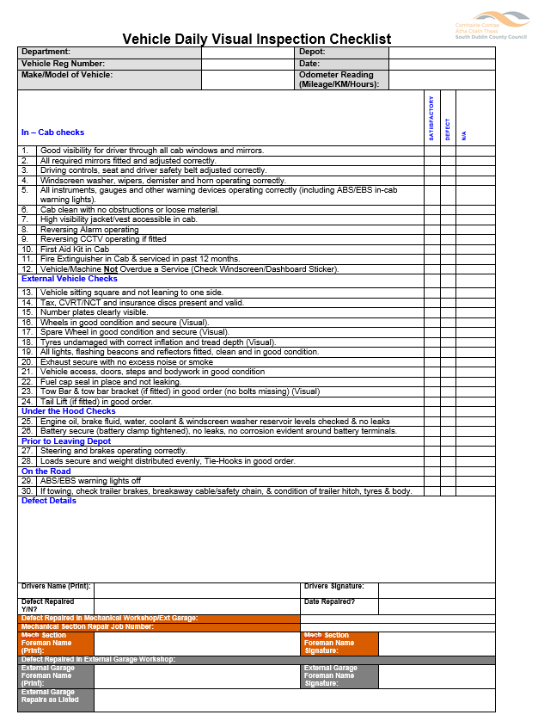

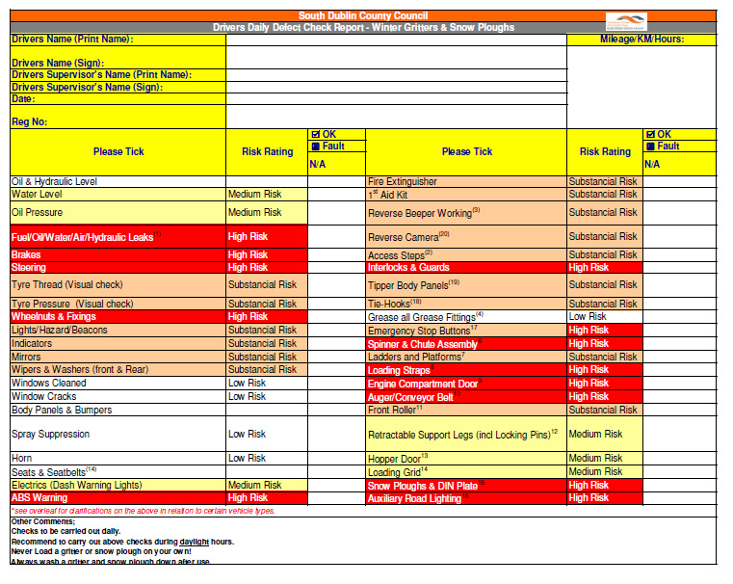
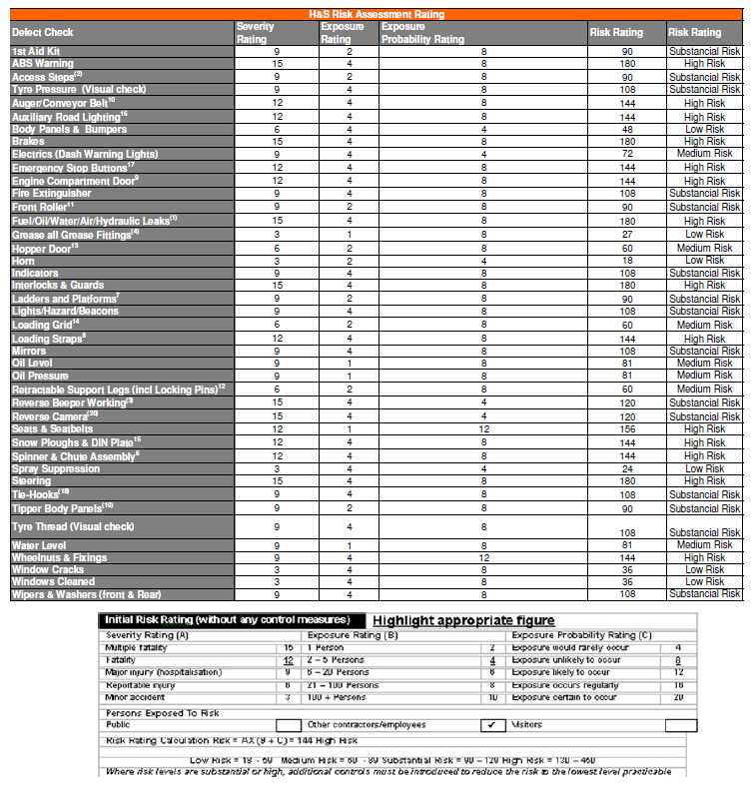
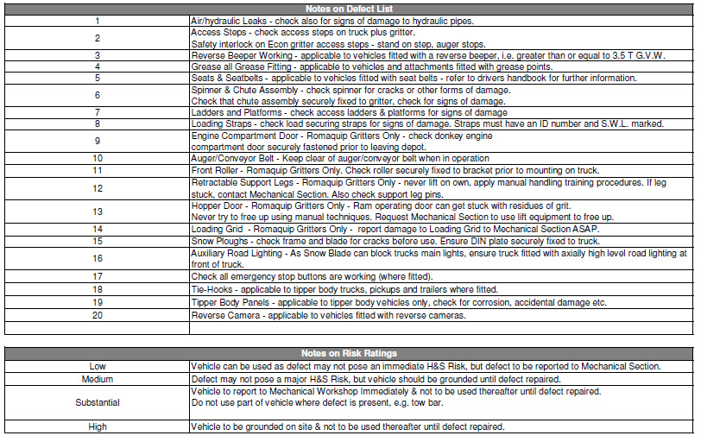

6.6 Appendix 6 - Safe Working Alone System

The Salt Spreading Operations are carried to prevent the occurrence of icy conditions on roads, the main period of activity is from mid-October to April 30th, but it is not exclusive to this period.
The operation when activated is scheduled each night to finish approximately two hours before the onset of icy conditions on the road. The equipment consists of a truck and a gritter mounted on the truck. The gritters are located in the Machinery Yard and the Salt used is stored in the salt barns.

Hazards
The Risk Assessments of the winter salting activity refers to the activity of lone working and lists the controls as follows.
- In the event that a driver operates the Salt Spreading Unit without an attendant, a Safe Working Alone System must be put in place.
- A communication procedure and an emergency procedure must form part of the system.
- An arrangement for periodic checks must be included.

Safe Working Alone System
The following is the lone working procedure to comply with these controls
- Before leaving the depot
  - Complete check of machine
  - Complete check of controls
  - Complete communications check with designated contact

- During Route
  - Check in with designated contact at approximately 30-minute intervals or agreed timing
(Specific check in locations and timings should be agreed with the supervisor and recorded to coincide with specific points on the route e.g. end of specific section of road, suitable stop point, etc)
  - Check in with designated contact on completion of route

Stop Procedure
In the event of stopping during the route, the following shall be the procedure
- Park in a safe location
- Communicate with the designated contact
(When leaving the cab, inform the designated contact that you are leaving the cab, for what purpose and how long you expect to be out of the cab)
- Contact your designated contact on return to the cab
- Personnel Should never mount the Bridge of the Salt Spreader unattended

Breakdown Procedure
- In the event of breakdown during the route, the following shall be the procedure
Park in a safe location
- Communicate with the designated contact
- Remain in the cab and await instructions from your supervisor.

Standard Operating Procedure No. 16
Use of Equipment, Tools and Plant: COVID-19 Requirements
Date: 14th May 2020 Version: 1.0

Potential Hazards
- Contamination with COVID-19 virus.
- Spread of COVID-19 virus.
- Coming into contact with someone who has the virus and is coughing and sneezing. Close contact includes face to face contact; spending more than 15 minutes within two metres of an infected person; living with an infected person.
- Touching surfaces that an infected person has coughed or sneezed on.
- Inability to maintain physical distancing requirements in line with public health advice

COVID-19 Personal Protective Equipment (PPE)

PPE requirements should be determined by risk assessment

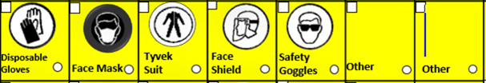
Procedures
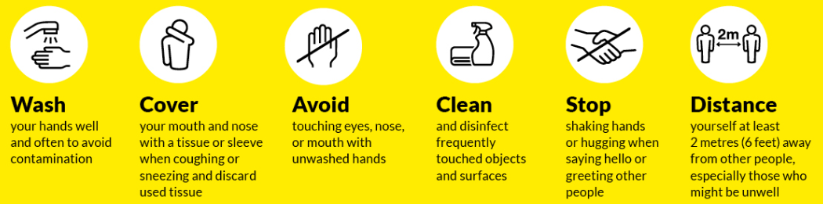
Line Manager
- Ensure COVID-19 Induction training has been provided
- Ensure a log of contact / group work is kept to facilitate contact tracing
- Arrangements to be made for one individual to use the same tool, plant and equipment as much as possible.
- Ensure adequate provision of hand sanitising facilities and cleaning materials.

General Arrangement for use of Equipment, Tools and Plant:

- All tools and equipment should be properly sanitised to prevent cross contamination.
- Sharing of tools and equipment should be avoided if possible.
- Plan work for one individual to use the same equipment or tool as much as possible.
- Where this is not possible then commonly used surfaces / touch points must be wiped down with disinfectant between each use by the user.
- Cabs and touch points of vehicles and site plant to be cleaned by operator and maintained daily thereafter).
- Consider provision of posters / stickers in the workplace to encourage staff to complete ongoing disinfection of tools and equipment that is shared

Close Working Less than two metres
In the first instance, all options to eliminate the close working activity should be considered and exhausted.

Where two metres physical distancing cannot be avoided the following is required:
- Risk assessment to be carried out and control measures determined including PPE requirements.
- Only those required for the task shall be allowed within the physical distancing exclusion zone, erect barriers where necessary.
- Limit the amount of time of close working to the absolute minimum.
- Hygiene to be maintained to a high standard:
  - Clean hands before and after activity
  - Avoid touching face
  - Practice good respiratory hygiene and cough etiquette
  - Work environment and equipment to be cleaned before and after activity
- Avoid physical contact and personnel to operate side by side, facing away from each other where possible.
- PPE used is to be removed and disposed of appropriately i.e. disposable PPE to be double bagged and placed in a bin and non-disposable PPE to be sanitised.

Monitoring of Arrangements

- Covid-19 arrangements on site to be monitored regularly by the Site Supervisor.

If you are feeling unwell or displaying symptoms, self-isolate and make phone contact with your GP/ Line Manager and Human Resources Department.

Standard Operating Procedure No. 14
Travel for Work: COVID-19 Requirements

Date: 14th May 2020 Version: 1.0

Potential Hazards
- Contamination with COVID-19 virus.
- Spread of COVID-19 virus.
- Coming into contact with someone who has the virus and is coughing and sneezing. Close contact includes face to face contact; spending more than 15 minutes within two metres of an infected person; living with an infected person.
- Touching surfaces that an infected person has coughed or sneezed on.
- Inability to maintain physical distancing requirements in line with public health advice

COVID-19 Personal Protective Equipment (PPE)

PPE requirements should be determined by risk assessment

Procedures
Travelling to / from Work
- Where possible, walk or cycle, to and from work.
- Where possible, travel alone in your private vehicle.
- Parking arrangements for additional cars and bicycles may need to be considered as for employees during this time.
- If availing of public transport, follow physical distancing guidelines provided by operators. Minimise contact with frequently touched surfaces, e.g. handles, roof straps, isolation bars.
- Sanitise hands on arrival at work location.

Travelling in Council Works Vehicles
- Site meetings to be conducted remotely where possible.
- The occupancy level of vehicles is to be minimised and single occupancy for vehicles is preferable unless vehicles are partitioned to facilitate higher occupancy levels or when the two metres physical distancing can be achieved
- If more than one per person per vehicle, the following measures must be followed:
- Employees should not enter a work vehicle with others if they have any symptoms or have had contact with a confirmed case of COVID-19.
- Sit as far apart as the vehicle allows.
- Passenger to travel in the back of the vehicle at left passenger side.
- Keep windows of vehicles open, at least partially.
- Practice good respiratory hygiene.
- Key touch points in vehicles are to be wiped regularly (e.g. door handles, steering wheel, handbrake, gear stick, radio controls) and hands sanitised before and after entering / exiting the vehicle. Hygienic wipes and hand sanitiser must be available for this purpose.
- Sanitise hands before and after entering / exiting the vehicle.

Line Manager must:

Ensure COVID-19 Induction has been provided.

Consider the partitioning of vehicles to facilitate higher occupancy levels

Ensure a log of contact / group work is kept to facilitate contact tracing

Ensure adequate supplies of hygienic wipes and hand sanitiser are available for use in Council vehicles.

Arrange work crews to reduce sharing of vehicles as far as is reasonably practicable.

If possible, designate a single driver to a specific vehicle. Similarly, if vehicle is shared with crew member/s, crew should be assigned a specific seat for the shift.

Where possible, allow for staff to travel directly to site, to reduce numbers in depots/confined areas.

Drivers must:
- Regularly clean/disinfect all hard surfaces likely to be touched by the passenger and/or driver.
- Keep cleaning products in the cab/vehicle.
- Use disposable gloves and hand hygiene measures when filling fuel at public service stations.
- Wash hands with soap and water or hand sanitiser when filling fuel at depot
- When sharing vehicle, maintain airflow in vehicle throughout journeys, i.e. keep windows at least partially open.

Note 1: IPB has issued an advisory note in relation to the partitioning of vehicles to facilitate higher occupancy levels to Local Authorities. Local Authorities should ensure that they are informed about this item.

Note 2: Commercial Vehicle Roadworthiness (CVR) testing is currently suspended. However, vehicles should continue to be maintained in a road worthy condition

Monitoring of Arrangements

- Covid-19 arrangements on site to be monitored regularly by the Site Supervisor

If you are feeling unwell or displaying symptoms, self-isolate and make phone contact with your GP/ Line Manager and Human Resources Department.

Duty Engineer Roster 2020-2021
Winter Service Duty Engineer' Roster for the Period 12th October 2020 to 30th April 2021
Local Authority Name: |  |  |  | SOUTH DUBLIN COUNTY COUNCIL
Week Starting Monday | Duty Engineer's Initals | Week Starting Monday | Duty Engineer's Initals | Week Starting Monday | Duty Engineer's Initals |  | Week Starting Monday | Duty Engineer's Initals
12/10/2020 | TOG | 30/11/2020 | JMcC | 18/01/2021 | CL |  | 08/03/2021 | CO’C
19/10/2020 | TOG | 07/12/2020 | MG | 25/01/2021 | CL |  | 15/03/2021 | CO’C
26/10/2020 | TOG | 14/12/2020 | MG | 01/02/2021 | CL |  | 22/03/2021 | CO’C
02/11/2020 | JMcC | 21/12/2020 | MG | 08/02/2021 | CL |  | 29/03/2021 | TOG
09/11/2020 | JMcC | 28/12/2020 | MG | 15/02/2021 | CL |  | 05/04/2021 | TOG
16/11/2020 | JMcC | 04/01/2021 | MG | 22/02/2021 | CO’C |  | 12/04/2021 | TOG
23/11/2020 | JMcC | 11/01/2021 | MG | 01/03/2021 | CO’C |  | 19&26/04/21 | MG
Duty Engineer's Name & Initials |  | Office Phone No |  | Office E-mail Address |  |  | Mobile Number
Tony O'Grady (TOG) |  | 01 4149000 ext 3225 |  | togrady@sdublincoco.ie |  |  | 086 856 0552
John McCormack (JMcC) |  | 01 4149000 ext 3149 |  | jmccormack@sdublincoco.ie |  |  | 086 858 9113
Michael Glynn (MG) |  | 01 4149000 ext 9235 |  | mglynn@sdublincoco.ie |  |  | 086 172 3274
Caitriona Lambert (CL) |  | 01 4149000 ext 3232 |  | clambert@sdublincoco.ie |  |  | 086 850 6771
Cian O’Connell (CO’C) |  | 01 4149000 ext 3149 |  | coconnell@sdublincoco.ie |  |  | 086 033 3017
Send to :CAFO, Met. Eireann, Glasnevin Hill, Dublin 9. Attention Duty SMO. E-Mail: forecasts@met.ie
Copy to Ms.Margaret Claffey, Transport Infrastructure Ireland, Pargate Business Centre, Pargate St., Dublin 8. E-Mail: margaret.claffey@tii.
ie

