|  |
| --- |
| **51.1 Outcome of the Public Consultation Process RTFB issues** |

The statutory consultation period on the Draft Bye Laws ran from 23rdJuly, 2020 to 11th September, 2020 inclusive.

A total of 231 submissions were received during the public consultation period of which c 7 were from the Tallaght Area, raising 8 issues, with some submissions referring to multiple issues.

The purpose of this report is to advise the Tallaght ACM of matters specific to the local area(s) and to solicit the recommendations of the ACM on such specific matters. The recommendations will be included in the statutory Chief Executive’s report on the public consultation process which will be presented to full Council later.

While submissions were also received on other issues of countywide matters, these submissions/ matters will be for the decision of full Council as part of the consideration of the Chief Executive’s report as referred to above.

The following are details of proposed Pay & Display locations within the Tallaght LEA which were the subject of most divided local submissions:

1. **Airton Road, Tallaght in its entirety**

|  |  |  |
| --- | --- | --- |
| 1 | **Airton Road, Tallaght** |  |
|  | ***Against pay and display on Airton Road, Tallaght*** | ***1*** |
|  | ***In favour of pay and display in Airton Road, Tallaght*** | ***0*** |
|  | Airton Road, Tallaght was included as a proposed paid parking location in the Draft Bye Laws, as there is extensive parking along the road.  While there is currently partial restriction / prohibition on parking with the presence of DYLs at this location, parking appears to be a mixture of transient parking and all day parking which is giving rise to complaints of illegal parking, limited turnover of parking spaces and restriction on sight lines and safe exiting from premises.  ***See images below*** |  |
|  | **Executive Recommendation:**  **This is primarily a commercial area with relatively high levels of parking.**  **Noting that the road is sufficient in width to facilitate parking on both sides, the Executive recommends the introduction of Pay and Display parking to assist with turnover of spaces, management of illegal parking and delivery of safe sightlines.**  **See image below** |  |

It is a matter for the Tallaght ACM to deliberate on the above and its recommendation will be included in the overall CE Report to the December 2020 Council Meetings.

**Airton Road, Tallaght**

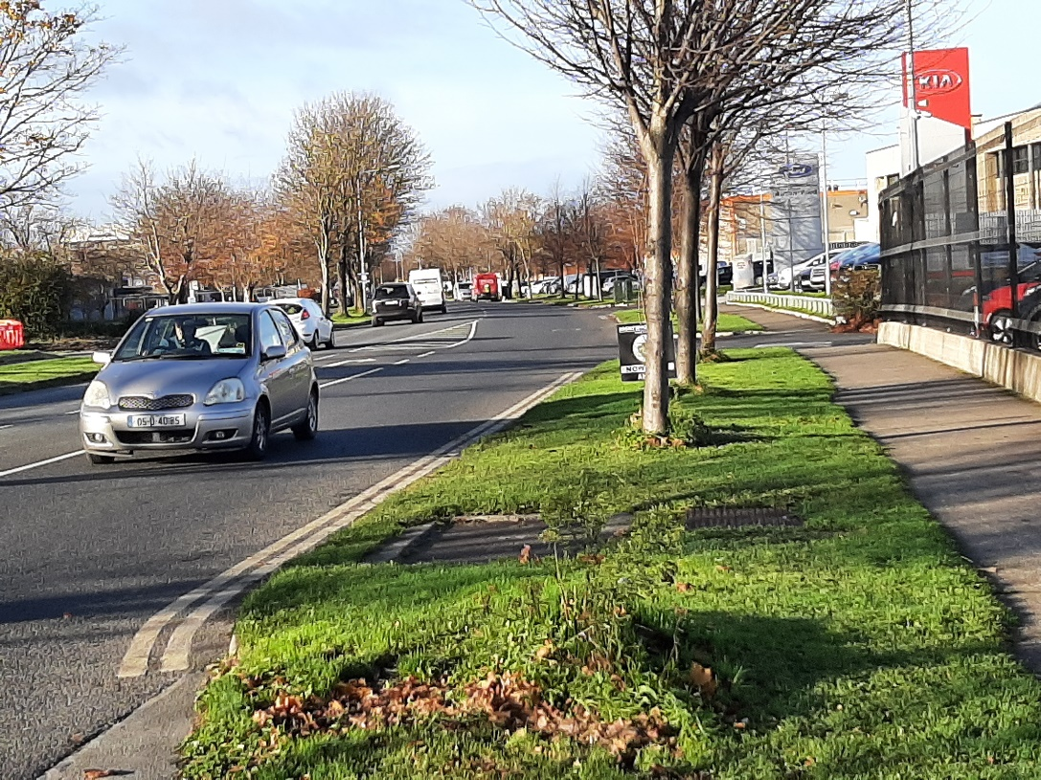

**Airton Road, Tallaght**

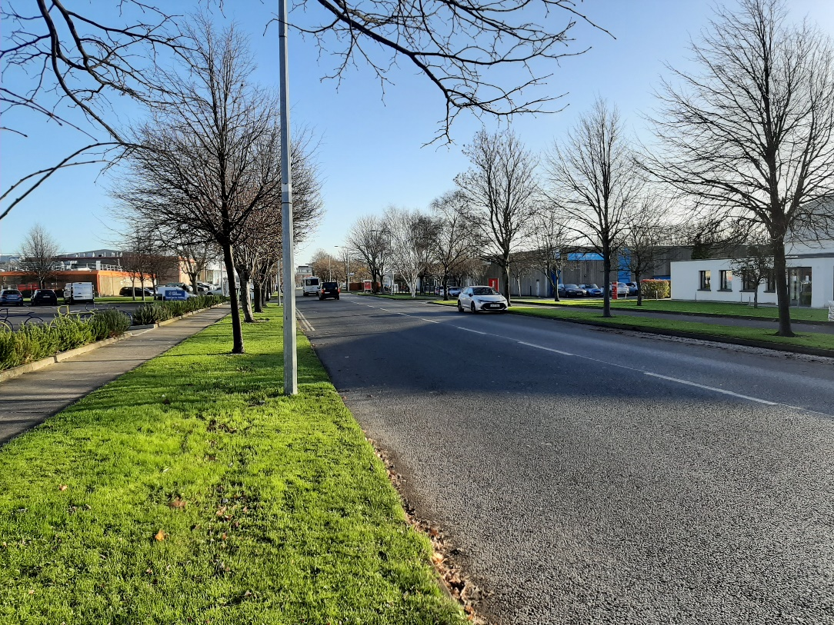

**Airton Road, Tallaght**

**Airton Road, Tallaght**

