South Dublin Libraries

**Online services**

All online services such as eBook, eAudiobooks, eMagazines, Tumblebooks for kids and eNewspapers continue to be available 24/7 with your library card and an email address.

You can also learn and language or upskill with our online courses in your own time, in the comfort of your home. Anyone wishing to join the library to avail of these services can do so online via the website.

**Call and collect**, this service was very well received with our library users and momentum was growing daily. Unfortunately, due to level 5 restrictions the service has been withdrawn for the moment.

**Housebound service,** this service is continuing during level 5 and the number of people requesting the service has increased significantly since level 5 came into force. The service is for cocooners and others who have difficulty accessing our services. U**nder the Lid**, is a DAF funded project that aims to further supplement and highlight this element of the service, borrowers give library staff their preferences and staff choose items that meet these and an Under the Lid box of various books, audio books and other materials is delivered for the borrower to keep. This service is also designed to support carers.

**In person events**

Where’s Wally, scavenger hunt took place at Rathfarnham castle on Saturday 17 October. The event was organised by staff in Ballyroan library and was part of the Red Line Book Festival programme 2020. 90 children took part, and it was a resounding success. All HSE guidelines were adhered to.

**Online events**

South Dublin Libraries have a full programme of online events and workshops for all ages. Many of the workshops and events are delivered via Zoom these include: Sign language for children, English, Irish, French, and Spanish classes, coding classes, adult digital fabrication and steam workshop, menopause talk.

All online events are available for booking across South Dublin and are not specific to the local library remit.

**Some of our online highlights include:**

**Paint Poolbeg Strolls Online Painting class for the over 55’s** this was part of Creative Ireland project. Participants took part in a live zoom events and finished the workshop with their completed piece of art. All materials were provided by the facilitator and delivered by library mobile drivers to those taking part. There were 4 sessions with 15 places on each.

**Painted Sign Workshop for families: Saturday 7 of November 11am and 2pm**

This family maker workshop is designed to help families get creative. All materials have been posted to the participants. Booking via Lucan library Eventbrite

**Online Magic Show; for children with hearing impairment. 21 November 11am**

A very special show put together specifically by Lucan Library as part of Social Inclusion week. Hearing impaired children and their families can enjoy this specially adapted fun magic show

**Season of Science – our annual celebration of all thing’s science**

**School events managed locally and booked by schools through their local library.**

Science workshop with Rediscovery Centre, 2,3,4,10 of November

Virtual Forensic Workshop, 10,11,12 of November

Reptile Zoo, 12,13,16,17,18 of November

Mysterious Microbes, 23, 24, 25, 26, 27 November

**Science events for adults as part of Season of Science; 26 November 7pm**

A crime has been committed; can you solve the mystery using forensic science?

The presenter will give a brief talk about forensic science and will teach participants how to do 2 tests commonly used in forensic scientists – chromatography and acid-based testing (kits will be sent out pre event)

Booking via Tallaght and North Clondalkin Eventbrite

**Music Generation presents Early Starters Classes**

A 6-week programme for parents and young children, beginning 12 November, 11.30 and 12.15pm

Booking via NCL Eventbrite.

**Music Tech for Young Adults**

Lucan library facilitated a music tech workshop for young adults, 8 attended and completed a 4-week online course via zoom. They learnt how to use software and equipment to record and lay down tracks. Feedback was excellent.

Following on from this success North Clondalkin Library (NCL) are finalising details for a Rock Camp facilitated by Rock Jam and funded by the DAF, the camp will target teenagers in the NCL area

**Literacy events**

Writing and publishing workshop for children, facilitated by Emma Jane Leeson from John Magory Books. This 6 week course sees a child write, illustrate and develop their own story which will then be published as a physical book that each child will receive by Christmas, participants will be given a link to print ore copies if they wish. This workshop can accommodate 10 participants and was booked out almost the moment it went live, we decided to add a further workshop which is also fully booked.

Booking was via Lucan library Eventbrite

**Keeping Well**

The Government have recently launched the nationwide **Keeping Well** campaign.

South Dublin Libraries continues to provide health-based events and workshops as part of our core programme. Recent events include: Menopause talks, mindfulness, healthy eating and cookery, yoga and chair yoga, bouncing baby club, cyber safety for children, setting healthy boundaries.

Libraries are working on a partnership with Arts to deliver “Covid Concert’s” to local nursing homes each library will identify a home to work with. Libraries hope to offer some resources to be shared with the residents to compliment the concerts for e.g. recordings of music to be played at the concert to familiarise the audience etc.

**David Coleman 24 November 7pm live webinar followed by Q&A**

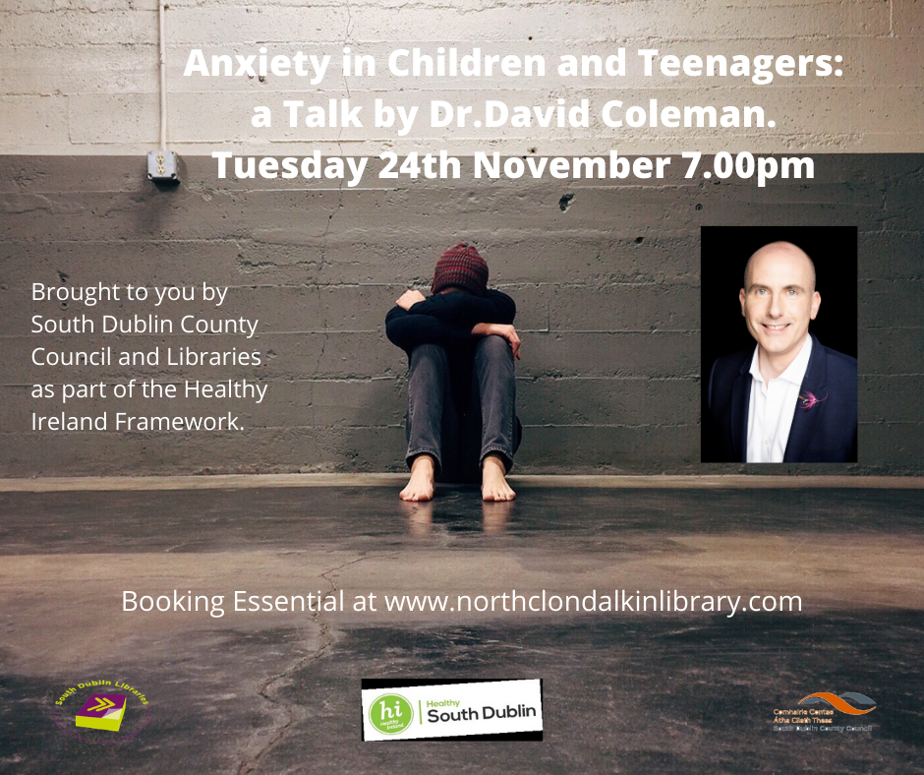

**Dr Eddie Murphy of Operation Transformation live webinar followed by Q&A. Dr Murphy will talk about navigating anxiety and stress over the festive season, particularly during these uncertain Covid times.**

**Thursday 3 December 7pm booking via Lucan library Eventbrite**



**Decade of Centenaries**

**South Dublin Libraries is delighted to present this lecture series as part of our Decade of Centenaries programme, supported by the Department of Tourism, Culture, Arts, Gaeltacht, Sport and Media. The lectures will take place online via Zoom every Thursday evening at 7:00pm in November. All events are free of charge and booking is essential at ballyroanlibrary.eventbrite.ie.**

Thursday 5th November at 7:00pm

Lorcan Collins

*The IRA’s Guerrilla Campaign 1919-21*

Lorcan Collins founded the 1916 Rebellion Walking Tour in 1996. He is the author of several books on Irish revolutionary history including a biography of James Connolly and his most recent work Ireland’s War of Independence: The IRA’s Guerrilla Campaign 1919-21. He was co-editor on the 16 Lives Series of biographies on the executed leaders of the Easter Rising. Lorcan also presents the Revolutionary Ireland Podcast.

Booking open now at [https://www.eventbrite.ie/e/decade-of-centenaries-lecture-series-the-iras-guerrilla-campaign-1919-21-tickets-126550328439](https://eur04.safelinks.protection.outlook.com/?url=https%3A%2F%2Fwww.eventbrite.ie%2Fe%2Fdecade-of-centenaries-lecture-series-the-iras-guerrilla-campaign-1919-21-tickets-126550328439&data=04%7C01%7CLCorry%40sdublincoco.ie%7Cc8c652698ca14a1d439e08d87c217707%7C6a3c00c019d0492da8de95fad8fda1d4%7C0%7C0%7C637395830464636380%7CUnknown%7CTWFpbGZsb3d8eyJWIjoiMC4wLjAwMDAiLCJQIjoiV2luMzIiLCJBTiI6Ik1haWwiLCJXVCI6Mn0%3D%7C1000&sdata=YWYUFTnl998itv%2BdM%2Ba46I24TMywCxBmQ%2F0pn%2BgMbHY%3D&reserved=0)

Thursday 12th November at 7:00pm

Dr Sínead McCoole

*Women & the Campaign for Independence*

Dr Sinéad McCoole, from the Commemorations Unit of the Department of Tourism, Arts, Culture, Gaeltacht, Sports and Media will be presenting on women and the campaign of independence, looking at some well-known women, and some not so well known, with a special focus on the region of South County Dublin.

Booking opens on 3rd November at [https://www.eventbrite.ie/e/decade-of-centenaries-lecture-series-women-the-campaign-for-independence-tickets-126552153899](https://eur04.safelinks.protection.outlook.com/?url=https%3A%2F%2Fwww.eventbrite.ie%2Fe%2Fdecade-of-centenaries-lecture-series-women-the-campaign-for-independence-tickets-126552153899&data=04%7C01%7CLCorry%40sdublincoco.ie%7Cc8c652698ca14a1d439e08d87c217707%7C6a3c00c019d0492da8de95fad8fda1d4%7C0%7C0%7C637395830464646372%7CUnknown%7CTWFpbGZsb3d8eyJWIjoiMC4wLjAwMDAiLCJQIjoiV2luMzIiLCJBTiI6Ik1haWwiLCJXVCI6Mn0%3D%7C1000&sdata=ufckumifNN4msO%2Fj%2Bs92wcHpaPhtvj7Tij5YMIZ4ZQQ%3D&reserved=0)

Thursday 19th November at 7:00pm

Dr. Myles Dungan

*The War in the Shadows – A talk on Michael Collins, the Squad and the IRA versus British Intelligence*

Dr Myles Dungan, PhD, is one of Ireland’s best-known and most respected broadcasters, hosting current affairs, arts and sports programmes on both radio and television for more than two decades. A Fulbright scholar, educated at UCD and the University of California, Berkeley, he is the author of a multiple books, including Irish Voices From The Great War (1995) and Mr. Parnell’s Rottweiler: Censorship & the United Ireland Newspaper (2014), plus works on the Irish in America, the Great War, the Irish Crown jewels and golf. He is the presenter of The History Show on RTÉ Radio 1.

Booking opens on 10th November at [https://www.eventbrite.ie/e/decade-of-centenaries-lecture-series-the-war-in-the-shadows-tickets-126554755681](https://eur04.safelinks.protection.outlook.com/?url=https%3A%2F%2Fwww.eventbrite.ie%2Fe%2Fdecade-of-centenaries-lecture-series-the-war-in-the-shadows-tickets-126554755681&data=04%7C01%7CLCorry%40sdublincoco.ie%7Cc8c652698ca14a1d439e08d87c217707%7C6a3c00c019d0492da8de95fad8fda1d4%7C0%7C0%7C637395830464646372%7CUnknown%7CTWFpbGZsb3d8eyJWIjoiMC4wLjAwMDAiLCJQIjoiV2luMzIiLCJBTiI6Ik1haWwiLCJXVCI6Mn0%3D%7C1000&sdata=WR9awg3h5V%2BS7EFlkr0okv6xXcXa5lfR15AnXBvzvlw%3D&reserved=0)

Thursday 26th November at 7:00pm

Dr Ida Milne

*The other great pandemic: Spanish flu in Ireland 1918-19*

Dr Ida Milne is a historian of disease, specialising in the 1918-19 influenza pandemic in Ireland and in infectious diseases of childhood. She is European History Lecturer at Carlow College. Her book, Stacking the Coffins, influenza war and peace in Ireland 1918-19 was published in 2018 and has come to be viewed as a handbook for understanding different societal impacts of the current COVID-19 pandemic. She is a frequent contributor to national and international media on the historic context for the current crisis.

Booking opens on 17th November at [https://www.eventbrite.ie/e/decade-of-centenaries-lecture-series-the-war-in-the-shadows-tickets-126554755681](https://eur04.safelinks.protection.outlook.com/?url=https%3A%2F%2Fwww.eventbrite.ie%2Fe%2Fdecade-of-centenaries-lecture-series-the-war-in-the-shadows-tickets-126554755681&data=04%7C01%7CLCorry%40sdublincoco.ie%7Cc8c652698ca14a1d439e08d87c217707%7C6a3c00c019d0492da8de95fad8fda1d4%7C0%7C0%7C637395830464646372%7CUnknown%7CTWFpbGZsb3d8eyJWIjoiMC4wLjAwMDAiLCJQIjoiV2luMzIiLCJBTiI6Ik1haWwiLCJXVCI6Mn0%3D%7C1000&sdata=WR9awg3h5V%2BS7EFlkr0okv6xXcXa5lfR15AnXBvzvlw%3D&reserved=0)

**Other historical themed events**

**Dubliners*: The Sisters, Eveline, A Painful Case, Ivy Day in the Committee Room, The Dead***

A study on a selection of short stories by James Joyce including his most famous story, The Dead. The series will start on Wednesday 18th Nov and run for 5 Wednesdays, finishing up on 16th December. bookings at [library@stewartscare.ie](mailto:library@stewartscare.ie)

**Introduction to Genealogy with Eneclann – a 6-week online course beginning**

**5 November at 7pm**

Booking via Lucan library Eventbrite