|  |
| --- |
| **1.1 Outcome of the Public Consultation Process Clondalkin issues** |

The statutory consultation period on the Draft Bye Laws ran from 23rdJuly, 2020 to 11th September, 2020 inclusive.

A total of 231 submissions were received during the public consultation period of which 17 were from the Clondalkin Area, raising 6 issues, with some submissions referring to multiple issues.

The purpose of this report is to advise the Clondalkin ACM of matters specific to the local area(s) and to solicit the recommendations of the ACM on such specific matters. The recommendations will be included in the statutory Chief Executive’s report on the public consultation process which will be presented to full Council at the December 2020 Council Meeting

While submissions were also received on issues of countywide matters, these submissions/ matters will be for the decision of full Council as part of the consideration of the Chief Executive’s report as referred to above.

The following are details of Pay & Display submissions and locations within the Clondalkin AC which were the subject of most local submissions:

1. **Monastery Rise**
2. **Monastery Park/Drive (not included in the Draft Consultation process)**

|  |  |  |
| --- | --- | --- |
| 1. | **Monastery Rise, Clondalkin** | 6 |
|  | ***In favour of Pay and Display*** | ***2*** |
|  | ***Against Pay and Display Monastery Rise, Clondalkin*** | ***4*** |
|  | This area was Included in draft Parking Bye Laws at the request of local residents.  On recent inspections there was no evidence of parking issues which could be addressed by Pay and Display.  However, it is understood that pre Covid there were issues with car parking at the end of the cul-ded sac end of the Rise. This may be addressed through the extension of Double yellow lines. |  |
|  | ***Executive Recommendation: Not to include in the Parking Bye Laws as no parking issues identified at this location***  ***See images below*** |  |
| 2. | **Monastery Park/Drive – beside Lexington Nursing Home** | 6 |
| 2 | This area was not included as a proposed location for P & D parking in the Draft Byelaws. However, a number of submissions (5) were made citing issues relative to illegal parking and some (2 number ) suggesting that P & D be introduced as a remedy to illegal parking.  A number of the submissions (6 referred to alleged parking issues associated with construction of a nearly nursing home  2 submission referred to potential parking issues that might arise when the nearby nursing home is operational  A number of other submissions sought the introduction of or the continuation of signing and lining restrictions (DYLs)  On inspections there was no evidence of parking on the double yellow lines along Monastery Park. On-street parking was observed on both Monastery Park and Monastery Drive, but not to the degree that would impede traffic free flow or to the degree as set out in some of the submissions. |  |
|  | ***Executive Recommendation:***  ***There is currently no evidence of issues arising to warrant inclusion of this area as a P & D area and the executive recommends that this location not be included as a P & D area .***  ***As this area was not included in the list of proposed locations for Pay & Display in the initial public consultation, any intent to include it now would be considered a material change to the draft ByeLaws as published and would require a further public consultation process specifically for this location (.Monastery Park/Drive).***  ***See images below*** |  |

It is a matter for the Clondalkin ACM to deliberate on the above and its recommendation on each of the locations will be included in the overall CE Report to the December 2020 Council Meetings.

**Monastery Park**

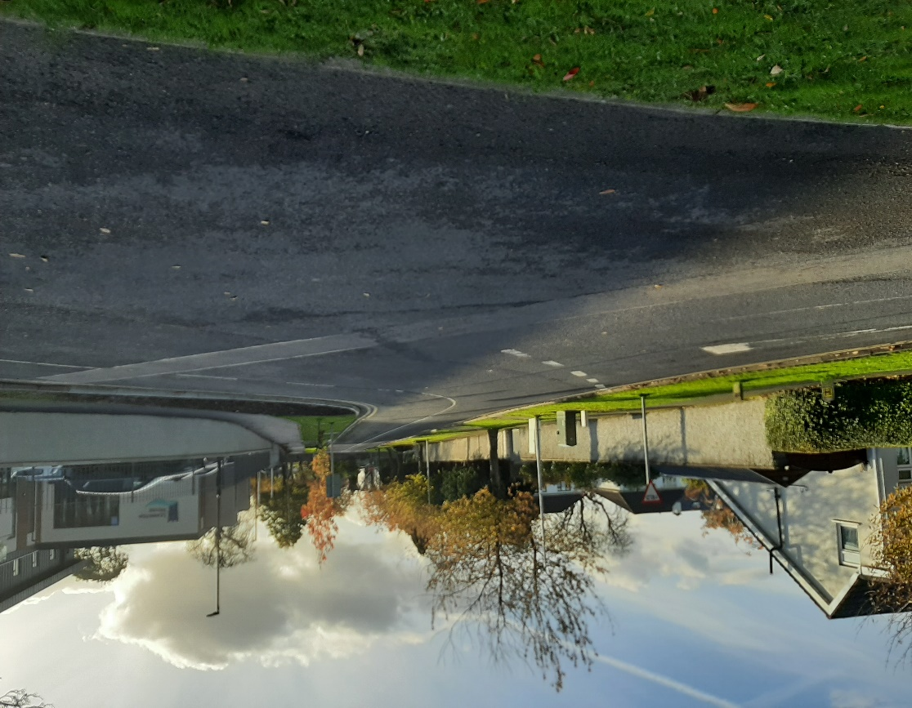

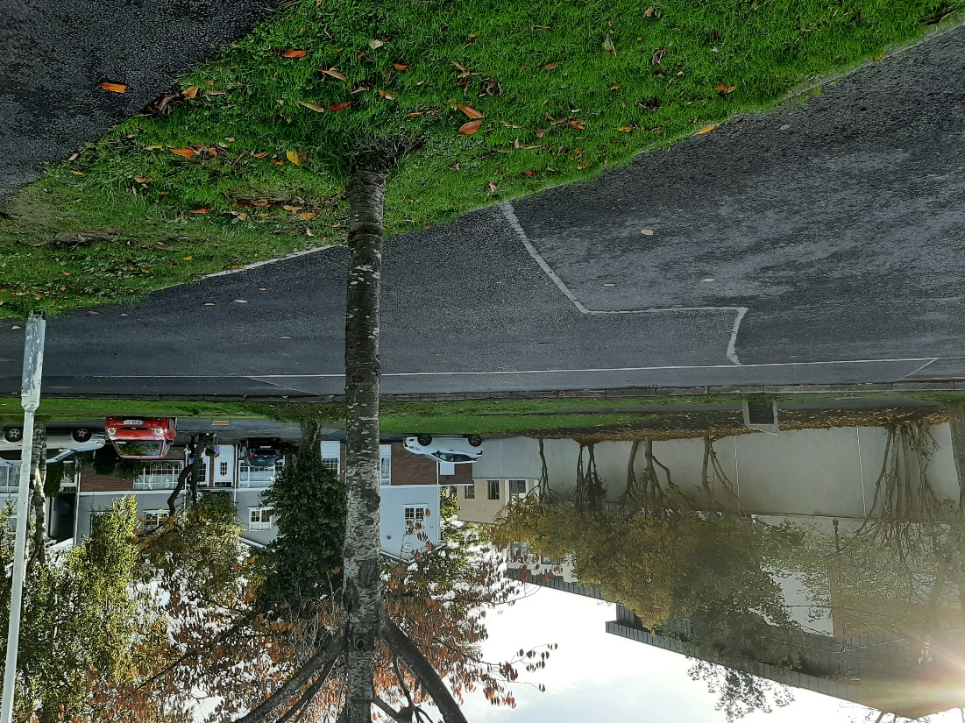

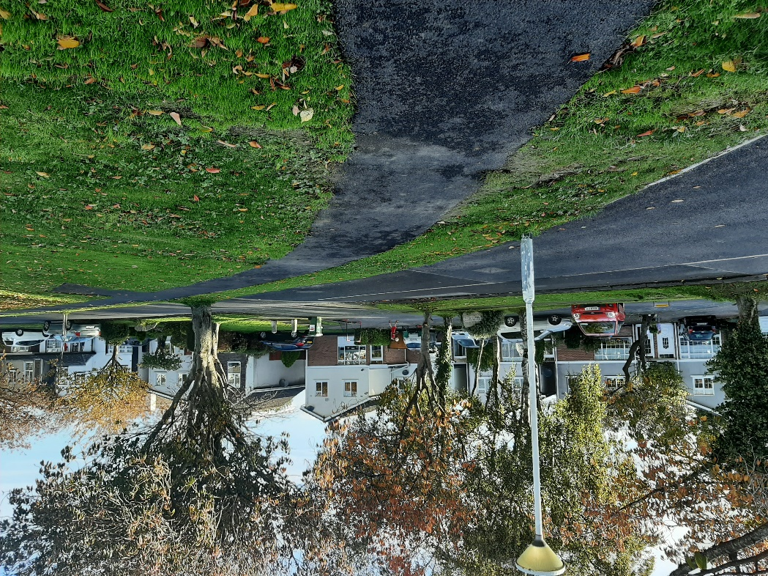

**Monastery Drive**

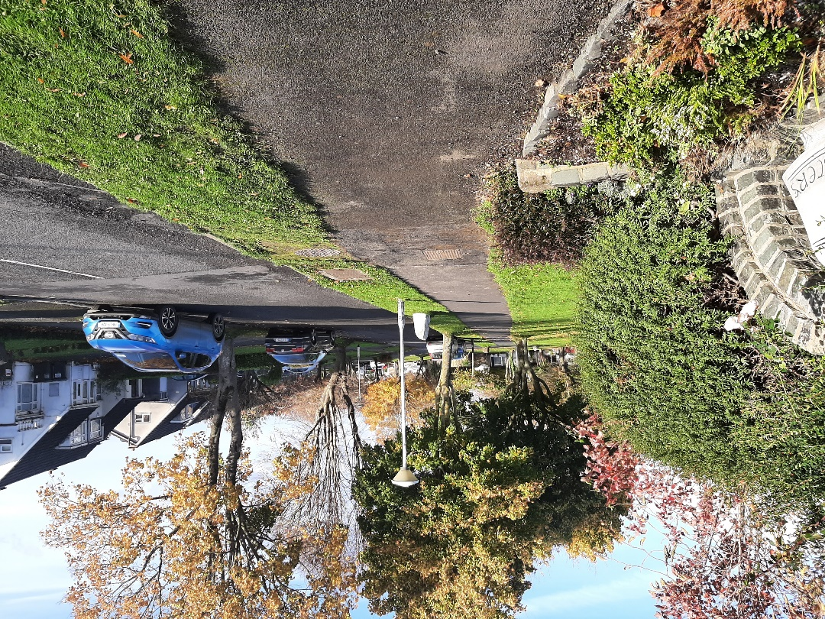

**Floraville Ave (Pay and Display in place)**

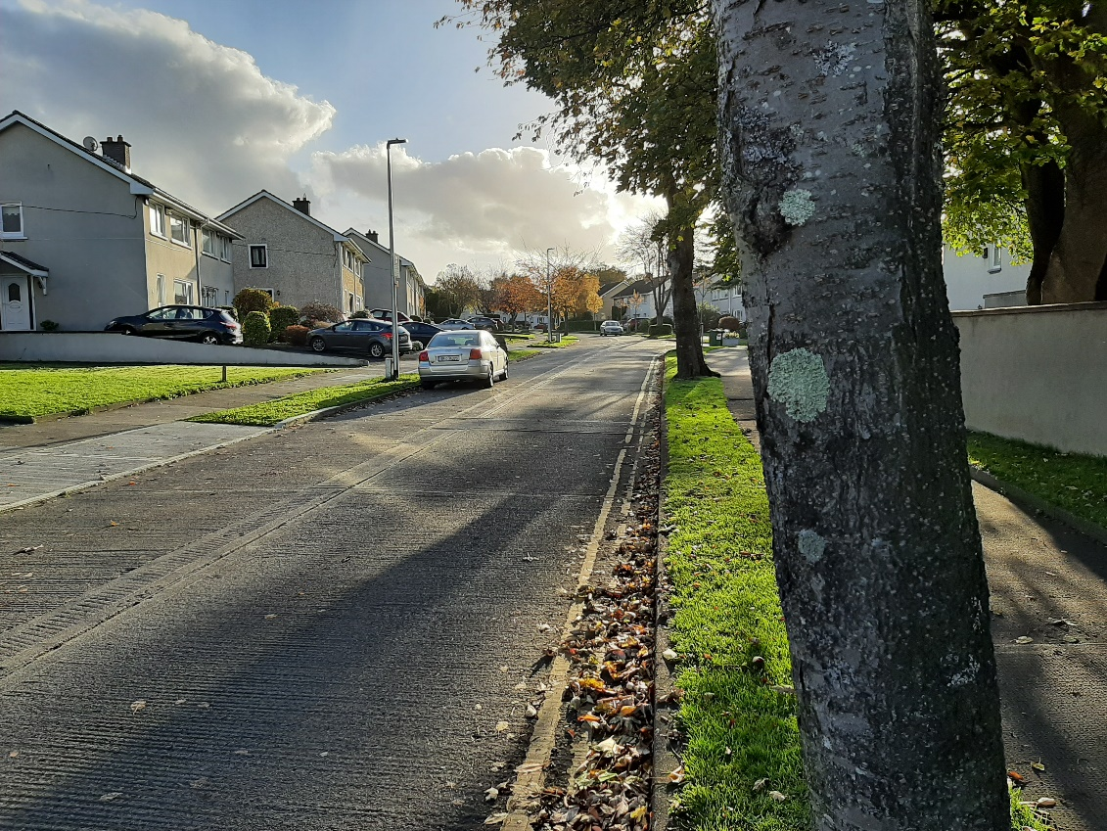

**Monastery Rise**

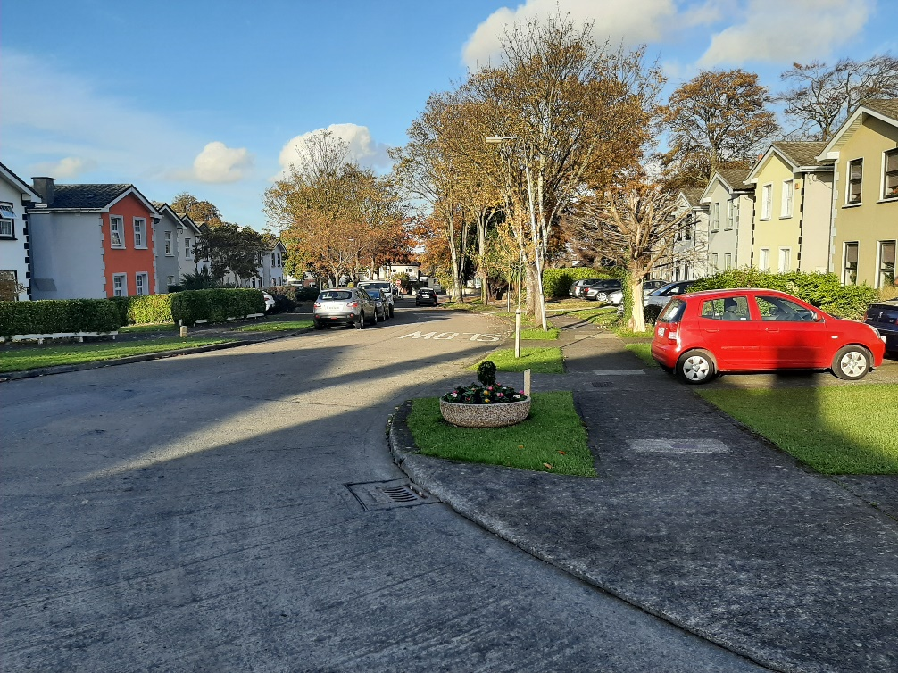

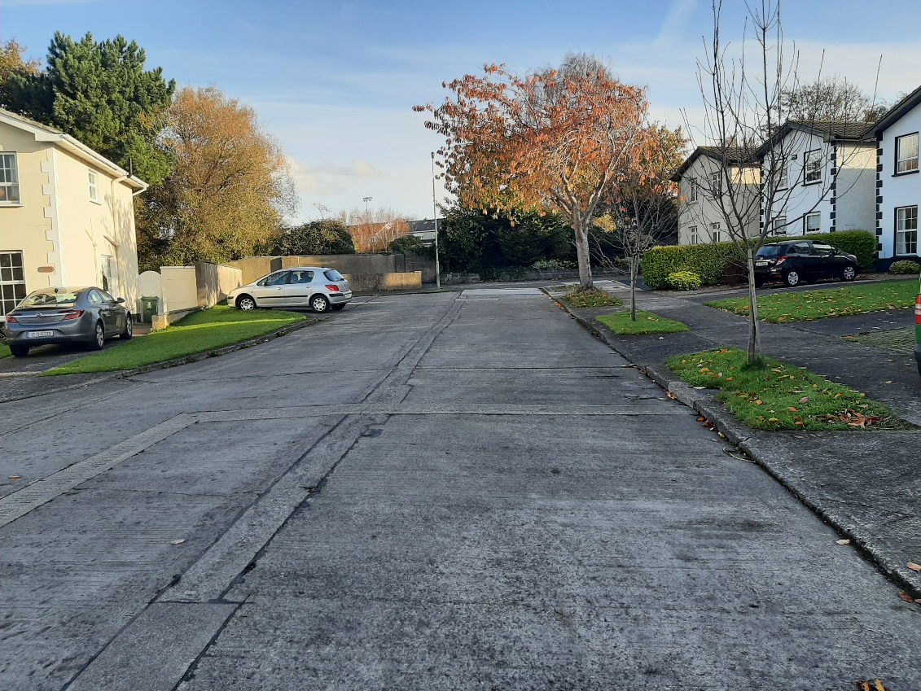

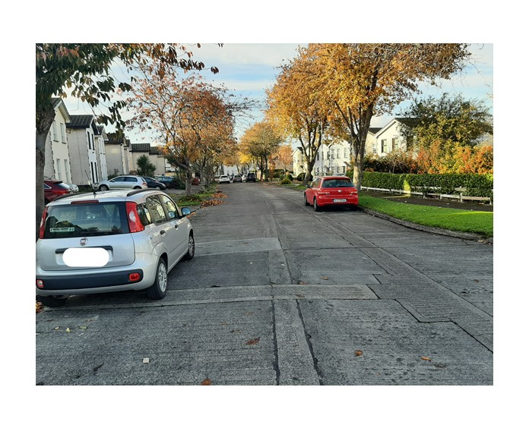

**Cul de sac end of Monastery Rise**

