|  |
| --- |
| **1.1 Outcome of the Public Consultation Process RTFB issues** |

The statutory consultation period on the Draft ByeLaws ran from 23rdJuly, 2020 to 11th September, 2020 inclusive.

A total of 231 submissions were received during the public consultation period of which c 140 were from the RFTB Area.

The purpose of this report is to advise the RTFB ACM of matters specific to the local area(s) and to solicit the recommendations of the ACM on such specific matters. The recommendations will be included in the statutory Chief Executive’s report on the public consultation process which will be presented to full Council at the December 2020 Council Meeting

While submissions were also received on other issues of countywide matters, these submissions / matters will be for the decision of full Council as part of the consideration of the Chief Executive’s report as referred to above.

The following are details of proposed Pay & Display locations within the RTFB LEAs which were the subject of most divided local submissions :

1. **Rosemount Car Park, Ballyroan**
2. **Barton Drive (at shops), Rathfarnham**
3. **Beaufort Villas, Rathfarnham**
4. **Butterfield Crescent, Rathfarnham**

|  |  |  |
| --- | --- | --- |
| 1 | **Rosemount Car Park** |  |
|  | ***Against pay and display in Rosemount S.C., Rathfarnham*** | ***30*** |
|  | ***In favour of pay and display in Rosemount S.C., Rathfarnham*** | ***8*** |
|  | Rosemont Car park was included as a proposed paid parking location in the Draft ByeLaws, following representations from RPC (Rosemount Parking Committee) citing issues with long stay parking resulting in limited turnover of parking spaces.  On inspections it was observed that there were ample spaces available in the “Ballyroan” end of the car park, with the “Supermarket” end more heavily trafficked and evidence of kerb side parking immediately in front of the shops which is permitted.  It was observed that that the majority, although not all, of the outlets are likely to attract short stay customers.  It was further observed that there is private parking in the location of the Church and Pastoral Centre with limited access.  There is significant parking to the rear near Ballyroan Library accessible from Orchardstown Ave  ***See images below*** |  |
|  | **Executive Recommendation: As there is a relatively high level of usage of the facility, the Executive recommends the introduction of Pay and Display parking to assist with an equitable use and turnover of spaces across the carpark as a whole.** |  |
| 2 | **Barton Drive (at shops)** |  |
|  | ***Against Pay and display Barton Drive, Rathfarnham (these were primarily from local residents)*** | ***10*** |
|  | ***In favour of pay and display on Barton Drive*** | ***2*** |
|  | Barton Drive was included as a proposed paid parking location in the Draft ByeLaws as representations were made over a period of time citing a problem (for residents) which might be remedied by the introduction of pay and display parking.  Site inspection confirmed that the problem reported exists at certain times only – which appears to coincide with crèche times.  Further observations demonstrated that the majority of commercial outlets would be patronised by short stay customers, although it was observed that potentially two premises may attract customers who would require longer parking periods. these two premises were not trading at times of site inspections due to Covid 19 restrictions. (A hairdresser and a beauty salon)  ***See images below*** |  |
|  | ***Executive Recommendation: The Executive recommend that this location be removed from the Parking Bye Laws as paid parking would not resolve issues identified by residents around crèche time.*** |  |
| 3 | **Beaufort Villas, Rathfarnham** |  |
|  | ***Against Pay and Display in Beaufort Villas, Rathfarnham*** | ***4*** |
|  | ***In favour of pay and display at Beaufort Villas*** | ***0*** |
|  | This area was included in the draft Bye Laws as it was an existing location in the current and previous Bye Laws.  On inspection there was no evidence of Pay and Display implementation, with no ticket machine to facilitate payment in the vicinity.  Similarly, the location demonstrated minimal number of spaces where safe parking access and egress could be provided.  ***See images below*** |  |
|  | ***Executive Recommendation: The Executive recommend that this location be removed from the Parking Bye Laws as its size does not lend itself to safe access and egress for multiple users.*** |  |
| 4 | **Butterfield Crescent, Rathfarnham** |  |
|  | ***Against pay and display Butterfield Crescent, Rathfarnham*** | ***5*** |
|  | ***In favour of pay and display Butterfield Crescent, Rathfarnham*** | ***2*** |
|  | This area was included as a proposed paid parking location in the Draft ByeLaws, on foot of a petition from some residents in Butterfield Crescent.  On inspection of the location, there was no evidence of the area being used as a parking area for the nearest commercial area of Rathfarnham Shopping Centre/ Long stay parking.  It was further observed that the road is not of a sufficient width to accommodate P & D on both sides of the road  ***See images below*** |  |
|  | ***Executive Recommendation: Executive recommends that this location be removed from the Bye Laws as pay and display could only be implemented by initiating specific parking prohibitions on one side only which would be non-conducive to a fair and equitable basis for P&D / Residents’ permits.*** |  |

It is a matter for the TFB ACM to deliberate on the above and its recommendation on each of the locations will be included in the overall CE Report to the December 2020 Council Meetings.

**Barton Drive**

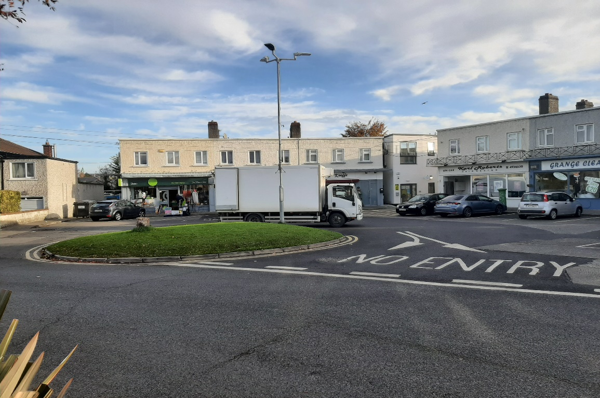

**Butterfield Crescent**

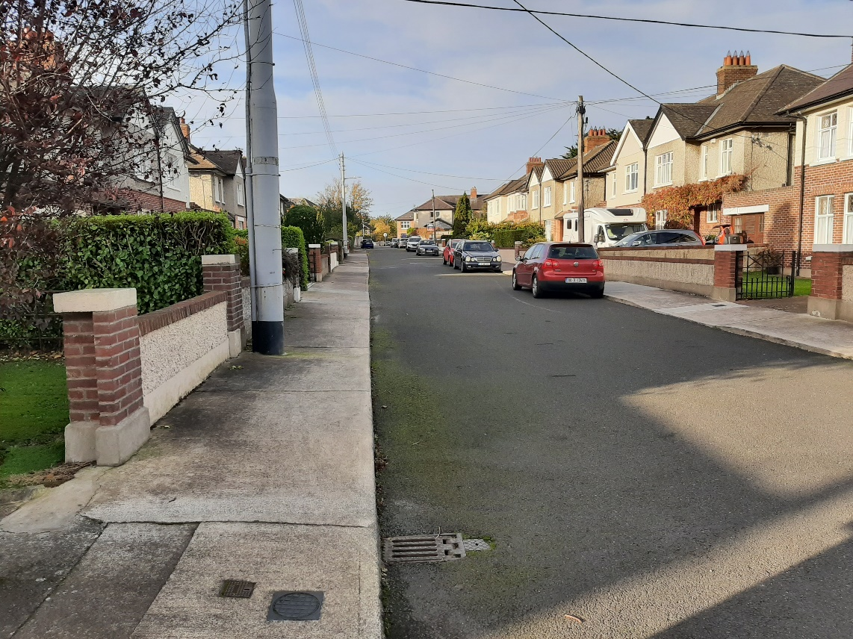

**Butterfield Crescent**

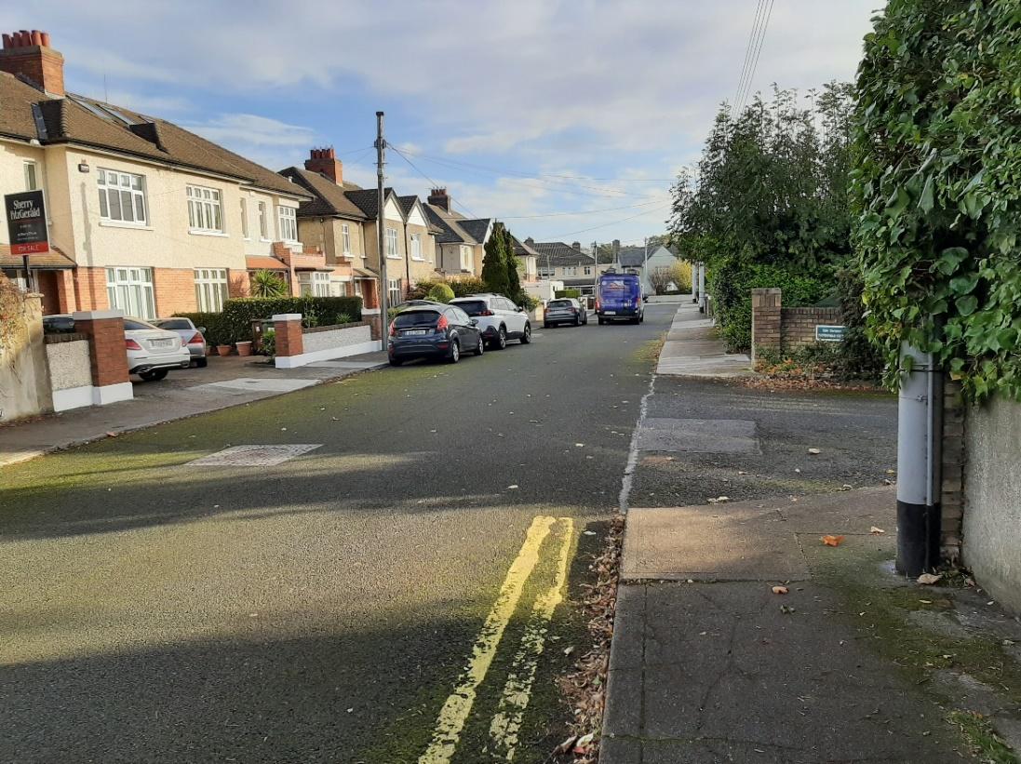

**Beaufort Villas**

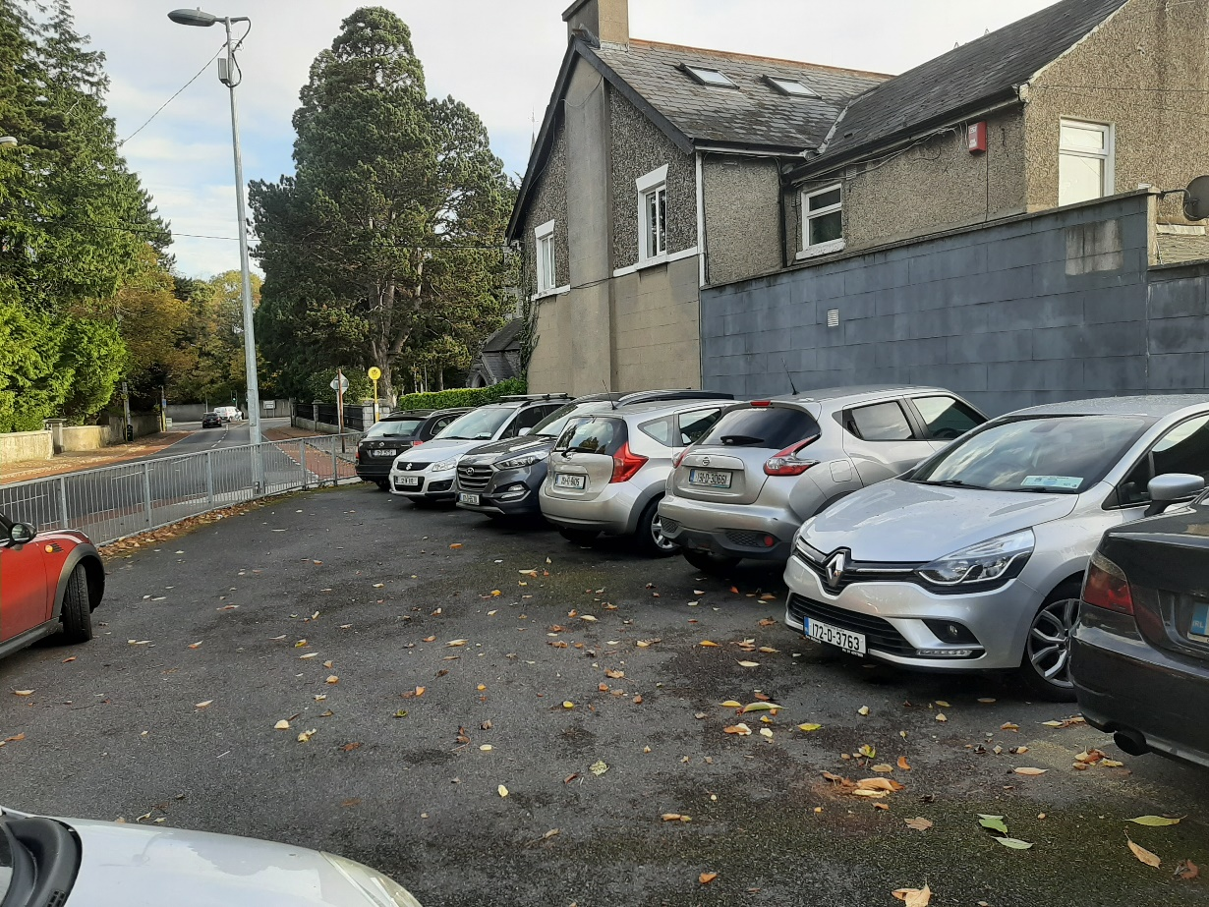

**Rosemount Shopping Centre**

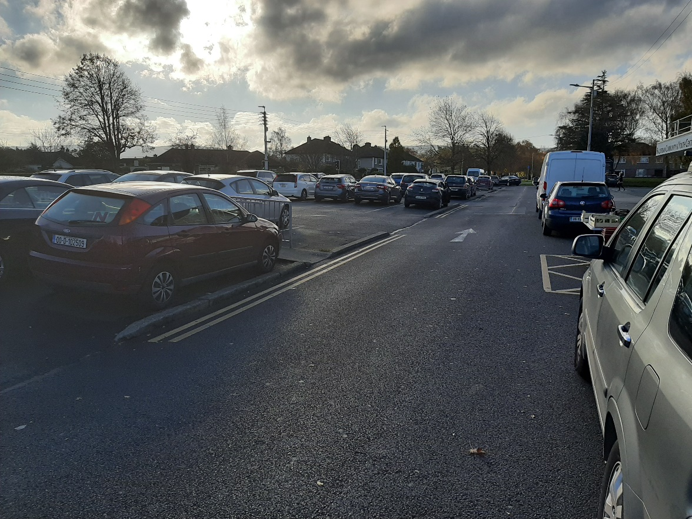

**Rosemount Shopping Centre**

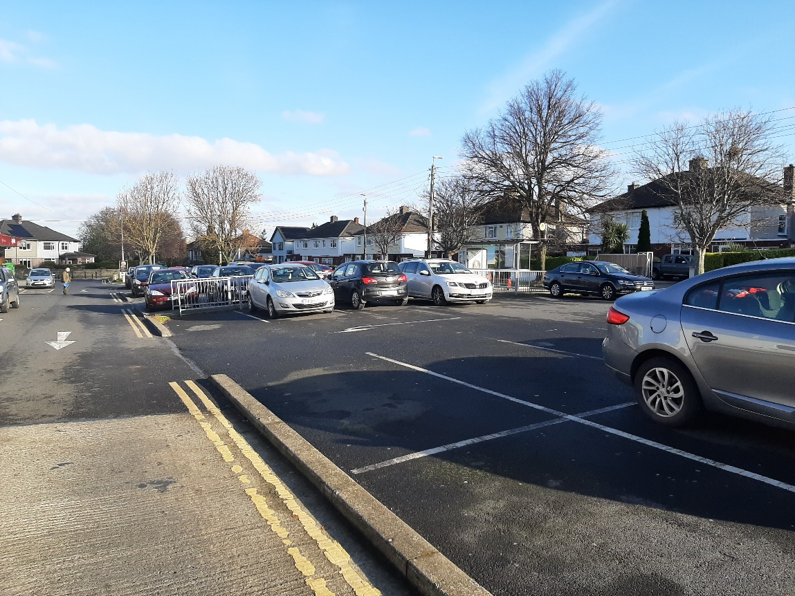

**Rosemount Shopping Centre**

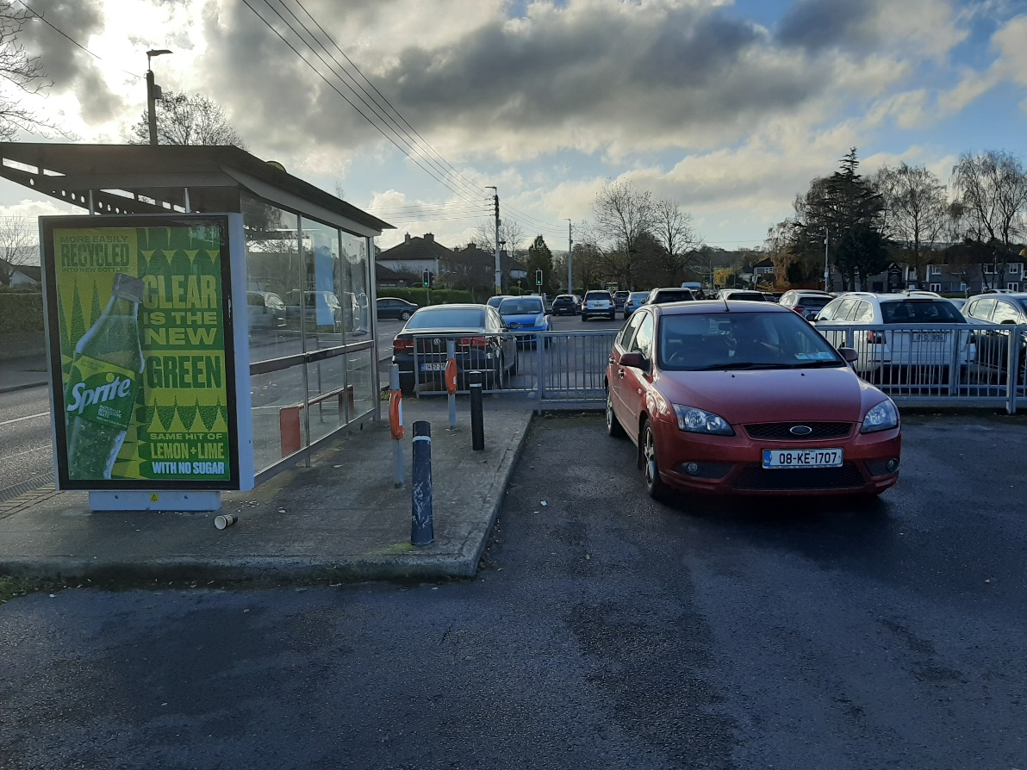

**Rosemount Shopping Centre**

