A Protocol

For conducting Hybrid

Council Meetings

Contents

Introduction: 3

Using the platform: 4

Joining the meeting 6

The toolbar 6

Video 6

Mute 7

Other features 7

Chat 7

Participants 7

Hang Up 7

Meeting Etiquette: 8

# Introduction:

Microsoft Teams is the Council's corporate standard for conducting or participating in online meetings.

# Meeting procedures:

Management of hybrid meetings

1. Members should notify the Meetings Administrator in advance if they intend to attend the meeting remotely, by emailing [Meetingsadmin@sdublincoco.ie](mailto:Meetingsadmin@sdublincoco.ie).

2. Any member participating in a meeting remotely must, when they are speaking, be able to be heard (and seen, where practicable) by all other members in attendance, and the remote participant must, in turn, be able to hear (and see, where practicable) those other members participating.

3. The Chair will at the outset, and at any reconvening of a meeting, call a roll call of participating members and ensure that they can hear and, where practicable, see those in attendance. Any member participating remotely should also confirm at the outset and at any reconvening of the meeting that they can hear and, where practicable, see the proceedings. Members should inform the meeting if they lose connection in accordance with provisions on connectivity within the agreed standing orders.

4. The attendance of those members at the meeting will be recorded by the Meetings Administrator, by roll call. For members who join the meetings after the roll call, they must ensure their camera is on when being admitted to the meeting. The Mayor / Chair will acknowledge the member’s attendance as soon as possible without disrupting the meeting proceedings.

5.The normal quorum requirements for meetings as set out in the Council’s Standing Orders will also apply to a remote meeting. Members attending physically and remotely will together constitute a quorum.

6. Each member participating remotely has personal responsibility to ensure and confirm to the Meetings Administrator that there are no other persons present who are not entitled to be either hearing or seeing consideration of such items, and/or recording the proceedings, in accordance with standing orders that apply.

7. Subject to compliance with General Data Protection Regulations (GDPR), the Meeting Administrator may facilitate the recording of the meeting for the purposes of taking minutes. However, this recording shall only be used for this purpose and will be deleted once the minutes are agreed.

## Before joining the meeting

* The meeting organiser will email you an invitation to the meeting. Once accepted, the meeting details are added to your Outlook calendar.
* The Meetings Administrator will coordinate the facilitation of the meeting. An appropriate official will assume responsibility for controlling the conferencing technology employed for remote access and attendance, and to administer the member interaction, engagement and connections on the instruction of the Mayor.
* Members should allow sufficient time to establish a connection prior to the commencement of the meeting to allow themselves and the Meeting Administrator the opportunity to test the connection.

# Using the platform:

Members should notify their Meetings Administrator in advance if they intend to attend the meeting remotely.

## Joining the meeting

* The meeting organiser will email you an invitation to the meeting. Once accepted, the meeting details are added to your Outlook calendar.
* To join the meeting, click the Join Microsoft Teams Meeting link

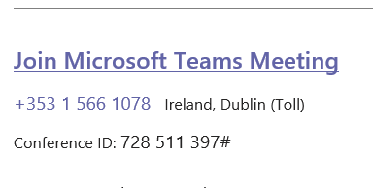

* Then click ‘Join now’

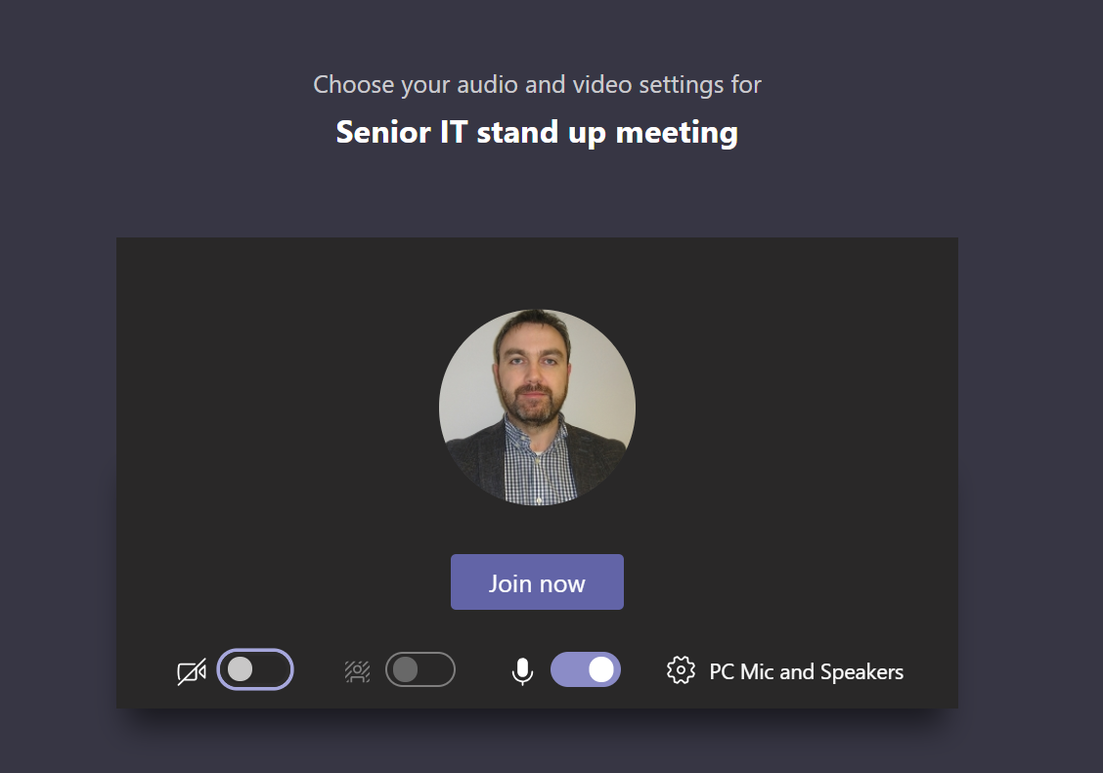

* You are now in the meeting.
* Please ensure your microphone is muted from the beginning.
* Using a headset will improve the quality of the sound for the meeting.

## The toolbar



While in a Teams meeting you will notice the control toolbar. It allows you to manage your participation. By clicking the buttons, you can control your camera, microphone and chat window. On the left-hand side, you will see the meeting duration and by clicking the ‘hang up button’ on the right hand side you can leave a meeting.

### Video



Click this button to share your video / click again to cancel. Doing this allows other meeting participants to see you. This must be on when speaking, including when responding to a roll call or a vote.

### 

### Mute



Click this button to mute / unmute your microphone. Doing this allows other meeting participants to hear you. It is important to ensure you microphone is muted during the meeting except when you have been invited to speak.

### 

### Other features



Clicking this button presents the user with a number of features such as customised background, live captions and device settings.

### 

### Chat



Click this button to indicate that you wish to speak on an item. Please note that the chat function should only be used to indicate your wish to speak, and that your chat can be seen by all meeting participants. Please review the section on meeting etiquette for more details.

### 

### Participants



Click this button to see all other participants on the meeting.

### 

### Hang Up



Click this button to leave the meeting. You can re-join by clicking the link to the meeting your mailbox (as you did at the start).

# Meeting Protocol:

1. The Chair will explain the procedure at the beginning of the meeting to all participants.
2. All participants will be muted at the beginning of the meeting. Members can chose to have their camera on or off for the meeting, but must have their camera on for the roll call, when speaking, and during voting.
3. By clicking the screen, the below window (menu) will appear.



4. Only unmute when you are invited to speak.

5. Use **Show Conversation** to confirm your attendance at the meeting.

6. Attendance call will be held as is the norm by the Meeting Administrator, Members will also be requested to sign in on the **Show Conversation** screen, especially if / when joining the meeting post Attendance Call.

7. The item number being discussed will appear in **Show Conversation (Meetings chat)**. Please indicate that you want to speak on this item by inputting your name here.

8. The Chair will invite you to speak, you should then unmute your **mic.** Please state when you have concluded your contribution and remember to mute the **mic** when you have finished speaking.

9. Normal time limits will apply.

10. There is a short delay to change the view of the CMAS screen. Please give time for this to happen.

11. If you are having difficulty during the meeting, let the administrator know in **Show Conversation** (this can be seen by everyone). If at any time a member is having difficulty during the meeting please let the administrator know in **Show Conversation.** Alternatively, there is an option to “ring in” on the number assigned to the meeting in the meeting invitation. If you have lost all internet connection, please ring the Meeting Administration number, issued in the meeting invitation.

12. Remember to check your **mic** in case you have it muted when you should be speaking. Please remember to mute when you have finished speaking.

13. The Chair will be controlling the meeting and progressing through the agenda in the usual manner. All requests must go through the chair.

14. The CMAS screen will be shared by the Meeting Administration team.

# Meeting Etiquette:

* Please ensure your microphone is muted from the beginning.
* Using a headset will improve the quality of the sound for the meeting for those participating remotely, but must be used for those attending the meeting in the location.
* Use the chat function to indicate your wish to speak on the item, and not to express a view on the subject.
* Please do not speak unless called on by the Chair of the meeting.