**Update of South Dublin Libraries September/October 2020**

Libraries are continuing to deliver and develop a full programme of online events and activities for the citizens of South Dublin including:

Coding classes, science workshops, Lego workshops, Spanish classes, Irish, classes, beginner’s genealogy classes, mindfulness, yoga, cookery classes for children, book clubs and much more.

South Dublin Libraries are very aware of the appetite of our community to attend “in person” events and workshops. (With this in mind and pre-Dublin moving to stage 3) Keith Payne, our Writer in Residence and part of the Red Line Book Festival has held in person writing workshops in Tallaght library on Mondays and Wednesdays as part of a 10 week programme, these have been moved to online for the present.

**Culture Night**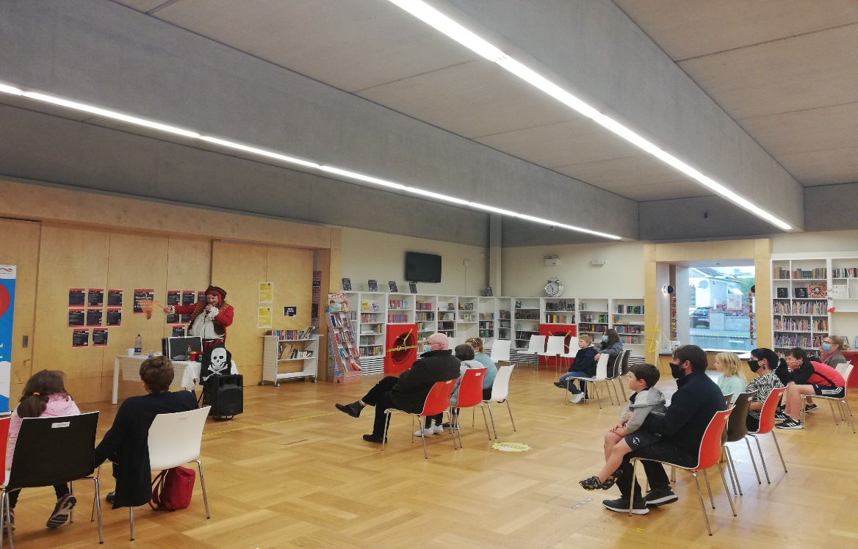

Ballyroan and Tallaght library held in person events to celebrate Culture Night.

Theses were a mixture of children’s events, talks and exhibitions.

The new North Clondalkin Library hosted private tours of the new library to showcase the library to the local community.

**What is coming up in October**

North Clondalkin Library have also produced a virtual tour of the building which has been included in the annual **Open House programme 8-11 of October** [www.openhousedublin.com](http://www.openhousedublin.com)

**Red Line Book Festival**

The programme is now mostly online, all events are free to attend and events are booking up very well. The festival is particularly welcomed by those living within the Dublin area, as it offers some cultural respite in the current climate.

One event **“Where’s Wally”** a treasure hunt taking place in Rathfarnham park on the 17 of October will take place. 90 children have enrolled, and the numbers will be managed as per HSE guidelines

We have postponed a few events that will be better kept as in person events in early 2021. We hope to have a small sub festival “Between the Redlines” to showcase these. The programme has been updated and the online version can be viewed here: [https://www.redlinebookfestival.ie/siteDocs/Redline2020.pdf](https://eur04.safelinks.protection.outlook.com/?url=https%3A%2F%2Fwww.redlinebookfestival.ie%2FsiteDocs%2FRedline2020.pdf&data=02%7C01%7CLCorry%40sdublincoco.ie%7C3b228048e325422aebeb08d866b147b3%7C6a3c00c019d0492da8de95fad8fda1d4%7C0%7C0%7C637372258877155110&sdata=MrJcFmasu3vwJv6PBrFI3%2BLNv3v4Mws%2FSn7qry94%2FcY%3D&reserved=0)

Red Line is receiving good publicity nationally and was mentioned by author Sinead Gleeson on RTE Arena programme, podcast available here: [https://podcast.rasset.ie/podcasts/audio/2020/0930/20200930_rteradio1-theartofth_c21843795_21843843_232_/20200930_rteradio1-theartofth_c21843795_21843843_232_.mp3](https://eur04.safelinks.protection.outlook.com/?url=https%3A%2F%2Fpodcast.rasset.ie%2Fpodcasts%2Faudio%2F2020%2F0930%2F20200930_rteradio1-theartofth_c21843795_21843843_232_%2F20200930_rteradio1-theartofth_c21843795_21843843_232_.mp3&data=02%7C01%7CLCorry%40sdublincoco.ie%7C0e748084f2624a8b05c408d866b60abf%7C6a3c00c019d0492da8de95fad8fda1d4%7C0%7C0%7C637372280364121095&sdata=PGOoSxUI6nOiSa%2F7hRYOOYWvhZfh17O5qhTc3anlPEE%3D&reserved=0)

The festival also featured in the Irish Independent and Journal.ie, as well as more local papers.

Today, 2 October there is an excellent feature in the Irish Times online available here: [https://www.irishtimes.com/culture/books/writers-on-editing-how-do-they-kill-their-darlings-1.4368417](https://eur04.safelinks.protection.outlook.com/?url=https%3A%2F%2Fwww.irishtimes.com%2Fculture%2Fbooks%2Fwriters-on-editing-how-do-they-kill-their-darlings-1.4368417&data=02%7C01%7CLCorry%40sdublincoco.ie%7C0e748084f2624a8b05c408d866b60abf%7C6a3c00c019d0492da8de95fad8fda1d4%7C0%7C0%7C637372280364131060&sdata=7lOhf%2FKxVSMj%2FPj%2Fd7A3BzsFMSpcqhkA0qIG%2B3u7Wb4%3D&reserved=0)

**Children’s Book Festival 5 – 21 of October**

Normally this festival is delivered by class visits to the library. However, this year the festival is being delivered online with live Zoom into classrooms.

The authors this year are Sibeal Pounder, Sarah Moore Fitzgerald and Shane Hegarty. They will deliver 18 sessions across the primary school network.

**October Highlights online activities**

**3 October – funded by SFI**

During October libraries will be delivering more coding workshops for older children, with a 5-week coding class running from 3 October. The 5-week attendance ensures a good learning outcome.

**6 October**

Paint Poolbeg Strolls Online Paining Class for 55+Online painting class for over 55’s. This live painting class takes place via Zoom. All materials required are provided in a handy starter kit. No experience is required as you will be shown in easy step by step instructions how to go from blank canvas to finished masterpiece! The lead artist will answer any questions as you work. Facilitated by Paintclub.

This event is supported by the Creative Ireland Programme South Dublin. All 15 spaces for Ballyroan have sold out.

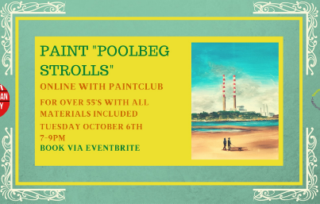

**10 – 18 October Maths Week**

**Maths Detectives (Online) funded by SFI**

Presents the 5 curriculum strands (numbers, algebra, shapes, space, measures, and data) to students in a fun and interactive way whilst practicing maths skills to solve mysteries, puzzles, and crimes. There will a pack per class to be selected by the teacher. All activities are linked to the primary curriculum.

3rd to 6th class.

Schools from Tallaght, Ballyroan, North Clondalkin and Lucan have signed up to take part in these online live Zoom events.

**Exhibitions**

County library will host; From Under the Hill - a new solo show of works by leading contemporary gothic painter Pat Byrne 21-31 October. The artist will give two gallery talks on 31 of October, one will be a sensory talk on the exhibition for the visually impaired and the second will be for the public. Numbers will be limited.

“In this exhibition we see superstitions manifest into dark creatures walking the earth paradoxical in their darkness as shards and glimmers of humanity reflect back at us”

**Halloween and midterm – round up**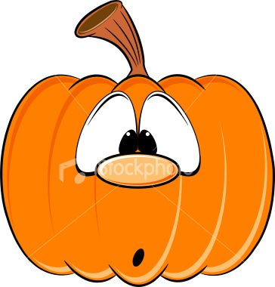

**Cool Food School Halloween Treats!**

Learn how to make healthy Halloween snacks with this interactive online workshop for children.

Booking Essential. Children can book on any of the library Eventbrite links.

**Ballyroan Library** Tuesday 27th October @ 2.00pm booking on [https://www.eventbrite.ie/o/ballyroan-library-2184216231](https://eur04.safelinks.protection.outlook.com/?url=https%3A%2F%2Fwww.eventbrite.ie%2Fo%2Fballyroan-library-2184216231&data=02%7C01%7CLCorry%40sdublincoco.ie%7C78fc676d738c474f0c4d08d85f088eaf%7C6a3c00c019d0492da8de95fad8fda1d4%7C0%7C0%7C637363837636714446&sdata=zDAP9hLgDA%2BfeHCFk4wQtOoWIDiHyyc%2BhwFhcEdJFEE%3D&reserved=0)

**North Clondalkin Library** Wednesday 28th October @ 3.00pm booking from 10.00am Wednesday 14th October on [https://www.eventbrite.ie/o/north-clondalkin-library-31079450849](https://eur04.safelinks.protection.outlook.com/?url=https%3A%2F%2Fwww.eventbrite.ie%2Fo%2Fnorth-clondalkin-library-31079450849&data=02%7C01%7CLCorry%40sdublincoco.ie%7C78fc676d738c474f0c4d08d85f088eaf%7C6a3c00c019d0492da8de95fad8fda1d4%7C0%7C0%7C637363837636724445&sdata=fd1pSEkMzFIHZr7R%2FalimCNyecq7hMzculag5O4QPjM%3D&reserved=0)

**County Library Tallaght**  Friday 30th October @ 12.00pm booking on [www.talib.eventbrite.com](https://eur04.safelinks.protection.outlook.com/?url=http%3A%2F%2Fwww.talib.eventbrite.com%2F&data=02%7C01%7CLCorry%40sdublincoco.ie%7C78fc676d738c474f0c4d08d85f088eaf%7C6a3c00c019d0492da8de95fad8fda1d4%7C0%7C0%7C637363837636734434&sdata=xLtSvMlYySL5IekRH3nHu5Ry4CFrsV6t5GOuAFTnagg%3D&reserved=0)

**Lucan Library** Thursday 29th October @ 10.00am booking from Monday 19th October on [www.lucanlibrarydublin.eventbrite.ie](https://eur04.safelinks.protection.outlook.com/?url=http%3A%2F%2Fwww.lucanlibrarydublin.eventbrite.ie%2F&data=02%7C01%7CLCorry%40sdublincoco.ie%7C78fc676d738c474f0c4d08d85f088eaf%7C6a3c00c019d0492da8de95fad8fda1d4%7C0%7C0%7C637363837636724445&sdata=iFlb0%2FpqtbqqYKacOZZYZCwTazpDB0WiEmt37h%2BibOQ%3D&reserved=0)

**Clondalkin Library** Friday 30th October @ 2.00pm booking on [http://clondalkinlibrary.eventbrite.ie](https://eur04.safelinks.protection.outlook.com/?url=http%3A%2F%2Fclondalkinlibrary.eventbrite.ie%2F&data=02%7C01%7CLCorry%40sdublincoco.ie%7C78fc676d738c474f0c4d08d85f088eaf%7C6a3c00c019d0492da8de95fad8fda1d4%7C0%7C0%7C637363837636734434&sdata=xaUOO0Gj1MeBXODU0VTVoaSkF0BLbI2n6btMutemrrQ%3D&reserved=0)

**Lucan Library**

String up some lights and send us your pictures because we have prizes for best family dress up, best family haunted house and best carved pumpkin.

Send your entries to: [lucan@sdublincoco.ie](mailto:lucan@sdublincoco.ie) from Monday 12th October.

**Clondalkin Library**

**Tuesday 27th October 2.00-4.00pm.** Online stop motion workshop for 8-12-year olds with Create School.

**Wednesday 28th October 3.00-4.00pm**. Online Halloween costume upcycling for adults with Rediscovery.

**Wednesday 28th October 2.00-4.30pm.** Online Song writing for age 12+ with Create School.

**Thursday 29th October 2.00-4.30pm.** Online Podcasting for age 12+ with Create School.

Booking Essential on [http://clondalkinlibrary.eventbrite.ie](https://eur04.safelinks.protection.outlook.com/?url=http%3A%2F%2Fclondalkinlibrary.eventbrite.ie%2F&data=02%7C01%7CLCorry%40sdublincoco.ie%7C78fc676d738c474f0c4d08d85f088eaf%7C6a3c00c019d0492da8de95fad8fda1d4%7C0%7C0%7C637363837636744432&sdata=vikC3WE5jAsQNhIL9SlXJnW%2FSiQhm0ZvEJ1nP8%2BW%2B6U%3D&reserved=0)

**County Library Tallaght**

**Wednesday 28th October 3.00-5.00pm.** Online Laser Cut Model workshop for age 10-12 with Create School.

**Wednesday 28th of October 2.00 - 4.30**

Online Smartphone Film Making course for TY students).

The course will be 2.5 hours long and will consist of Script writing, Directing, Working with Actors and Smartphone Film Making.

Booking Essential on [www.talib.eventbrite.com](https://eur04.safelinks.protection.outlook.com/?url=http%3A%2F%2Fwww.talib.eventbrite.com%2F&data=02%7C01%7CLCorry%40sdublincoco.ie%7C78fc676d738c474f0c4d08d85f088eaf%7C6a3c00c019d0492da8de95fad8fda1d4%7C0%7C0%7C637363837636744432&sdata=%2FQt8eN9kt0qhYcMMgfVYDWXE22SYH0TzABJPvbMcZKg%3D&reserved=0)

**North Clondalkin Library**

**Halloween Colouring Competition**. Collect a colouring page in the library or download from Facebook and return to North Clondalkin Library by Saturday 31st October to be in with a chance to win Spooktacular prizes.