Rathfarnham/Templeogue/Bohernabreena Area committee

13th October 2020.

**ID: 67109**

**“To ask the manager for a report on the Noise reduction measures to be put in place for Castlefield, as outlined in the Noise Action Plan”.**

**Some key points of explanation regarding Noise**

# Noise Maps

## EU Directive 2002/49/EC, transposed into Irish law by Statutory Instrument NO. 140 of 2006 (the ‘Environmental Noise Regulations 2006'), and this calls for the development of strategic noise maps and action plans for major roads, railways, airports and cities.

## Under these Regulations, Transport Infrastructure Irleand TII is responsible for the development of strategic noise maps for all national roads carrying in excess of 3 million vehicles a year and for light rail lines (i.e. the Luas network) which has more than 30,000 passages per year. TII is responsible for the M50 and the other major roads such as N4, N7, and N81 in this county.

Castlefield is directly adjacent to the M50 on the northern side. The key components to reducing the noise in areas adjacent to the major national roads is primarily influenced by:

* the speed at which traffic is travelling at,
* the overall quantity of vehicles in the traffic flow,
* the proportion of heavy commercial vehicles (HCVs) in the flow and
* the type of road surface in the area.
* The installation of wooden or concrete noise barriers or the creation of earth banks

## What is a Strategic Noise Map?

A strategic noise map is a graphical representation of the predicted situation with regards to noise in a particular area with different colours representing different noise levels in decibels [dB(A)].

The manner in which the noise propagates away from the source must then be calculated which involves determining the reduction in noise level as it propagates from the source. Distance, ground cover and the presence of barriers such as walls, noise barriers, etc. will all influence the level of noise attenuation. All barriers along the M50 are in the ownership of TII, who have fixed monitors along this route and all other major national roads.

 All noise maps are presented in terms of two noise indicators: Lden and Lnight.

**Lden** is the day-evening-night noise indicator and it represents the noise indicator for overall annoyance. It is ‘weighted’ to account for extra annoyance in the evening and night periods.

**Lnight** is the night time noise indicator and is used in the assessment of sleep disturbance.

 These indicators are based on year long averages of the day (07:00-19:00), evening (19:00-23:00) and night (23:00-07:00) time periods.

* Fom a planning perspective in South Dublin, noise is being viewed more closely in residential developments particularly those close to major roads, and in a much more critical and analytical manner.
* Developers are being requested to have noise mitigation plans at the original date when such applications are being lodged.
* The current 4th European Noise Action Plan will last until 2023.
* In the past noise was not considered an issue, whereas today it is viewed on a par with Air Pollution across most countries in Europe
* Monitoring of both is now more often done simultaneaously at the same site as traffic is a major source of both.
* EPA Ireland funded research have just completed 2 projects on noise and in particular Environmental Traffic Noise. One of the big findings is that there is very little national guidance in Ireland or policy statements or objectives from central government on Noise.
* In 2018, the Government issued the National Planning Framework 2040, which includes - **Policy Objective 65** to:
  + Promote the pro-active management of noise where it is likely to have significant adverse impacts on health and quality of life and support the aims of the Environmental Noise Regulations through national planning guidance and Noise Action Plans.
* Noise Mapping is largely centred around the large cities or agglomerations throughout Europe. In Ireland, the cities of Dublin Cork and Limerick are involved in Round 4.
* The Dublin agglomeration includes all four local authorities, SDCC,DCC, Fingal and DLR Rathdown.
* The EPA is the statutory agency for reporting to the EEA in Copenhagen and from there to EU Brussels.
* South Dublin is represented on the National Noise strategic committee by Environmental Health and Road Traffic departments with input and involvement also from Planning Department. TII are also on this strategic committee and we interface with them on issues such as Castlefield or other similar residential areas along our major roads.
* The National Planning Framework (NPF) notes that …….” as we seek to promote more compact and efficient forms of development within our settlements, it is important to more proactively manage noise’. For larger urban areas, the extra value placed on ‘Quiet areas’ has been highlighted as a key priority in the national planning framework. The role out of Objective 65 of the NPF is expected to be the main driver for environmental noise policy in Ireland over the coming decades.
* In this context, the Dept. of Environment (DCCAE) are hoping to initiate a dialogue on the establishment of some sort of Regional structure for Air & Noise (REGAIN). The DCCAE are also considering a Noise Policy Statement which will include Objective 65 and national noise planning guidance. These issues could then be developed as part of any new programme for Government.

**Strategic Noise Maps**

A strategic noise map is designed to assess noise exposure in a given area, resulting from particular noise sources for:

* major roads (>3 million vehicle movements/annum),
* major rail (>30,000 rail passages),
* major airports (>50,000 air movements/annum) and
* agglomerations - & inside Dublin, Cork & Limerick (>100,000 inhabitants).

The noise maps are the product of assimilating a collection of digital datasets, and over the past 10 years there have been some significant improvements to the quality of the digital datasets describing the natural and built environment in Ireland.

Each LA is required to identify their noise sensitive locations, which may include drawing up a short list of potential areas for action, both above the recommended onset values for noise mitigation measures, and below the recommended level for preservation (to help identify Quiet Areas).

An example for the Dublin agglomeration is shown below, along with an example for Dublin airport. The EPA Maps can be used to assess noise exposure of the population in a given area. <https://www.epa.ie/monitoringassessment/noisemapping/>

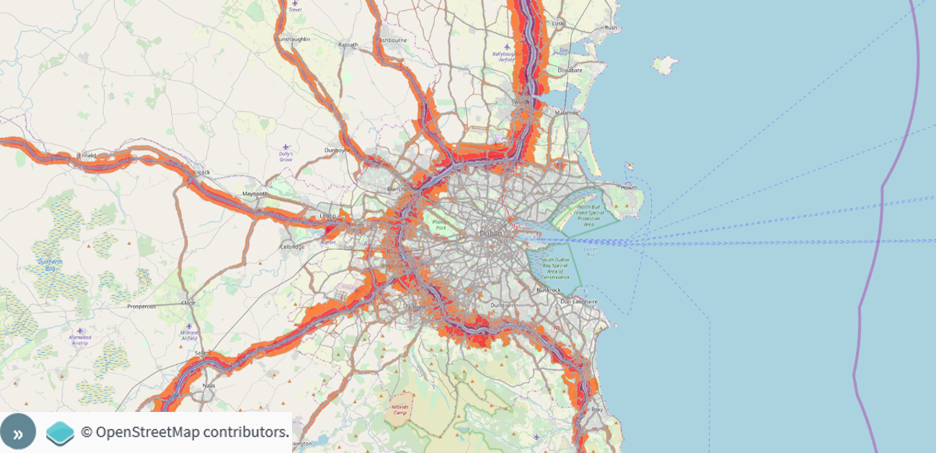

Figure 1: Dublin agglomeration roads noise map

can be accessed at: <http://www.epa.ie/monitoringassessment/noisemapping/howtoaccessdata/>

.

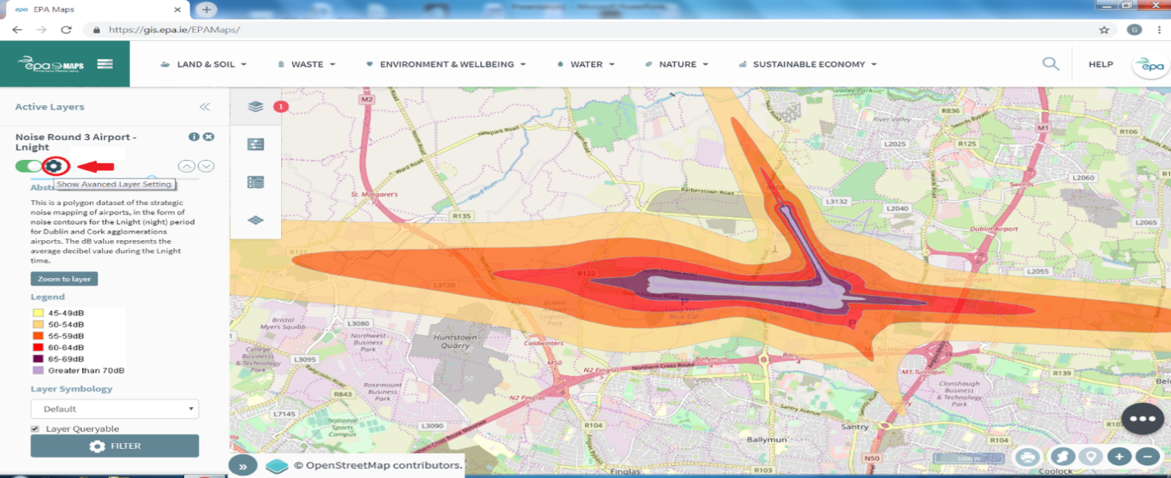

Figure 2: Dublin airport noise map – Lnight

In conclusion, Environmental Health will actively raise the matter with Transport Infrastructure Ireland as part of the Noise Plans in relation to the suitability of the Noise barriers at this area and to request a report from their nearest monitors in this regard. I will keep the members abreast of any outcomes.