**Cycle South Dublin**

**Draft 22 September 2020**

**Vision**

For South Dublin to become one of Ireland’s most cycle friendly counties.

**Mission**

The Council’s mission is to deliver a robust programme of cycling improvements that will enable people to choose cycling as their preferred mode of transport.

**Objectives**

* Provide a comprehensive and connected cycle network across South Dublin;
* Make cycling a more achievable mode of transport for all adults and children; and
* Improve the cycling identity of the County.

**Critical components**

* Identify cycle priorities: NOW (next 4 years), SOON (5 – 8 years), and LATER (8+ years)
* Design and deliver cycle infrastructure in line with best practice guidelines (DMURS and the NTA Cycle Design Manual)
* Engage with people to build community support
* Develop a robust cycling infrastructure maintenance programme
* Monitor delivery

**1 Why cycle?**

1.1 In 2016 the population of South Dublin County was 278,767 (2016 Census) and between 2016 and 2031 this will grow by a further 50,000 people up to 329,000.

1.2 This growth will generate increased need for new homes, employment space, services, amenity and community spaces. New development will follow a Compact Growth pattern where the emphasis will be on encouraging much of this new development into existing built-up areas, the intention of which is to avoid continued sprawl into greenfield land. This approach has been set by Government in the adopted National Planning Framework (2018).

1.3 As South Dublin continues to grow, the Council is keen to ensure that our existing and further citizens are supported with the right type and level of transport. Central to this will be the delivery of a high-quality transport network that provides frequent, safe and desirable public and active transport measures for people, including walking and cycling.

* Cycling can help manage increases in traffic congestion

1.4 In 2019 RTÉ news reported that Dublin had become the third worst city in the world for sitting in traffic, with Dubliners spending 246 hours sitting in traffic in 2018.

1.5 In South Dublin vehicle traffic on our key roads has increased by approximately 11% since 2016[1]. When current levels of traffic are coupled with increases in our future population growth the coming years will see yet further increases in traffic congestion. Building more roads in existing built-up areas to accommodate increased vehicle trips will not solve the issue of traffic congestion, and in most cases, is not physically possible.

1.6 The provision of higher frequency and more reliable bus, rail and Luas services are critical to help manage congestion, and to provide people with an alternative means of travel. In South Dublin there are existing rail stations at Clonburris and Adamstown on the Heuston to Kildare rail line, the Luas red line runs from the City to Tallaght and Citywest and we have many existing bus routes.

1.7 However, in recent years there has been an underinvestment in the provision of new public transport infrastructure and currently the level of existing public transport in the County is less than what is needed. The National Transport Authority (NTA) are making progress with upgrading many of the existing services and planning for new capacity via Bus Connects and DART+, but these substantial upgrades will take many years to deliver.

1.8 Cycling offers a credible alternative for short and medium length journeys. Daily within the Dublin Metropolitan area 60,000 trips are made by bike that would otherwise have been used by car (NTA, Bike Life, 2019, Pg8). By providing people with access to improved cycle infrastructure it will provide people with more realistic opportunities to cycle thereby reducing the number of unnecessary car trips.

* Cycling can help to reduce carbon emissions

1.9 Transportation contributes towards 20% of our national Greenhouse Gas (GHG) and Carbon emissions of which 52% are generated by cars. By 2030 Ireland needs to reduce its (GHG) emission by 30%, relative to 2005, and by 2050 the Government plans to achieve a net zero target (CAP, 2019). Today in Ireland cycling saves 28,000 tonnes of GHG emissions per year. Source: Bike Life Survey, 2019, Pg4.  Increasing the mode share of people cycling will lead to increased carbon savings.

* Support stronger local economies

1.10 Increased cycling investment produces tangible and measurable benefits to local economies.  By supporting cycling, we can boost economic activity in urban areas. Research from the European Cyclists Federation (ECF) has found that retailers often under-estimate the share of clients that go shopping by bike, and over-estimate the share of car users.

1.11 In New York, the City Department of Transport found that two years after construction, streets that received a protected bike lane saw a greater increase in retail sales compared to similar corridors.

1.12 In London, Transport for London found that over the course of a month, people who walked to their local center / high street spent up to 40% more than those people who would drive to the same center / high street the reason being that pleasant public realm and easy access resulted in an increased number of repeat trips and subsequently more money spent.

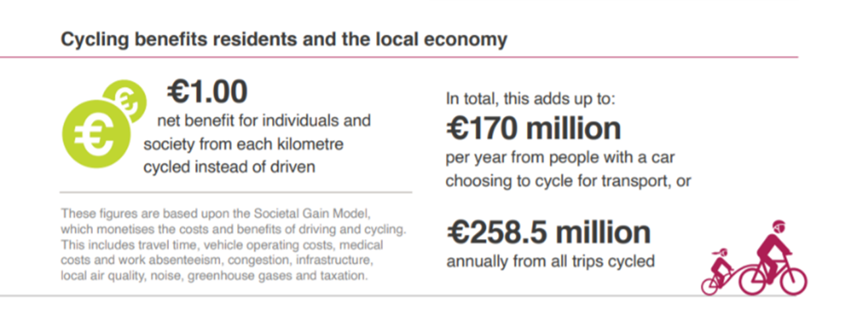

*Table 1: Cycling benefits for the local economy, NTA Bike Life 2019*

* Cycling can improve people’s health and wellbeing

1.13 Motorised transport contributors to sedentary behavior, particularly for door-to-door trips made by the car. The Worlds Health Organisation (WHO) recommends a minimum of 60 minutes of moderate-intensity daily exercise for children aged 5 – 17 years. Today in South Dublin 50% of children are driven to school by car (Census 2016). Cycling could play an increased role in people of all ages getting more exercise and thereby leading more healthy lifestyles.

**2 How do people currently travel in South Dublin**

2.1 Ireland’s National Cycling Policy Framework (NCPF) promotes a 10% cycle mode share. By comparison Manchester has a 10% cycle mode share, London a 25% cycle mode share and the Netherlands has already achieved a 50% cycle mode share.

* In Dublin 24% of adults cycle at least once a week, in South Dublin this figure is 13%[2]
* In Dublin 11% of adults cycle 5 days a week+, in South Dublin this figure is 3.8%
* In Dublin 21% of people don’t cycle but would like to, in South Dublin this is 21%

2.2 The 2016 Census figures for cycling in South Dublin, show that 6,899 of people cycle on a regular basis, which is a 3.8% transport mode share. This is an increase from 2011 when 4,985 people cycled with a 3% transport mode share. Whilst the numbers of people cycling is increasing, the existing cycle numbers are too low to meaningful address the challenges of increased traffic congestion and the association negative environmental impacts. Appendix 1 provides a detailed breakdown of mode share comparing 2011 and 2016.

**3 Numbers and mode share of people cycling to work and education in South Dublin**

3.1 Table 2 shows the number, and percentage share, of cycling trips that people made going to work and education across each of the 14 settlements in South Dublin. Where the percentage per settlement is below the NCPF 10% target it is highlighted in red, where it comes close it is highlighted in orange and where it exceeds the 10% target it is highlighted green.

|  |  |  |  |  |  |
| --- | --- | --- | --- | --- | --- |
| **Share of cycling trips made to the 14 settlements in South Dublin to go to WORK** | | | **Share of cycling trips made to the 14 settlements in South Dublin to go to EDUCATION** | | |
| **Settlement** | **Cycle** | **% Share** | **Settlement** | **Cycle** | **% Share** |
| **Adamstown** | 62 | 4.2% | **Adamstown** | 23 | 4.5% |
| **Clonburris** | 26 | 5.0% | **Clonburris** | 16 | 3.2% |
| **Clondalkin** | 640 | 4.7% | **Clondalkin** | 78 | 2.7% |
| **Liffey Valley** | 656 | 4.2% | **Liffey Valley** | 316 | 3.4% |
| **Lucan** | 306 | 2.9% | **Lucan** | 101 | 4.4% |
| **Newcastle** | 32 | 2.2% | **Newcastle** | 0 | 0% |
| **Rathcoole** | 32 | 1.5% | **Rathcoole** | 2 | 0.5% |
| **Rathfarnham_SDCC** | 2,026 | 7.7% | **Rathfarnham_SDCC** | 569 | 9.8% |
| **Red Cow_SDCC** | 26 | 4.8% | **Red Cow_SDCC** | 6 | 3.8% |
| **Saggart** | 34 | 2.0% | **Saggart** | 2 | 0.3% |
| **SDCC Rural** | 28 | 1.5% | **SDCC Rural** | 12 | 1.3% |
| **South Tallaght** | 972 | 4.5% | **South Tallaght** | 269 | 3.7% |
| **Tallaght** | 492 | 4.0% | **Tallaght** | 66 | 1.7% |
| **West Tallaght** | 250 | 3.0% | **West Tallaght** | 74 | 1.0% |

**Table 2: Share of people going to work on a bicycle**

3.2 The table shows that none of the South Dublin settlements achieve the 10% cycle share target for commuting to work or education. The Rathfarnham settlement comes the closest at 7.7% for work and 9.8% for education. The cycle mode share across all other settlements is less than 5% for cycling to work or education. This is very low when compared to the NCPF target.

**4 Distances people travel by different modes**

4.1 Informed by the 2016 Census data tables 3 and 4 provide a breakdown of the distances people travel by different travel modes from 0k to 300km.

*Table 3: breakdown of distance travelled by mode share*

|  |  |  |  |
| --- | --- | --- | --- |
| **Distance travelled KM** | **% Walk** | **% Cycle** | **% Combined** |
| Up to 1km | 65.0 | 3.8 | 68.8 |
| 2 | 28.0 | 6.2 | 34.2 |
| 3 | 10.9 | 6.3 | 17.2 |
| 4 | 4.0 | 5.7 | 9.7 |
| 6 | 1.7 | 7.5 | 9.2 |
| 8 | 1.0 | 6.4 | 7.3 |
| 10 | 0.8 | 4.2 | 4.9 |
| 15 | 0.6 | 2.4 | 2.9 |
| 20 | 0.7 | 1.2 | 1.9 |

*Table 4: percentage of distance travelled by walking and cycling up to 20km*

4.2 The tables show nearly 69% of all trips under 1km are made by walking and cycling (65% walking), which is positive, but over 30% of trips made by motorised transport. The number of people walking and cycling reduces significantly for journeys over 2km. Whilst understandable for walking trips, the number of cycle trips for short journeys up to 5km should be much higher.

**5 Why don’t people cycle?**

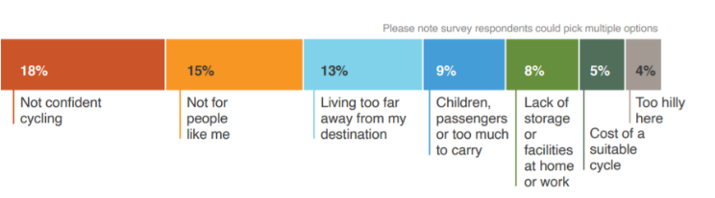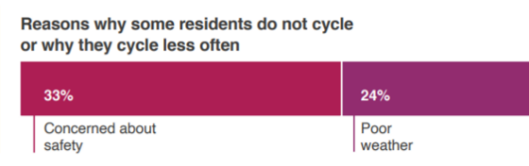

*Table 5: Reasons why people choose not to cycle (NTA, Bike Life, 2019)*

5.1 Table 5 highlights the primary reasons people choose not to cycle. The two most common reasons being cycling is not safe (33%) and poor weather (24%).

* The evidence demonstrates that the provision of high quality and safe cycle infrastructure will encourage more people to cycle. The intention of the Council’s Cycle South Dublin programme is to comprehensively address this concern and to provide a coordinated plan for the roll out of cycle infrastructure over the next decade.
* Of note is that in Amsterdam the weather is wetter than in Dublin. The average number of wet days in Amsterdam per annum is 132 wet days (with 838mm of rainfall) when compared to South Dublin with 128 wet days (758mm of rainfall). In Amsterdam the cycle mode share for all trips below 15km is nearly 50%, whereas in South Dublin the cycle mode share for the same distance is only 3.8%.

**6 What has the Council done**

6.1 In South Dublin today there is 207 km of existing cycle lanes. The map in appendix XX shows where these cycle routes are located. Over the last 4 years the Council has delivered:

* New cycle lanes (as segregated cycle lanes and/or alongside new roads) at
* Grand Canal Greenway at 10.5km
* The Grange Greenway at 600m
* Tallaght to Templeogue walking and cycling route at 1.7km
* Scholarstown Road walking and cycling route at 350m
* Willsbrook Road walking and cycling route 2.1km
* Bawnogue permeability route at 900m
* R120 new Nangor Road to Adamstown with cycle lanes at 6.6km
* 2 new cycle lockers and 4 cycle maintenance stands
* €150,000 per annum on the maintenance of existing cycle tracks

6.2 Some excellent walking and cycling schemes have been delivered in recent years. However, the Council does recognise that increased emphasis is required to deliver a more comprehensive and connected programme of cycle infrastructure over the next 10 years that will need increased investment in the delivery and maintenance of cycle infrastructure.

**7 What more can the Council do?**

7.1 The Council’s aspiration is provide people with a safe and desirable cycle network that gives people of all ages and abilities a credible alternative to using their private vehicles. A well connected, well designed and safe cycle network will provide a credible alternative choice for all people, which will not only address the traffic and environmental a challenges we face but will also offer people healthier lifestyles and provide benefits for our economies. To this end Cycle South Dublin is the Council’s proposed approach to delivering an ambitious programme of cycling improvements across the County over the next 10 years.

Route selection

7.2 Cycle South Dublin identifies a set of cycle infrastructure projects to be provided across four stages of delivery.

* NOW (next 4 years),
* SOON (4 to 8 years),
* LATER (8+ years) and via
* Bus Connects with cycle routes to be delivered by NTA

7.3 The appended maps show the locations of the proposed routes under each of these four stages of delivery. The appended tables provide more detail on each route including an initial high-level assessment of the complexity of each route including highlighting some of the key challenges for each route. In summary there are:

* NOW – 12 projects, 85km (inc. 12km existing), high level cost of €XXm
* SOON – 5 projects totalling 40km (inc. 7km existing), high level cost of €XXm
* LATER – 5 projects totalling 35km, (inc. 3km existing), high level cost of €XXm
* BUS CONNECTS – 6 projects totalling 39km (delivered by NTA)
* TOTAL – 28 projects totalling 200km (inc. 22km existing)

Funding

7.4 At this stage, the level of public investment required to deliver Cycle South Dublin has not been set. However, based on early indications it could cost in the region of XXXm over the next 10+ years to deliver the projects currently identified in the NOW, SOON and LATER phases. The Council is in discussions with the NTA as to how funding these works with an emphasis on the projects included in the NOW phase.

Audit and maintenance of existing cycle routes

7.5 Alongside the selection of the preferred routes in each delivery phase (NOW, SOON and LATER), the Council will audit the existing cycle network across the County and identify where this existing cycle infrastructure a) requires maintenance and b) is sub-standard and requires upgrade.

7.6 In recent years, the Council has allocated €150,000 a year to maintain the Council’s cycle network. For 2021 the intention is to increase the cycle track maintenance allocation, and this will be set as part of the Council’s budget planning process. In future years and informed by the audit of existing routes, the Council will keep this level of funding under review with the potential to increase this further if required and agreed by Council as part of the budget process.

Detailed route design

7.7 The general location of the proposed routes included in each of the NOW, SOON and LATER phases has been informed by the adopted GDA Cycle Network plan and supplemented with a local officer understanding as to where improved cycle infrastructure would be beneficial.

7.8 At this stage, the exact location and the detailed design for each route has not yet been set. This level of detailed design work will follow at the next stage once the overarching programme has been agreed. The detailed design of routes would be done on a project by project basis and specialist design teams would be procured to support this detailed design work. Part 8 applications would be progressed for each project in the Cycle South Dublin programme.

7.9 There are several projects identified in the NOW projects list that are already being progressed and are at different stages of design and delivery. It isintended to continue to progress these projects. The status of each project is included in the appended tables and a summary list of the projects is below:

* Dodder Greenway cycling scheme at 14km
* The Canal cycle loop from Grand Canal to Lucan at XXX
* The Grand Canal cycle extension at XX
* Wellington Lane cycling scheme at 3km
* Celbridge Link Road including new walking and cycling works at 1.2km
* Monastery Road walking and cycling scheme 650m
* Grange Road cycling scheme at 630m
* N81 Jobstown Junction walking and cycling scheme at 500m
* Belgard North Link Road including new walking and cycling works at 500m

Public and Councillor engagement

7.10 The delivery of successful and desirable cycle infrastructure requires the input and knowledge of local people. To this end the Council will commit to following levels of public engagement in the design and delivery of Cycle South Dublin:

* Public consultation on the draft Cycle South Dublin programme (late 2020 / early 2021)
* Council decision of Cycle South Dublin programme
* Non-statutory local community and Councillor engagement in the early design stages of Cycle South Dublin projects to help inform the preferred design approach
* Statutory public consultation on Part 8 applications is progressed for Cycle South Dublin
* Council decision on Part 8 applications for Cycle South Dublin

**Next Steps**

* September 2020 Discuss CySD with Land Use Planning and Transport SPC
* November 2020 Present CySD to Council prior to beginning public consultation
* November 2020 Commence public consultation on CySD
* February 2021 Council approval of the CySD programme and progress delivery

1. Based on yearly average figures gathered from traffic monitoring equipment at 13 locations across South Dublin.
2. NTA Bike Life 2019