South Dublin County Council

Directional Sign Strategy

DRAFT

18 September 2020

Land Use Planning and Transport

1 PURPOSE AND CONTEXT

1.1 South Dublin County Council (“SDCC”) is a relatively densely populated county within the Greater Dublin Area (GDA). There is a need to provide appropriate and coordinated directional signage for people to be able to move around the County. Advances in Technology have reduced dependence upon traditional road signing especially for commercial and industrial requirements with a variety of devices and systems providing guidance to required destinations. However, a need for concise, legible, consistent and relevant directional signing will always exist.

1.2 There are several different documents already used to guide the design, location and management of directional signs within South Dublin. The Council is currently required to use the adopted Traffic Signs Manual (TSM) to guide the design and location of road traffic signs. The Council has supplemented the TSM with a Wayfinding Policy, as adopted by the Council in 2018. This provides additional guidance in the provision of ‘Tourist, cultural and commercial signage’.

1.3 However, there is currently no consistent approach to guide the provision of ‘local directional signs’ for pedestrians and cyclist. As such there has been a miss-match of sign types provided across the Greater Dublin Area which leads to confusion and variations in quality. In response to this issue, Failte Ireland has developed a design guide for local / visitor signage as set out in Failte Ireland Visitor Orientation Signage 2020 (see Appendix One). The aim now is for the four Dublin authorities to agree to use this as a standardised approach across the GDA.

1.4 The Council has developed this draft ‘Direction Sign Strategy’ to guide the provision of direction signage within the County. The proposed approach is to continue to use the TSM and Council’s adopted Wayfinding policy as set out in paragraph 1.2, but to supplement these with the Failte Ireland Visitor Orientation guide as well as with a South Dublin specific ‘Welcome Sign’ for the Counties nine historic villages.

1.5 This draft strategy relates to directional signing only i.e. signing (fingerpost, panels, totems and welcome signs) that gives direction to people to specific destinations or facilities. Signing, such as interpretive or educational signs, which give information about specific locations are not included.

2 DIRECTIONAL SIGNS OBJECTIVES

2.1 In the design and location of directional signs it is the policy of the Council to:

- Apply the Traffic Signs Manual in the design and location of ‘Road Traffic Signs’
- Apply the Council’s adopted Wayfinding Signage (2018) in the design and location of ‘Tourist, cultural and commercial signage’
- Apply the Failte Ireland Visitor Orientation Sign guidance in the design and location of South Dublin’s Local Direction Signing
- To have regard to Transport Infrastructure Ireland’s (TII) Policy Provision of Tourist and Leisure Signage on National Roads.
- To adopt consistent technical standards to ensure easier recognition and legibility for people
- To comply with the Official Languages Act 2003 and to provide bi-lingual signage.
- To encourage the rationalisation of signs and to utilise existing structures as appropriate.
- To remove all unauthorised signs and to avoid clutter.
2.2 This policy excludes and does not relate to

- Signing on Private Land (that require approval under the Planning and Development Acts).
- Temporary Signs that require approval from the Council under the Litter Pollution Acts.
- Election posters, which are subject to regulation under the Electoral Acts.

3 DIRECTIONAL SIGN TYPES

3.1 Direction signs in South Dublin County Council can be divided into three categories.

- Traffic signs
- Wayfinding signs
- Local directional signs

- Traffic Signs

3.2 This type of sign is governed by the adopted Traffic Signs Manual, which the Council must comply with and can be best be explained as signing for vehicles. Traffic Signs are divided into three types:

- Information – signs which give directions or information to road users.
- Regulatory – signs which give instructions, prohibitions or restrictions.
- Warning – signs which warn of hazards ahead.

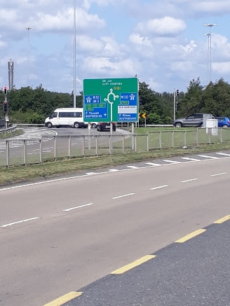   Image 1: TSM Information Image 2: TSM Regulatory Image 3: TSM Warning

3.3 To be effective traffic signs must be readily recognised and must

- Have messages that can quickly be read and understood
- Be co-ordinated with the road geometry so they are conspicuous by day and night
- Be so located as to give the road user sufficient time to take appropriate action.

3.4 All matters relating to this type of signing are addressed within the Traffic Signs Manual (TSM). The TSM has detailed requirements for the manufacture of road signs, permitted content, recommendations as to the amount of information to be displayed, letter size, permitted script, and colour coding. All signing which has the purpose of informing, directing or warning road traffic must conform with the provisions of the Traffic Signs Manual as published and amended by DTTAS. This Directional Signage Strategy is proposing to continue with this current practice and is not proposing any changes.

- Wayfinding signs

3.5 The TSM includes guidance on the design and location of Tourist and Cultural signs, which meet international standards. The TSM is supplemented by the Council’s policy on Wayfinding Signs, which was adopted by the Council in 2018. Wayfinding Signing is defined, for the purpose of this document, as signing which may be required for:

- Tourist accommodation and attractions
- Cultural, sporting destinations.
- Commercial and industrial premises.

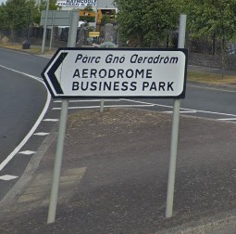
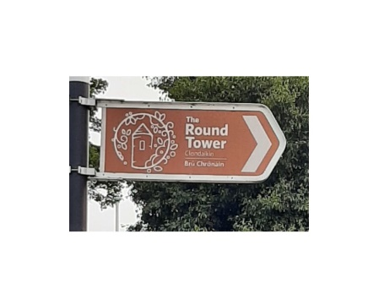
3.6 The existing Traffic Signs Manual and the Council’s Wayfinding Policy already provide the guidance on the size, location, layout, mounting and colouring. This guidance will continue to be followed for new signs.

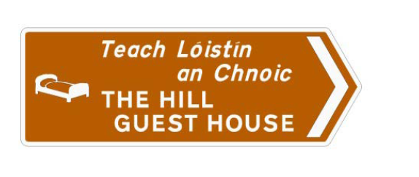

Image 4: Tourist accommodation Image 5: Tourist / Cultural destination Image 6: Commercial

3.7 The Council’s policy on ‘Wayfinding signs’ includes a permit system for signing of commercial and Tourism related businesses, which sets out the parameters for the licensing and fees for such signs within the county. Appendix Two includes the Council’s adopted Wayfinding policy. This Signage policy is not proposing any changes to this.

3.8 It should be noted that if any sign or structure has not been authorised by the Local Authority, it is an unauthorised structure. A Local Authority has power to remove an unauthorised structure from the public road under Section 71 of the Roads Act, 1993. There are penalties for the removal of such signage.

- Local Direction Signs

3.9 Local Direction Signs (LDS) are signs that provide directions for people to places of local interest (i.e. services and facilities) and are aimed at pedestrians and cyclists.

3.10 There are no National or Council standards currently in place for Local Directional Signs. This has resulted in inconsistency in use of local signs across the country and within South Dublin. This miss-match of sign types can be confusing and can lead to variations in quality.

3.11 To address this, Failte Ireland, working in conjunction with the four Dublin Authorities, has produced guidance on the design and location of local / visitor directional signs. It is now proposed that SDCC adopt these Failte Ireland guidelines for the purpose of guiding the design of local directional signs within the County. The guidelines are included in Appendix One.

Step 1: When should Local Direction Signs be used?

3.11 The purpose of LDS is to provide people with information relating to how they can find their way to, and around, an area and what they can do while there. The intention is that having a consistent style, format and content within Local Directional Signs helps people find their way wherever they are in Dublin. The purpose is to ensure a consistency of style, layout and approach to maximise impact and visibility for visitors throughout the Greater Dublin Area.

Step 2: Where will Local Direction Signs be located?

3.12 The following are those locations where the Local Directional Signs should be provided:

- Tallaght Town Centre, the 9 historic villages and District Centres
- Public parks and open spaces
- Key transport nodes
- Heritage and cultural trails

3.13 Appendix Three includes an indicative set of locations within each of these four areas. Subject to Council approval of the Directional Sign Strategy the intention is to agree a set of locations under each of these four areas with each of the Council’s ACMs. Once these locations are agreed the Council would progress detailed design and delivery.

3.14 Within these four areas, the exact location of each sign will need to be considered on a case-by-case basis. The positioning of signage requires great care. It must take account of the needs of the users, visibility and sight lines, other signing nearby, available space, health and safety, rights and permissions. In determining exact locations, the following questions would need to be considered:

- Where are the key destinations that people are trying to go to?
- What do people need to know is nearby?
- How long will it take to get there?
- Where are the nearest transport options?

Step 3: What information should be included on Local Directional Signs?

3.15 Local Directional Signs must stand out and be recognisable, but at the same time, they must be in tune with the surroundings, therefore a balanced design approach is needed.

3.16 Within an area, once the locations of signs are decided upon, the content for each sign will need to be designed. As part of this design process the following will need to be considered:

- What is the objective of the new sign?
- What geographical area needs to be included?
- What are the key local destinations (e.g. tourist attractions, transport sites, local amenities)
- What are the walking and cycling routes and distances?
- Is there a need to identify alternative accessible routes?
- How we can provide bi-lingual signs?

Step 4: What sign type to use?

3.17 Informed by the analysis set out in steps 1, 2 and 3 the right sign type will need to be selected. The types of directional signs that can be used include fingerposts, wall panels, totem or welcome signs. Summary information on each of these sign types is included below with more detail design information included in the Failte Ireland document in Appendix One. Once the most appropriate sign type has been selected the detailed design should:

- Assess existing signage for retention/replacement/ removal.
- Identify the specific signing requirements
- Establish the detailed signing specification.
- Survey each proposed location.
- Identify required works.
- Revise signing specs and layouts as required

4 DESIGN OF FINGERPOST AND WALL PANELS SIGNS

4.1 Fingerpost and wall panel signs should be erected and designed to be clearly visible and accessible and be bi-lingual. Fingerpost and wall panel signs have the advantage that the can be read quickly and easily. The type of information provided should be simple and include direction information to nearby destinations along with information on walking / cycling times.

4.2 The main difference between the fingerpost and the wall panel is that, for the fingerpost sign the sign is mounted onto a poll as shown in image 7 and in the wall panel the sign is mounted onto the wall as shown in image 9 and is generally advised for use internally.

4.3 Where multiple panels are provided users must have space to stand and read the signs without causing obstruction. It is also important that “too much” information is not provided as it can make the signs difficult to read.

Image 7: Fingerpost sign type (Failte Ireland)

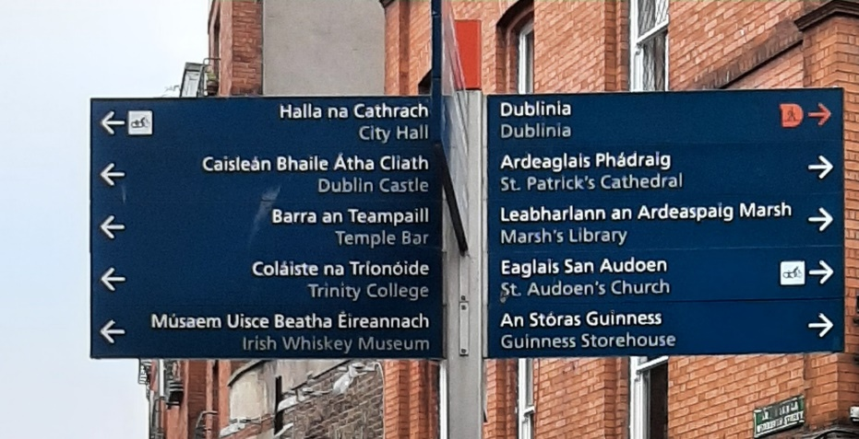
Image 8: Example of a finger post sign from Dublin City Centre

Image 9: Wall panel sign (Failte Ireland)

5 DESIGN OF TOTEM SIGNS

5.1 Totem signs are larger and contain distinct bands that offer people more information about the local area. Totems will include both directional information and information about the local area. On totems there is also opportunities including branding, QR codes and maps. Totem signs will generally provide information on:

- Walking/cycling times (i.e. 5min, 10min to 20-min intervals as appropriate),
- The location of transport nodes
- Public buildings (libraries, Garda Station, health facilities etc)
- Sports and leisure facilities and places of interest.
- Branding information and QR codes can be included
- Signs should also be bi-lingual

5.2 Where maps are included on Totem Signs they will generally be provided as ‘Heads-Up-Mapping’, which is now considered best practice. The term describes a map that is orientated to the user rather than the traditional “north is up” orientation. The map contains a” You are here “marker and everything above the mark is in front of the user.

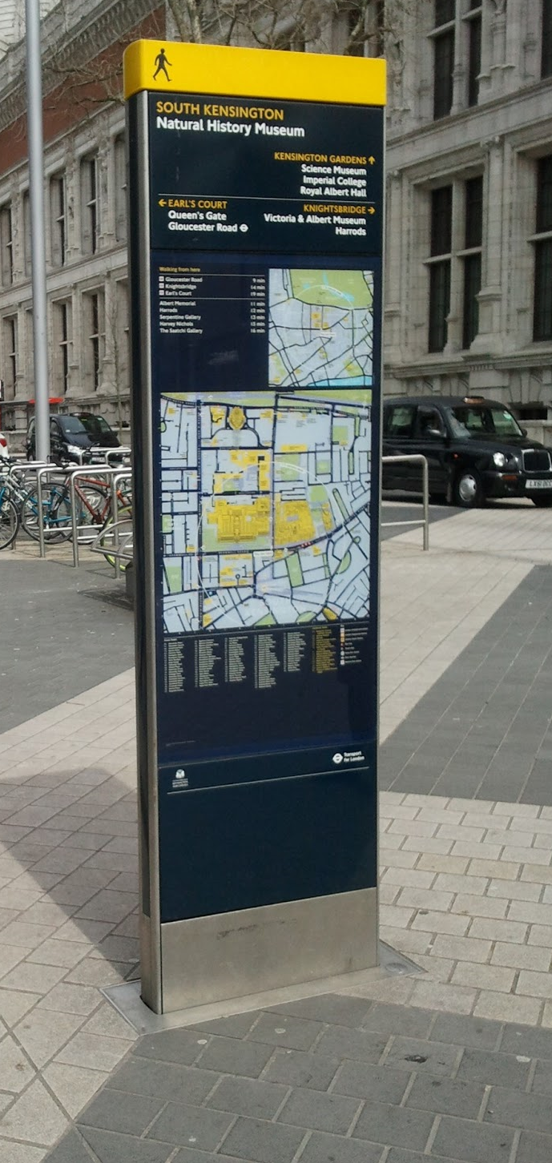
Image 10: Totem panel (Failte Ireland) Image 11: Example of Totem Sign with map (London)

5.3 There are existing Totem signs provided in some locations around Tallaght. These signs were designed and delivered as part of a pilot project and the following lessons have now learned:
- The materials used has meant that the signs have weathered poorly
- The layout and maps used were hard for people to understand
- The colouring has meant that the signs were not recognisable and hard to read
- The extent of delivery was limited and so there was a lack consistency across Dublin
5.4 As part of this strategy the design challenges have now been addressed and the intention is to see delivery of these signs types (as per the Failte Ireland guide) across Dublin. As part of this and during detailed design, the Council will review the existing Totem and Fingerpost signs in Tallaght, which may see these existing signs replaced in time.

6 DETAILED DESIGN CONTENT OF FINGERPOST, WALL PANELS AND TOTEMS

6.1 The detailed design approach for fingerpost, panels and totem signs is set out in the Failte Ireland guidance document. Images 7 to 11 above give examples of a fingerpost and totem signs from Dublin City Centre and London.

6.2 The Failte Ireland document allows for some local distinction and variation within the detail design of these signs. The final detailed design of fingerposts, panels and totems for South Dublin would be progressed following Council approval of this strategy and the subsequent appointment of a detailed design team. The following sections identify where there is scope for variation within the detailed design of signs.

Type Face and Colouring

6.2 The Failte Ireland guidance contains excellent advice on type face and colour combinations which have been proven to enhance legibility and visibility. By adopting the Failte Ireland guidance these typefaces and colours would be used to the greatest possible extent. For further information the suggested type face and colour combinations can be found in the Failte Ireland Document section “Typography” starting on Page 13.

Signing layout

Image 12: Sign types and layout (Failte Ireland)

6.3 Content should be positioned with all users in mind, whether they be standing or walking, tall or short, in a wheelchair or having impaired vision. Viewing bands guide where content should be is positioned to be most effective. Critical information is positioned within the primary band, support information within the secondary band and incidental details within the tertiary band. Further information is included in section on signage content and position starting on page 21.
Use of colours and beacons

6.4 The use of beacons has been shown to improve visibility of sign locations, and together with the use of viewing bands improves legibility and consistency of layout. It is the Councils policy that all such signs shall include the use of beacons. Further information on the use of colours and beacons starts on page 27.

6.5 Beacons may be colour codes by route or by area and such decision shall be part of the design process. Where appropriate, signs, especially totem signs, shall be constant with these layouts and any branding or sponsorship branding shall be confined to the tertiary view bands.

6.6 A ‘beacon colour’ should be bright and bold to contrasts distinctly with the environment in which the signage scheme is installed. Bright yellow, orange, blue and pink are good examples. Muted colours such as olive green, brown, dark blue and burgundy are likely to be poor examples.

6.7 Beacon colour choice contributes to the overall graphic identity of a wayfinding scheme in a similar way to how colours contribute to brand identity. The choice of colour should not be taken lightly. Testing colours ‘on-the-street’ in different lighting conditions and at different times of the day is recommended.





Image 13: Effective beacon (Failte Ireland) Image 14: Ineffective beacon (Failte Ireland)

7 WELCOME SIGNS IN TALLAGHT TOWN CENTRE AND OUR 9 HISTORIC VILLAGES

7.1 Tallaght Town Centre is the County’s capital. The intention is to provide a recognisable Welcome to Tallaght sign at key entry and exit points to the County capital. The detail design and location of this would need to be processed at the next stage of detailed design

7.2 South Dublin has 9 Historic Villages

- Lucan
- Palmerstown
- Newcastle
- Clondalkin
- Rathcoole
- Saggart
- Tallaght historic village
- Templeogue
- Rathfarnham

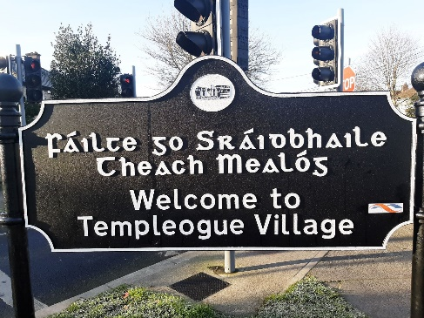
Image 15: Existing Welcome Sign in Templeogue Village

7.3 The Directional Signage Strategy proposes the Council adopt a consistent standard and design approach to all directional signing though-out the County including within our 9 Historic Villages. Heritage style ‘Welcome Signs’ similar to the above have already been erected in 5 of the 9 historic villages, namely in Rathcoole, Saggart, Clondalkin, Templeogue and Newcastle.

7.4 In recognition of these existing signs it is proposed that this type of Welcome Sign be provided in each of the Counties 9 Historic Village. They would only be located on the primary entry and exit route into the village. This type of sign would not be provided outside of these locations.

7.5 All ‘Welcome Signs’ must be similar in layout and construction to the example shown. The SDCC logo must be prominently visible on the sign face. A logo or inset of local interest or significance may also be attached but permission on both size and content must be obtained. These signs may be provided on the historic or traditional village boundaries and only one sign may be provided per approach.

7.6 In addition to Welcome Signs the provision of fingerposts, wall panels and totems will also be used to provide consistent and legible directional information for people within the 9 historic villages. There is an opportunity to apply a heritage element to the Failte Ireland fingerpost, wall panel and totem whilst still being in line with the guidance. The Council will design a standard heritage fingerpost, wall panel and totem on this basis that would be used in each of the 9 villages. An example of a heritage fingerpost sign is included below. The detailed design type would need to be progressed once the strategy is adopted.

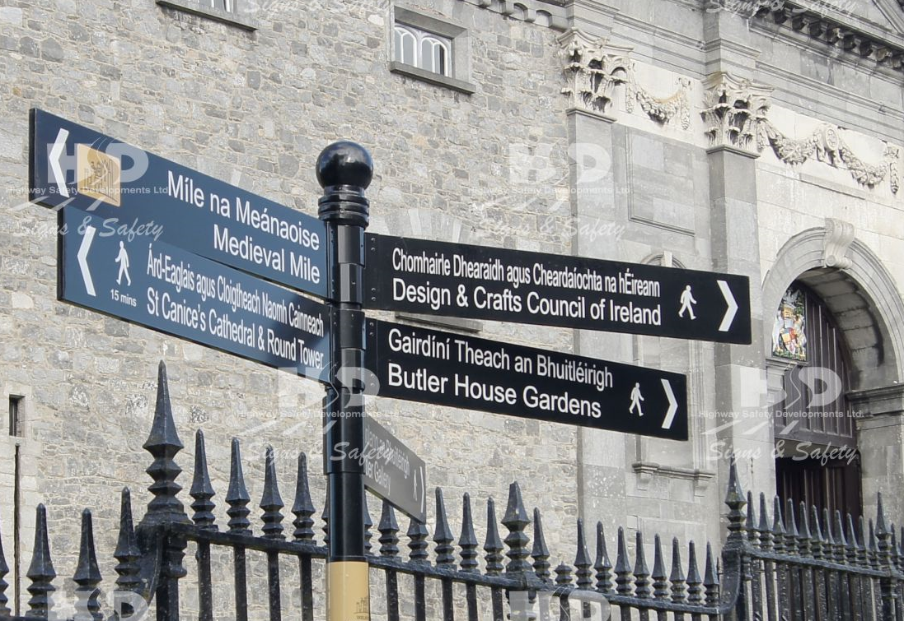
Image 16: Heritage fingerpost sign in Kilkenny

8 HERITAGE AND CULTURAL TRAILS

8.1 The formation of South Dublin has taken place over many hundreds of years. The forces that shape the County range across geographical, economic, and societal. Many of these forces are still evident today, whilst others are less obvious, but none the less as important in telling the story of why South Dublin is the way it is.

8.2 This Signage Strategy presents an opportunity to better tell this story. The intention of the heritage and cultural trails is to develop a consistency of heritage trail(s) across the County that provide people with information of how the County has developed across the lowland settlements and upland areas.

8.3 Within South Dublin there are several potential heritage and cultural trails that would both help to tell County’s story and would also benefit in having their own designated trail. Some examples are included in appendix 3.

8.4 On heritage and cultural trails the intention is still to use the fingerpost, panel and totem signs as set out in the Failte Ireland guidance as the primary source of directional signs.

8.5 However, in addition to this and depending on the specific heritage or cultural trail there may be an opportunity to supplement these sign types with bespoke, trail specific signage. For example, this could include signage provided as street furniture, planters, paving or plaques.

8.6 Where a heritage and/or cultural trail has been identified then a detailed assessment and design of the route would need be progressed. The detailed design of each trail would need to consider if there is a need for any supplementray sign types to help people to navigate that agreed trail. This Directional Signage Strategy provides scope for this to emerge for bespoke heritage and cultural trails.

8.7 Some examples of supplementary cultural and heritage sign types are set out below:
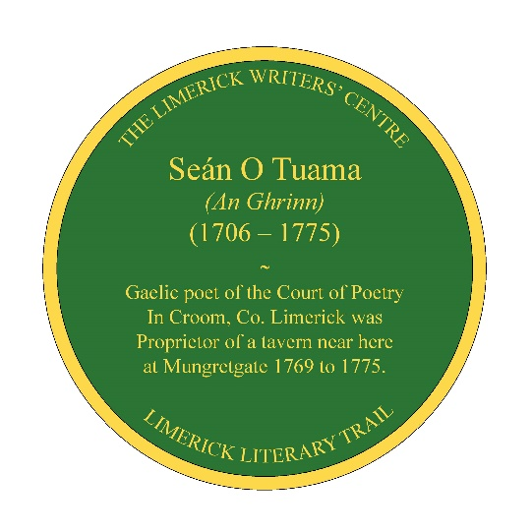. 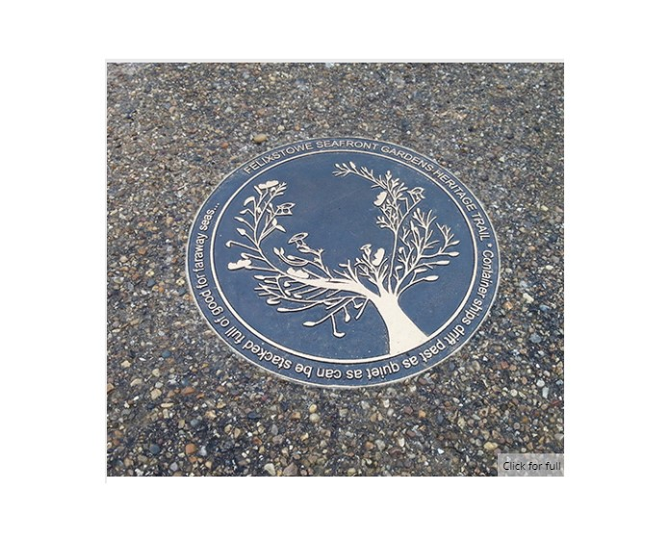

Image 17: Literary Trail Marker Image 18: Floral Route Marker (Ground Mounted)
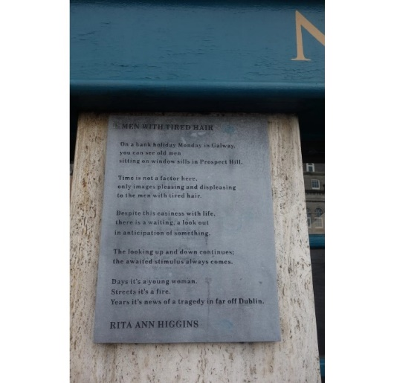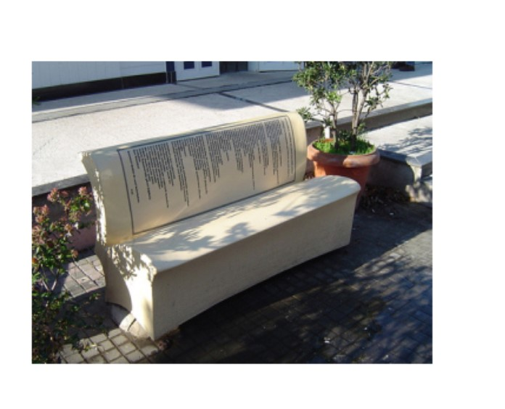

Image 19: Literary Trail Plaque Image 20: Book Bench

9 NEXT STEPS

9.1 The implementation process will consist of

- Presentation of the proposed Directional Signage Strategy to LUPT SPC.
- Adoption of the Directional Signage Strategy by full Council
- Identification and agreement of schemes under the four headings at ACM
- Appointment of design consultants to progress the detailed design of the agreed schemes
- Present draft proposed schemes to ACM
- Secure any necessary planning or licence approvals
- Tender for contractors
- Deliver the initial schemes

LIST OF APPENDICES

Appendix 1

Failte Ireland – Visitor Orientation Sign ‘Signage with Purpose’ 2020 (attached)

Appendix 2

Council’s adopted Wayfinding Strategy 2018

Appendix 3

Below is an indicative list of potential locations where new Directional signs could be located. Once the policy is agreed by the Council it is then the intention to agree locations under each of these headings with the ACMs. Once these are agreed a selection of locations will be progressed to detailed design and delivery.
Heritage and Cultural trails
- Rathfarnham Village and Castle, Clondalkin Village, Tallaght Heritage Trail, Lucan Village to Demesne, Dodder Greenway to Mountains
Tallaght Town Centre, 9 historic village and district centres
- Tallaght Town Centre
- The 9 historic villages
- The district centres of Bawnogue, Deansrath, Neilstown, Dodsboro, Castletymon, Rosemount, Whitechurch, Old Bawn and Grange Road. These district centre locations coincide with the 10 district centre locations included the District Centre Enhancement Program
Parks and Open Spaces
Tymon Park, Corkagh Park (including Camac Valley Caravan Park), Griffeen Park, Dodder Valley Park, Waterstown Park, Lucan Demesne, Rathfarnham Castle Park, Sean Walsh Park, Kiltipper Park, Butler McGee Park, Collinstown Park, Killinarden Park-(subject to regeneration plan).
Transport Nodes
- Liffey Valley shopping centre, Tallaght The Square, Irish Rail Stations, Luas Stations.

