**Report on South Dublin Libraries Summer 2020**

South Dublin Libraries has held it’s first in-person events since the lockdown came into force in March. On Monday 17th of August and Wednesday 19th of August, the first of the Red Line Book Festivals’ writer in residence (WIR) workshops took place. Keith Payne WIR facilitated the workshops and the feedback from participants was excellent. Those attending expressed their gratitude to the libraries for organising these “in person” workshops and remarked that they were so delighted to be out of their homes to take part. (All HSE Covid 19 guidelines were in place.)

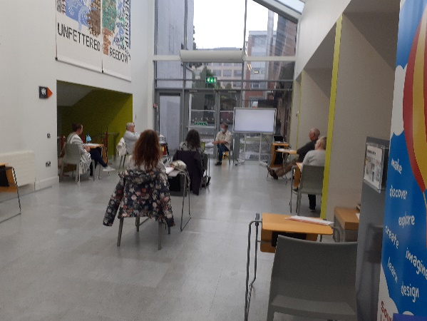

*Tallaght Library, socially distanced participants attend creative writing workshop as part of the Red Line Book Festival WIR*

The Dublin Inquirer reported on the event and the Red Line Book Festival.

Read here:

[https://dublininquirer.com/2020/08/26/writing-group-prepares-to-capture-the-sounds-smells-and-taste-of-tallaght](https://eur04.safelinks.protection.outlook.com/?url=https%3A%2F%2Fdublininquirer.com%2F2020%2F08%2F26%2Fwriting-group-prepares-to-capture-the-sounds-smells-and-taste-of-tallaght&data=02%7C01%7CLCorry%40sdublincoco.ie%7C476c9be533bd4d1a0b4008d849a75b45%7C6a3c00c019d0492da8de95fad8fda1d4%7C0%7C0%7C637340330843306235&sdata=Kyo59yMTYh9tmnKJht4zpkYElBboZZUbCMeDmPZsJt0%3D&reserved=0)

The library network across south Dublin continues to deliver a range of online events and workshops with over 180 online offerings over the July and August period.

**Snapshot of July and August**

**Heritage Week**: 15th-23rd of August marks Heritage Week in Ireland. SDL had a series of events online to mark the occasion.

**Dig It Kids**

18 August - 20th August 10.00am - 12.30pm each day.

65 families attended.

3-day workshop where the Dig It kids built a Viking longboat, a passage grave and a round tower. The participant learnt about local historical landmarks and built stories around them. They also created models to replicate their favourite landmarks.

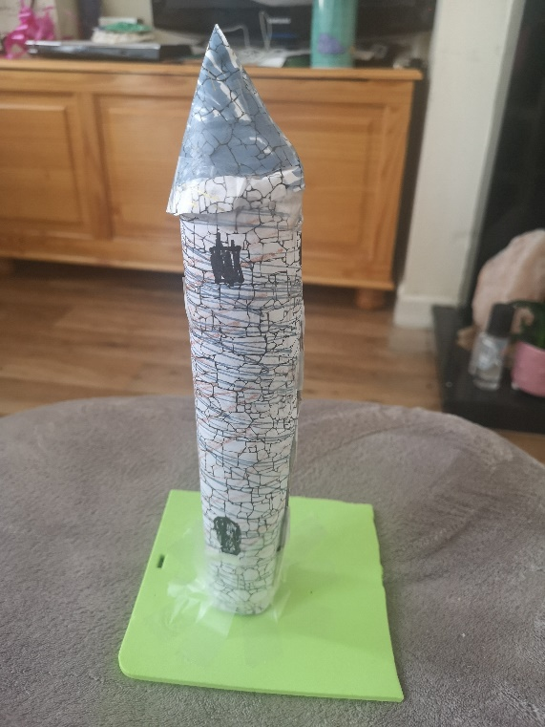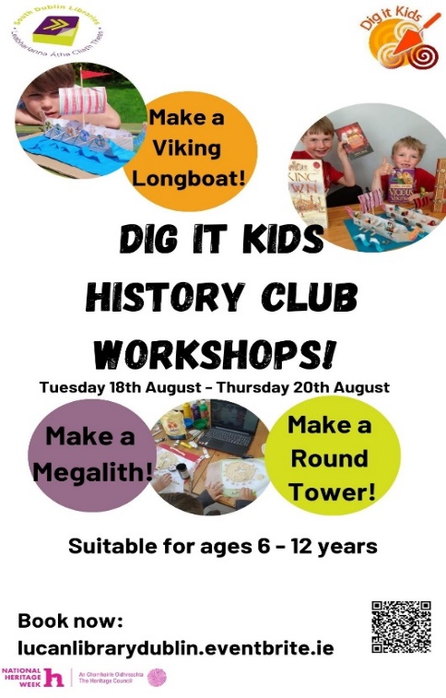

Round Tower Clondalkin as produced by the Gillan family, Tallaght

Heritage week was also marked by outdoor historical walks which were facilitated by a local historian.

Local history and heritage events have been very well received online over the past few months and Ballyroan library are bringing the first “in person” event on the 28th August, with the School of Archaeology facilitating an outdoor Viking coin and pouch making workshop for children.

**Online activities:**

During the summer months online activities were delivered across the library network these included:

* Coding workshops via zoom
* Upcycling clothes workshop via zoom
* Summer Stars online book clubs
* Laser cut model building via zoom
* Harry Potter event via Zoom
* South Dublin Libraries, adult quiz night with Allison Spittle via Zoom
* Creative writing workshops via zoom
* Cookery classes via zoom
* Irish for beginners via zoom
* Health talks via zoom

This is a snapshot of our activity and all events are detailed on the Libraries events spreadsheet.

**Competitions:**

**The Red Line Book Festival competition** closed on Wednesday 19th August

**Life in Lockdown photography competition** has also closed and after considering the 36 entries the winner (below) was chosen. The photographs will form a digital exhibition which will run across the digital screens in all our libraries in the coming weeks. It will also form a platform for discussion with the groups attending the WIR workshops and work arising from that will be archived with the exhibition for future showings.

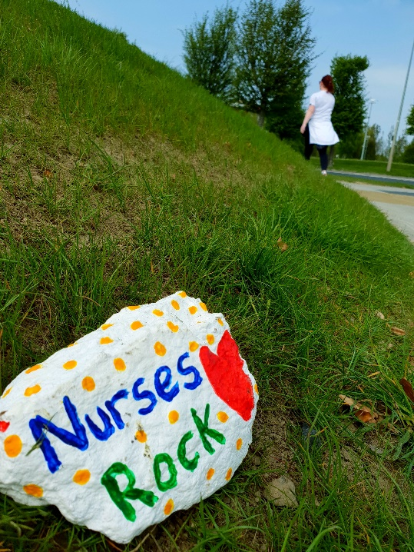

**Coming Up:**

South Dublin Libraries will continue to deliver a robust online programme of events matching the needs of our citizens. However, we are slowly opening our doors to “in person” events/workshops (adhering to all HSE Covid 19 guidelines). Outdoor events are being explored with the afore mentioned School of Archaeology event taking place in Ballyroan.

**EPIC** a school based creative writing project with author Colm Keegan will run in early September. This partnership between the Arts office and Libraries has been running very successfully for several years. This year brings new challenges and may require alternative means of engagement with schools. However, we are keen to build on the previous years success and continue to develop the project further.

**Culture Night - Friday 18th September**

Ballyroan, Tallaght and the new North Clondalkin Library are planning to open their doors on Culture Night. The events will take place in controlled spaces with controlled numbers after library opening hours. Events include:

**North Clondalkin Library** **–**

5-7pm Sneak Peak– behind closed doors library tour of the new library. An opportunity to see the new North Clondalkin Library (NCL) before its official opening. Includes viewing of the Una Gildea exhibition and music.

**Tallaght Library –**

6-7pm Jack Flash in junior library.   A magic show with fun and hilarity for all the family.

**7.30pm Exhibition -The Girl in the Diary: Searching for Rywka from the Łódź Ghetto.**

**Ballyroan Library –**

5.30pm Hilarious Histories

Join us on Culture Night for this Hilarious History show with our Pesky Pirate!  This is a fun event mixing history, magic and comedy, suitable for the whole family.

**7:00pm Talk: Michael Flanagan, the man, the Alderman**

Join historian Cathy Scuffil for this illuminating talk on the alderman, and grandfather of Liam Cosgrave, Michael Flanagan, and his associations with the Greenhills and Tymon area of South Dublin County.

(Booking is essential at all Culture Night Events. All HSE Covid 19 guidelines will be implemented.)

**The Red Line Book Festival – update**

**“Online, Offline, we’re still Redline”**

Our new tagline explains how we are developing this year’s programme. The WIR programme is underway with Keith Payne and 2 “in person” workshops have taken place.

This year the programme will be an approximate 50 percent split between online and in person events. As the constrictions and landscape is ever changing, we have decided to host the majority of our in person events in our library venues, with the exception of an event in Rossecourt community centre and the closing event which will take place in Casement Aerodrome. All events will be free to attend and require booking.

This year we decided to highlight a book as part of our festival, “The Art of the Glimpse” an anthology of short stories edited by SÍnead Gleeson, is the **Red Line Book 2020.** Some of the contributors to the book will form part of the programme including Blindboy Boatclub an influencer/tv presenter/podcaster/author and part of the Rubber Bandits, who will take part in one of our online events.

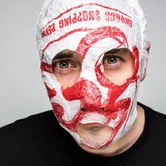

The programme is currently being finalised and will be available soon.