COMHAIRLE CONTAE ÁTHA CLIATH THEAS  
SOUTH DUBLIN COUNTY COUNCIL



MEETING OF SOUTH DUBLIN COUNTY COUNCIL

Monday, July 13, 2020

HEADED ITEM NO.20

**HEADED ITEM: Economic, Enterprise and Tourism Development.**

**DUBLIN MOUNTAINS PROJECT – PLANNING UPDATE**

1. **INTRODUCTION.**

By letter dated 26th June 2020, (attached to report), An Bord Pleanála has granted approval for the Dublin Mountains Visitor Centre following an exhaustive planning process set out briefly below :

* In February 2017 the project was the subject of a screening request to ABP in accordance with Part X of the Planning Act 2000.
* The Board did not accept the Inspectors recommendation and ruled that an EIAR be submitted to the Board.
* This was submitted in July 2017.
* Following a full Oral Hearing number and Further Information requests the project was approved by letter dated 26th June 2020.
* The approval is subject to conditions which condition undertakings given by SDCC in the submissions to the Board.

In the decision the Board clearly states the proposed development would not *“..adversely effect the environment, would not seriously injure the amenities of the area, would respect the existing character of the area and would be acceptable in terms of traffic and pedestrian safety…”*

Accordingly, it is now proposed to proceed to procure a detailed design and delivery team with a focus on meeting the requirements laid out by An Bord Pleanála in their decision. This process will be progressed in conjunction with our strategic partners Coillte and the Dublin Mountains Partnership and in consultation with the local community.

The history of the entire process can be followed on the Councils website and through the update reports given to Council in relation to the project. However, for ease of reference for members the main facets of the project and its history are summarised below.

1. **BACKGROUND STRATEGY,**

The project is based on recommendations incorporated in both strategic plans and local studies over the years since 2007 :

* 2007 Dublin Mountains Strategic Plan
* 2013 Failte Ireland Report - *Grow Dublin*
* 2015 South Dublin Tourism Strategy
* 2016 – 2022 County Development Plan
* 2016 SDCC Council-approved feasibility study
* 2017 SDCC Council approved planning process.

1. **PROJECT SCALE**

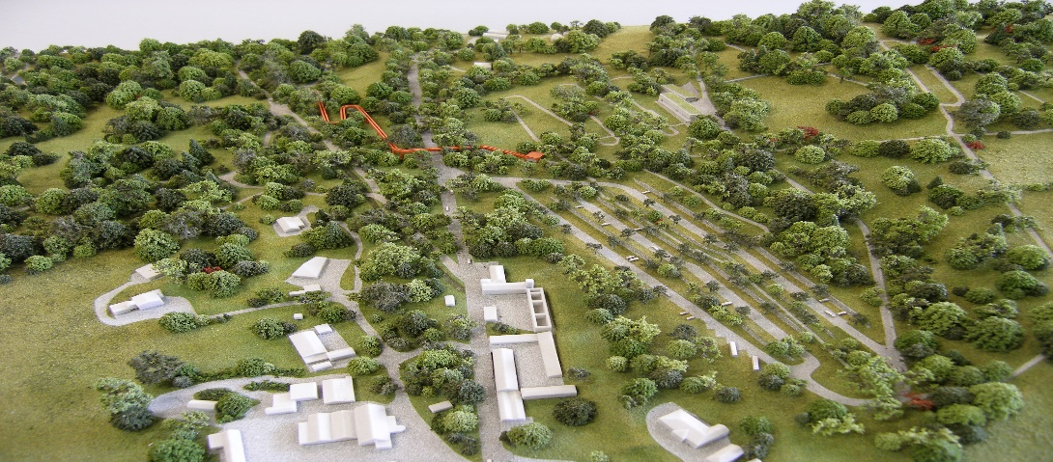

CENTRE

BRIDGE

CAR PARK

In order to clarify the project scale and impact the model shown above was prepared demonstrating the limited scale and impact of the project alongside existing developments. The model remains available for viewing.

The project consists of :

* Treetop Walkway.
* Visitors centre (under 1,000m2 reduced from c1,600m2 in feasibility study)
* Improved walks and trails
* Access and parking improvements.
* Archaeology and heritage conservation.

1. **HELLFIRE CLUB/MASSEYS WOOD**

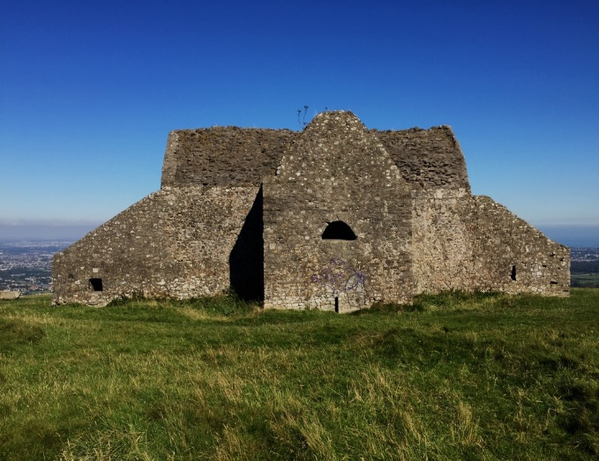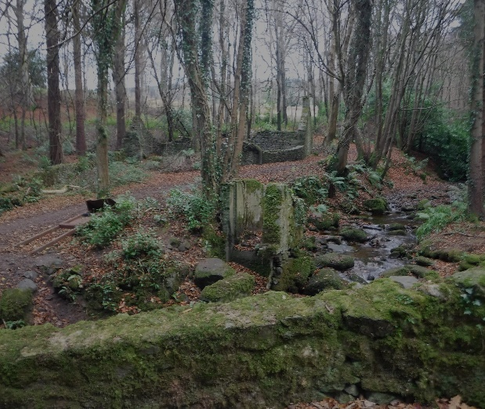

* Heritage value will be protected.
* Visitor ‘destination’ potential.
* Minimal intervention – conservation & repair
* Manage safety & anti-social behaviour issues

1. **VISITOR CENTRE**

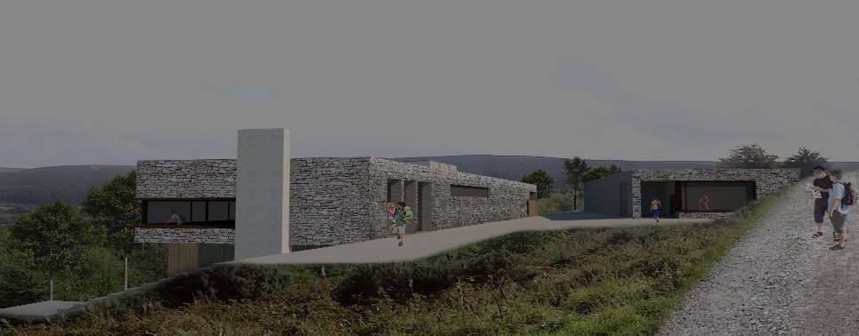

* Considered response to sensitive context
* Natural materials – stone and wood
* Integrated into landscape setting
* Disabled parking and family facilities

1. **TREETOP WALKWAY**

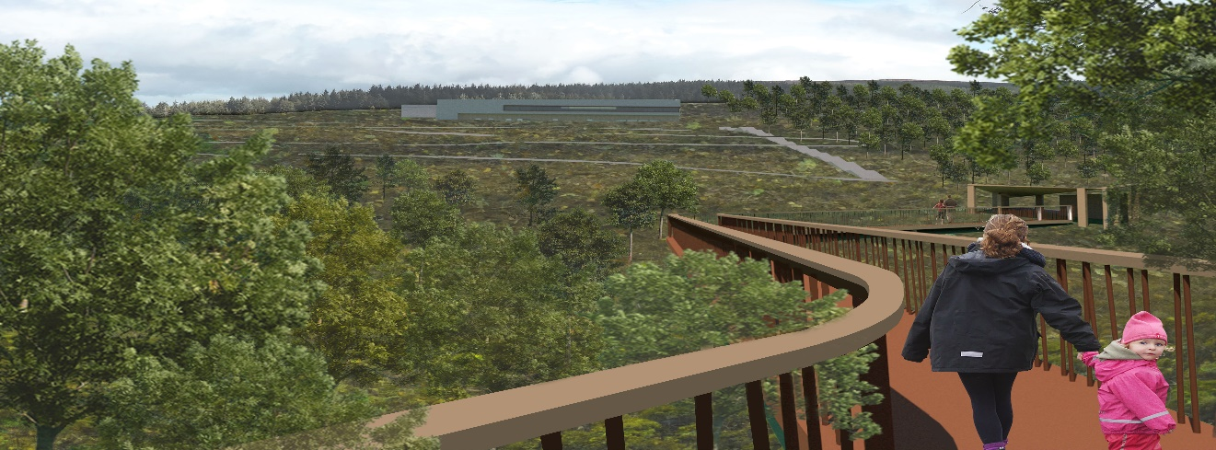

* Amenity & visitor attraction
* Connect Montpellier Hill with Massy’s Wood
* Safety – reduce R115 pedestrian footfall
* 1:20 gradient – accessible walkway
* Enhance nature and wildlife experience.

The Board stated : “*In deciding not to accept the Inspectors recommendation to omit the treetop bridge ….the Board considered that the Inspectors concerns in relation to… biodiversity had been addressed by the response to the Boards further information request….and did not consider that there were would be any unacceptable impacts on visual amenity associated with it.”*

1. **COSTINGS.**

In 2017 the estimated construction cost was €15M. Failte had provisionally approved a grant of €5M for the project. Failte have been informed of the ABP approval.

These costings will now have to be rechecked which will form part of the brief set out in the introduction above.