**Update on the Integrated Constructed Wetland assessment and improvement works to the green space near Ned Kelly Park and the M50**

*This update follows on from information provided in the May 2020 Tallaght ACM. The Dublin Urban Rivers LIFE project has assessed the local stream for the possible siting of an integrated constructed wetland (ICW). The existing poor water quality condition of the stream indicates directing some or all the flow through an ICW would greatly improve its quality as the ICW would filter and purify water as it passes through it. The project has also assessed there is potentially enough land area to install an ICW of suitable size to do the job of water purification and still retain most of the existing green open space albeit with some alterations to existing setups.*

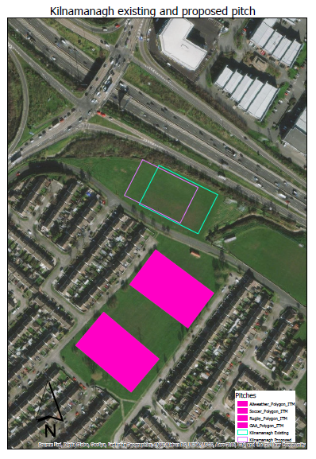*The LIFE project has carried out a topographical survey of the area and will assess the quality of soil at the proposed ICW location to determine its clay and waste content, if any, in July. The results of this assessment will determine if the soil can be reused locally in the green space - thus improving the local topography, reducing disposal costs, and reducing the carbon footprint of the ICW build.*

**Key:** Blue triangle is the area assessed for ICW location

*The project is also in consultation with the ESB to discuss any technical barriers presented by the presence of nearby overhead and underground hight voltage electricity cables.*

*Therefore, some site assessment work remains outstanding but once the project knows the outcomes of these a plan and vision for the location can be prepared, including previous commitments to provide a footpath in the area, and then presented to the Committee and discussed with interested local parties. This will be completed by the end of 2020.*