**SDCC Libraries News and Events**

South Dublin Libraries have commenced a partial reopening of library services to the public since 8th June. This service consists of a ‘call and collect’ service, a return of items service along with continuing a comprehensive programme of events and activities across social media platforms. Our online presence has strengthened greatly over the past number of weeks. Library staff have used their skills and ideas to find new ways to reach out and engage with the community including live streamed storytelling sessions, craft sessions, photography exhibitions, local history talks and blogs and much more. We continue to deliver programmes under the LGMA national initiatives of Right to Read, Healthy Ireland and Work Matters.

Our Libraries’ Facebook page <https://www.facebook.com/SouthDublinLibraries/> and our twitter page <https://twitter.com/SDCClibraries> as well as Instagram <https://www.instagram.com/sdcclibraries/> are used to promote our online events.

**Online Resources**

In addition there has been a huge uptake of South Dublin Library online resources including E-books, E-audio, Newspaper Articles, Language Learning and Community Education Courses available at [https://www.sdcc.ie/en/services/sport-and-recreation/libraries/library-services/online-resources/](https://eur04.safelinks.protection.outlook.com/?url=https%3A%2F%2Fwww.sdcc.ie%2Fen%2Fservices%2Fsport-and-recreation%2Flibraries%2Flibrary-services%2Fonline-resources%2F&data=02%7C01%7Cbfennell%40SDUBLINCOCO.ie%7C9bdb3d6c8c014479b0b808d7e75b43ac%7C6a3c00c019d0492da8de95fad8fda1d4%7C0%7C0%7C637232251475674477&sdata=kbYs18we4dtEpc3I0xTgRDl5Hy1XvgPuH1zO5wLHvU0%3D&reserved=0)

The following statistics show **the increase on uptake** on our **SDCC library online resources** with **238,676 items issued in April 2020**.

|  |  |  |  |
| --- | --- | --- | --- |
| **March Increase on February** |  | **April increase on March** |  |
| Borrowbox Total | 41% | Borrowbox Total | 51% |
| Borrowbox eAudio | 21% | Borrowbox eAudio | 50% |
| Borrowbox eBook | 69% | Borrowbox eBook | 51% |
| eMagazines | 33% | eMagazines | 18% |
| Enclopaedia Britannica | 341% | Enclopaedia Britannica | 61% |
| Tumblebooks | 673% | Tumblebooks | 9% |
| Universal Class | 544% | Universal Class | 236% |
| Press Reader | 458% | Press Reader | 488% |

**Promotional Video on Online Library Resources**: is now available at [https://vimeo.com/412691986](https://eur04.safelinks.protection.outlook.com/?url=https%3A%2F%2Fvimeo.com%2F412691986&data=02%7C01%7Cbfennell%40sdublincoco.ie%7C245e7b12358140c176fe08d804e1435e%7C6a3c00c019d0492da8de95fad8fda1d4%7C0%7C0%7C637264712827255799&sdata=D9d1NRZ531vIvy4UQRMnFTz4tFpCQzNHqzFN3u6rR3c%3D&reserved=0). The link will be sent out to DETB leaders for use by their students.

A talk in conjunction with LEO on **‘How to Galvanise Your Business Online’** took place on 25th May. Dorcas Reamonn, website maker and consultant demonstrated the basics of setting up a WordPress website for business. This interactive session was booked out and got great feedback from those who participated.

**Managing Your Finances During COVID-19** took place on 26th May and was facilitated by MABS (Money Advice and Budgeting Service) and presented advice, tips, and guidelines for managing your finances during the current period.

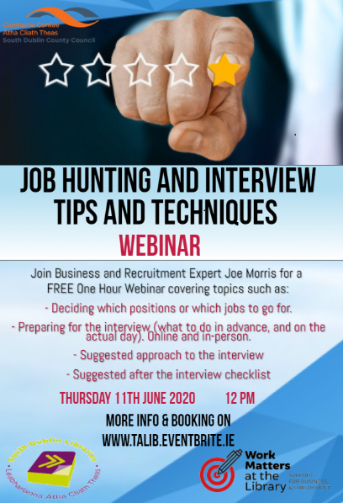

**Job-Hunting and Interview Tips and Techniques**

Thursday 11th June, 12:00pm - 1:00pm

You may have lost your job suddenly, or feel like you are in limbo, unsure of whether you will have a job to return to.

This webinar will help get you back into the right frame of mind, right and will cover:

- Deciding which positions or which jobs to go for

- Preparing in advance and on the day for an online or face-to-face interview

- Suggested approach to the interview

- Suggested checklist for after the interview.

**Creative Campus:**

**A Game of Codes (Secondary school students)**

Wednesday 10th, Thursday 11th and Friday 12th June, 2:00pm - 3:00pm

As part of the South Dublin Creative Campus Programme, supporting secondary school students.

All Game of Codes workshops are funded by Science Foundation Ireland.

These three-day coding workshops will be facilitated by The Academy of Code and delivered online using Zoom.

A parent or guardian will be required to be present for the duration of the workshop and there is a limit of one pupil per computer screen. All participants must be able to attend all three days of these workshops.

**HEALTHY IRELAND**

Under the Healthy Ireland at your Library banner, South Dublin Libraries will be scheduling further talks on **‘Looking after Your Mental Health’** for June.

Coping and Management Skills During Corvid - This talk by Seamus Power was fully booked out with 18 people attending an interactive talk on coping with anxiety during Covid. Feedback for this event was very positive.

Mandala and Meditation with Patricia Fitzgerald - These workshops continue to be very popular with 25 people attending the latest workshop on June 4th.

These events are now available on the South Dublin Libraries website, Vimeo, and South Dublin social media platforms.

**Creative Cocooners** is a programme of events designed to engage with our cocooners and their families, creating a nice intergenerational connection in these difficult times. Events include:

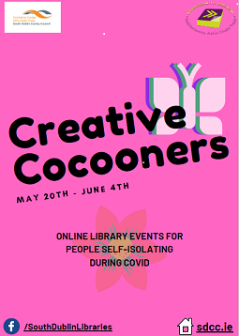Aoife Munn Gardening videos x 3 - Horticulturist Aoife Munn concluded her series of videos, with **‘How to Make a Vegetable Patch’.** It attracted a reach of 1297, 47 engagements, 13 likes 5 shares and 59 views.

20th May - Ogham workshop, live talk via Zoom

20th May - The Singing Librarian - live music show via Facebook live

27th May - JFK and the Summer of 1963 - history talk via Facebook

28th May - Coping and Anxiety Management Skills - live talk via Zoom

20th - 31st May - SDL Gardening competition - borrowers submit photos of their gardens, featured on social media and 1st, 2nd, 3rd prize available

4th June - Mandala and meditation with Patricia Fitzgerald - live talk via Zoom

**Carmel Wynne’s R.E.L.A.X. talks** – each aimed at different audiences – took place each evening at 7pm. Its reminder promo post had a good reach of 1406 with 19 engagements and 6 shares.

We also hosted two Mindfulness Origami sessions on 11th May at 10.30am and 11.30am.

**OTHER HIGHLIGHTS**

**STEAM**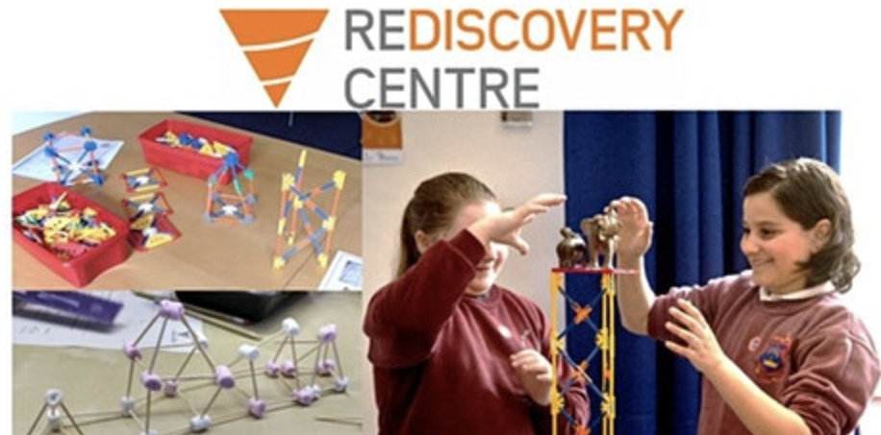

Coding classes are continuing to be delivered via Zoom and the demand is growing. 24 children aged 10 -12 attended the last sessions. Rediscovery centre delivered a Space workshop via Zoom which was booked out and a Volcanoes workshop via Zoom with Anyone4Science also was booked to capacity.

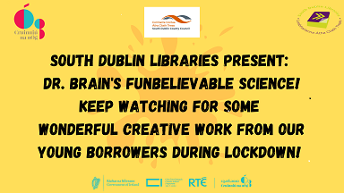

Dr Brain’s Funbelievable Science’s series of six videos is almost halfway through and continue to be popular with the third video – Water You Waiting For? – garnering a Facebook Reach of 2199, 104 engagements, 6 likes, 10 shares and 62 views.

**Love Your Library, Facebook Page** with full-filled children’s activities organised and delivered by staff included:

* Weekly Philosophy Club
* Weekly Instagram TV Craft
* Weekly STEM sessions

**Weekly Online Safety Classes for Children**

A new series of webinars, which will be delivered live by our fantastic Education Team, to support children in 3rd – 6th class to be smart digital citizens. Each webinar will last 20 minutes and will have an optional follow-on assignment. The sessions follow 13-year old Emma and 9-year old Eoin, covering a range of online safety issues that will encourage kids to solve different problems:  
Week 1 - Get your CyberSafe check up!   
Week 2 - Social Media & Gaming Week 3 - Be proud of your Digital Footprint   
Week 4 - Do not believe everything you see!

Wednesdays at 12.30pm starting 20th May for 4 weeks and repeated for a further 4 weeks due to demand.

Our Parental Cybersafe course promo had a reach of 1910, 33 engagements, 7 likes and 7 shares.

**Summer Stars 2020**

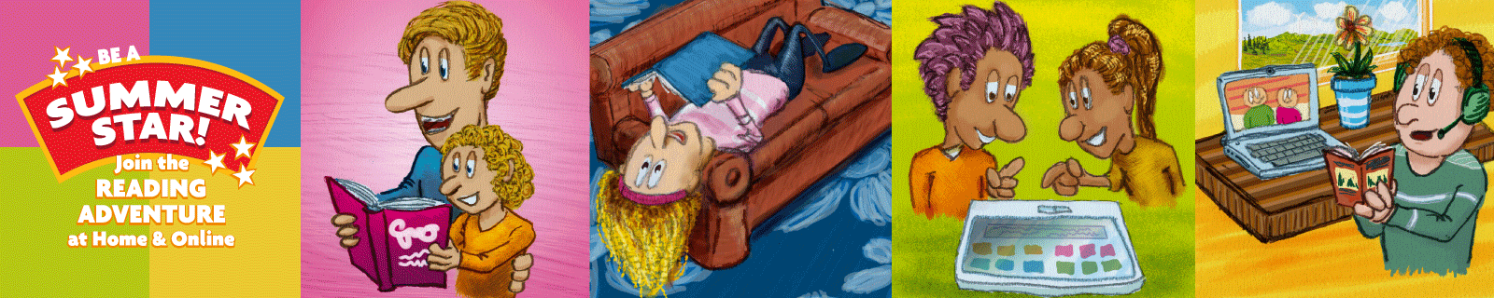

South Dublin Libraries will participate in the national children’s reading initiative **Summer Stars** from mid-June with lots of online activities as well as planned reading packs for collection from branch libraries.

As in previous years, children will receive a reading card on which to record the books they read. Initially this will be in pdf format which can be downloaded. Children can borrow books using the digital book resource, Borrowbox, and access physical books through a “contact and collect” service when the libraries re-open. An agreement with Bolinda will see lots of new titles added to the Borrowbox resource from mid-June to cater for the extra demand. This has only been facilitated for Republic of Ireland as a direct result of the huge uptake of the Borrowbox resource during these past few weeks while the libraries have been closed.

South Dublin Libraries will hold raffles at the end of the programme in late August, where all children who participated will have the chance to win a tablet from their branch library.

Children’s events will continue online on South Dublin Libraries’ Facebook page, with lots planned for the summer months including creative writing classes, illustration workshops, interviews with authors / illustrators, online story times, STEAM activities and lots more.

Libraries Ireland are organising a national short story competition for children and teens, with three age categories (6-9, 10-14, 15-18yrs). South Dublin Libraries will be delighted to be involved in this and encourage entries from all over the County.

**Cruinniú na nÓg South Dublin** will take place on 13th June with a webcast <Https://bit.ly/CruinniuTVSD> that brings together a variety of artists from across South Dublin to showcase projects, workshops, readings and performances. **Staying Connected** with South Dublin Libraries will showcase a video of Science Fun with Dr. Brain and a montage of creative projects and artworks completed by local children in the run up to 13th June.

**History at Your Fingertips – South Dublin Local History May and June 2020**

History at Your Fingertips is a series of online local history and genealogy activities, workshops and events by South Dublin Libraries during May and June 2020. Like other library services, Local Studies has found its activity curtailed because of the current crisis. Our response has been to take as much of our activity as possible online.

|  |  |  |
| --- | --- | --- |
| Introduction to Family History workshops. | These will take place weekly via Zoom and will be delivered by expert genealogist Fiona Fitzsimons. The workshops will cover civil records, census, parish records, Griffith’s Valuation, gravestone, and cemetery records, and using newspapers for family history research. | Wednesdays 13th, 20th and 27th May, and 3rd, 10th and 17th June. |
| Family History Blogs | To complement the workshops, our Local Studies Librarian will conduct a weekly blog with advice and information to help people navigate their way through the main online resources they will need to start growing their family tree. See [www.localstudies.wordpress.com](https://eur04.safelinks.protection.outlook.com/?url=http%3A%2F%2Fwww.localstudies.wordpress.com%2F&data=02%7C01%7Cbfennell%40SDUBLINCOCO.ie%7Cacb1c6a2440143fe1d7608d7fb3898cb%7C6a3c00c019d0492da8de95fad8fda1d4%7C0%7C0%7C637254092803571303&sdata=COc7%2FBuZIAStV%2BDYXJQ8r7Wl5Rhi7VHhSyyNCwCBPWo%3D&reserved=0) or South Dublin Libraries on Facebook. | Weekly on Thursdays. |
| Talk: Michael Flanagan, the man, the Alderman | Join local historian Cathy Scuffil for this illuminating talk on the alderman, and grandfather of Liam Cosgrave, Michael Flanagan, and his associations with the Greenhills and Tymon area of South Dublin County. Talk will be shown on South Dublin Libraries’ Facebook page. | June 2020  Date TBC |
| Talk: JFK and the Summer of 1963, Civil Rights, Cold War Politics and an Irish Homecoming | Historian Cecelia Hartsell looks at John F. Kennedy’s troubled summer of 1963 dealing with major issues in the US before he embarked on a joyful homecoming to Ireland. Talk will be shown on South Dublin Libraries’ Facebook page. | Wednesday 27th May at 7:00pm on South Dublin Libraries Facebook. |
| Talk: History of Tallaght | Local Studies Librarian Michael Keyes will give a talk on the fascinating history of Tallaght, from early Christian settlement to modern metropolis. Talk will be shown on South Dublin Libraries’ Facebook page. | Thursday 11th June at 1.00pm |
| Leaving Certificate History Guide | With much disruption to the Leaving Certificate exams the History Research Study deadline has been extended to 15 May. Our Local Studies Team have prepared a step by step guide on how to complete the History Research Study and this has been posted at localstudies.wordpress.com. Between now and 15 May we will be reminding students that while the libraries are closed our Local History staff are available online to help and offer advice on their history projects. | Guide is available now. Staff available for queries in run-up to 15th May deadline. |
| Tallaght Historical Society Lecture Archive | Each week, a recorded lecture from Tallaght Historical Society’s archive will be posted and promoted on South Dublin Libraries’ Facebook page. | Weekly throughout May and June. |
| History all Around Us: Rathfarnham Colouring Book | This colouring book has been made available to download free of charge for parents and teachers, via [www.southdublinlibraries.ie](https://eur04.safelinks.protection.outlook.com/?url=http%3A%2F%2Fwww.southdublinlibraries.ie%2F&data=02%7C01%7Cbfennell%40SDUBLINCOCO.ie%7Cacb1c6a2440143fe1d7608d7fb3898cb%7C6a3c00c019d0492da8de95fad8fda1d4%7C0%7C0%7C637254092803571303&sdata=iztR7WmS5sdRf4Co7RNKVwFpYW5M3VFJHD46libuCXg%3D&reserved=0). The book features images and short histories of Rathfarnham’s many historic sites. | Available now. |

**Introduction to Family History: Parish Records** took place on 27th May. There were

99 places available, but all were fully booked after less than 13 hours. People who booked came from Dublin 70, Rest of Ireland 24, Northern Ireland 3, England 1, and the UK – unspecified – 1.

Some very good feedback too:

“I found it very informative. Fiona gave an excellent presentation."

*******************

“It was most informative."

*******************

“Just to let you know, I have truly enjoyed the first two sessions of this series; in fact, they have been the highlight of my week. I look forward to them and I plan my other activities around them. I appreciate Fiona’s expertise, and have learned so much from these sessions.”

**********************

**Introduction to Family History: Census** took place on 20th May at 7pm

Wednesday 20th May, 7:00pm. There were 99 places available, fully booked after less than 8 hours. Of the 99 booked and who attended they came from Dublin 70, Rest of Ireland 16 Canada 2, USA 4, England 5, and Northern Ireland 2.

**Introduction to Family History: Civil Records (Birth, Marriages & Deaths)** took place on13th May at 7:00pm Of the 99 booked they included: Dublin 71, Rest of Ireland 17, Canada 3, USA 2, England 2, Scotland 2, Northern Ireland 1 and New Zealand 1.

**Capital Projects**

A partial handover of **North Clondalkin Library** took place from 27th April. The tender for furniture and fittings is awarded and we await delivery of furniture items and shelving in the next three months. The contractor is completing snagging at the library, returning since 18th May.

**Castletymon Library**

The contractor has started to remobilise on site with a view to commencing work from 18th May 2020. In compliance with the criteria set out in return to work roadmap, the contractor will be carrying out mostly external works during the next 3 weeks.

We are awaiting an updated programme from the contractor but given the time lost and new protocols on safe working due to Covid-19, we would expect that the project will not be completed until the 4th quarter of the year.