COMHAIRLE CHONTAE ATHA CLIATH THEAS
SOUTH DUBLIN COUNTY COUNCIL

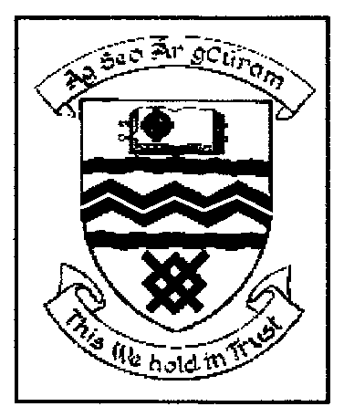

MEETING OF TALLAGHT AREA COMMITTEE (2)

MONDAY 27TH MARCH, 2006

Motion No. 3

Motion: Councillor Caitríona Jones

“That the Manager discuss the possibility of compelling developers to include visible unit numbering on each dwelling in new residential developments”

Report:

There is no requirement under existing planning legislation or regulations to enable the Council to compel developers to include a number on each new dwelling.

However it is this Council’s practice to encourage developers to install a number on each new dwelling. In practice, following the advice of the Council, developers now install a number on apartment and high density developments.

