COMHAIRLE CHONTAE ATHA CLIATH THEAS
SOUTH DUBLIN COUNTY COUNCIL

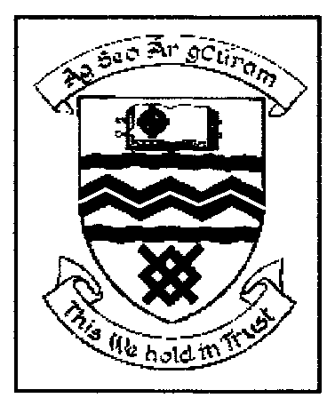

MEETING OF TALLAGHT AREA COMMITTEE (2)

MONDAY 27TH MARCH, 2006

QUESTION NO. 5

Question: Councillor K. Warren

“To ask the Manager what is the inspection rate of compliance with Part M of the building regulations for development and would he make a statement on the matter?”

REPLY:

The Building Control Section carries out inspections on buildings under construction. The national inspection target as set out by the Department of the Environment is that inspections should be 12% to 15% of buildings covered by valid commencement notices.

South Dublin County Council’s inspection rate for 2005 was 18.1%.

There is no stated inspection for compliance with Part M of the Building Regulations. However on any inspection visit by the Building Control Inspectors, Part M compliance will be checked, if applicable.

On receipt of the list of Commencement Notices, all single houses are identified and the drawings are examined to check if they comply with Part M. If the drawings are not compliant, the designer / client is contacted and informed of the non compliance and a follow up site visit takes place.

The Building Control Section also carries out inspections for Disabled Persons Grants. There were in excess of 300 applications in 2005. As part of the inspection all relevant new work has to comply with Part M of the Building Regulations.

