Social Distancing to Support Mobility

Introduction

Due to Covid-19, Local Authorities all over Ireland are considering implementing Social Distancing measures to protect against the further spread and control of Covid-19. The Council has prepared a Social Distancing report to support mobility for the County, which identifies how the Council can deliver enhanced social distancing measures to support mobility.

The report sets out our key objectives, legislative background, information on what is being done in our neighbouring Dublin Authorities, the types of intervention that could be delivered, the initial locations identified and a programme for roll out of works.

Key Objectives

We propose to progress the delivery of County-wide temporary measures to reallocate public space on a strategic basis that will:

- Support physical distancing in line public health guidelines on Covid-19 in congested areas
- Facilitate changing travel patterns
- Support the economic recovery of the County

Legislative Framework

The two main legislative provisions that enable the implementation of the above physical measures are:

- Section 95 of the Road Traffic Act 1961 (as amended by Section 37 of the Road Traffic Act 1994); and
- Section 38 of the Road Traffic Act 1994.

In addition to required planning consent, section 46(2) of the Public Transport Regulation Act 2009 sets out circumstances where certain measures are exempted from the normal Part VIII planning process. In addition, the normal exemption for works under the value of €127,000 also applies. Appendix XX to this report expands on the relevant legislative sections.

Activities in our neighbouring counties

The neighbouring Dublin Authorities are progressing similar works and more information on what works they are progressing are below

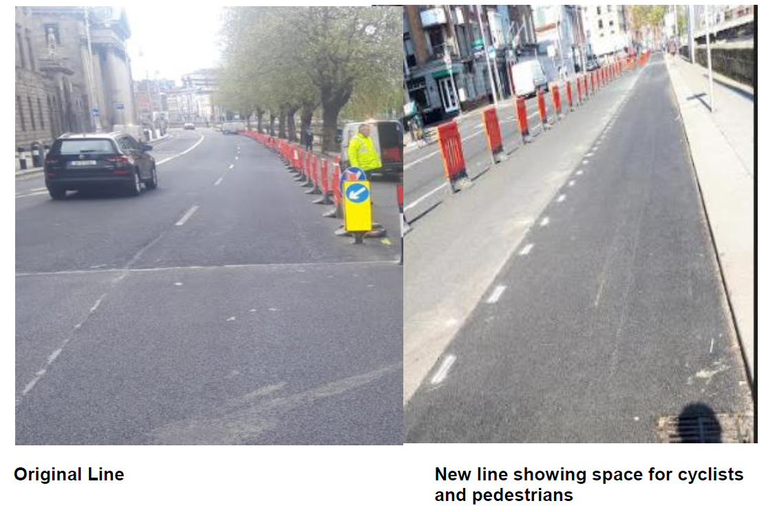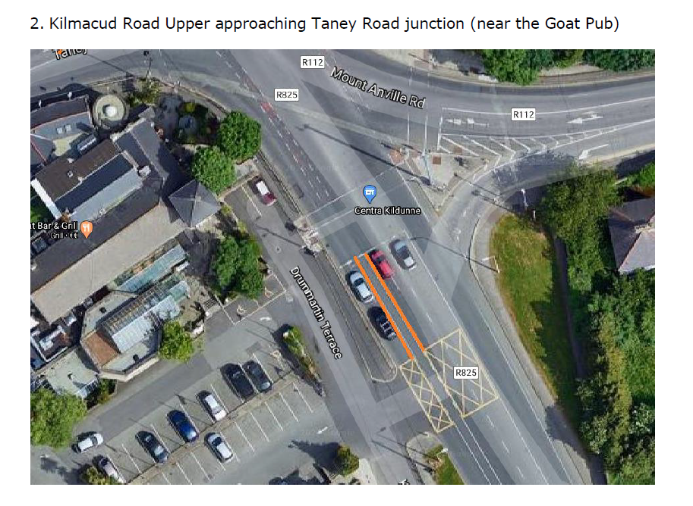

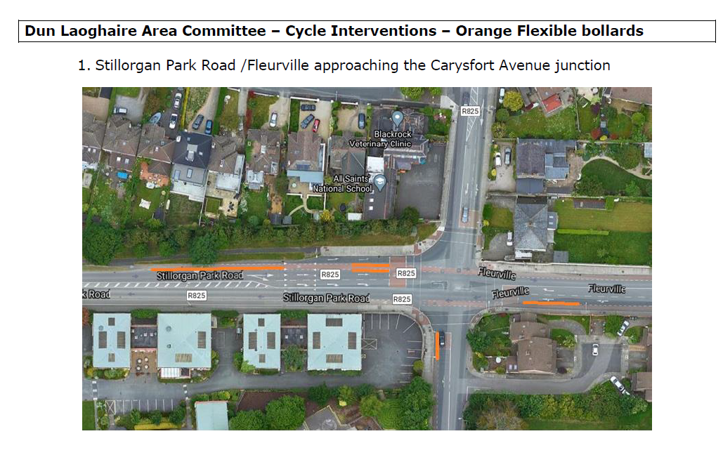

Submissions and queries raised to date

To date we have received formal requests from the following bodies. In addition to this there is a small but increasing number of queries from the public.

- Irish wheelchair association
- National Council for the Blind
- Disability federation of Ireland.
- Dublin Cycling Campaign
- Green Party
The message from all the above is concentrated around the area of queues on footpath and the reallocation of road space to cyclists. Pedestrians including vulnerable people are being forced onto roads frequently where no dropped crossing or other guides exist.

Rationale for intervention

An analysis of our public realm, villages and centres across the County is underway. Those areas under consideration fall into two broad categories

- Places that present Social Distancing challenges for people for example where there are narrow and congested foot paths and cycle paths, or locations that have busy commercial premises at street level that result in congestion and/or queuing of people on the street.
- Areas where it is possible to introduce improved cycle infrastructure and capacity to support people that will not be able to travel by public transport as result of the significant decrease in capacity

The Roadmap for Reopening Society and Business sets out how the COVID-19 restrictions will be lifted but there will be no significant difference to public transport. Restrictions on public transport is noteworthy as can be seen in the table. As society is once again on the move, public transport limitations will have considerable effect on how people travel to work and carry out day to day personal requirements.

Table: Covid 19 Public Transport Capacity
Type of Public Transport | C19 Capacity *
Dublin Bus | 17%
Luas | 5%
Dart | 5%
*Figures supplied by National Roads Authority

Types of intervention

Where locations are identified as appropriate for temporary interventions there are a range of measures from minor to major adaptations that can be delivered. The exact intervention would be dependent on the exact location and circumstances. Some examples of the type of intervention

- Bollards
- Altered ped signal crossing times
- Protected cycle tracks
- Temporary reuse of car parking and loading bays
- Reallocation of road space to pedestrian and cycle
- Rearranging queuing spaces at bus stops
- Cycle priority lights

Temporary measures that are to be installed would be both functional and sympathetic to the public realm where they are installed to optimise aesthetics and acceptance by the local community. temporary measures provided should be designed for a life span of at least 1 year and a maximum of 2 years to accommodate the reduced capacity of our public transport systems. They inform that C19 temporary measures should be considered for both increased pedestrians and cyclists.

Locations

This section of the report deals with a) specific locations of high congestion on the footpath and b) areas where improved cycle ways could be delivered.

Specific locations
Sixteen locations that experience or may experience localised congestion issues have been identified. To date four have been identified to progress with the first round of temporary interventions. The remaining twelve will continue to be monitored. Over time additional locations may be identified in the future as being suitable and in line with the objectives of this report and in this situation, officers would deliver these works. It is important to note that where these temporary works have been delivered and are found not to be successful or have unintended consequences then the works can be removed quickly and easily.

AIB Clondalkin Village
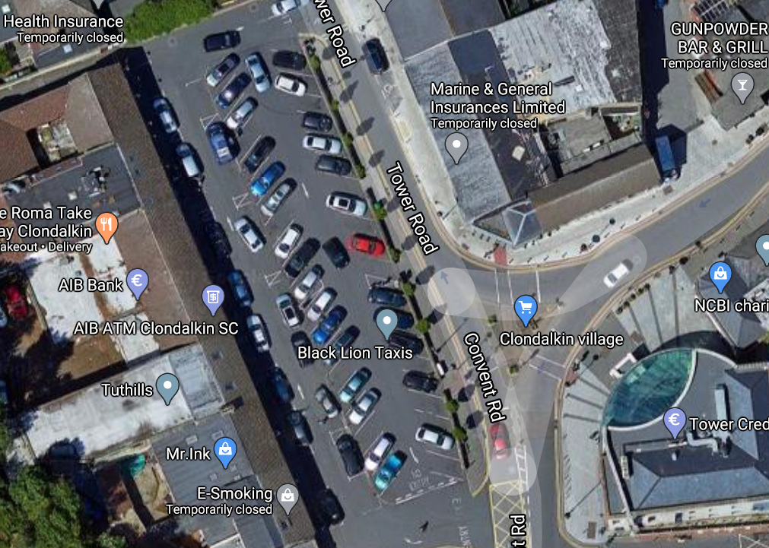
Description: Temporary closure of 4 to 6 parking bays to facilitate frequent queuing

Centra Lucan Village
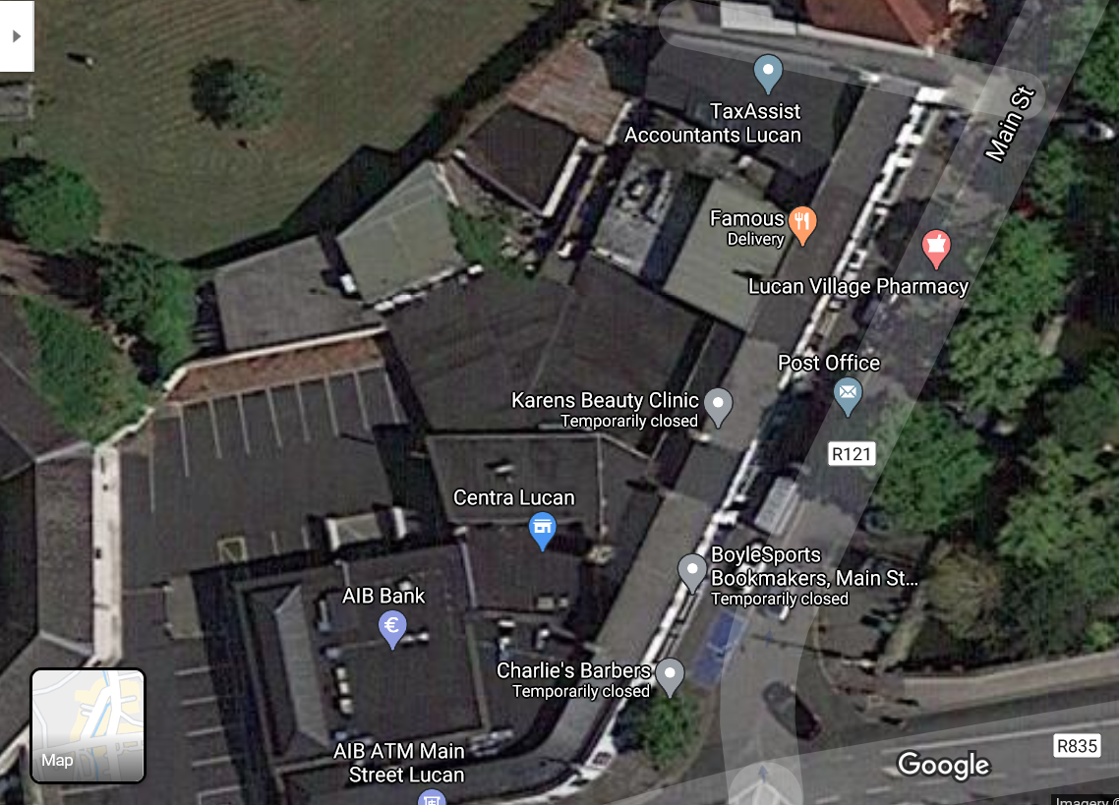
Description: Temporary closure of 6 to 8 parking bays to facilitate frequent queuing

Rosemount shopping centre
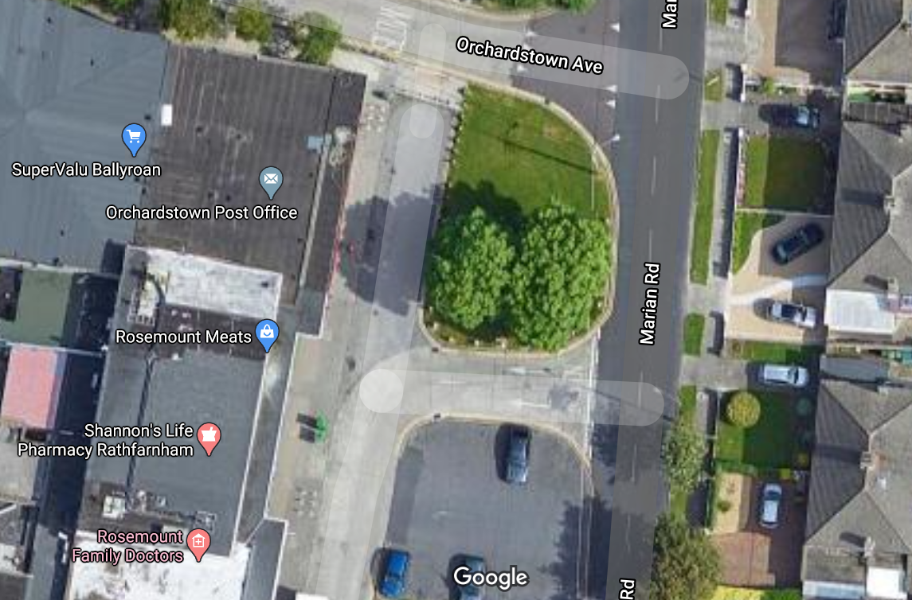
Description: Temporary closure of c.6 parking bays to facilitate frequent queuing

Saggart Village
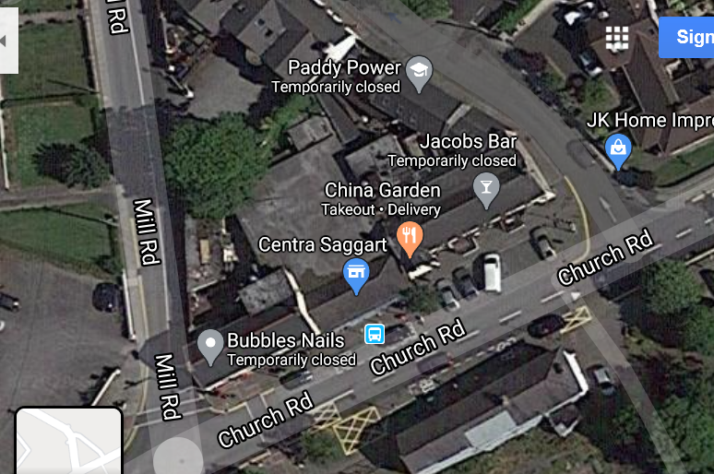
Description: Temporary relocation of the bus stop in front of Centra to address congestion issues

In addition to the above four locations the following have also been identified as locations that may require some level of temporary social distancing intervention. However, further analysis is required:

- Main St, Rathfarnham
- Social Welfare Office, Clondalkin
- Barton Drive Local Centre
- Post Office, Clondalkin
- Muckross Ave, Mace
- The Pantry, Lucan Village
- St Peters Road, Cherrytree Spar.
- Coffee Work, Lucan Village
- Lidl, Old Belgard Road
- Main St, Lucan
- Euro Giant Belgard Sq. West
- Clondalkin Village

Temporary Cycling Proposal for Wellington Road

SDCC propose to provide C19 temporary measures along the full length, where possible, of Wellington Lane, from its junction with the N81 at the Spawell, and along Whitehall Road to its junction with Kimmage Road West.
The temporary measures will consist of road markings, bollards and armadillos, which are used as a cycle lane segregator, preventing vehicles from entering cycle lanes. These temporary measures can be removed at any time.
This route was chosen as a trial route for the following reasons:

- A Scheme exists called the Wellington Lane Walking and Cycling Scheme aiming to create a safer environment for all vulnerable road users in this vicinity
- C19 temporary measures will not impact on vehicle capacity
- It consists of a good mix of domestic and commercial frontage and no frontage at all
- Citizen, Councillor, and school forums undertaken in 2019 indicate an appetite for safer facilities for cyclist and pedestrians along this route
- The area has a number of small shopping facilities, parks, churches, and schools
- A Part 8 is being prepared for this Scheme, which will greatly improve safety for all road users without impacting on vehicle capacity
It is believed that the temporary cycle track when established will show the community the benefits of a cycle track on this route, and the additional safety benefits that can be realised from a fully segregated cycle track.

The roundabouts, signalised and non signalised junctions along this route cannot be effectively addressed by the proposed C19 temporary measures. Interim measures may further complicate safety and for this reason junctions will not be changed.

The Part 8 for the Wellington Lane Walking and Cycling Scheme is currently being prepared, this will address all junctions along this route, addressing all health and safety issues for vulnerable road users.
Consideration to construct the junctions first at construction stage will be prioritised, as temporary cycle tracks can be utilised throughout the build.

This is the first planned temporary cycle intervention to be introduced by the Council, it is envisaged that more within the functional area of South Dublin could be rolled out on foot of the envisioned success of this project.

