COMHAIRLE CHONTAE ATHA CLIATH THEAS
SOUTH DUBLIN COUNTY COUNCIL

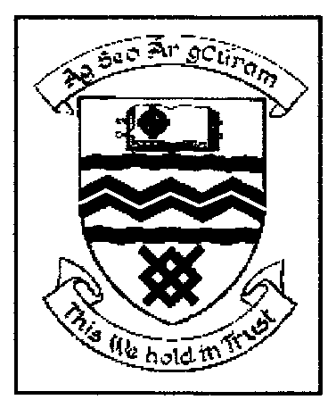

MEETING OF TALLAGHT AREA COMMITTEE (2)

MONDAY 27TH MARCH, 2006

Question No. 3

Question: Councillor J. Neville

“To ask the Manager to list in detail the postal names & addresses of all apartment developments constructed in the greater Belgard square area within the last three years?”

REPLY:

The following is a listing of the names and address of apartment development constructed in the Belgard Square area in the past 3 years and for which naming and numbering schemes have been approved : -

- Exchange Hall, Belgard Square North, Tallaght, Dublin 24
- Abberley Square, Tallaght, Dublin 24
- Westend Gate, Tallaght, Dublin 24
- Tuansgate, Old Blessington Road, Tallaght, Dublin 24
- Aengus Hall, Belgard Square West, Tallaght, Dublin 24
- Loftus Hall, Belgard Square West, Tallaght, Dublin 24
- Horan Hall, Belgard Square West, Tallaght, Dublin 24
- Alen Hall, Belgard Square West, Tallaght, Dublin 24
- Virginina Hall, Belgard Square West, Tallaght, Dublin 24
- Swan Hall, Belgard Square West, Tallaght, Dublin 24
- Losset Hall, Belgard Square West, Tallaght, Dublin 24
- Tallow Hall, Belgard Square West, Tallaght, Dublin 24

