COUNTY ARCHITECT’S REPORT  ON COMPLETION OF PART VIII DISPLAY – DRAFT 29/5/2020  Proposed Saggart Community Centre.  Conservation, renovation and extension at  St Marys National School (protected structure)  Slade Castle Walk  Boherboy  Saggart  Part 8 Process, carried out under Part 8 of the Planning and Development Regulations 2001, Part 8.  Consultation Process stage.  This is an advisory report. The full report will be issued following the conclusion of the Consultation Process.  Issued June 2020  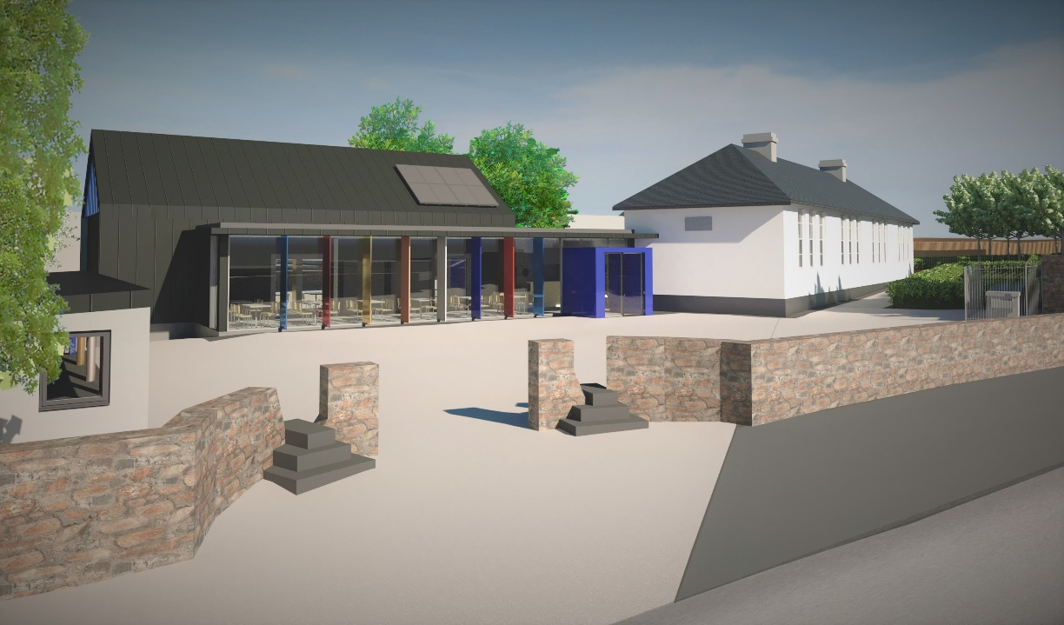 |  |  | 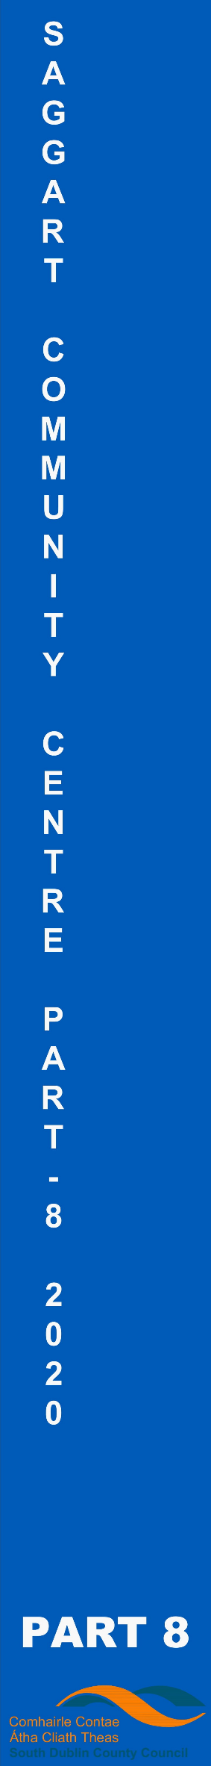
 |  | COUNTY ARCHITECT’S REPORT – Part 8 – Display / Consultation
 | Project Title: | Proposed Saggart Community Centre,  Conservation, renovation and extension at  St Marys National School (protected structure)  Slade Castle Walk, Boherboy, Saggart
 | County Architect:  Senior Arch:  Senior Exec Arch:  Dept: | Eddie Conroy FRIAI  Anne Lynch FRIAI  Aidan McNamara MRIAI  Architectural Services Department, South Dublin County Council
 | Outline of Part 8 Process carried out under Part 8 of the Planning and Development Regulations 2001 | Part 8 (Public Consultation Developments)  Developments by a local authority are subject to a public consultation process as set out in the Planning & Development Regulations, 2001 - 2012. This procedure requires that notice of the proposed development be given in the public press and that a site notice be erected. If any submissions or observations are received, a report is presented to the members of the Council. This report contains a list of the objector's names along with a summary of the points made by them and the Local Authority' response.  Arising from consideration of the representations, the report sets out whether or not it is proposed to proceed as originally planned or to proceed with a modified proposal.  Development by a Local Authority: 'Part 8'  From time to time the Local Authority may carry out development within its administrative area, such as the construction of houses, roads, swimming pools, public toilets, sports pavilion etc.  Development carried out by a Local Authority is often referred to as a 'Part 8’: - this is reference to Part 8 of the Planning and Development Regulations 2001 which sets out the procedure for carrying out such developments.  Public consultation is an intrinsic part of the 'Part 8' process. This is achieved by public notices, public display of the proposal, observations by members of the public, reportage on observations received and a recommendation that considers all internal and public observations. The consultation may extend to advisory consultation meetings with local community and interest groups dependant on the particular circumstances and impact of the proposal, though such meetings are not proscribed under the legislation. The primary purpose of the process is to notify the public of the proposal and incorporate any observations validly submitted into a report to inform the Council on its decision to recommend the proposal.  Comments and observations on Proposed Developments by a Local Authority can only be received in writing between certain dates. The public notices should be referred to in this regard to ascertain the final date of receipt for observations.  Part 8 of the Planning and Development Act 2000 – 2007 refers to requirements in respect of specified development by, on behalf of, or in partnership with Local Authorities. Part 8 applications are generally lodged by the proposing department within the Council. Article 80 of the Planning and Development Regulations 2001 sets out a list of the types of development prescribed for the purposes of the act.  The process is as follows:  Public Notices of the proposed development must be placed in an approved newspaper. A site notice (or notices) must be erected on the land on which the proposed development is situated – Article 81(1)(a)(b) of the Planning and Development Regulations 2001 provides guidance on the requirements.  The application, which must be submitted on the same date as the newspaper notice, must include a cover letter / report, a copy of the newspaper notice and site notice and public display of the proposal in a designated public area accessible to the public during normal office hours – normally County Hall. Drawings can be made available to the public on request.  There is no fee payable on a Part 8 application.  The application is referred to internal works Departments in the City Council – (Roads, Water, and Drainage).  In the case of protected structures, the application is referred to the Conservation Section, An Taisce, DEHLG and the Heritage Council.  The timeframe for third party Observations/Submissions on the Part 8 application is six weeks from the date of lodgement. This date is specified in the public notices. There is no fee charged for observations/submissions on a Part 8.  The proposing Department completes a report for the attention of the Executive Manager of the Planning Department. The Executive Manager will make a recommendation to the proposing department on foot of this report.  A report will then be compiled for a meeting of the Council. Following consideration of this report by the Council, the proposed development may be recommended, unless the local authority, by resolution, decides to vary or modify the development, otherwise than as recommended in the report, or decides not to proceed with the development’ – as per Section 179(4)(b) of the Planning and Development Act 2000 (as amended). For a part 8 application the period for observations/submissions is 6 weeks.  The making of a decision on a Part 8 application is a reserved function of Council, while for a normal planning application this is an executive function.  The above is a summary of the Part 8 requirement for consultation. It is intended for guidance only. The Planning Acts set out the requirements in full.
 | Public Notice: | Pursuant to the requirements of the above, notice is hereby given of the proposal to construct the following development by South Dublin County Council:  Proposed Saggart Community Centre, including conservation, renovation and extension of St. Mary’s National School, Protected Structure,  Slade Castle Walk, Boherboy, Saggart, Co. Dublin  The Community Centre development will consist of  Conservation, restoration and renovation of existing St. Mary’s National School building (unoccupied), Protected Structure, for use as Community Centre  Demolition of rear north section of projection-extension of St. Mary’s National School building to accommodate new entrance.  Construction of new single storey entrance/ reception/ service area and new single storey multi-function hall for the proposed Community Centre with total floor area (including existing) of 610m²  Five car parking spaces off Slade Castle Walk as per existing layout  All associated works and services  Provision of CCTV for security  The proposal has undergone Appropriate Assessment Screening under the Habitats Directive (92/43/EEC) and screening for Environmental Impact Assessment. The Planning Authority has made a preliminary examination of the nature, size and location of the proposed development. The authority has concluded that there is no real likelihood of significant effects on the environment arising from the proposed development and a determination has been made that an Environmental Impact Assessment (EIA) is not required. Any person may, within 4-weeks from the date of publication of this notice, apply to An Bord Pleanála for a screening determination as to whether the development would be likely to have significant effects on the environment.  Drawings of the proposed development will be on public display at County Hall, Tallaght, Dublin 24 and Clondalkin Civic Offices, Dublin 22, during normal working hours and on http://www.sdcc.ie/, during the period from 21st February 2020 to 23rd March 2020.  The plans and particulars can be viewed on the Council’s Public Consultation Portal website http://consult.sdublincoco.ie  Submissions or observations with respect to the proposed development dealing with the proper planning and sustainable development of the area in which the proposed development will be situated may be made in writing up to 4:30pm on the 6th April 2020 and may be submitted either via:  Online Submissions: http://consult.sdublincoco.ie  or  Post to:  Senior Community Officer,  Housing, Social & Community Development Department,  South Dublin County Council,  County Hall, Tallaght, Dublin 24 YNN5.  NOTE: Please make your submission by one medium only. All submissions should include your name and a contact address. It should be noted that the Freedom of Information Act, 1997-2006 (as amended) applies to all records held by South Dublin County Council.  Director, Housing, Social & Community Development, South Dublin County Council, County Hall, Tallaght, Dublin 24.  Visit www.southdublin.ie for all your information needs  Site Notice Erected on: 20.02.2019
 | Context: | The proposed development is to be carried out on the site of the St Marys National School in Saggart which is located on Slade Castle Walk at the southern end of Saggart Village.  St. Mary’s National School has been unoccupied since 2014. The original school completed in 1937 was one of the first in the series of national schools designed by Basil Raymond Boyd-Barret for the OPW and is a protected structure. When South Dublin County Council purchased the school building, they identified the opportunity to save an important part of the heritage of Saggart and link the strong community roots of the existing site to the wider, newer community growing in the village by adapting and extending the school as a new Community Centre and Civic space.  The development comprises of the conservation, renovation of the existing school, demolition of part of the rear ancillary building and construction of a new single storey extension entrance/reception/ service area and new single storey multi-function hall for the proposed Community Centre with total floor area (including existing) of 610m²  The new extension will overlook a new civic space framed by the original school, play-shelter and entrance gateway. Five car parking spaces will be provided off Slade Castle Walk as per existing layout. Provision of CCTV is included for security purposes.  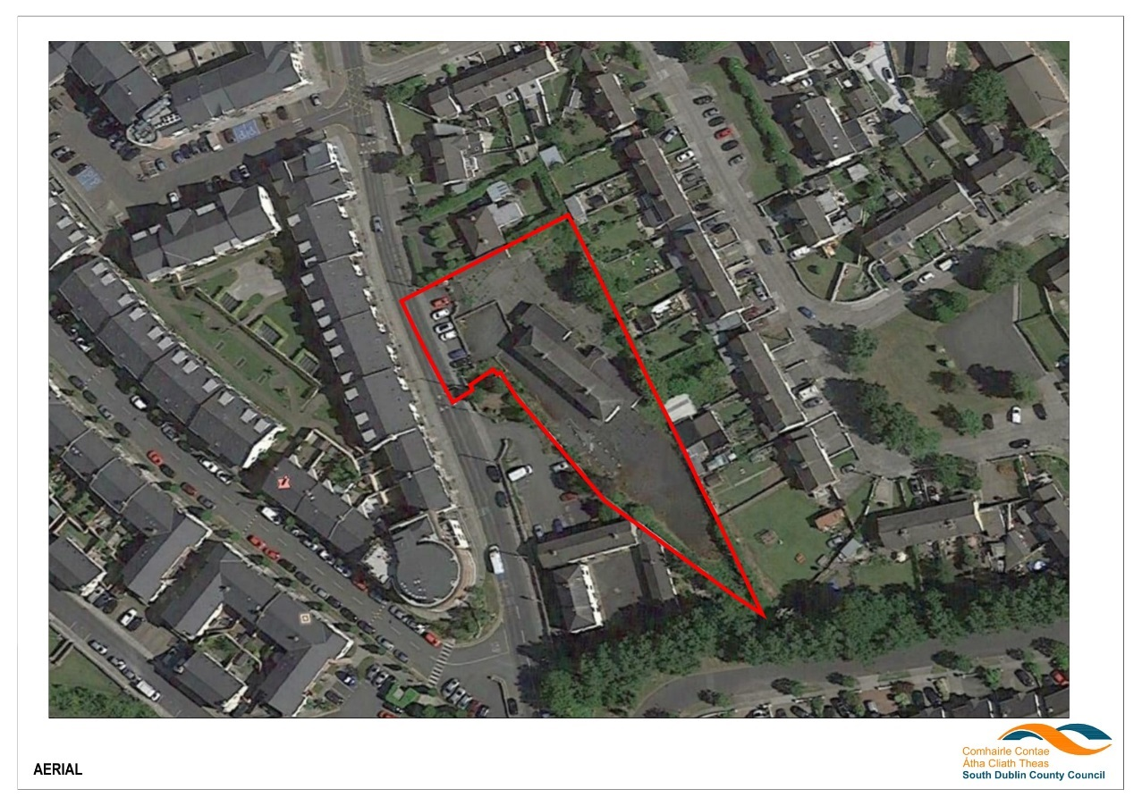  Ariel view of Location (outlined with a red line)  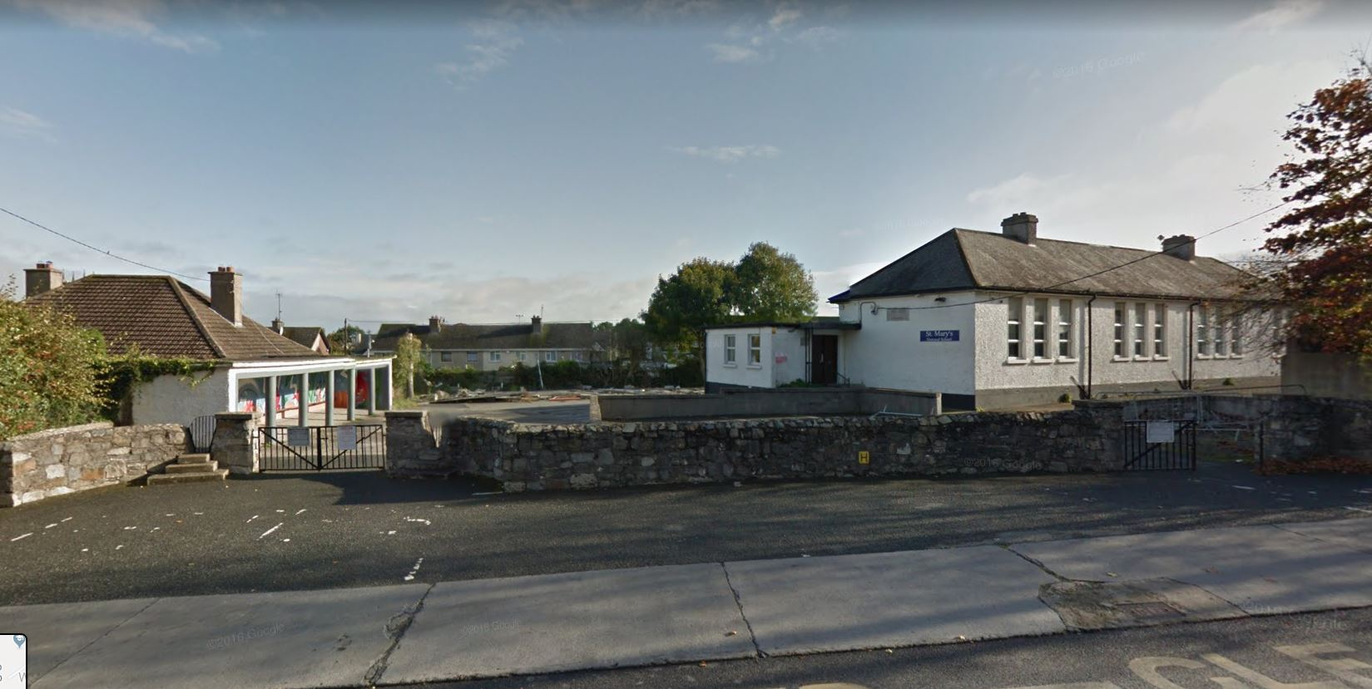  View 1 from Slade Castle Walk, the access point to the site  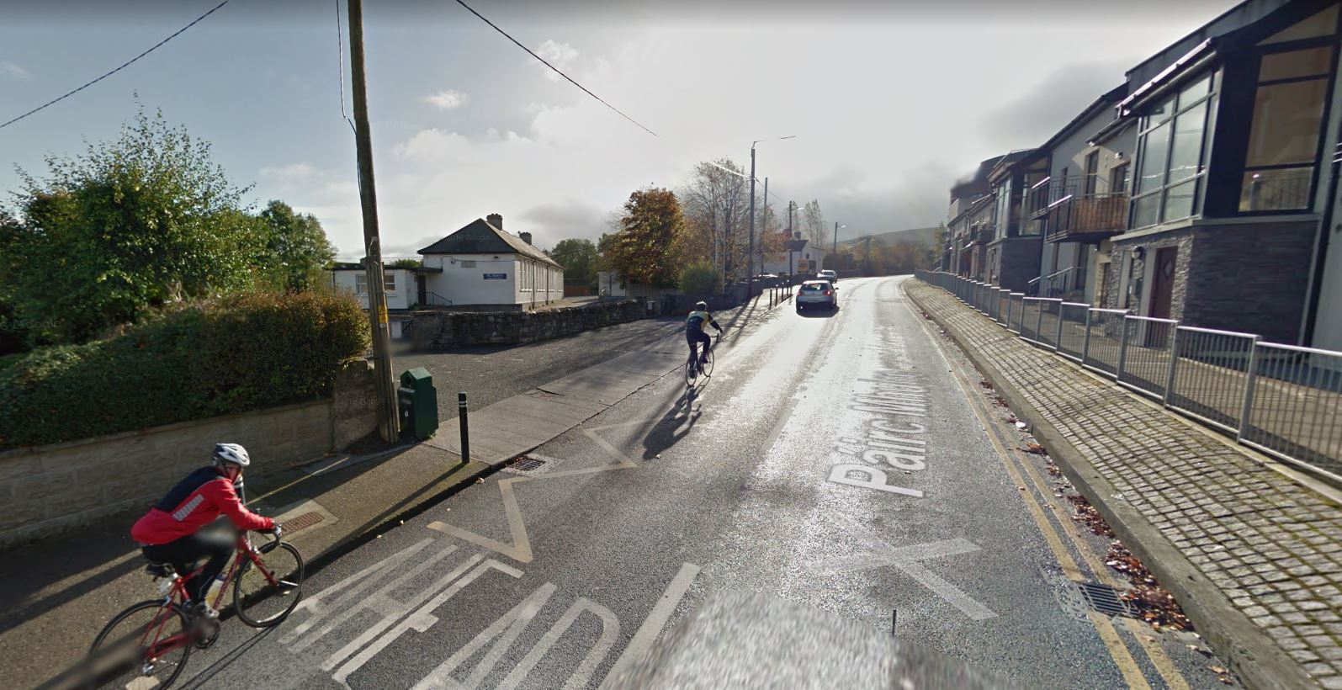  View 2 from Slade Castle Walk looking south towards the site  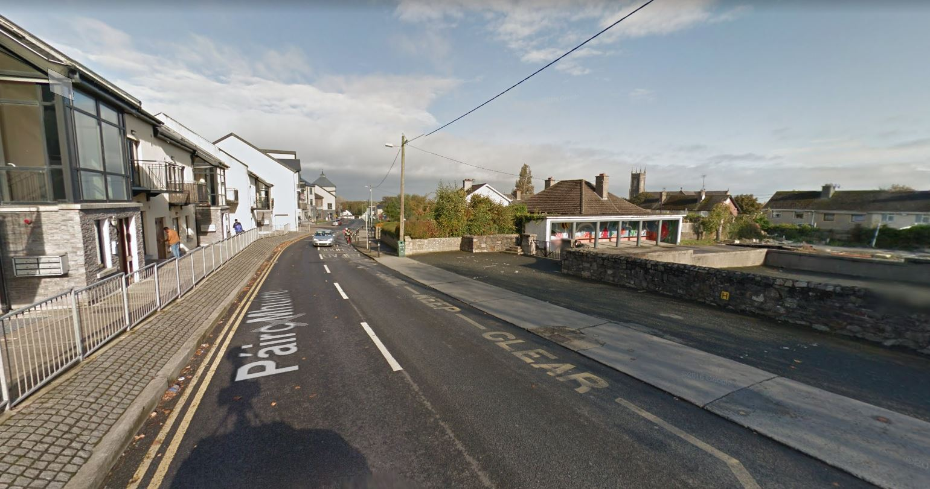  View 3 from Slade Castle Walk looking north towards the site  The site falls approx. 1.5 m from north to south.  All services are available  The site was originally used as a school.  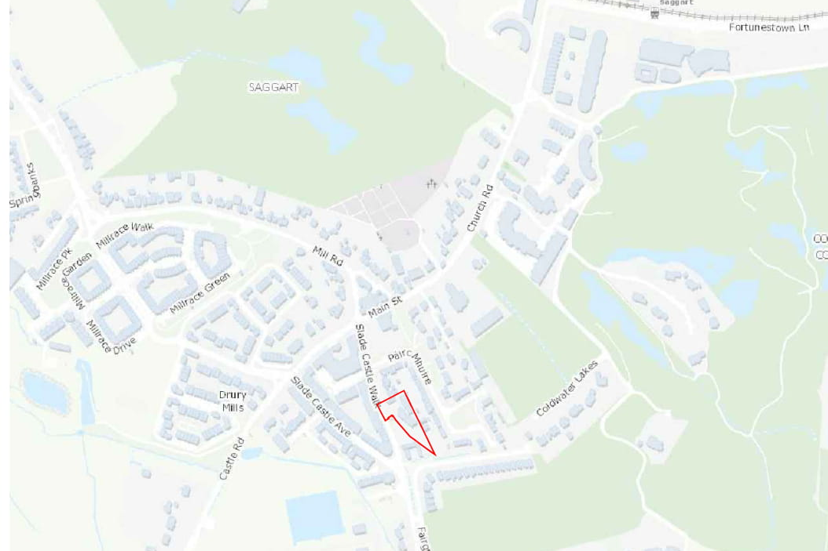  Site Location Map and local road network (site outlined in red)  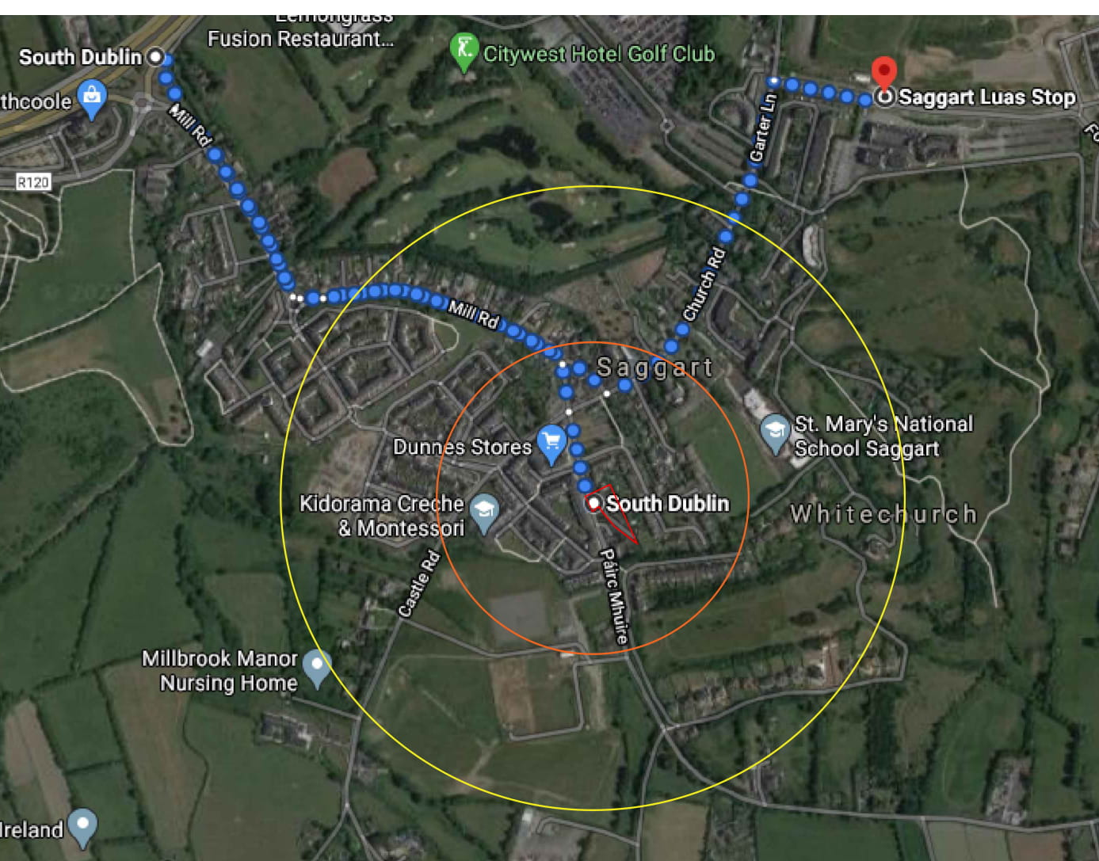  Site Location: 500m and 1000m walking radius and Luas stop  The site is situated at the south end of Saggart village and is within 5-10 minutes walking distance of most of developments in the village and within 12 minutes walking distance to the Luas stop.  Junction 8 of the N7 is approx. 1.2 m due west
 | Planning / Zoning for the site | Planning / Zoning  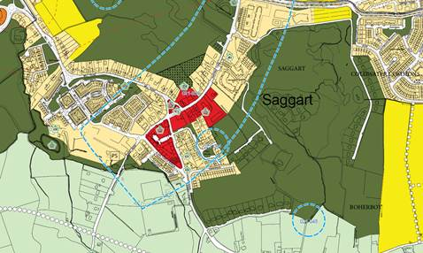  Zoning map for Area (extract from the County Development Plan 2016 – 2022)  Zoning:  The site is zoned as residential and it is located within an area of archaeological potential. The building is a protected structure (No 424) as identified on the above map  The Zoning Objective for the site is ‘to protect and/or improve residential amenity’ and use as a Community Centre is identified as ‘open for consideration’ in the use classes related to this zoning objective, as per below extract from Development plan.  In addition, the site is immediately adjoining the area with Zoning objective VC ‘to protect, improve and provide for the future development of Village Centres  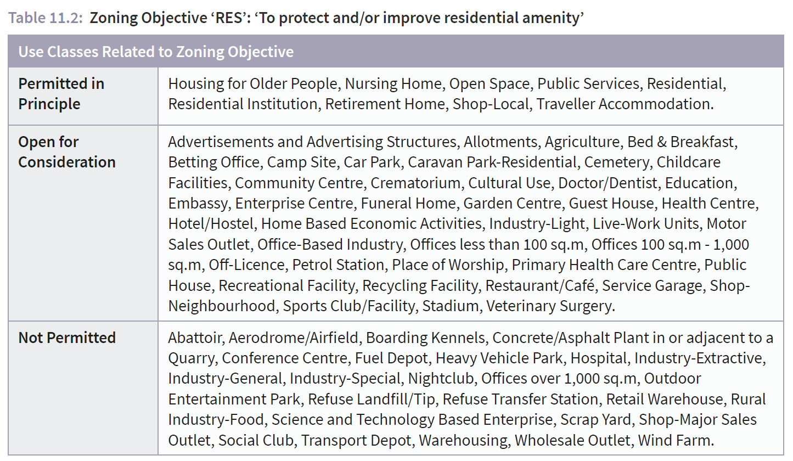  The zoning of the site, its location in the Village of Saggart in a zone of archaeological potential, the listing of the building as a protected structure and the historical use of the site as a school since 1937 is compatible with the proposed development as a Community Centre and the relevant applicable criteria from the Development Plan supports the design proposed. In this regard, the proposed development complies with the relevant Development plan polices.  Previous Planning history:  The previous Planning history for the site is summarised below:  SD07A/0336 Installation of a free standing pre-fabricated single storey classroom building to southern side of existing school building. Permission Granted  SD06A/0438 Remove an existing two classroom prefabricated building and replace with a prefabricated, free standing, 242.6sq.m. single storey three classroom building to the side and rear of the existing main school building along with all necessary associated site works. Grant Permission  SD03A/0653 Erection of Detached single storey prefab classroom, resource room and toilets. Grant Permission  Identification of need for development:  The need for community centre is clearly identified in the County Development Plan – as per COMMUNITY INFRASTRUCTURE (C) Table 3.1 Appraisal of Existing and Planned Community Facility Provision  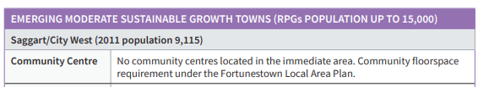  Development plan policy objectives:  The development plan policies that affect the site are listed below  Core Strategy (CS)  Policy 4 Small Towns It is the policy of the Council to support the sustainable long-term growth of Small Towns based on local demand and the ability of local services to cater for growth.  COMMUNITY INFRASTRUCTURE (C)  Policy 1 Community Centres Policy C1 It is the policy of the Council to ensure that all communities have access to multifunctional community centres that provide a focal point for community activities.  C1 Objective 1: To carry out an assessment of community floorspace needs in South Dublin County.  C1 Objective 2: To support the provision of a network of district scale community centres across the County that can function as multifunctional, active and vibrant community hubs.  C1 Objective 3: To support the clustering of community facilities such as community centres, sports and leisure facilities and open spaces to create multi-purpose community hubs.  C1 Objective 4: To ensure that community facilities are provided in new communities on a phased basis in tandem with the provision of housing in accordance with approved Local Area Plans or Planning Schemes.  C1 Objective 5: To support the provision of new or improved facilities in established areas.  C1 Objective 6: To ensure that community buildings are flexible and adaptable and can be used by all age cohorts, including young people (youth programmes, youth cafés, etc).  C1 Objective 7: To provide additional youth cafés in areas with high population of young adults and to utilise existing buildings which can be adaptable to youth programme facilities such as local libraries.  COMMUNITY INFRASTRUCTURE (C) Policy 8 – Childcare Facilities Policy C8 (a) It is the policy of the Council to support and facilitate the provision of good quality and accessible childcare facilities at suitable locations in the County. Policy C8 (b) It is the policy of the Council to require the provision of new childcare facilities in tandem with the delivery of new communities.  C8 Objective 1: To support and facilitate the provision of childcare infrastructure at suitable locations such as town, village, district and local centres, adjacent to school sites and in employment areas.  C8 Objective 4: To support the provision of childcare facilities in community buildings, such as community centres and schools.  HERITAGE, CONSERVATION AND LANDSCAPES (HCL) Policy 2 Archaeological Heritage It is the policy of the Council to manage development in a manner that protects and conserves the Archaeological Heritage of the County and avoids adverse impacts on sites, monuments, features or objects of significant historical or archaeological interest.  HCL2 Objective 1: To favour the preservation in-situ of all sites, monuments and features of significant historical or archaeological interest in accordance with the recommendations of the Framework and Principles for the Protection of Archaeological Heritage, DAHGI (1999), or any superseding national policy document.  HCL2 Objective 2: To ensure that development is designed to avoid impacting on archaeological heritage that is of significant interest including previously unknown sites, features and objects.  HCL2 Objective 3: To protect and enhance sites listed in the Record of Monuments and Places and ensure that development in the vicinity of a Recorded Monument or Area of Archaeological Potential does not detract from the setting of the site, monument, feature or object and is sited and designed appropriately.  HERITAGE, CONSERVATION AND LANDSCAPES (HCL) Policy 3 Protected Structures It is the policy of the Council to conserve and protect buildings, structures and sites contained in the Record of Protected Structures and to carefully consider any proposals for development that would affect the special character or appearance of a Protected Structure including its historic curtilage, both directly and indirectly.  HCL3 Objective 1: To ensure the protection of all structures (or parts of structures) and the immediate surroundings including the curtilage and attendant grounds of structures contained in the Record of Protected Structures.  HCL3 Objective 2: To ensure that all development proposals that affect a Protected Structure and its setting including proposals to extend, alter or refurbish any Protected Structure are sympathetic to its special character and integrity and are appropriate in terms of architectural treatment, character, scale and form. All such proposals shall be consistent with the Architectural Heritage Guidelines for Planning Authorities, DAHG (2011) including the principles of conservation.  HCL3 Objective 3: To address dereliction and encourage the rehabilitation, renovation, appropriate use and re-use of Protected Structures.  HCL3 Objective 4: To prevent demolition and inappropriate alteration of Protected Structures.  The proposed development is compatible with the above policies and seeks to reinforce the character of the adjoining developments and is allowable under the County Development Plan. The proposals as submitted for Part 8 Public Consultation are in compliance with the County Development Plan Objectives.
 | AA & EIA Assessment | Stage 1 Screening for Appropriate Assessment (AA) has been carried out for the site in accordance with the requirements of Article 6(3) of the EU Habitats directive. This screening shows that the project is not foreseen as likely to have any significant effects on any European site.  A copy of the Screening for Appropriate Assessment Report is included as part of this Part 8 consultation  Screening for Environmental Impact Assessment (EIA) has been carried out for the site and it has been determined that an Environmental Impact Assessment (EIA) is not required because the proposed development is not of a class listed in Schedule % and is of a nature and scale such that there is no real likliehood of significant effects on the environment arising,  A copy of the Environmental Impact Assessment Report is included as part of this Part 8 consultation  Any person may, within 4 weeks from the date of this notice, apply to An Bord Pleanála for a screening determination as to whether the proposed development would be likely to have significant effects on the environment.
 | Protected Structure  Status | A Conservation Report is included as part of this Part 8 consultation which outlines the following aspects related to the proposed development:  - Summary of documentary research  - Outline of conservation philosophy, inspection methodology and condition assessment  - Assessment of archaeological significance and impact on architectural heritage and context  - Design approach statement
 | Project Description  & Design | The proposed single storey development comprises of the following key elements:  Conservation and renovation of the existing school building to enable the existing classrooms to be repurposed as four generous spaces for multipurpose use (including sessional childcare) with associated ancillary areas repurposed as WC office and storage  A short section of the existing rear ancillary building will be demolished to form the connection to the new entrance and extension  The new extension will house a Multi-Function Hall for larger gatherings with associated storage area.  The new glazed entrance / reception / youth café / ancillary area will form the hub of the building. This area will also house a small kitchen, store and WCS  The new glazed entrance areas will overlook a new public space, formed by upgrading of the existing school yard (also framed by the existing play shelter) which links the development to the village centre.  A secure play space is proposed for the south end of the site.  Landscaped planting will be provided at the existing boundaries to enhance privacy and screening and provide an appropriate setting for the new building  Additional ancillary works to adjacent areas include foul drainage connection to the existing sewer. and an on site sustainable drainage system and soakaway to retain surface water run off  The floor area of the existing school building to be retained is 277 m2  The overall floor area of the completed development will be 610m2  The site area is 3,043 m2  Below drawings describe the key elements of the proposal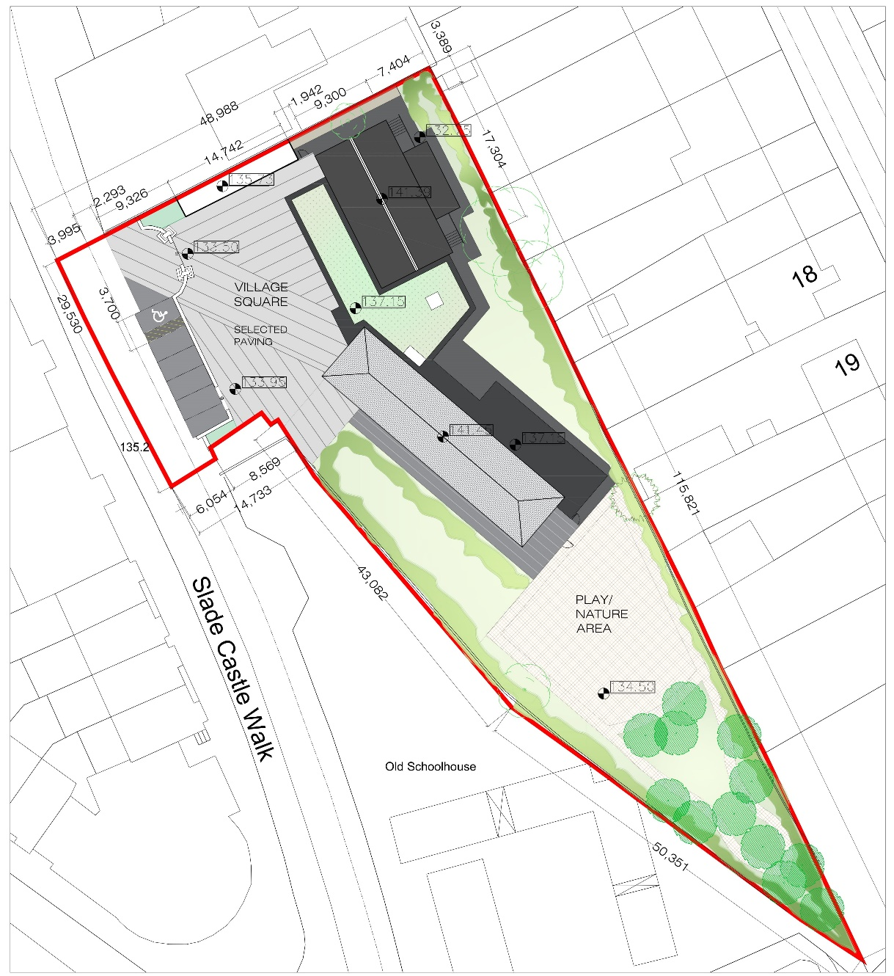  Proposed Site plan:  The new extension has been deliberately set back from the building line of the school and adjoining buildings to ensure that the existing context is not negatively impacted by the new building.  The proposed Multi-function Hall will have a pitched roof form which will complement its village setting while using contemporary materials and detailing to distinguish it architecturally. This will afford the space a generous ceiling height while minimising the mass of the building. The ridge of this will be limited to the height of the existing school building. The new glazed Entrance/ Reception/ Youth Café area will form the face of the Community Centre and make the transition between the new and the old. As the site slopes down from south to north, the old school building is currently accessed up 7 steps. To respond to this sloping site, the new building is set at the lower ground level to make it accessible and minimise its height on the site.  Careful execution of this proposal, will enable the school to be brought back to full and vibrant use, once more at the heart of Saggart community  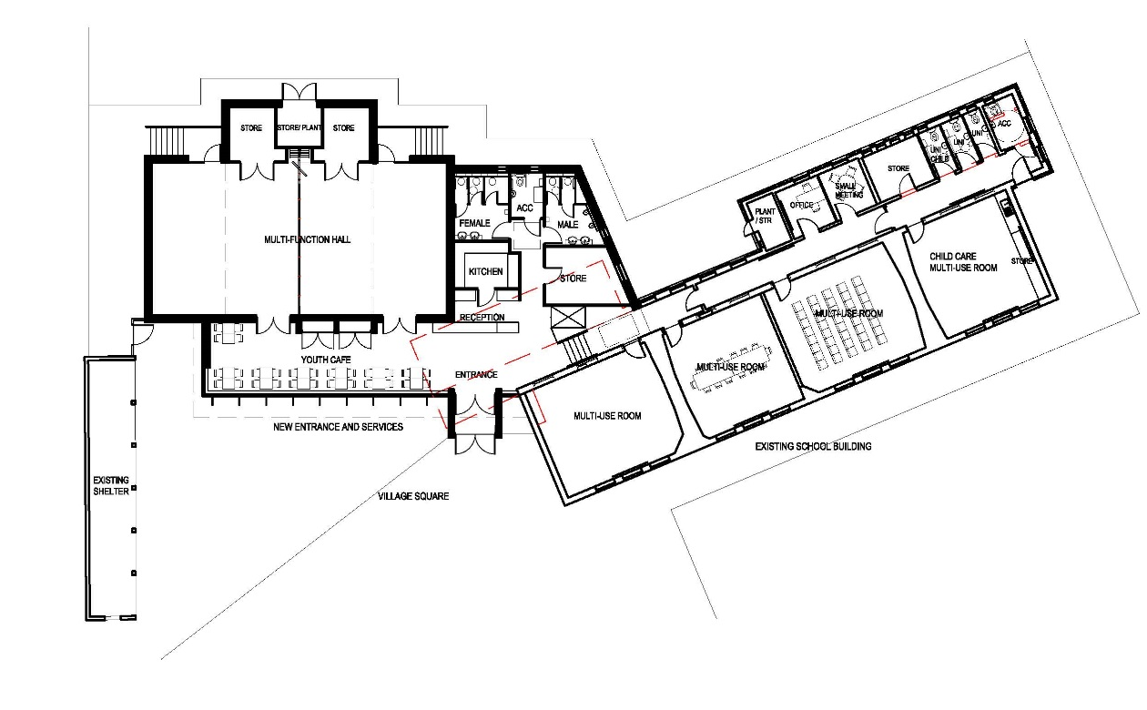  Proposed plan  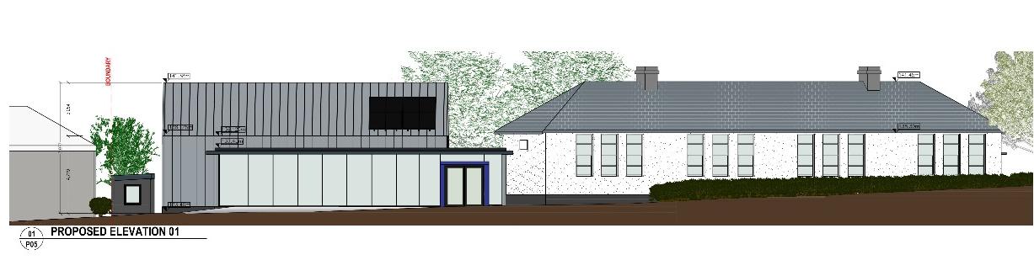  Proposed elevation  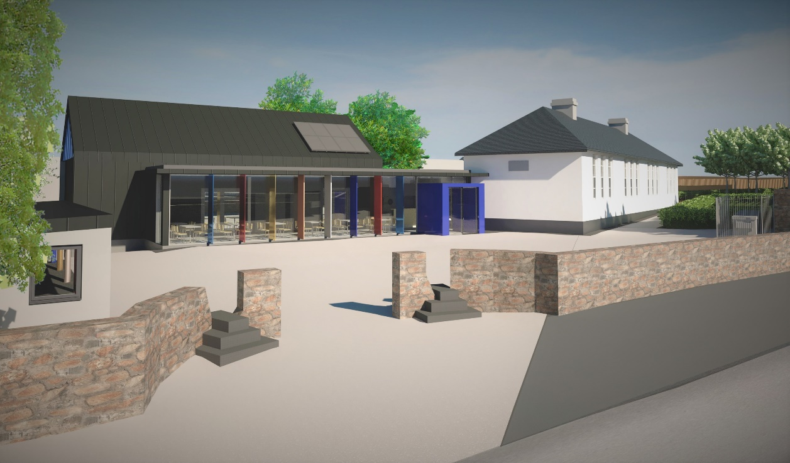  3d view of proposed development from the north
 | Landscaping | Landscaped planting will be provided at the existing boundaries to enhance existing privacy and screening and provide an appropriate setting for the new building. The south end of the site will be planted as a nature area
 | Ancillary Works Project: | Connection to existing local services (drainage, water, gas, electrical, telecoms)  Alteration / Upgrading of existing landscaping and open space.
 | Project Partners | Housing, Social and Community Development
 | Site / Services Constraints: | All major existing services runs have been identified for the design. Local alterations to layout are likely when on site investigations establish precise underground service locations.
 | Internal Comments | To be advised
 | Flood | No flood risks reported
 | Surface Water | Surface water discharge is to be retained on site by the use of carefully designed and integrated sustainable drainage measures, including the following the installation of a green roof over at the entrance area and hub, landscaped Swales at the site perimeter in conjunction with boundary planting. This represents a substantial increase in the area of permeable and planted surfaces on the site. Final surface water discharge will be to 2 soakaways on site designed to meet BRE 365 standards.
 | Foul drainage | Foul drainage connection will be to the to existing FS on Slade Castle Road.
 | Roads  Access | Roads access and capacity are within acceptable and safe limits.  No formal report has been received.  However, the provision of on street parking spaces adjoining the development was discussed during pre-submission consultation.
 | Irish Water | Application for Foul services connection to be completed.  There is an existing water connection on the site
 | Parks | For Comment  No formal report has been received. However the nature and use of the informal play space was reviewed with Parks during pre-submission consultation.
 | Circulation to prescribed bodies | Environmental Protection Agency, NPWS (Department of Arts, Heritage and the Gaeltacht), National Monuments (Department of Arts, Heritage and the Gaeltacht), Inland Fisheries Ireland, Health Services Executive, Office of Public Works, National Monuments Service, National Park & Wildlife Service
 | Contact Details | Anne Lynch FRIAI Senior Architect  Aidan McNamara Senior Executive Architect
 | Part 8 Submissions  & Response | All submissions will be recorded by the Community Department and a commentary will be provided below on the main issues raised during the consultation period.

Part 8 Submissions  & Response  DRAFT | A Total of 4 submissions were received on the Part VIII for Saggart Community Centre. The main areas covered in the submissions fall into the following categories:  - General Proposal and Design  - Conservation of Protected Structure  - Archaeology in an Area of Archaeological Interest.  - Car parking provision  The submissions are outlined in full below together with response and recommendations. The recommendations are summarised in the final paragraph of this section  Submission from the South Dublin Conservation Society  We welcome the restoration, conservation and renovation of the former St. Mary’s National School in Saggart, County Dublin. As it is a protected structure, it is only right and proper that it be preserved for future generations to admire and appreciate. It too is very much welcomed that this former schoolhouse will provide sustainable facilities to improve the social, cultural and economic fabric of the local community of Saggart in the years ahead.  We would encourage South Dublin County Council to retain as much as possible any period features associated with the building and incorporate them into the fabric of this development. As the village of Saggart and its immediate surroundings has such strong historical associations going back over centuries, it would be a good idea for South Dublin County Council to reflect this amazing heritage through such measures as a display of historical images, local ephemera, e.g., paper products from Swiftbrook Paper Mills and of course items associated with the building when it was in use as a school, such as school furniture, chalkboards, etc.  Response:  South Dublin County Council will retain any period features associated with the building insofar as possible and incorporate them into the fabric of this development in balance with the provision of a state of the art Community Centre that is accessible and energy efficient to current standards  A display of historical images and local ephemera is not a planning matter but is a worthwhile idea which the Community Centre Board of Management can consider.  Submission from the South Dublin County Council Architectural Conservation Officer  PART 8 - PROPOSED SAGGART COMMUNITY CENTRE, INCLUDING CONSERVATION, RESTORATION AND EXTENSION TO ST. MARYS NATIONAL SCHOOL (A PROTECTED STRUCTURE, RPS REF. 424).  Record of Protected Structures  St. Mary’s National School (former) is referred to in the Council’s Record of Protected Structures - Schedule 2 of the South Dublin County Development Plan 2016-2022 under Map Ref. No.424. Under Section 2 of the Planning and Development Act 2000, the term ‘structure’ means “any building, structure, excavation, or other thing constructed or made on, in, or under any land, or any part of a structure so defined, (a) where the context so admits, includes the land on, in or under which the structure is situate, and (b) in relation to a protected structure or proposed protected structure, includes (i) the interior of the structure, (ii) the land lying within the curtilage of the structure, (iii) any other structures lying within that curtilage and their interiors, and (iv) all fixtures and features which form part of the interior or exterior of any structure or structures”. Therefore, the entire site is a protected structure, including all existing buildings on site including their exteriors, interiors, fixtures and fittings. The Protection also extends to the lands of the site and as such come under the provisions of the Planning and Development Act 2000.  Appraisal  This is a Part 8 for the proposed Saggart Community Centre which includes for the conservation, restoration and renovation of the existing former St. Marys National School building for use as a new community facility, including the construction of a new single-storey multi-function hall for a proposed community centre, which is to be an addition to the existing building, a protected structure as detailed above. The existing building is currently unoccupied, and the new use allows the continued long-term use of the building which is very much welcomed.  It is proposed to restore and conserve as far as possible those original elements of the Protected Structures and associated features as detailed in the Conservation Report which includes a design rationale/conservation philosophy and condition assessment carried out by the Architectural Services Department. It should be noted that the existing building remains largely intact and in a reasonable condition and there is no change to the original layout of the existing building apart from the removal of an existing section which projects from the rear north, which is a later addition to the original school structure. This will allow for the new proposed main entrance to the building providing a clear connection to the new single-storey community multifunctional hall and the existing building.  The introduction of a new use and the adaptation of the existing structure will enable the existing building to be reused and continue to remain as an important building within the community. The overall plan allows the existing structure and site to be utilised in a manner which conserves the architectural integrity and original design elements thus improving the viability of the area, it is a very welcomed development and addition to the existing village. The new proposed addition to the former school building will bring architectural interest and quality to the site.  The existing Protected Structure will be adapted to accommodate community use and required facilities, the main original classroom layout will remain unchanged with some changes to the layout at the rear of the building to form new uses i.e. small meeting rooms and offices. The toilets will be relocated in the new building which will also include a kitchen, reception, storerooms, youth café and multi-functional Hall. The new structure will be structurally independent from the Protected Structure as already detailed. The new main entrance will act as a link between the two buildings, allowing minimal intervention to the original built fabric of the Protected Structure.  It is considered that overall the proposed development allows an opportunity for the existing building to be repaired, refurbished and re-used at the same time as retaining the integrity and architectural importance of the former National School and the new development sits sensitively alongside the existing building. The overall design allows the Protected Structure to remain as the dominate building on the site. The new extension is set back from the existing building line which allows a clear reading of the original building form of the former school, at the same time allowing the new contemporary simple formed extension to sit within the site, bringing a contrast of design elements, texture and colour to the existing architectural quality.  The form and scale of the new extension delivers a contemporary vernacular design. The structural element of the existing external shelter located within the school yard has been used as a design element to the front of the new extension allowing the glazed area to be broken up with columns and the squared entrance reflecting the design ethos of the school building. The design of the new build and overall context of the proposed development allows a very important architectural and social site to be maintained and utilised in a very positive and viable manner and provides a much needed community centre and community services within Saggart Village.  The condition assessment which is included in the Conservation Report, provides an overview of the external and internal condition of the existing structure to include existing rooms, layout and finishes with brief details of the proposed works/interventions. It is considered that a Method Statement and Schedule of Works will be required for agreement and approval regarding the specific treatment of internal finishes and the repair and reinstatement of architectural features.  It should be noted that external insulation is referenced on the proposed elevation drawings, however it is considered that insertion of external insulation to a Protected Structure is not acceptable and any internal insulation will have to be justified and specified for prior agreement with the Councils Architectural Conservation Officer prior to formal design stage. Specifications for all internal works and finishes will be required, ensuring that any internal insulation is warranted and deemed acceptable prior to the commencement of development. It is fully understood that energy efficiency upgrading is required, however this should be done in a holistic way in order to examine and assess the best possible approach adhering to best conservation practice in this regard.  It is considered that the proposed development is acceptable, subject to the following recommendations/conditions:  Recommendations  - It is considered that conservation, repairs and restoration work to the existing Protected Structure shall be carried out in accordance with the details and drawings contained within the Conservation Report for Part VIII public display/consultation process (20th Feb 2020). However details shall be agreed and approved with the Councils Architectural Conservation Officer and agreement will be based on details provided in a Method Statement and Schedule of Works which should be prepared as part of the methodology for the works to the Protected Structure. This will allow the specific details and specifications to be agreed prior to the work ensuring the best conservation practice and approach in the adaptation and upgrading of a Protected Structure.  All works to the existing Protected Structures shall be carried out in accordance with good conservation principles and conservation methodology as per the details provided in the Conservation Report. A clear methodology by way of a schedule of works and method statement shall be agreed prior to formal design and tender stage, ensuring the correct use of suitable materials and methods.  Reason: To ensure works to the existing structure are carried out in accordance with good conservation practice and that works to a Protected Structure is carried out in accordance with conservation principles ensuring the correct use of materials and traditional methods are applied.  - It should be noted that external insulation is referenced on the proposed elevation drawings, however it is considered that insertion of external insulation to a Protected Structure is not acceptable and any internal insulation will have to be justified and specified for prior agreement with the Councils Architectural Conservation Officer prior to formal design stage. Specifications for all internal works and finishes will be required, ensuring that any internal insulation is warranted and deemed acceptable prior to the commencement of development.  It is fully understood that energy efficiency upgrading is required, however this should be done in a holistic way in order to examine and assess the best possible approach.  Reason: To ensure energy efficiency upgrades are carried out in accordance with best practice. To ensure the best possible approach is taken based on a full examination of appropriate systems for approval and agreement.  - The Protected Structure should be safeguarded during the proposed works. A method statement for how the Protected Structure and associated features i.e. boundary wall and existing shelter etc should be provided and agreed with the Councils Architectural Conservation Officer.  Reason: To ensure a safety statement is provided in the safeguarding of the Protected Structure and all associated features as part of an overall Method Statement for works to the existing building.  Response:  The requirements of the Conservation Officer regarding the Protected Structure are noted and will be followed as part of the development process.  A schedule of works and method statement have been prepared by SDCC Architectural Services and issued to the Conservation Officer. This will be developed when the project progresses to detailed design stage.  All works to the existing Protected Structures shall be carried out in accordance with good conservation principles and due consideration will be given to maintaining the character of the building. This will be balanced with the provision of a state-of-the-art Community Centre which is energy efficient and accessible to current standards.  3. Archaeology in an Area of Archaeological Interest.  Submission from the Department of Culture Heritage and the Gaeltacht  Outlined below are heritage-related observations/recommendations of the Department under the stated heading(s).  The Department notes that the development site is located within the zone of archaeological potential for Saggart and that the Conservation Report attached to the application states that the council will appoint a consultant archaeologist to prepare an  Archaeological Impact Assessment and monitor all excavation works (Conservation Report, Section 9).  It is the Department’s recommendation that the following condition pertaining to archaeological monitoring be included in any grant of planning permission that may issue:  1. The applicant is required to engage the services of a suitably qualified archaeologist to monitor all topsoil stripping and overburden at the development site.  2. Should archaeological material be found during the course of monitoring, the archaeologist may have work on the site stopped pending a decision as to how best to deal with the archaeology. The developer shall be prepared to be advised by the National Monuments Service of the Department of Culture, Heritage and the Gaeltacht with regard to any necessary mitigating action (e.g. preservation in situ, and/or excavation). The applicant shall facilitate the archaeologist in recording any material found.  3. Having completed the work, the archaeologist shall submit a written report to the Planning Authority and to the Department of Culture, Heritage and the Gaeltacht in advance of the planning decision. Where archaeological material/features are shown to be present, preservation in situ or preservation by record (excavation) may be required and the National Monuments Service will advise the Applicant/Developer with regard to these matters.’  Reason: To ensure the continued preservation (either in situ or by record) of places, caves,  sites, features or other objects of archaeological interest.  Response:  The requirements of the Department of Arts, Heritage and the Gaeltacht regarding Archaeology will be followed as part of the development process.  As noted in the Conservation Report Section 9; South Dublin County Council will appoint a consultant archaeologist to prepare Archaeological Impact Assessment and monitor all excavation work.  It is noted that most of the site is covered in tarmac and concrete. As this was not original to the site, this build up can be removed without undue disturbance of the older ground below.  Submission from the Board of Management of Saggart School House Community Centre  ‘We, the Board of Management of Saggart School House Community Centre, are making a submission in relation to the Part 8 Consultation for Proposed Saggart Community Centre.  We have been charged with responsibility to manage this community amenity once the development work has been completed. This community centre will be a fantastic resource to the residents of Saggart and surrounding areas.  Having examined in detail the plans for the development of the amenity we are making this submission with thought and foresight on how the facility will be used and by whom. We feel that the proposed style of the building is a well-blended mixture of traditional with modern, protecting and conserving the special character of Saggart as a traditional village, while maximising the new spaces and light within the new structure. The layout of the building and the rooms and associated facilities within will facilitate a wide range of service users, visitors, groups and activities, important for the success of the community centre.  However, the absence of adequate parking, in our opinion, will diminish significantly the potential success of the community centre. We make this assertion in the context of poor parking facilities within Saggart Village and its current impact:  There is currently minimal on-street parking for visitors in the village. Traffic is already an issue of significant disruption for residents. Several businesses have not remained viable due to lack of parking for potential visiting customers. Remaining businesses report a downturn in business due to lack of parking at Slade Castle. The residents of this development use the ground level parking and not the underground parking. This development is still in private ownership and there have been reports of anti-social behaviour in the underground carpark.  The new Village Plaza upgrade works, while very much welcomed, have resulted in the removal of 2 parking spaces in the village.  Planning permission is granted on the Maxol site (large site in the Village at the crossroads) for 29 units comprising of 1, 2 and 3 bed homes along with shop units with a total of 30 spaces provided. No parking has been designated for the proposed new shops to cater for staff or visitors to the business let alone multiple cars per household or visitors to these homes. This development also removes existing parking spaces at Pairc Mhuire and this has been a huge concern for residents of that estate. You will see further information on the submissions made about this development on http://www.sdublincoco.ie/Planning/Details?regref=SD18A%2F0202  Understanding this and planning for the development of a community amenity in Saggart village, it is our assertion that ample parking must be provided for users of this amenity. We would have welcomed the opportunity to discuss the plans in more detail with the designer prior to the publication of this part 8, however time constraints did not allow so. We request in the strongest manner possible that the current plans be re-examined to include and cater for the following:  • Parking for staff (Manager, TUS and CE) – 3/4 people per shift.  • Drop off for trainers, group facilitators who will have equipment; parking needs to be close to the centre  • Conferences or all-day meetings may not be viable without parking.  • Service users participating in groups and activities need parking. Many of these activities  will be during late dark afternoons and evenings. Not all people who will use the centre will live in the immediate vicinity as is the case with other community centres.  • Parking is necessary to attract / facilitate visitors from neighbouring villages to attend the centre and use the facilities.  • Parents of potential creche users will need to be able to park and do so safely to bring small children inside.  • Suitable location off the main road needed for elderly / less mobile people who may be attending by taxi or a lift.  Without a comprehensive plan to accommodate additional parking for this facility beyond the proposed plans, there is a real danger of people parking on roads and footpaths instead causing  traffic issues and accessibility issues for wheelchair users or buggies.  The Board are of the view that the success of this project would be dependent on appropriate  parking on site. In our considered opinion, this community facility requires a minimum of 20 car spaces to meets its needs and to maximise it's full potential.  Response:  The concerns of the incoming Board of Management are noted. The centre has been designed to engage directly with the village and to prioritise people over cars in line with criteria set out in the current Development Plan. In this regard, a car-free space is proposed at the entrance to the proposed Community Centre for safe access and for use by the public. The viability of carparking on the site is limited by a number of key constraints including safety, the extent of the brief and the size and shape of the site. On further review an alternative layout has been identified as described on the site plan below which allows for an additional number of on-site spaces for staff and delivery parking bringing the total number of spaces to 10. The cars have a separate vehicular entrance and are separated from the pedestrian entrance by bollards for safety purposes. Some of these bollards can be removable to facilitate pedestrian events in the square. This represents the maximum number of additional spaces that can be provided without unduly compromising the character or safety of the site. SDCC will seek to further enhance parking in the area to engage with the local community with regard to opening up the existing underground parking across the road from the proposed development.  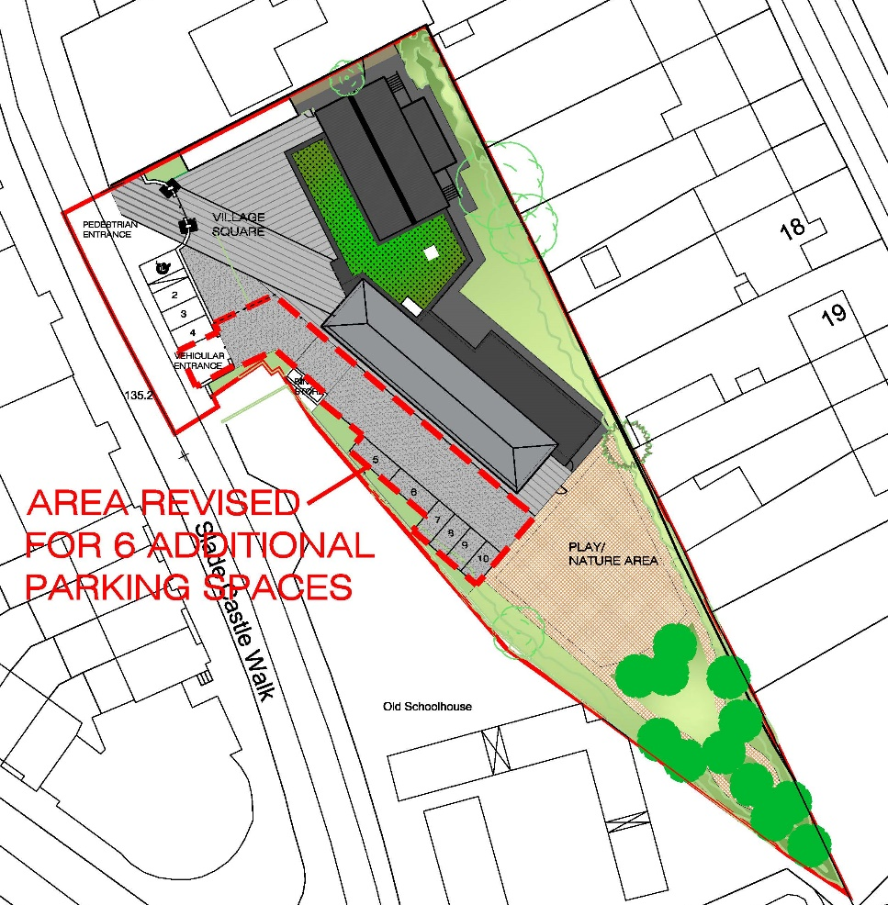  Proposed Site Plan with additional on-site parking  Conclusion / Recommendations  General Proposal and Design  The enthusiasm and support for the proposed development across all of the submissions is noted and welcomed  Conservation of Protected Structure  The requirements of the Conservation Officer regarding the Protected Structure are noted and will be followed as part of the development process.  Archaeology in an Area of Archaeological Interest.  The requirements of the Department of Arts, Heritage and the Gaeltacht regarding Archaeology are noted and will be followed as part of the development process.  Car parking provision  An additional 6 carparking spaces should be provided on site to take account of the concerns of the Board of Management

