COMHAIRLE CHONTAE ATHA CLIATH THEAS

SOUTH DUBLIN COUNTY COUNCIL
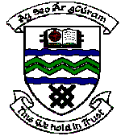

MEETING OF TALLAGHT AREA COMMITTEE MEETING (1)

Monday 20th March, 2006.

Headed Item No: H (I) 8

New Works - Update on Baallymount Park Access.

The Council’s Law Agent is currently examining the Lease and Licence Agreement between South Dublin County Council and Glasnevin Cemetaries Group Ltd and the planning permission granted. Due to the complexities of the matter the examination is continuing.

The Law Agent’s findings will be forwarded to the Committee Members when to hand.

Further discussions have recently taken place with Glasnevin Cemetaries Group Ltd. And they have now agreed to provide the Council with keys to the gate/barrier. Glasnevin Cemetaries will continue to open the gates daily at 7.30 am while the Council’s Park Ranger service will close the gates on a daily basis.

