**SDCC Libraries News and Events**

Since the closure of our branch libraries on 13th March, South Dublin Libraries continues to deliver a comprehensive programme of events and activities across social media platforms. Our online presence has strengthened greatly over the past number of weeks. Library staff have used their skills and ideas to find new ways to reach out and engage with the community including live streamed storytelling sessions, craft sessions, photography exhibitions, local history talks and blogs and much more. We continue to deliver programmes under the LGMA national initiatives of Right to Read, Healthy Ireland and Work Matters.

Our Libraries’ Facebook page <https://www.facebook.com/SouthDublinLibraries/> and our twitter page <https://twitter.com/SDCClibraries> as well as Instagram <https://www.instagram.com/sdcclibraries/> are used to promote our online events.

**Online Resources**

In addition there has been a huge uptake of South Dublin Library online resources including E-books, E-audio, Newspaper Articles, Language Learning and Community Education Courses available at [https://www.sdcc.ie/en/services/sport-and-recreation/libraries/library-services/online-resources/](https://eur04.safelinks.protection.outlook.com/?url=https%3A%2F%2Fwww.sdcc.ie%2Fen%2Fservices%2Fsport-and-recreation%2Flibraries%2Flibrary-services%2Fonline-resources%2F&data=02%7C01%7Cbfennell%40SDUBLINCOCO.ie%7C9bdb3d6c8c014479b0b808d7e75b43ac%7C6a3c00c019d0492da8de95fad8fda1d4%7C0%7C0%7C637232251475674477&sdata=kbYs18we4dtEpc3I0xTgRDl5Hy1XvgPuH1zO5wLHvU0%3D&reserved=0)

**TumbleBooks** is a curated database of children’s eBooks, animated talking picture books, read-along books, National Geographic videos, Maths stories, and graphic novels.  The content is designed for use by parents with younger children (3 - 7 years).

**Universal Class** offers adults access to over 500 online Continuing Education Courses and members can enrol for up to five courses at a time.

**Transparent Language Online** features a wide variety of high-quality learning materials, and a seamless integration of real-life language used by native speakers, all packaged together in an easy-to-use interface.

The following statistics show **the increase on uptake** on our SDCC library online resources:

|  |  |
| --- | --- |
| March increase on February | |
| BorrowBox Total | 41% |
| BorrowBox eAudio | 21% |
| BorrowBox eBook | 69% |
| eComics | 300% |
| eMagazines | 33% |
| Encyclopaedia Britannica | 341% |
| Tumblebooks | 673% |
| Universal Class | 544% |

**Creative Writing**

South Dublin Libraries have created an innovative opportunity for beginning and emerging writers to engage on a one-to-one basis with a published author.

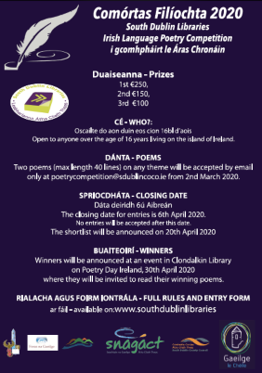We have partnered with acclaimed poet and fiction writer Brian Kirk to deliver a series of “writers’ surgeries”, where selected participants submit a 1,500-word writing sample for critique and receive one-to-one feedback. We offered eight, one-off sessions, delivered virtually via Zoom, to selected writers who applied. Sessions began to be delivered on Tuesday 21st of April and will be completed on Friday 1st of May. All sessions are fully booked, a waiting list has been established.  
  
Our first Irish Language Poetry Competition, **Comórtas Filíochta,** closed for entries on the April 6th.

We received a great response with 39 entries and a wide range of poems. The shortlist was published on 20th April. Winners were announced on Poetry Day Ireland, 30th April, with the poems published on South Dublin Libraries’ website. The competition was judged by singer-songwriter John Spillane.

The 6th Annual **Ballyroan Library World Poetry Day** competition. This is open to adult poets based in Dublin. Closing date for entry is April 30th and works will be judged by local poet and librarian, Mark Ward.

**500 Words a Writing Competition for Children**

Children will submit 500 words of fiction by the 30th of April. This is a new competition and has been developed to keep children busy in this time of lockdown.

**Connection Reset**   
Following on from their success with last year’s programme and Lisa Harding, The Red Line Book Festival has just put out its call out for a new Writer-in-Residence. The theme of this year’s residency is ‘Connection Reset’, stemming from an internet term when the website you are browsing resets the connection. This concept has been developed as a response to the uncertain times we are living through.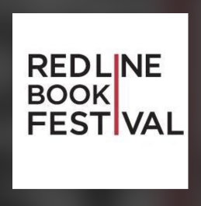 Further details at https://www.redlinebookfestival.ie/news/2020/red-line-book-festival-2020-writer-in-residence-scheme-connection-reset.

**WORK MATTERS**

Work Matters and Tallaght library have organised for the Migrant Teacher Project who provide support to fully qualified teachers outside Ireland seeking registration and employment as a teacher in primary or secondary schools in Ireland, to give a talk via Zoom on Monday 11th May at 11am. Booking via Eventbrite.

SDCC libraries in conjunction with LEO are organising a talk in May with Lecturer and Trainer, Dorcas Reamonn on the topic of **”How to Galvanise Your Online Business “.** In this session, Dorcas will discuss the basics of how to propel your business online in the challenging times we face.

**Promotional Video on Online Library Resources**: currently in process. Once available the link to this will be sent out to DETB leaders for use by their students.

**Project Sums: Maths Grinds delivered via Zoom**

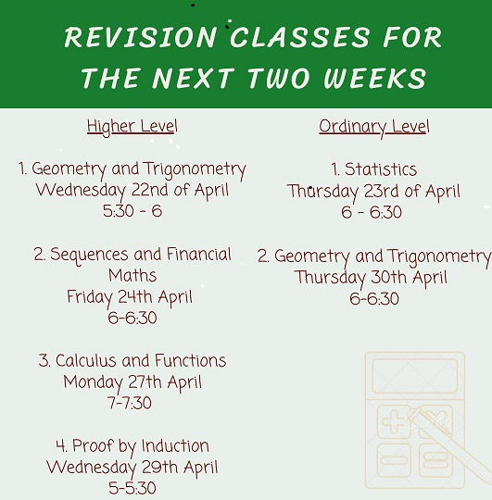The immensely popular project sums returned on the 22nd April offering classes to Higher Level and Ordinary Level maths students with the help of volunteer maths tutors from all walks of life. The request was sent to the volunteers to move the successful Tuesday night grinds to an online format and the response was

overwhelming. Geometry and Trigonometry took place on the 22nd of April with classes for Sequences and Financial Maths on Friday 24th, Calculus and functions on Monday 27th and Proof by Induction on Wednesday 29th April. Depending on the responses and future announcements by the Department of Education we would hope to maintain a class per week at least through May and into June.

**HEALTHY IRELAND**

Under the Healthy Ireland at your Library banner, South Dublin Libraries scheduled four *wellbeing and coping* health talks at the end of April during the Covid-19 lockdown.

1. Anxiety
2. What Drives our Behaviour
3. Parenting and Home-schooling.
4. Mindfulness

The online events, hosted by Jacci Jones, Psychotherapist and Life-Coach culminated in a live Zoom event on May 1st with an audience of twenty.

These events are now available on the South Dublin Libraries website, Vimeo and South Dublin social media platforms.

Activity work sheets and day-diary sheets are also available to help boost wellbeing and to help people stay in the moment and record their feelings each day - these pages are printable and can be used by children as well as adults.

A series of talks will be broadcast at 7pm from the 27th April until 1st of May. The theme is staying mentally well during Covid-19.

**OTHER HIGHLIGHTS**

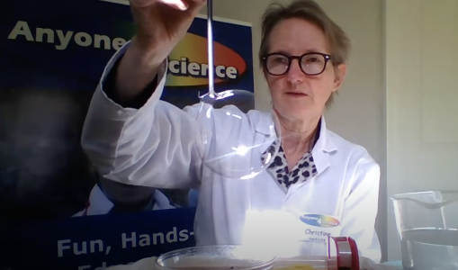

Continuing our commitment and rollout of STEM activities, The Harry Potter Science Show 21st April, was presented by Anyone4Science through our social media. It garnered a huge amount of reach and engagement, with an unparalleled reach of 28,513 and an engagement of 1,652. The event was hugely popular with around 770 people viewing the live stream and the recording is still available for future viewing and re-use.

**Love Your Library, Facebook Page** with full-filled children’s activities organised and delivered by staff:

* Origami Dinosaur Claw 20th April
* Eco Craft Bug Hotel 22nd April
* Weekly Philosophy Club
* Weekly Instagram TV Craft
* Weekly STEM sessions

**History at Your Fingertips – South Dublin Local History May and June 2020**

History at Your Fingertips is a series of online local history and genealogy activities, workshops and events by South Dublin Libraries during May and June 2020. Like other library services, Local Studies has found its activity curtailed as a result of the current crisis. Our response has been to take as much of our activity as possible online.

|  |  |  |
| --- | --- | --- |
| Introduction to Family History workshops. | These will take place weekly via Zoom and will be delivered by expert genealogist Fiona Fitzsimons. The workshops will cover civil records, census, parish records, Griffith’s Valuation, gravestone and cemetery records, and using newspapers for family history research. | May and June, dates TBC |
| Family History Blogs | To complement the workshops, our Local Studies Librarian will conduct a weekly blog with advice and information to help people navigate their way through the main online resources they will need to start growing their family tree. See [www.localstudies.wordpress.com](http://www.localstudies.wordpress.com) or South Dublin Libraries on Facebook. | Weekly on Thursdays. |
| Talk: Michael Flanagan, the man, the Alderman | Join local historian Cathy Scuffil for this illuminating talk on the alderman, and grandfather of Liam Cosgrave, Michael Flanagan, and his associations with the Greenhills and Tymon area of South Dublin County. Talk will be shown on South Dublin Libraries’ Facebook page. | Date TBC |
| Talk: JFK and the Summer of 1963, Civil Rights, Cold War Politics and an Irish Homecoming | Historian Cecelia Hartsell looks at John F. Kennedy’s troubled summer of 1963 dealing with major issues in the US before he embarked on a joyful homecoming to Ireland. Talk will be shown on South Dublin Libraries’ Facebook page. | Thursday 14th May. |
| Talk: History of Tallaght | Local Studies Librarian Michael Keyes will give a talk on the fascinating history of Tallaght, from early Christian settlement to modern metropolis. Talk will be shown on South Dublin Libraries’ Facebook page. | Date TBC |
| Leaving Certificate History Guide | With much disruption to the Leaving Certificate exams the History Research Study deadline has been extended to 15 May. Our Local Studies Team have prepared a step by step guide on how to complete the History Research Study and this has been posted at localstudies.wordpress.com. Between now and 15 May we will be reminding students that while the libraries are closed our Local History staff are available online to help and advise on their history projects. | Guide is available now. Staff available for queries in run-up to 15th May deadline. |
| Tallaght Historical Society Lecture Archive | Each week, a recorded lecture from Tallaght Historical Society’s archive will be posted and promoted on South Dublin Libraries’ Facebook page. | Weekly throughout May and June. |
| History all Around Us: Rathfarnham Colouring Book | This colouring book has been made available to download free of charge for parents and teachers, via [www.southdublinlibraries.ie](http://www.southdublinlibraries.ie). The book features images and short histories of Rathfarnham’s many historic sites. | Available now. |

**Capital Projects**

A partial handover of North Clondalkin Library took place from 27th April. The tender for furniture and fittings is awarded and we await delivery of items in the next three months.