**UPDATE OF SOUTH DUBLIN DISTRICT HEATING COMPANY-MARCH 2020.**

In 2018 SDCC succeeded in a multi-city bid under Inter-Reg North West Europe, to secure funding relating to pilot-projects promoting the development of district heating. The HEATNET project secured circa. €1m to fund the development of Phase 1 of a district heating piped network connecting the County Hall and adjacent civic buildings to a datacentre, now approaching completion on Belgard Road. The Datacentre has agreed to provide waste heat to SDCC as the initial major heat source for the new district heating network. In February 2020 final confirmation was received of the award of a further €4.5m in grant-aid under the Climate Action Fund from the Department of Communications, Climate Action and Environment, to support the construction of this heat network and energy centre . .

Based on international experience it was decided to establish a not-for-profit company owned by the Council, to procure the design, construction, management and maintenance of the district heating network and energy centre. The stated objective of the South Dublin District Heating Company is the promotion of a low-carbon economy through the generation and supply of heat to customers within the county, using district heating networks The District Heating Company will be not-for-profit, limited by guarantee with no share capital and only one share owned by SDCC, the sole member of the Company. The Council has existing similar arrangements in place for the management of our Leisure and Arts Centres The Company will have two directors for fiduciary and corporate governance purposes. The Company will have an Advisory Committee with representation from Elected Members and Council staff, CODEMA and sectoral stakeholders/ subject matter experts.

The District Heating Company will charge for the supply of heat and any annual surplus will be re-invested in extending the heat network and maintaining good value in heat costs to customers The company will report to SDCC at regular intervals, will also be responsible for forward planning and pricing policy, including the future expansion of the network. The company will be called the “South Dublin District Heating Company Limited By Guarantee ” and will trade as “Heatworks”. The company has been registered with Company Registration Office , Revenue Commissioners and other statutory bodies. Company design graphics and branding are in position and a website is under construction.

Operationally, contract negotiations are at final stage with the data -centre for the supply of waste heat to the District Heating Company and a lease for a site adjoining the data-centre for the construction of the energy centre. Contracts will be signed before end March 2020.

The Council has procured, through Competitive-Dialogue tender process, an energy supply company (ESCO) to design, build, operate and maintain the energy centre and heat network for an initial contract period of 10 years. The ESCO will charge the District Heating Company for the supply of heat to and through the heat network. All assets post construction of network and energy-centre will belong to the District Heating Company. Initial customers for the heat supply will be the County Hall civic complex, Technological University of Dublin Tallaght ( agreed in principle), Tallaght Innovation Centre and a number of upcoming adjacent apartment developments. Work is now underway developing customer contracts and agreements.

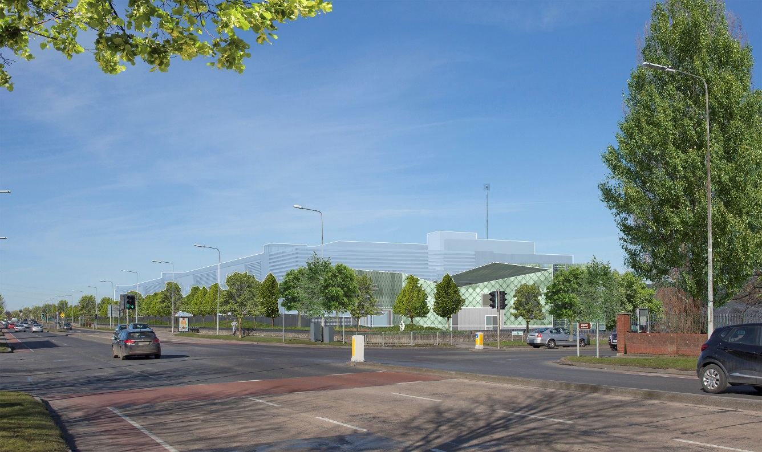

Image: Site location of Datacentre and adjacent Energy Centre

Contract negotiations with the ESCO are at final stage and contract will be signed before end March 2020. Laying of heat-network piping is set to commence in June and will take several months. Construction of the energy centre will commence Q2 2020 and completion of centre and first phase of pipe-network is targeted for Q1 2021. The County Hall will be the first customer to receive renewable heat in early 2021 .