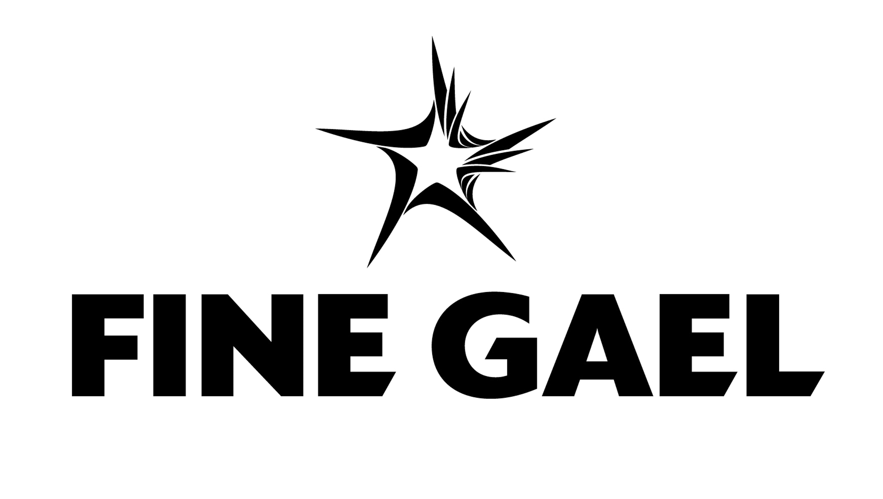

21/2/2020

Mr Tom O Neill
Administrative Officer
Corporate Performance & Change Management Department
South Dublin County Council
County Hall
Tallaght D24
D24 YNN5

Dear Mr O Neill

I wish to advise that in order to comply with S.19 (3) of the Local Government Act, 2001, the Fine Gael Party has held a convention to select a replacement to fill the casual vacancy on South Dublin County Council created by the election of Cllr Emer Higgins

Ms Shirley O Hara, 10 Furness Manor, Johnstown, Co Kildare is proposed as the replacement candidate. You can contact her on 087 2312260, shirleyohara7@gmail.com

I believe that our proposal is in accordance with the relevant provisions of the Local Government Act 2001, and specifically, the candidate proposed for co-option complies with the requirements of S.13 of the Act, as regards his eligibility for membership of the Council.

I trust you will find this in order.

Yours sincerely,

______________________________
Kathleen Fahy

Dublin Regional Organiser
0877450246
kathleen@finegael.com

