**COMHAIRLE CONTAE ÁTHA CLIATH THEAS  
SOUTH DUBLIN COUNTY COUNCIL**



**MEETING OF LUCAN/PALMERSTOWN/FONTHILL AREA COMMITTEE**

**Tuesday, February 25, 2020**

**QUESTION NO.**

**QUESTION: Councillor G. O'Connell**

To ask the Chief Executive for a report on both noise pollution and air pollution on Kennelsfort Road upper between the R148 and the entrance to Woodfarm Acres and to state in his reply if (a) noise and air quality are within safe limits (b) if not, at what times of the day or night are they exceeded and (c) if above the acceptable levels what action does he propose to take or recommend to remedy the situation?

**REPLY:**

Report on Noise Pollution and Air Pollution around Kennelsfort Road Upper between the R148 and the entrance to Woodfarm Acres.

1. **Air Quality**

The Environmental Protection Agency (EPA) has established an ambient air quality monitoring network in Ireland. The information from the air quality monitoring stations is available online on the EPA website and is presented on an Air Quality Index for Health Map.

There are three air quality monitoring stations in close proximity to the R148 and Woodfarm Acres and which have a similar profile i.e. urban traffic and suburban background areas.

**There is an air quality monitoring station located in Blanchardstown near the junction of the N3 and M50. This would have a similar profile in relation to measuring air quality adjacent to the M50 and is classed as an urban traffic monitoring station. This station measures** particulate matter (PM) **PM**10 **and NO2 which would be associated with vehicle emissions.**

**On the 17th February 2020 while drafting this report the air quality index for health indicated that the air quality at this location was good. This air quality monitoring data is updated constantly on the EPA website.**

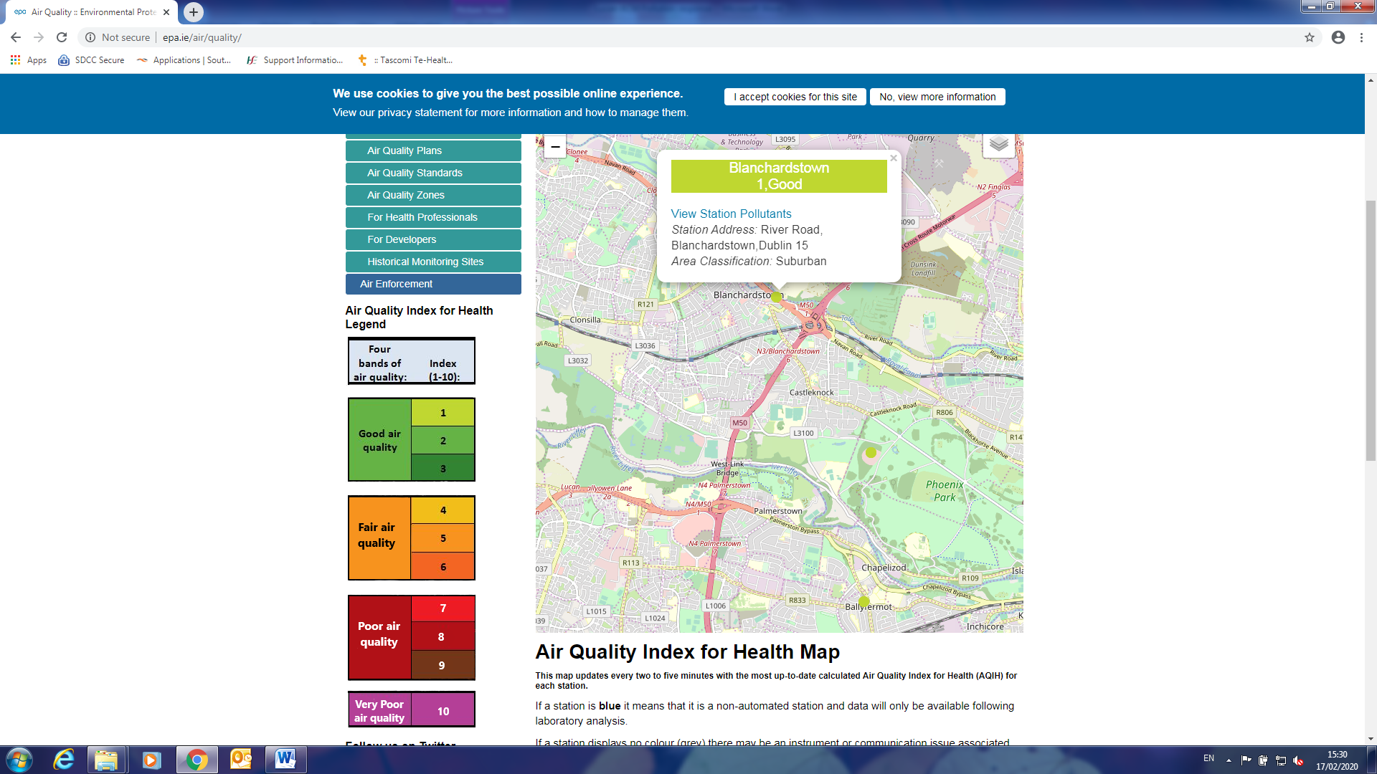

A further air quality monitoring station is located in Ballyfermot. This is classed as a suburban background location. This Ballyfermot station monitors NO2, PM10 and PM2.5 . Again the air quality index for health indicates the air quality as good on the 17th February 2020.

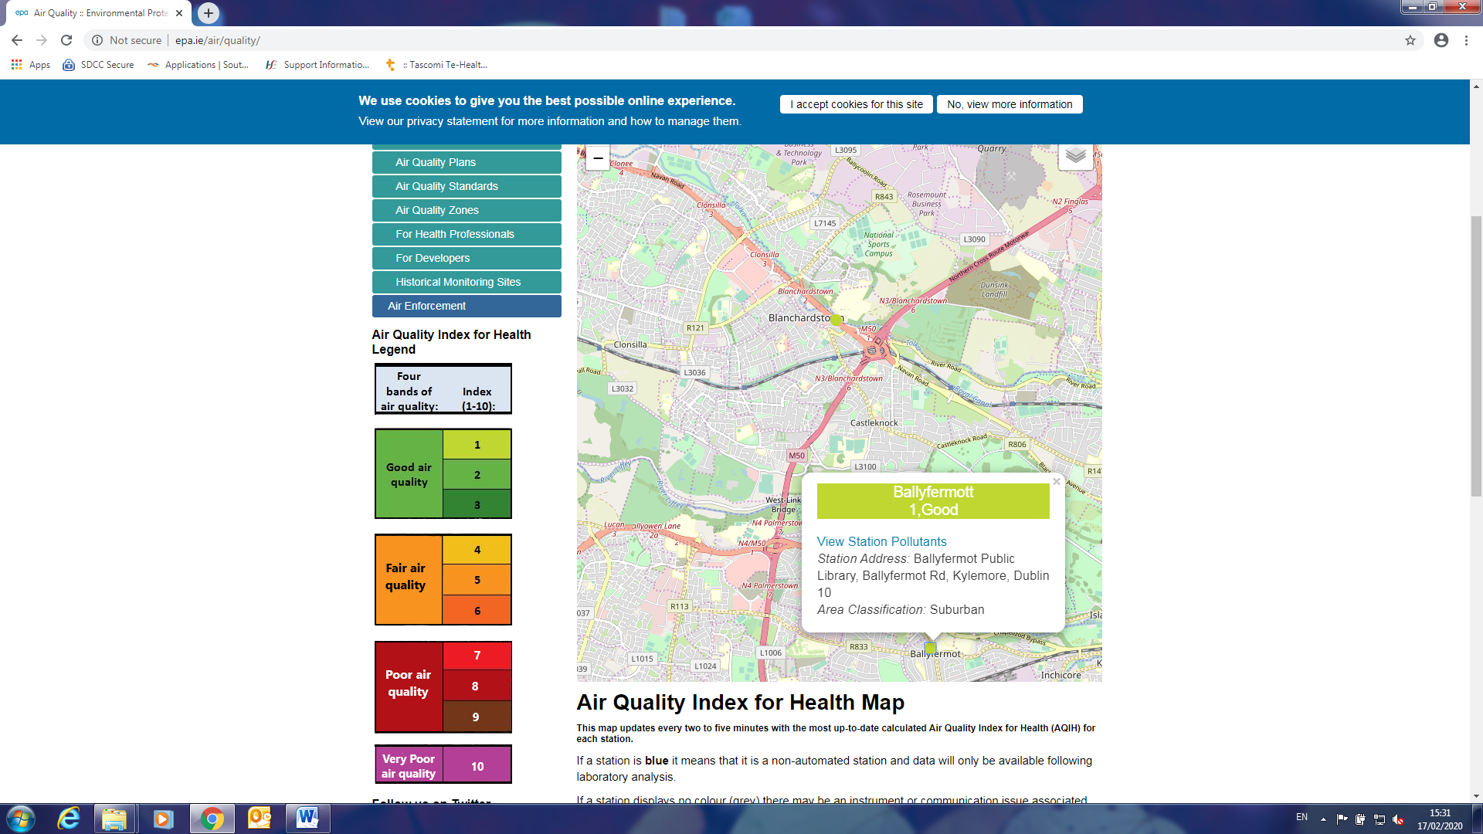

Another relevant EPA air quality monitor is located in the Phoenix Park. Again on the 17 February 2020 the air quality index for health indicates the air quality as good in this location.

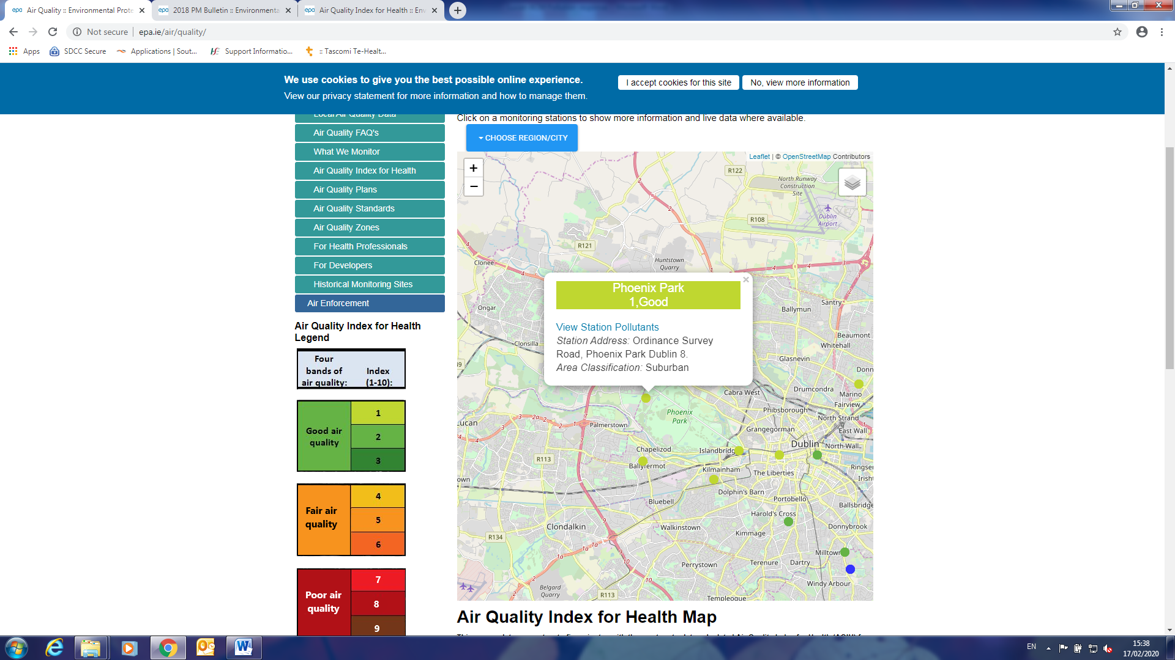

The air quality readings from all of these EPA air quality monitoring stations can be reviewed online at <http://www.epa.ie/air/quality/>.

**Aside from the EPA operated air quality monitoring stations Transport Infrastructure Ireland (TII) have a number of indicative air quality monitors along the M50. Again this information is provided to the public through their website and can be accessed at** <https://tii.sonitussystems.com/>.

**The TII have an air quality NO2 monitor and a noise monitor near the Old Lucan Road in Palmerstown. This is designated the reference name AQ35 on the following table. Monitoring data for 2018 which is the last full year average available online currently shows the annual average levels of NO2 at the AQ35 location in Palmerstown was below the EU annual limit value of 40**μg/m3**.**

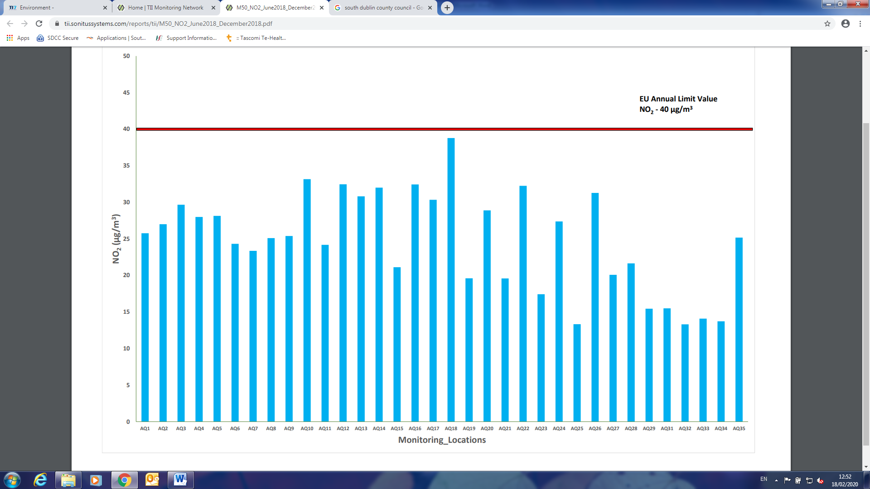

1. **Noise**

The following are the target values for undesirable high sound levels in the Noise Action Plan 2018-2023:

> 55 dB(A) Lnight

> 70 dB(A) Lday

The TII have a noise monitor located on the Old Lucan Road which would be indicative of noise at the roadside. South Dublin County Council has a noise monitor located in Palmerstown Court indicating the noise levels in the residential area nearby. Both sources of information are available online for the public at the following website addresses <https://tii.sonitussystems.com/readings> and <http://www.sdccnoise.sonitussystems.com/calendar.php?location=palmerstown-court&month=2&year=2020>

The readings from the Palmerstown Court noise monitor for February 2020 are as follows for the daytime period. By clicking into these dates online a full breakdown of the noise levels at various times of the day can be reviewed. Although set back from the M50 it gives a good indication of noise levels in nearby residential areas. The night-time noise levels at this location are above the desired 55 dB(A) Lnight at times. This has been raised with the TII.

Please be advised that weather conditions i.e. wind and rain can impact on the noise levels recorded and would influence the recordings detailed below.

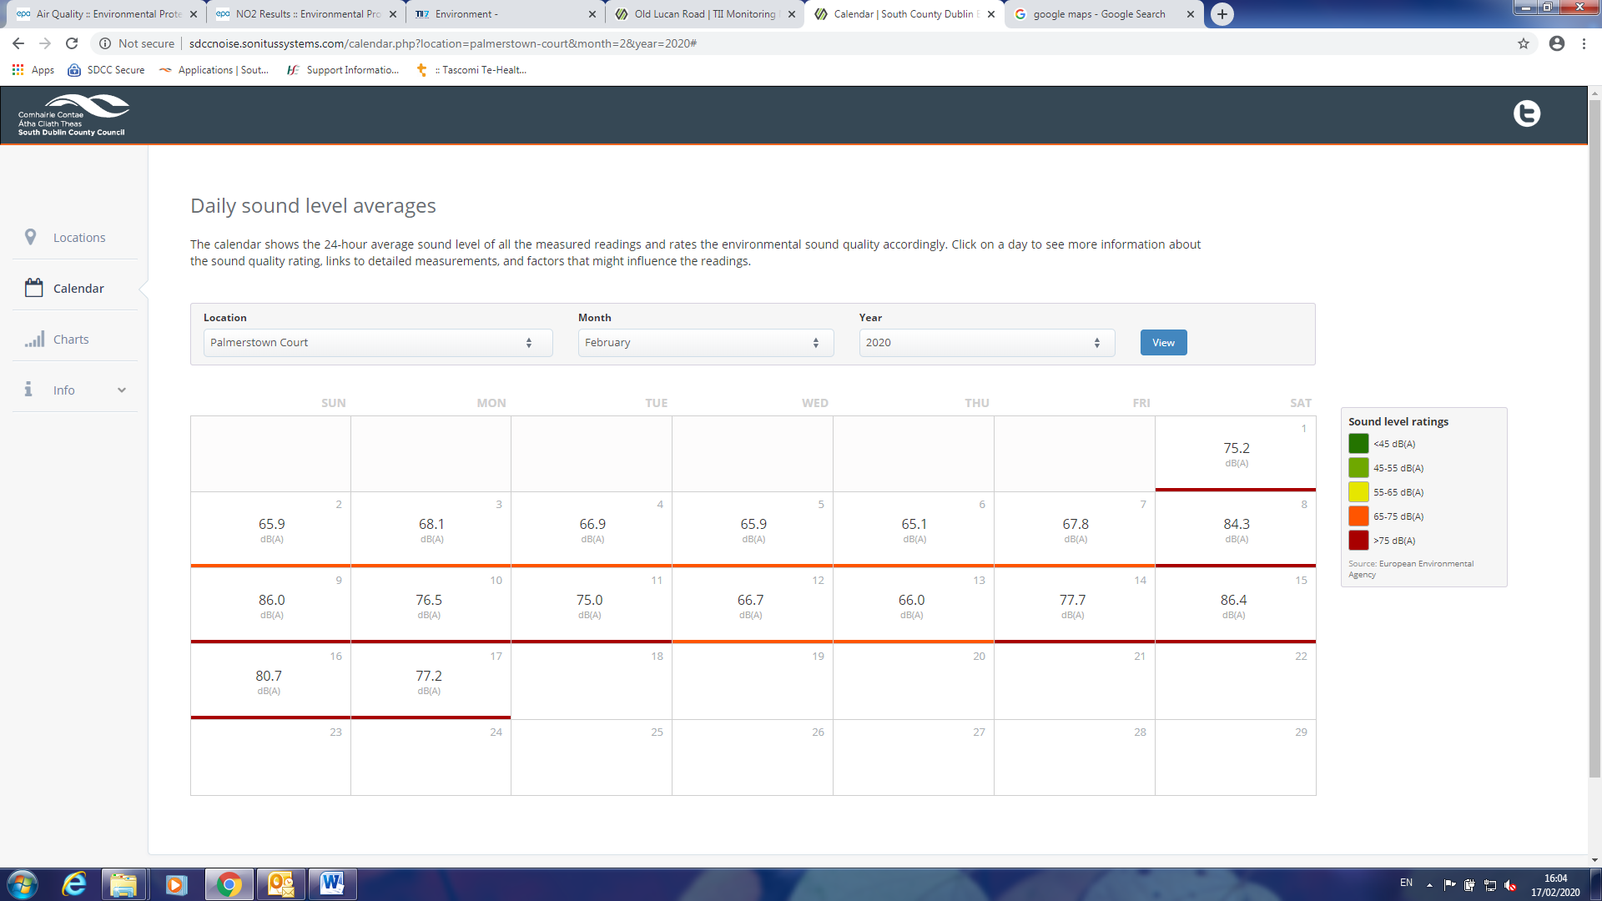

The TII noise monitor on the Old Lucan recorded the following data for the period of 01/01/2020 to the 01/02/2020.

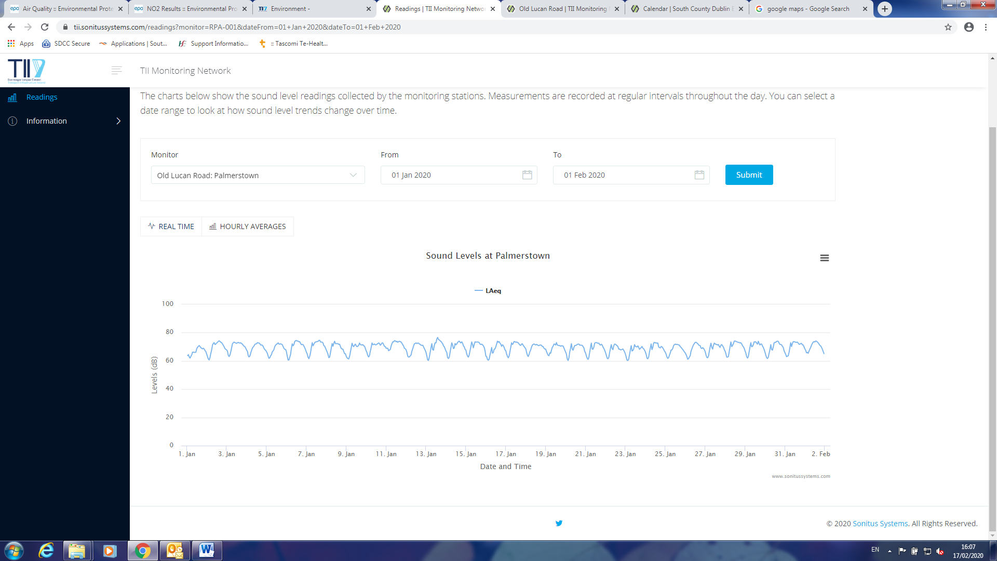

**Summary**

The air quality monitoring data indicates that the air quality rating for the Palmerstown area is good. That said we should always strive to have the least amount of pollutants in our atmosphere.

The best way to reduce PM in Ireland is to move to cleaner ways of heating our homes.  As we make our  homes more energy efficient, we will need less energy to heat our homes. If that energy comes in the form of solid fuel burning, then any reduction in that energy demand will lead to less production of PM and consequently less greenhouse gas formation. Improving our housing stocks energy efficiency and moving to clean home heating choices will have the twin benefit of lower emissions and improving air quality.

The main source of NO2 in Ireland is from road transport. Diesel engines produce more NO2 than petrol vehicles. Other sources of NO2 in Ireland include non-road machinery, industrial and construction activities and electrical and heat production equipment.

Actions needed to reduce air pollutants come in large part from government strategies. Accelerating the incentives for electric car and van use, making economic growth less transport intensive and the conversion of public transport fleets to zero carbon alternatives are all initiatives which can make a big difference.

Noise levels in the area around the R148 and Woodfarm Acres are higher than the desired night-time noise level of 55 dB(A) Lnight. This has been communicated to the TII and we await a response from them in relation to assessing the noise barriers and additional controls on the M50.