COMHAIRLE CONTAE ÁTHA CLIATH THEAS  
SOUTH DUBLIN COUNTY COUNCIL



MEETING OF ECONOMIC DEVELOPMENT, ENTERPRISE AND TOURISM SPC

Wednesday, 12th February 2020

HEADED ITEM NO. 3-Tourism update

**REPLY:**

 1. **Dublin: Surprising By Nature and Dublin’s Outdoors**

Grow Dublin, launched in 2014, involved a complete rethink and re-orientation of the Dublin Tourism product. In 2017 Fáilte Ireland undertook a series of research studies to evaluate the strength of the Dublin brand and ascertain how it is perceived by a broad range of stakeholders including international and domestic visitors, Dubliners, trade and business tourism interests.

The current proposition of Dublin as a vibrant capital city bursting with a variety of surprising experiences where city living thrives side by side with the natural outdoors tested extremely well scored very strongly against international benchmarks as a motivator for visitors to travel to Dublin. The re-brand: *Dublin: Surprising By Nature* fits well with SDCC’s Tourism brand *Dublin’s Outdoors.* This positioning offers an opportunity for our County leading with our mountains, rivers and other attractions in nearby areas, in order to maximise benefits for all areas.

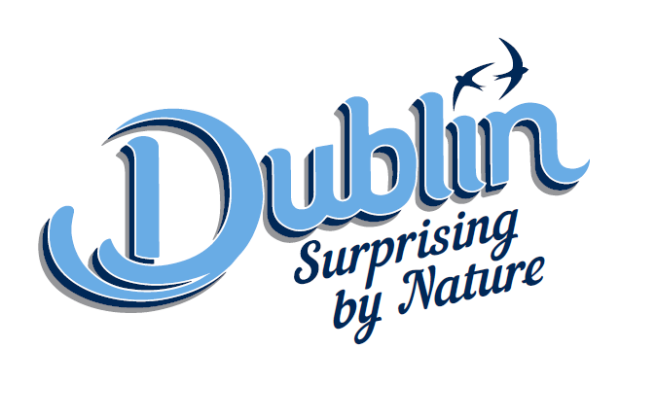

**Round Tower, Clondalkin**

* Surprising Stories Grant –Fáilte Ireland awarded SDCC €51,000 to help improve language capability at the visitor centre as well as refreshing interpretation. FI allocated an interpretation mentor to work with SDCC to bring a tender to market in Q1, 2020.
* Round Tower has been recommended for inclusion in Fáilte Ireland’s buyers guide for 2020 – this provides exposure for overseas tour operators at Meitheal and other trade shows overseas.
* Brain storming exercise with stakeholders to explore options to increase footfall at visitor centre over the next two years held on 30/01/20.
* Open Air Theatre Alice In Wonderland 20/06/20 (Saturday) and Emma 26/07/20) to take place.
* Calendar of further events drafted.

**The Castle Stables & Courtyard at Rathfarnham Project**

* No satisfactory submissions were received on foot of the PPQ advertised on etenders.
* Agent appointed and further targeted offer recommended.
* Recommend return to market Spring 2020.
* Agent recommends the provision of an outline design on a smaller scale.
* Consultant Architect to be engaged.

**Dublin Mountains Project**

* An Bord Pleanála issued another Further Information request, with response date of no later than 7 February 2020.
* FI submitted 24 December 2019.
* ABP have informed SDCC that they require public notice and invitation of further submissions in respect of the FI submission.

**Tallaght Stadium Branding**

* Tender for provision of consultancy services for a Tallaght Stadium advertising and branding strategy was issued on 2 July, 2019.
* Objectives are 1) to prepare a strategy to explore the potential of Tallaght Stadium as an entertainment venue and to raise overall awareness of the stadium, 2) to explore and develop advertising and branding opportunities in its current positioning and future strategic direction, and 3) evaluate a stadium branding and naming rights opportunity of the stadium.
* Contracts signed with consultancy firm on 22/10/19.
* Consultant to present to Council on 11/02/20.

**Clondalkin Self-Guided Trail.**

* This project is part of the 300K Have Your Say Participatory Budget 2018 scheme.
* English VO being rerecorded. Irish, French, and German recorded.
* Due for launch mid-February, 2020.
* Signage plan drafted with Roads Dept, working on designs.

**Liffey Valley Cluster - Lucan**

* The Grand Canal / Royal Canal Loop, an interagency project of regional importance led by Waterways Ireland, will have a significant potential impact on the development of the Liffey Valley Custer as envisaged in the South Dublin County Tourism Strategy. The Feasibility and Route Selection Study will be completed in the next month. The Study will then have to be approved by the Executive. Following this, the elected members will be briefed about the recommendations of the Study and the next stage of the process (i.e. planning consent).
* Failte Ireland has allocated up to €500,000 to South Dublin County Council on foot of its application for funding for Lucan under the Destination Town scheme. The funding will be allocated to improve the attractiveness and tourism appeal of the town.
* Met FI representative in Lucan to further proposals on 31/01/20
* Next step application due 31/03/20

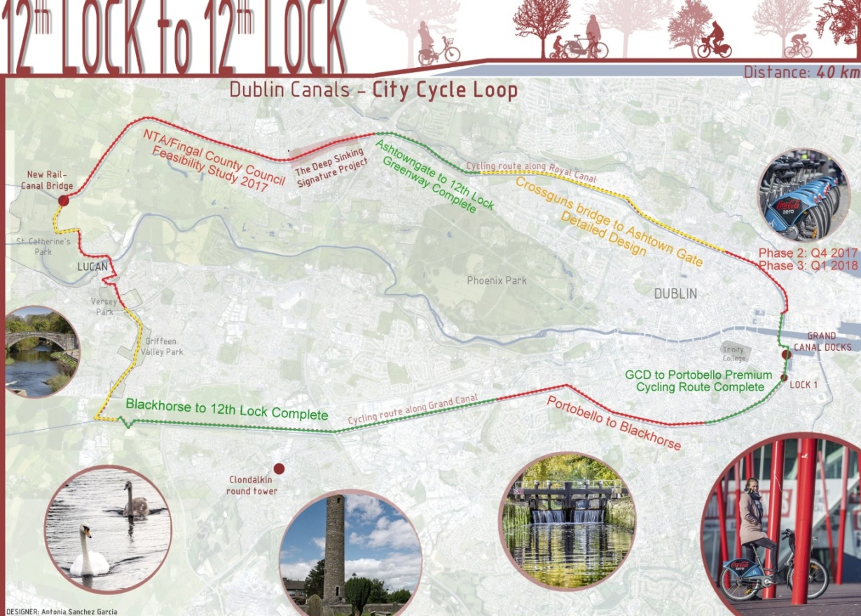

**Dodder Greenway**

* The Part 8 for the Dodder Greenway was passed by the Council in 2017.
* A framework for contractors set up and the first stage of this Greenway went out for tender Q3, 2019.
* The first phase entails the construction of the proposed bridges.
* Construction is planned to start in the new year but is weather dependent.

**Dublin Mountains Way**

* Continues to arrange a number of walk and talk events each month.
* New 10 year strategy for the Dublin Mountains Partnership being compiled.

**Events**

* Supporting the *Flavours Of South Dublin* event in Rathfarnham Castle on Sunday 14/06/20
* Open air theatre at the Round Tower on 20/06/20 and 26/07/20
* Expect to fund a number of third-party events via the Tourism Event and Festival Grant
* Developing event calendar with stakeholders for Round Tower.
* Exploring other events such as outdoor cinema and/or Proms in the Park.
* Engaging with hotels and service providers to develop shared goals.
* County Promotion Unit promoted the Dublin’s Outdoors and various service providers at Holiday World Show Limerick and Holiday World Show RDS in January, 2020.

**Events and Festival Grant**

* Funding programme aimed at organisations and organisers who plan to hold a public festival or event within South Dublin County Council’s administrative area
* Aim is to fund innovative events/festivals that are supported by local businesses and communities which will add value to the county’s tourism product.
* 2019 scheme launched 22nd March 2019.
* 11 applications funded in 2019 (Spend: €48,059.00)
* Example of events funded include Dublin Marathon Race Series 10k, international martial arts events, international basketball events, Liffey Descent.
* 2020 scheme to be launched mid-February 2020