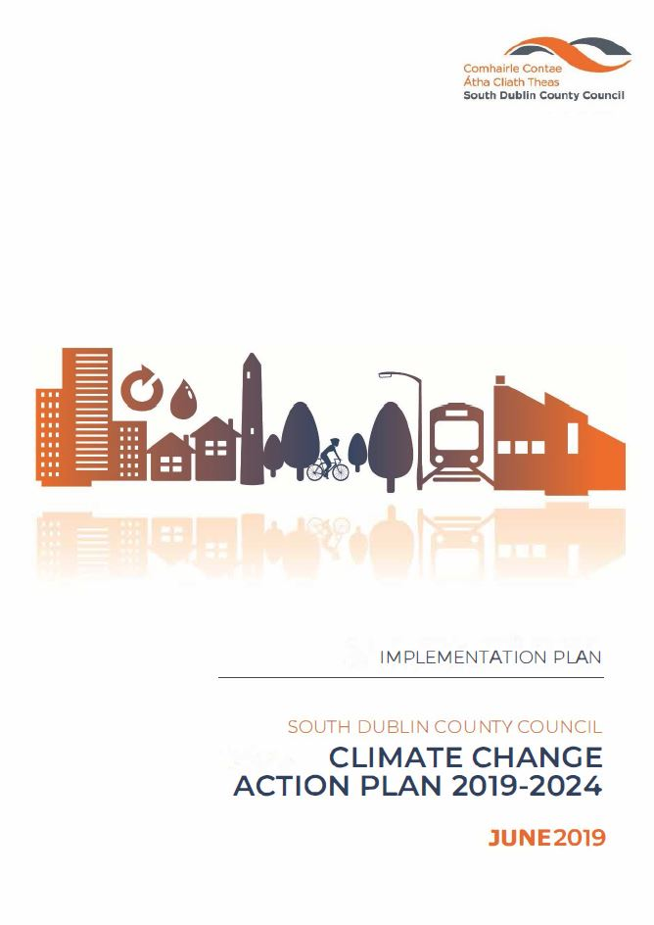

**January 2020**

**Implementation Plan for SDCC CCAP 2019-2024 (2020)**

Contents

1.0 Background 4

2.0 Targets 4

3.0 Introduction 5

4.0 Delivery 6

4.1 Administration of the CCAP 6

4.2 Teams 6

4.3 SDCC Climate Action Steering Group (CASG) 6

4.4 Action Teams 7

4.5 Action Team 6; Citizen Engagement 7

4.6 Budget 9

4.7 Meetings 9

4.7.1 SDCC Climate Action Steering Group 9

4.7.2 Action Teams 9

4.8 Reporting 10

4.8.1 Environment, Public Realm and Climate Change SPC and Council 10

4.8.2 Covenant of Mayors for Climate and Energy 10

4.8.3 Climate Action Regional Office (CARO) 10

4.8.4 DCCAE 11

4.8.5 LGMA 11

4.9 Risk 11

5.0 Actions/ Priority projects 12

5.1 Energy and Buildings 13

Key Actions 13

Actions progressing in 2020. 13

5.2 Transport 14

Key Actions 14

Actions progressing in 2020. 14

5.3 Flood Resilience 15

Key Action currently progressing and to continue in 2020 15

Action progressing in 2020 15

5.4 Nature Based Solutions 17

Key Actions 17

Action progressing in 2020 17

5.5 Resource Management 19

Key Actions 19

Action progressing in 2020 19

5.6 Citizen Engagement 20

Media 20

Climate Change and Environmental Awareness Officer 20

Community Workshops 20

Promotion 20

6.0 List of Acronyms Used 21

7.0 APPENDICES 22

7.1 Appendix I - ACTIONS 22

7.2 Appendix II -Climate Action Innovation Fund Request Sheet 28

Document Control:

|  |  |  |  |
| --- | --- | --- | --- |
|  | Author | Approved | Date |
| Draft | DM/CG |  | Dec ‘19 |
| Final | DM/CG |  | Feb ‘20 |
|  |  |  |  |

# 1.0 Background

In 2013 the EU published the EU Adaptation Strategy which sets out a framework and mechanism for enhancing the preparedness of the EU for the current and future impacts of climate change, and in 2014 the EU Climate & Energy Framework was published, setting out policy objectives in the 2020-2030 period and mandatory EU wide targets.

The Paris Agreement (COP 21), December 2015, Ireland, as a party to this agreement, recognises both the right and responsibility of all parties to pursue low carbon, climate resilient development and its supporting initiatives.

Ireland responded with the publication of the National Climate Action and Low Carbon Development Act 2015 (commonly known as the Climate Act 2015) which provides the required policy context for a strategic national adaptation response to climate change. The aim, as a fundamental national objective, is to achieve a transition to a competitive, low carbon, climate resilient and environmentally sustainable economy by 2050.

As part of the Climate Act 2015 reductions in greenhouse gas emissions and adaptation to the impacts of climate change is being addressed through national plans, the National Low Carbon Roadmap, the National Mitigation Plan (NMP) and National Adaptation Framework (NAF).

Irelands NAF and NMP were developed by the DCCAE and provides for an all of government approach to adaptation and mitigation and requires the development of local and sectoral plans.

South Dublin County Council Climate Change Action Plan 2019-2024 (CCAP) was launched in September 2019 and submitted to the Minister for Communications, Climate Action and Environment. This was done in accordance with the requirements of the National Adaptation Framework (NAF) 2018, as local adaptation strategies were required to be submitted by 30th September 2019.

# 2.0 Targets

In Ireland, the public sector has mandatory energy efficiency targets. It is set in the context of Ireland’s EU and national commitments and wider climate change goals, whereby a target of 33% energy efficiency improvement is to be achieved by all Irish public bodies (as defined in Statutory Instrument 426 of 2014) by 2020.

* 33% energy efficiency improvement is to be achieved by all Irish public bodies by 2020

There is currently no statutory requirement to undertake sectoral mitigation plans, including revised sectoral, local authority emissions reductions targets.Furthermore, as a signatory to the Climate Action Charter for Local Authorities, SDCC has committed to:

* Delivering a 50% improvement in energy efficiency by 2030.

Being a signatory to the EU Covenant of Mayors for Climate & Energy since 2018, this Council has voluntarily committed to:

* 40% reduction in its greenhouse gas emissions by 2030 and become a more climate resilient region.

# 3.0 Introduction

The Climate Change Action Plan 2019-2024 (CCAP) sets out how the Council will improve energy efficiency and reduce greenhouse gas emissions in its own buildings and operations, while making its functional area more adaptive to the impacts of climate change.

The plan concentrates on the two approaches required to tackle climate change. The first, mitigation, consists of actions aimed at reducing current and future GHG emissions; examples of these include reductions in energy use, switching to renewable energy sources and carbon sinks.

The second approach, adaptation, consists of measures aimed at reducing the impacts that are currently being experienced through our changing climate and those that are projected to happen in the future. The measures include flood protection, increased resilience of infrastructure and emergency response planning. The approaches are interconnected and should be planned together.

There are four key targets;

1. 33% improvement in the Councils energy efficiency by 2020
2. 40% reduction in the Councils GHG emissions by 2030
3. To make Dublin a climate resilient region by reducing the impacts of future climate change related events
4. To actively engage and inform our citizens on climate change

The Plan includes a range of actions, organised across five key action areas;

1. Energy & Buildings
2. Transport
3. Flood Resilience
4. Nature Based Solutions and
5. Resource Management

# 4.0 Delivery

## 4.1 Administration of the CCAP

The Management Team is key to driving the ownership of the actions to the managers within their departments, to ensure that climate change becomes part of the culture and day to day business of South Dublin County Council

There are five Action Areas in the Plan as identified above and delivery of the plan will be based around these five action areas. Action team will be tasked with delivery of the action in their area.

In order to satisfy the key target of actively engaging and informing our citizens on climate change, a further team was created;

Action Team 6 - Citizen Engagement

## 4.2 Teams

Ownership and implementation of this Climate Change Action Plan resides with every department of South Dublin County Council. The Plan demands an inclusive approach by the full Council, as the 130 actions listed connect every department across multiple sections. The Management Team is key to driving the ownership of the actions to the managers within their departments, to ensure that climate change becomes part of the culture and day to day business of SDCC.

Given the complexity and long-term nature of climate change, it is essential that progress on the actions is continuously monitored and that the delivery of actions is subjected to periodic review, both in terms of the validity of the underlying scientific assumptions and the appropriateness of projects, policies and programmes. Lessons learned and good practices identified during the monitoring and evaluation of ongoing and completed projects, policies and programmes should inform future actions, creating an iterative and evolutionary process.

## 4.3 SDCC Climate Action Steering Group (CASG)

To ensure the 130 actions in the CCAP are delivered a dedicated Climate Action Steering Group (CASG) is being established, the CASG will take forward the governance of the CCAP in this county. This team will include Senior Management, the chairs of the five Action Teams as outlined in the CCAP and the chair of the additional Action Team entitled Citizen Engagement. The proposed members of the Steering Group is outlined in Appendix 1: Steering Group and Action Teams.

The objectives of this steering group are;

* To ensure alignment with National legislation
* To ensure alignment with the other Dublin Authorities and the CARO’s
* To meet the targets of the CCAP
* To ensure budgets are aligned with targets of the CCAP
* To ensure projects are completed and on budget
* To ensure the actions of the CCAP are being carried out by relevant sections
* To ensure reports are issued and deadlines met
* To remove and include new and revised actions at annual revisions and iterations
* To receive the required information in order to report on the Action Teams
* To ensure all reporting requirement are completed e.g. SPC’s Covenant of Mayors CARO etc.

The purpose of this group is to bring the findings and reports from the Six Action Teams to this group for regional and national reporting purposes.

## 4.4 Action Teams

There are six action teams;

Action Team 1 - Energy and Buildings

Action Team 2 - Transport

Action Team 3 - Flood Resilience

Action Team 4 - Nature Based Solutions

Action Team 5 - Resource Management

Action Team 6 - Citizen Engagement

The purpose of these teams is to manage and deliver the actions of the CCAP, to ensure new actions are included and all work streams that can be captured are recognised and included.

The inclusion of Action Team 6; Citizen Engagement, acknowledges our role in increasing citizen awareness and public participation in climate change solutions.

## 4.5 Action Team 6; Citizen Engagement

This team’s role is to fulfil the underlying theme of the CCAP which includes engagement with our citizens. The objective of this team is to ensure a unified approach of engagement is conducted by each of the Action Teams for all citizens, those who live and work in our functional area. The members of this team will include Community, LEO, Communications and Corporate Support.

Initial members of each action team are identified in Appendix 1, but membership will evolve as different action in the CCAP are being progressed.

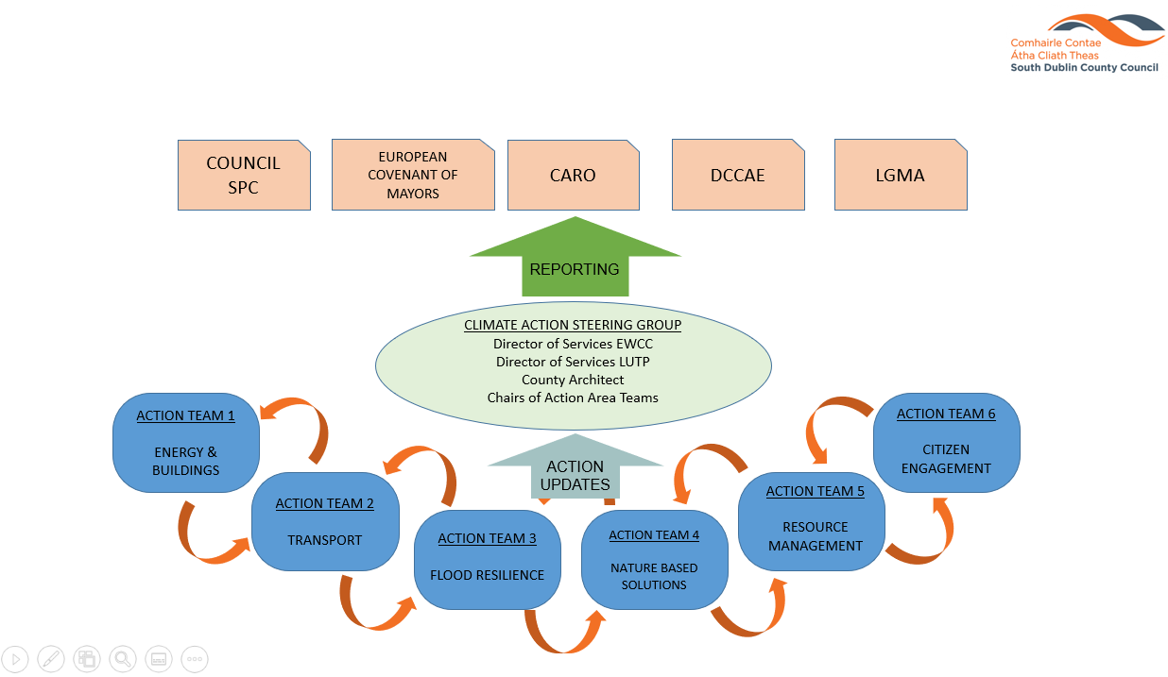

## 4.6 Budget

A review of the 130 actions listed, clearly shows that a lot of work is being carried out and budgets are already in place. For example, the upgrading of lights within County Hall to LEDs, upgrading of the public lighting stock to LED and flood alleviation schemes are all progressing and have been budgeted.

A Climate Action Innovation Budget of €300,000 has been provided for 2020. New and non-budgeted actions in the CCAP may avail of this Climate Action Innovation allocation through an application process.

It is proposed that projects or actions, once appraised and justified and confirmation that procurement criteria have been satisfied, they can be fully or partially funded from the Climate Action allocation.

The 2020 Climate Action Innovation Fund of €300,000 has been provisionally apportioned to the following projects;

* Installation of EV charging points at strategic locations in South Dublin €120,000;
* Provision of SDCC Staff Pool Car through partnership with SmartDublin €50,000;
* Provision of SDCC Staff Electric Bicycles €10,000;
* Citizen Engagement Workshops €20,000;
* Fund for innovative climate action pilot projects €100,000.

Projects and actions that have been approved for the Climate Change Action Plan have been included on an action tracker to allow progress, budgets and actual costs are to be monitored.

The Climate Action budgeted items are recorded in Agresso. In order to monitor additional cost and spending pertaining to but external to the Climate Action budget, a separate operational code will be made available.

Funding to the amount of €9,122,104.98 has been identified through departmental budgets to progress action on specific projects outlined in the CCAP 2019-2024.

## 4.7 Meetings

### 4.7.1 SDCC Climate Action Steering Group

The inaugural meeting of this group was held on 27th June, 2019, subsequent meeting will occur every month for three months reducing to every quarterly meeting thereafter. Provisional dates and times agreed at the inaugural meeting are arranged through our administrative support team. These dates should align with the Environment, Public Realm & Climate Change SPC meetings.

### 4.7.2 Action Teams

It is proposed that each Action Team meet monthly for the first three months of 2020 and revising to every second month thereafter. The dates and times agreed at the inaugural meeting are arranged through our administrative support team.

Actions should be reviewed by all team members prior to meetings. During the meeting team members will report on actions that are under their management.

## 4.8 Reporting

The following is the current list of bodies that the SDCC is responsible for reporting to, and from whom they take instruction regarding their reporting obligations;

* Environment, Public Realm and Climate Change SPC and Council
* Covenant of Mayors for Climate and Energy
* Dublin Metropolitan Climate Action Regional Office (CARO)
* DCCAE
* LGMA

To reduce the risks of omitting actions and significant items a top down and bottom up approach is required.

The Action Teams will be expected to report to the CASG through their Chairs. Reporting on the actions and their associated budgets. Introducing and revising actions on an annual basis.

The delivery of the CCAP will be a flexible process and subject to regular reviews in terms of the appropriateness of projects, policies and programmes, as well as climate projections.

### 4.8.1 Environment, Public Realm and Climate Change SPC and Council

The CASG will provide a report to the EPR & CC SPC at each of their meetings and in turn report to the full council.

This reporting system will be quarterly at each SPC meeting.

### 4.8.2 Covenant of Mayors for Climate and Energy

As the council is a signatory to the Covenant of Mayors for Climate and Energy, which is the world’s largest movement for local climate and energy actions, SDCC has pledged to support implementation of the EU 40% GHG reduction target by 2030 and to make SDCC a more resilient region. Accordingly, SDCC commits to submitting a Sustainable Energy and Climate Action Plan (SECAP), outlining the key actions it plans to undertake. The Plan will feature a Baseline Emission Inventory to track mitigation actions and a Climate Risks and Vulnerability Assessment. This commitment marks the beginning of a long-term process, a commitment has been made to submit a report on the implementation process every two years. The required information is provided to Codema, who compile and file the reports for all the Dublin LAs.

This reporting system is every two years.

### 4.8.3 Climate Action Regional Office (CARO)

Clearly climate change is a transboundary challenge. A Dublin regional approach has been adopted and will be overseen by the Dublin Metropolitan CARO. The task of the Dublin Metropolitan CARO is to liaise with the Dublin LA’s under their remit, the other three regional CAROs and respective central government departments to ensure alignment of actions. The CARO will also work with the University and Third Level section in relation to research and education on Climate Action.

Reporting to CARO by SDCC will be carried out formally on a quarterly basis, whilst informal reporting will occur weekly through associations.

Formal reporting procedures have yet to be fixed.

### 4.8.4 DCCAE

South Dublin County Council along with all public bodies, are required to report annual energy efficiency data to the Sustainable Energy Authority of Ireland (SEAI) which manages the reporting process on behalf of the Department of Communications, Climate Action and Environment (DCCAE). The required information is provided to Codema, who compile and file the reports for all the Dublin LAs.

This reporting system is annual.

### 4.8.5 LGMA

The LGMA circulated a research questionnaire to all LA’s in February 2019, the research was undertaken in partnership with the Climate Action Regional Offices (CAROs) on behalf of the County and City Management Association (CCMA) and the Environment Climate Change and Emergency Planning (ECCEP) Committee.

The questionnaire was devised to assist local authorities in developing a baseline assessment of local climate change actions. Nationally, local authorities are developing Climate Adaptation Strategies and Climate Change Action Plans throughout 2019, which indicate mitigation and adaptation responses. ECCEP indicated that emergency response (remediation) following extreme weather events should also form part of the baseline assessment to facilitate a thorough understanding of all climate change actions local authorities are currently engaged in. It is intended that the LGMA questionnaire will be circulated to all LA’s every January to report on the preceding year, tracking our progression over the forthcoming years.

This reporting system is annual.

Summary list of external bodies SDCC will be required to report to;

* CARO
* DCCAE through SEAI
* LGMA
* Covenant of Mayors for Climate and Energy through Codema

## 4.9 Risk

A high-level risk assessment was carried out as part of the CCAP process, but as described on page 31 of the plan a more detail risk assessment must be carried out. The aim is to identify potential future climate impacts, vulnerabilities and risks that are of greatest relevance to the council according to the key operational areas. There will also be new opportunities and benefits that will emerge during this exercise, these will also be logged and reviewed.

The key tasks are:

* Further assessment of potential future climate impacts and vulnerabilities
* Development of a Risk Register for each Action Team
* To prioritise climate risks

# 5.0 Actions/ Priority projects

It should be noted that actions identified in the CCAP are not listed in specific order. Actions must be prioritised and revised as agreed by each of the Action Teams.

The following is a list of projects that are scheduled to commence in 2020. The initial cost of each project will be appraised, and spending will be monitored by the lead section. Funding shall be arranged through the relevant section and Government procurement guidelines will be adhered to.

Projects scheduled to progress in 2020 are described below;

## 5.1 Energy and Buildings

### Key Actions

Heatnet **–** Continue to progress the Heatnet project, whereby heat generated by local large data centres which would otherwise be expelled into the atmosphere, is harvested and distributed locally through an underground pipe network to provide heating to buildings. Heatworks, a company set up and managed by South Dublin County Council, will progress the project in 2020. Amazon has been identified as the first major supplier of heat to the network and South Dublin County Council Civic Offices will be the first building to benefit from the surplus heat. The benefits to SDCC include low cost heating, improved energy efficiencies and reduced CO2 emissions compared with current natural gas heating. It is expected that a major service provider with international experience in similar systems will sign a Design Build Operate and Maintain Contract. The project provides scope for additional heat sources to connect providing future opportunities for business and homes to enjoy the benefits of low-cost sustainable energy. The expected cost of the initial scheme is €8 M, with €4.5 M coming from the National Climate Action Fund.

Public Lighting upgrades – With in excess of 30,000 units across the county, public lighting accounts for approximately 49% of the energy used by South Dublin County Council. SDCC has committed to upgrading the public lighting network from older Sodium Oxide to more energy efficient LED units. Phase 2 of the upgrade, scheduled for completion between 2020 and 2025 will see 12,500 of the old lighting heads being replaced at a total cost of €11M. 2000 replacements are scheduled for 2020. Energy savings of between 50% and 65% are anticipated.

County Hall Lighting upgrades - Phase 2 of the upgrade of lighting in County Hall will commence in 2020, including individual offices, open plan work areas, elected members facilities and public spaces. Works involve the removal of older lighting systems and replacement with low energy consuming LEDs, Passive Infrared (PIR) sensors, dimmer controls and emergency lighting. The estimated cost of work in 2020 is €300,000.

Upgrading insulation in County Council Housing Stock – Under the 2020 programme of housing works is the upgrade of loft and cavity wall insulation in 196 of SDCC’s housing stock. Work will also include the installation of an insulated loft door, insulating central heating and cold-water storage tanks, mechanical and passive fans to improve ventilation in kitchens, bathrooms and attic space.

### Actions progressing in 2020.

* Action E.12 - Development of the Tallaght District Heating Scheme.
* Action E.13 – Retrofit of the Council’s housing stock. Planned works include wall and attic insulation and ventilation improvements.
* Action E.15 - Ongoing upgrading of lights in County Hall to LEDs.
* Action E.17 - Replace existing SOX Public Lighting with LED lanterns.
* Action E.20 – Identify sites for trialling renewable energy projects, including Solar PV and Geothermal.
* Action E.21 – The Council will investigate the Lifecycle Assessment of traditional and new construction methods for residential projects in Dublin.
* Action E.24 – Assess feasibility of additional low carbon district heating networks: Clonburris and Grange Castle.

## 5.2 Transport

### Key Actions

Electric Vehicle – In 2018 SDCC replaced 5 of its maintenance fleet with equivalent Electric Vehicles. In the first 12 months, the 5 vehicles had travelled a total of 26,000km saving approximately €2,000 in fuel costs and cutting out 3.5 tonnes of CO2. In 2020 SDCC intend to expand the its EV Fleet with the inclusion of a staff pool-car and 3 electric bicycles.

Smart Mobility Hub – In partnership with SmartDublin.ie SDCC are trialing a pool-car and 3 electric bicycles to afford staff (who travel as part of their duties) the opportunity to choose alternative travel modes than their private car, reducing CO2 emissions and freeing parking space in staff car parks.

Charging Network - SDCC, in partnership with the other 3 DLAs, have engaged a consultant to examine and report on an integrated strategy for the roll-out and management of an EV charging infrastructure. SDCC has identified locations within communities where EV charging infrastructure can be installed to best serve the needs of current and future EV drivers. Grant funding of up to €5,000 per unit is available from the SEAI, to provide EV charging points in communities where private parking is unavailable. SDCC will take advantage of this grant aid and provide additional monies through the Climate Innovation Fund for charging units in locations that do not qualify for grant funding.

Greenway/Cycleway Routes - The 2020 Roadworks programme includes several schemes that enhance and extend our pedestrian, cycle and greenway networks. For example, the Dodder Greenway is currently under construction and will deliver 10km of cycle route from Bohernabreena to the Grand Canal Dock, including the construction of three bridges. Monastery Road Walking and Cycling Scheme and Belgard Square North to Cookstown Link road are both under construction and will provide 400m and 300m of connectivity and active travel options respectively.

The N81 Jobstown Cycling, Walking and Bus Facilities, the Grange Road Cycle and Celbridge link Road schemes are currently at detailed design and tendering stage, and will include up to 2.0km, 1.0km and 2.2km of junctions improvements, bus, pedestrian and cycling facilities.

The Green Schools Walkability Audits Infrastructure to improve pedestrian and cycle infrastructure, connectivity and safety of sustainable transport modes, the Wellington Lane Walking and Cycling Route and the Airton Road Extension scheme to include cycle facilities are currently at a preliminary design stage and will be progressed to Part 8 in 2020.

The Tallaght to Liffey Valley cycle route, a light segregation pilot project aimed at installing low cost safety barriers for cyclists along existing cycle routes and the N81 Transport and planning Strategy to assess the future traffic requirements including pedestrian and cycle needs are currently at option review stages.

### Actions progressing in 2020.

* Action T.2 - Ongoing replacement of Council vehicles with more energy-efficient alternatives, including EVs.
* Action T.7 – The Council will undertake an assessment of the number of existing and potential future Electric Vehicle Charge points in its jurisdiction.
* Action T.12 – Development of cycle/pedestrian greenways.
* Action T.21 - Expand availability of EV and other facilities for non-fossil fuel powers vehicle charging points in the County.

## 5.3 Flood Resilience

### Key Action currently progressing and to continue in 2020

#### Poddle Flood Alleviation Scheme

Background – The Poddle river has a history of extensive flooding resulting in damage and loss. In excess of 800 properties along the route of the Poddle are subject to the risk of flooding. With funding made available from the OPW, a preliminary design including environmental studies are being prepared for submission to An Bord Pleanála in Q1 2020 for planning permission under Part X of the Planning & Development Act 2000. Detail design will progress in parallel and the scheme is expected to progress to construction stage in late 2020 subject to ABP approval.

A Public consultation on the proposed works was held in December 2019.

#### Whitechurch Flood Alleviation Scheme

The Whitechurch Stream has been identified under the Dodder CFRAM project as being liable to flooding during a one in one-hundred-year flood event. Flooding occurs due to low banks and overtopping of the existing defences and insufficient capacity on the floodplain. Insufficient flow capacity on a number of bridges and culverts also cause the water to back-up upstream.

In partnership with the OPW, South Dublin County Council is planning to complete the FAS in Rathfarnham, providing up to 275 metres of flood defences against the 1 in 100-year event, protecting over 170 properties.

The Whitechurch FAS will go to An Bord Pleanála in Q1 2020 for planning permission under Section 177AE of the Planning & Development Act 2000. Detail design will progress in parallel and the scheme will progress to construction in late 2020 subject to ABP approval.

Several public engagement/information events were held in November, 2019.

#### Camac Flood Alleviation Scheme

Design consultant were appointed to the Camac FAS in late 2019. Progression of works is at an early stage. DCC is leading this project and SDCC are engaged through the Project steering group. Public consultation events were held in early December.

### Action progressing in 2020

* Action F.3 – Cross-boundary flood management with neighbouring local authorities.
* Action F.11 – Integrated constructed wetlands for water attenuation and purification.
* Action F.12 – Develop a Climate Change impact GIS risk map with scenarios for the Dublin Region.
* Action F.13 – Develop template to capture impacts, responses and costs (including ecosystem services/natural capital costs) for all major climate events.
* Action F.15 – Establish a working group to deal with the issue of pluvial flood risk, this shall include; How to manage Urban Creep and the increase in impermeable surfaces; Promotion of SuDS early in design process; development of pluvial flood forecasting through use of point rainfall forecasting.
* Action F.17, F.18 & F.19 – Whitechurch, Poddle & Camac Flood Alleviation Schemes.
* Action F.20 – Minor flood schemes and general maintenance that are designed and implemented to promote Nature Based Solutions where practical.
* Action F.21 – Communication and awareness campaigns on flood risk management and natural flood management measures.
* Action F.22 – Promote and encourage community involvement in the retrofit of SuDS in existing developments.

## 5.4 Nature Based Solutions

### Key Actions

#### Tree Management

Amongst our greatest natural assets in South Dublin are our 60,000 trees located in our public parks and open spaces. Our Tree Management Policy 2015-2020, ‘Living With Trees’ outlines our strategy for planting, maintaining and replacing this natural resource. Our objective in 2020 is to plant 2,000 trees, and to reduce the amount of removals to below 1,000.

#### Implementing SuDS Projects

Sustainable Drainage Systems (SuDS) are accepted as the preferred solution to managing our pluvial drainage requirements. Incorporating wetlands and swales into our amenities and developments provide many benefits such as the removal of many of the contaminants often picked up by flood waters and also the control of the discharge rate of rainwaters into rivers and streams preventing downstream flooding. SuDS solutions can include strategic planting and maintaining trees, hedgerows and grasses, grasscrete and permeable paving as alternatives to impermeable parking areas and maintaining and incorporating natural drainage paths and floodplains into our amenities and developments.

#### Green Infrastructure Strategy

Under The Irish National Biodiversity Action Plan, a Green infrastructure Strategy is required from South Dublin County Council to achieve a planned network of natural and semi-natural areas including environmental features designed and managed to deliver a wide range of ecosystem services such as water purification, air quality, space for recreation and climate mitigation and adaptation. SDCC are currently preparing tender documentation for the progression of its GI Strategy.

#### Biodiversity

South Dublin County Council is a listed partner with the National Pollinator Plan. SDCC supports the NPP by undertaking a range of projects to assist native pollinating insects including honeybees, bumblebees, hoverflies and butterflies. The projects includes reduced mowing of grass areas to encourage the growth and development of wildflower areas.

### Action progressing in 2020

* Action N.5 – Produce regional floodplain management guidelines.
* Action N.6 – Finalise Draft Biodiversity Action Plan.
* Action N.7 – Develop Green Infrastructure Strategy that identifies areas and priorities for green infrastructure and investment.
* Action N12 – Develop urban woodland management strategy and action plan.
* Action N.13 – Implement Tree Management Policy.
* Action N.14 – Increase tree canopy cover in the County through annual planting and maintenance.
* Action N.18 – Develop demonstration projects for successful planting and establishment of trees in urban hardscapes.
* Action N.20 – Review and climate-proof Biodiversity Action Plan, Invasive Alien Species Plan, and tree management Policy.
* Action N25 - Manage and monitor identified ‘pollinator protection sites’.
* Action N26 – Maintain and expand community gardens and allotments for local food production.
* Action N.27 – Support local communities with biodiversity education.
* Action N.28 – Sustainable gardening workshops.
* Action N.30 – Deliver Green Roof on Civic Buildings.
* Action N.31 – Maintain and increase Green Schools Programme participation.
* Action N.32 – Engage with residents and relevant stakeholders on Climate Change and Biodiversity to incorporate their ideas into Council strategies and plans.
* Action N.33 – Assess the benefits of increasing buffer distances of 10m from watercourses to protect biodiversity and provide greater flood attenuation for distances of 20m, 50m and 100m.

## 5.5 Resource Management

### Key Actions

#### Single Use Plastics

SDCC is committed to reducing the amount of single use plastic items being used in its jurisdiction. Continuing efforts are being made to eliminate SUPs in County Buildings at sponsored events. In 2019, SDCC introduced public water stations at key locations to provide potable water to citizens engaged in active travel and play. The water stations encourage users to refill their own bottles and eliminate the use of SUP. By the end of 2019 over 3,500 litres of water had been dispensed from the water stations, eliminating 7,000 plastic bottles from the waste cycle. Additional water stations are to be installed in 2020, bringing the total up to 17 units.

#### 2GoCup

SDCC has successfully implemented a 2GoCup scheme in County Hall. The 2GoCup scheme encourages participants to reuse their own cup when purchasing beverages from the canteen facilities, thereby eliminating the use of single use cups.

#### BigBellyBins

In 2019 SDCC introduced 8 Solar powered BigBellyBins on a trial programme. These solar powered street litterbins compact waste, thereby increasing overall capacity. Each unit is also fitted with communication capabilities that alert SDCC when the bin is ready to be emptied/collected, reducing unnecessary travel and associated carbon discharge.

### Action progressing in 2020

* Action R.19 – Examine the potential of Arthurstown Landfill for development of green energy uses.
* Action R.20 – Implement water conservation campaigns in civic buildings.
* Action R.21 – Identify pilot locations for water access points (Single-use plastic elimination)
* Action R.24 – Research feasibility of rainwater harvesting in Council Buildings.
* Action R.25 – Promote recycling and the circular economy to householders through a range of workshops, talks and programmes.
* Action R.26 – Explore collaborations with stakeholders such as Refill.ie to reduce single use items.

## 5.6 Citizen Engagement

We understand the importance of engaging with our citizens on all of our actions. Through representations and questions from our elected members, public consultation sessions and our own Customer Care management system, we are aware of the significant level of interest and concern that the public hold regarding the environment and climate change. Citizen engagement, including our use of social media, provides a platform to SDCC to discuss our activities and achievements with the public, and collect valuable feedback to benefit the scope of future works.

### Media

Our Climate Change Action Team liaise with the Community Development section to provide interactive workshops and discussions with communities, youth groups and the wider community. Our recent interactions with RTÉ, Radio Na Life, Tidy Towns groups and Comhairle na nÓg presented us with opportunities to showcase our CCAP, and to form a foundation for building worthwhile relationships.

### Climate Change and Environmental Awareness Officer

One of our main objectives for 2020 is to appoint a Climate Change and Environmental Awareness Officer to our Climate Change Action Team and whose role will include citizen engagement and the promotion of our CCAP.

### Community Workshops

Additional actions scheduled to be delivered include Climate Change workshops to Tidy Towns groups and interested groups by Gavin Harte of ESD Training aimed at helping communities to better understand the need for climate action at a local level and to help build climate knowledge.

### Promotion

Our Climate Change Action Team will also continue to promote Climate Change awareness and provide educational material and engagements at public events including the Flavours of South Dublin festival.

In association with CoDEMA, South Dublin County Council will take an active role in promoting events during Climate Action Week and Eco Week.

#### Actions progressing in 2020 will include

Promote Eco-Week

Promote Re-Use Month

Promote programmes to advise businesses on reducing waste

Eliminate Single Use Plastics at Council organised events

Promote leaf composting programme

Support Tidy Towns initiatives

Implement water conservation in County buildings

Promote recycling and the circular economy to householders through a range of workshops, talks and programmes

# 6.0 List of Acronyms Used

LAs Local Authorities

DLAs Dublin Local Authorities

NMP National Mitigation Plan

NAF National Climate Change Adaptation Framework

NEEAP National Energy Efficiency Action Plan

CARO Climate Action Regional Office

CCAP Climate Change Action Plans

LAPs Local Area Plans

ABP An Bord Pleanála

FAS Flood Alleviation Scheme

SDZ Strategic Development Zone

GHG Greenhouse Gases

SUP Single Use Plastics

ETS Emissions Trading Scheme

CAT Climate Action Team

CASG Climate Action Steering Group

LGMA Local Government Management Agency

SEAI Sustainable Energy Ireland

ECCEP Environment Climate Change and Emergency Planning committee, part of

CCMA County and City Management Association

SECAP Sustainable Energy and Climate Action Plan

CFRAM Catchment Flood Risk Assessment and Management

Codema City of Dublin Energy Management Agency

# 7.0 APPENDICES

## 7.1 Appendix I - ACTIONS

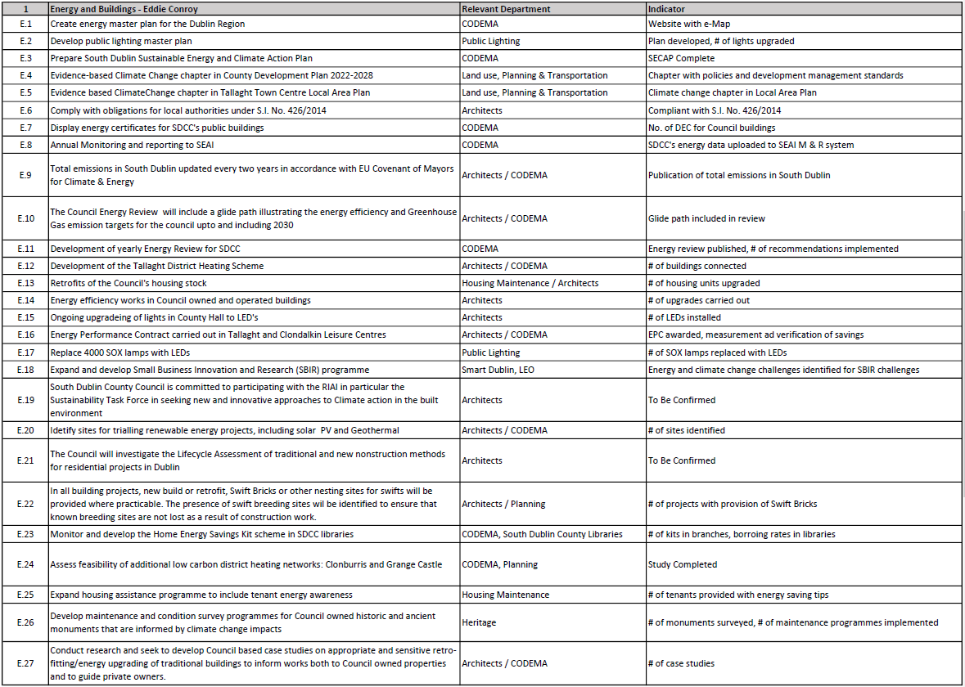

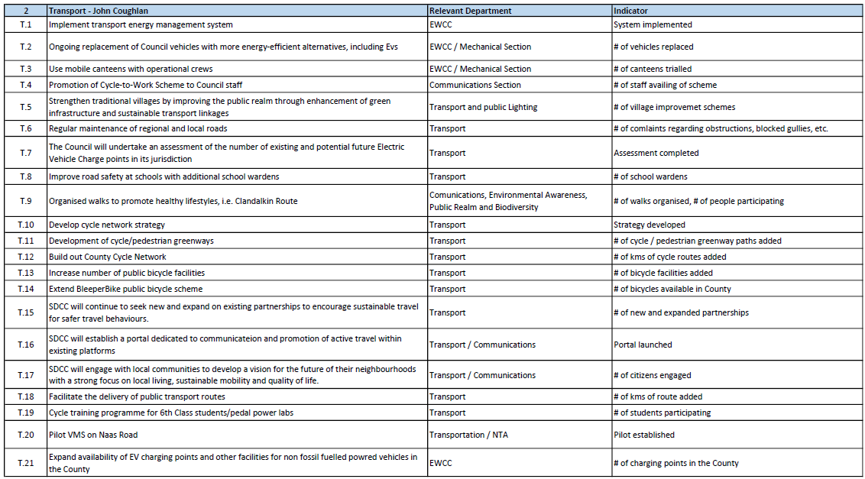

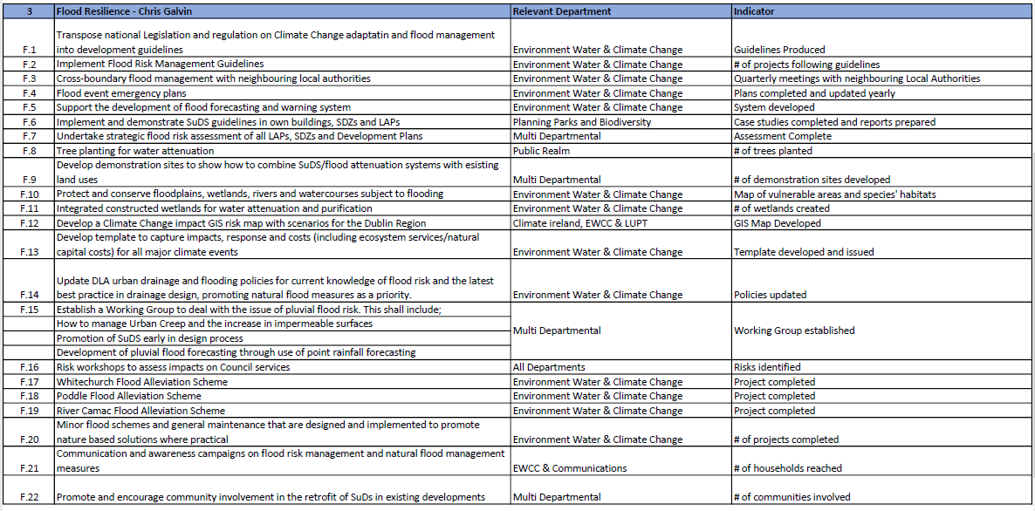

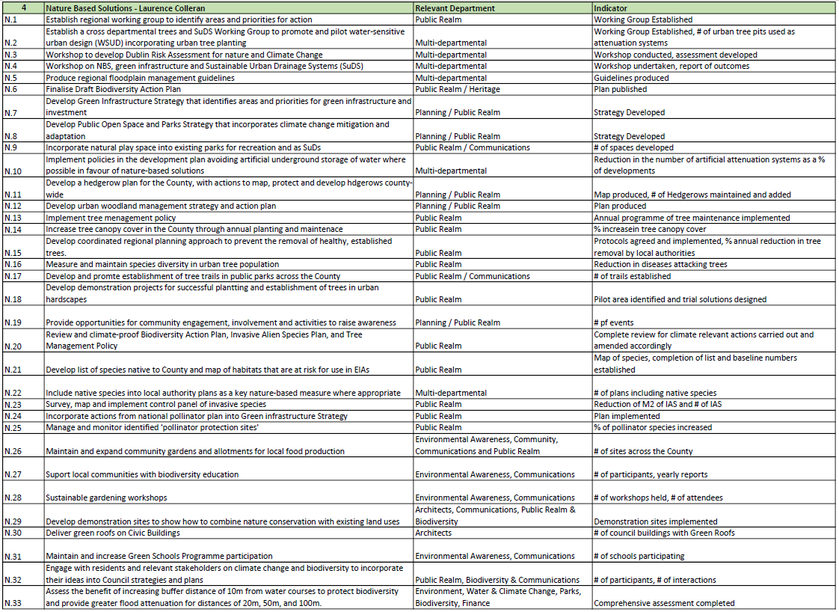

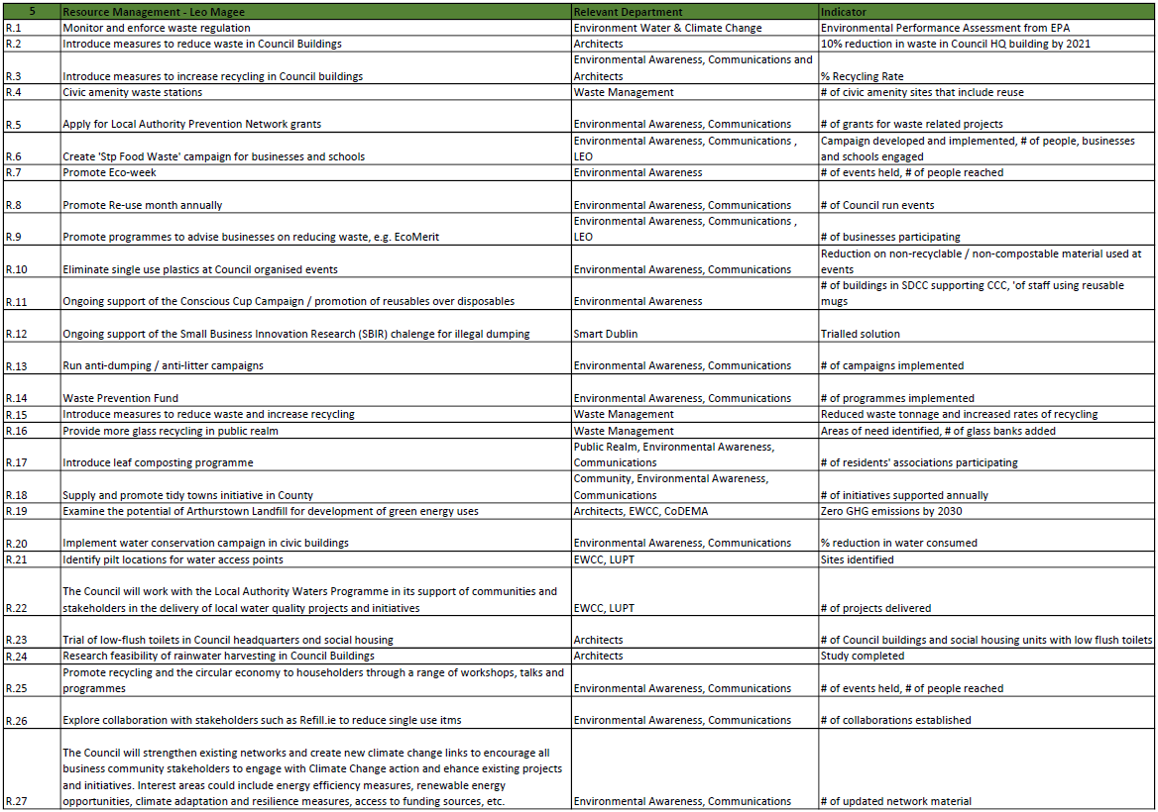

## 7.2 Appendix II -Climate Action Innovation Fund Request Sheet

